BRADFORD VTS TEACHING AIDS

The Numbers Don’t Tell the Whole Story:
CHD & bp, statins, exercise, weight & smoking cessation
Understanding ARR, RRR, NNT & Medical Statistics

By Dr Ramesh Mehay, GP Trainer (Bradford)), Former TPD
May 2026

This document explains modern cardiovascular prevention using simple language, modern evidence, visual explanations and patient-friendly examples. It emphasises that prevention is about more than simply preventing heart attacks and strokes.

The Biggest Misunderstanding in Medicine
Lowering systolic blood pressure by around 10 mmHg reduces major cardiovascular events by roughly 20% relative risk reduction over about 5 years (Ettehad et al, Lancet 2016; BPLTTC meta-analyses).
But a 20% relative risk reduction does NOT mean 20% of all patients are saved.
This is one of the most common misunderstandings in medicine.
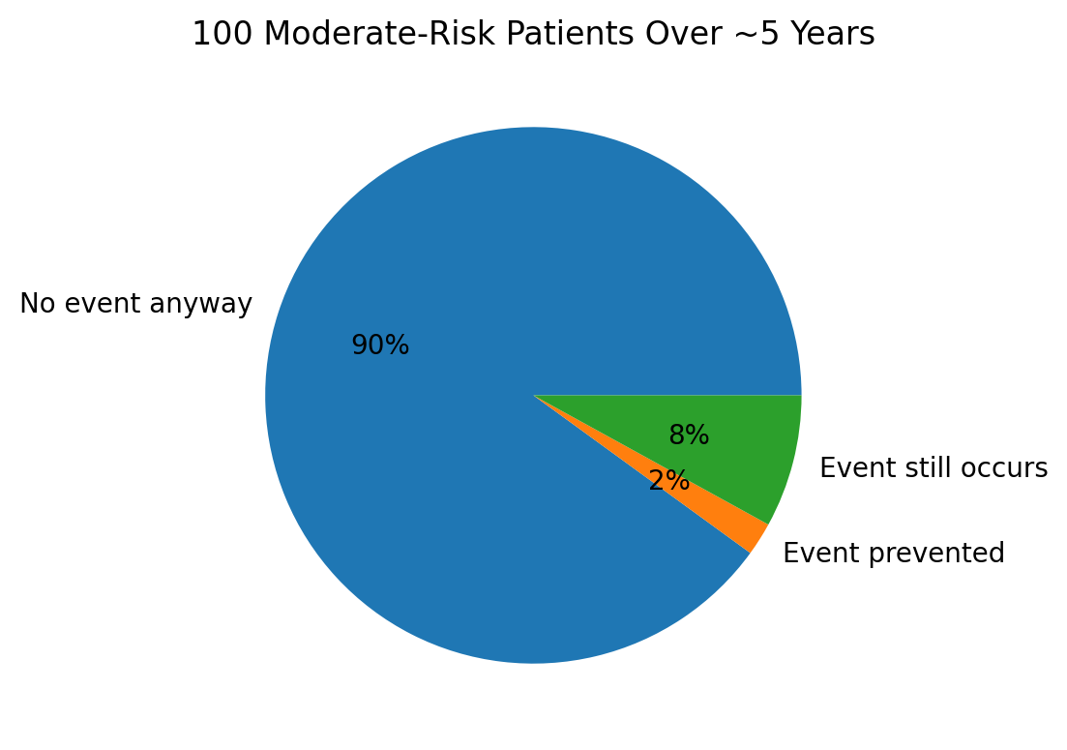
Example:
• Imagine 100 people with hypertension.
• Without treatment, maybe 10 people would have a cardiovascular event over 5–10 years.
• With treatment, this might fall to about 8 people.
• So around 2 people benefit directly.
• The other people either:
- were never going to have an event anyway, OR
- still had an event despite treatment.
So treatment absolutely helps — but the size of benefit depends heavily on the person's starting cardiovascular risk.
But it is NOT correct to say that the other 80% 'get nothing'. Rather:
• Some people would never have had a cardiovascular event anyway.
• Some people have an event despite treatment.
• Some people may gain benefits in other ways – see below in the sections that say “But Let Me Blow Your Mind Further…”
This is why we talk about probabilities and population benefit rather than guarantees. This is about population medicine, not individual medicine – because you can never guarantee an individual will be the one that benefits.

Blood Pressure Treatment

BP Reduction | Major CV Events | Stroke | Heart Failure | All-Cause Mortality
10 mmHg | ~20% RRR | ~27% RRR | ~28% RRR | ~13% RRR
20 mmHg | ~36% RRR | ~47% RRR | ~48% RRR | ~24% RRR
30 mmHg | ~49% RRR | ~61% RRR | ~63% RRR | ~34% RRR
Sources: Ettehad et al. Lancet 2016; Blood Pressure Lowering Treatment Trialists’ Collaboration.
What this table (and the pictogram below) tells you is that the greater the BP reduction, the greater the benefit.
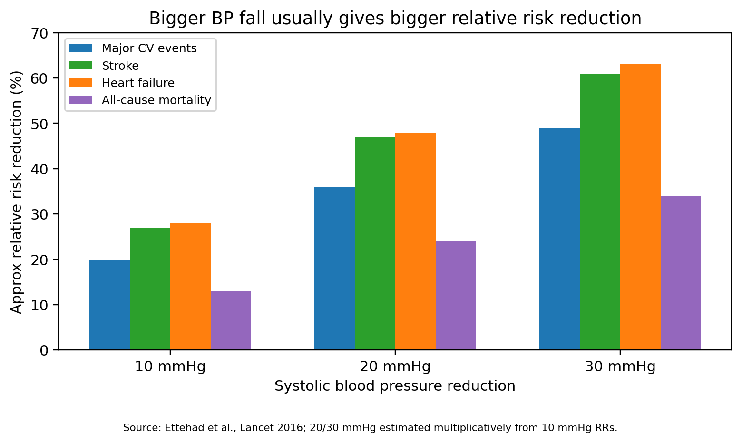
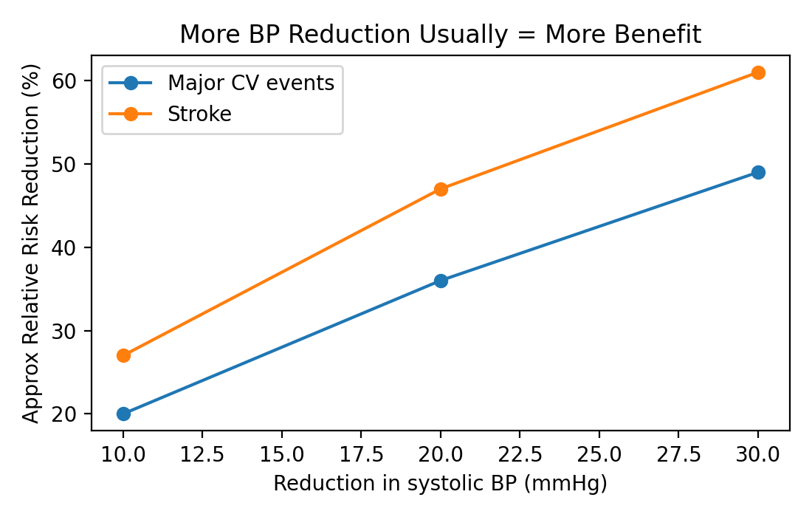
In fact, as an approximation, lowering the sBP by about 10mmHg causes a relative risk REDUCTION of approximately...
- Major cardiovascular events by about 20%
- Stroke by just over 25%
- Heart failure by just under30%
You might be wow’d by this. However, these are RELATIVE risk reductions.
But that’s not the whole truth:
- If I said to you I was going to give you 10 times greater a slice of cake than I gave you last week, you might at first be impressed.
- But if you then remembered that the slice of cake I gave you last week was 1mm thin, then this time you’re only going to get a 10mm thick slice – doesn’t look so great does it.
- The “10 times greater” is RELATIVE and RELATIVE RISK can looks more impressive that what it is.
- To understand it’s truth, you need to know the exact thickness of the slice of cake you got this week and the exact thickness of the slice you will get this week. In other words, the ABSOLUTE amount.
So, let’s have a look at the RELATIVE and ABSOLUTE risk reductions for 10mmHg BP lowering in patients.
Source: Ettehad et al., Lancet 2016
Baseline 10-year CV Risk | Risk WITHOUT treatment (absolute) | Risk WITH treatment (absolute) | RRR | Approx ARR | Approx NNT | Events prevented per 100 treated over 5y | Interpretation
5%  low risk | 5 in 100 | 4 in 100 | ~20% | 1% | 100 | 1 | Small absolute benefit
10%  low-moderate | 10 in 100 | 7.5 in 100 | ~25% | 2.5% | 40 | 2–3 | Moderate benefit
20%  moderate-high | 20 in 100 | 14.5 in 100 | ~27.5% | 5.5% | 18 | 5–6 | Much greater benefit
30%  high risk | 30 in 100 | 21.5 in 100 | ~28% | 8.5% | 12 | 8–9 | Large absolute benefit
Look at the Numbers Needed to Treat for just ONE patient to benefit?
(Note, drug companies often use relative risk to big up their drug’s advantages and they use absolute risk to play down the side effects and negatives!)

Key Clinical Teaching Points
- Relative risk reductions often sound larger than the true absolute benefit.
- Absolute risk reduction (ARR) and NNT are usually more meaningful for shared decision-making.
- People at higher cardiovascular risk benefit more in absolute terms.
- Lower-risk younger patients may have very high NNTs over 5 years.
- Hypertension treatment is about probability reduction, not guarantees.
- Modern guidelines favour overall cardiovascular risk assessment rather than BP alone.

Important Caveat About NNT
NNT changes depending on:
• The patient's baseline cardiovascular risk
• The length of follow-up
• Which outcome is measured (stroke, MI, death, composite events)
• How much blood pressure is lowered
• Whether the patient is also taking statins, aspirin, or making lifestyle changes
This means there is no single universal NNT for hypertension treatment.
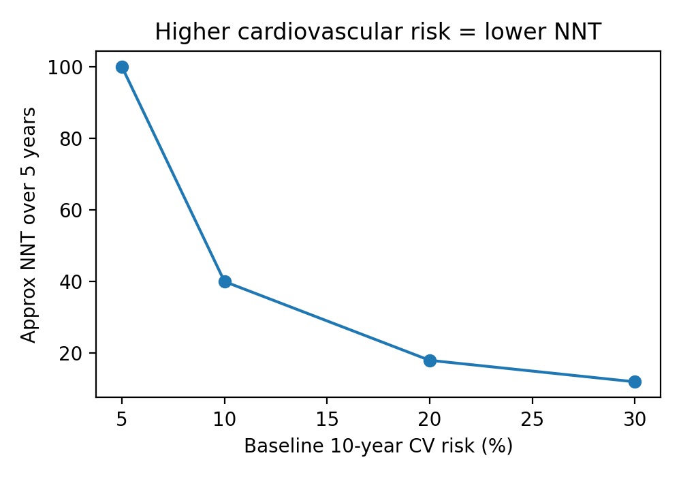

But Let Me Blow Your Mind Further…
So, from the above table, you might think “Oh so for moderate risk patients, you will need to treat 50 people for 1 to benefit over the 10 years. And the other 49 get absolutely nothing for their efforts! They take the tablet every day for 10 years for absolute nothing!”. But that’s not entirely true. It’s not just about reducing the risk of heart attacks and strokes. Reducing someone’s BP also offers…
- Kidney protection – Especially in diabetes and proteinuria.
- Reduced heart failure – About 25–30% relative reduction.
- Reduced atrial fibrillation – Probable 10–20% reduction long-term.
- Eye protection – Less hypertensive and diabetic retinopathy.
- Reduced vascular dementia – Likely modest reduction in vascular cognitive decline.
- Reduced left ventricular hypertrophy – Strong evidence of reverse heart remodelling.
So the story is NOT just about heart attacks and strokes. Some benefits are harder to measure in trials, but matter hugely to patients. Helping patients to decided whether to take a BP lowering tablet or not needs to take all of this into account. This is why NICE now focuses heavily on TOTAL cardiovascular risk (for example QRISK3), not simply the blood pressure number alone.
Have I fried you brain yet? Don’t worry if I have because this is an intensely complex area that not many doctor experts talk to you about! But seriously, don’t worry if you’re brain is fried. Read this article 2-3 times and each time it will get easier.

Bottom Line
Blood pressure treatment works — but usually not in the dramatic way patients sometimes imagine.
The main benefit is a modest reduction in cardiovascular probability over time. That modest reduction becomes much more important in people at higher baseline risk.
Good shared decision-making means explaining BOTH relative and absolute benefit honestly and clearly.

How Trainees Should Explain Treatment
Avoid saying:
• 'This tablet will stop you having a stroke.'
• 'This dramatically reduces your risk.'
• 'This prevents heart attacks.'
These statements sound more certain than the evidence really supports.
Instead, try patient-friendly explanations like:
- “This treatment lowers your chances of stroke and heart attack, but it cannot remove the risk completely. The aim is to lower your chances of getting these things, not reducing that chance to zero, because that is impossible. We need to shift the odds in your favour”
- “And they might have other benefits too, like protecting your kidneys, keep your brain, heart and eyes healthy.”
- “I need to be open and honest with you. For some people the benefit is small, but across large populations it prevents many strokes and heart attacks.”
- “The higher your starting risk, the more likely you are to benefit. This medicine shifts the odds more in your favour.”
- And if then talking about statins, weight loss and stopping smoking, you might say: “Your blood pressure matters, but your overall cardiovascular risk matters even more. Your cardiovascular risk is determined by how high your blood pressure is, how high your cholesterol is, how health a level your weight is and whether you smoke or not and do exercise. Shall we talk a bit about each of these?”
Okay, let’s move onto statins and cholesterol reduction !

Cholesterol Reduction with Statins
Each 1 mmol/L reduction in LDL cholesterol reduces major vascular events by about 20–25% over around 5 years (CTT Collaboration, Lancet 2010). NICE now aims for a greater than 40% fall in non-HDL cholesterol for primary prevention when statins are used. (NICE NG238, 2023; reviewed 2025)
Best simple phrase: “The statin lowers the cholesterol that drives artery furring. The benefit depends on your starting risk and how much LDL/non-HDL falls.”
LDL reduction | Major vascular events | Stroke | All-cause mortality | Meaning | Source
1 mmol/L | 22% RRR | 17% RRR | 10% RRR | Typical useful statin effect size | CTT Collaboration, Lancet 2010
2 mmol/L | 39% RRR* | 31% RRR* | 19% RRR* | Bigger LDL fall gives bigger benefit | Estimated from CTT 2010 RRs

Outcome | Approx Reduction | Timeframe | Main Source
Major vascular events | ~22% | ~5 years | CTT 2010
Stroke | ~17% | ~5 years | CTT 2010
CV mortality | ~14% | ~5 years | CTT 2010

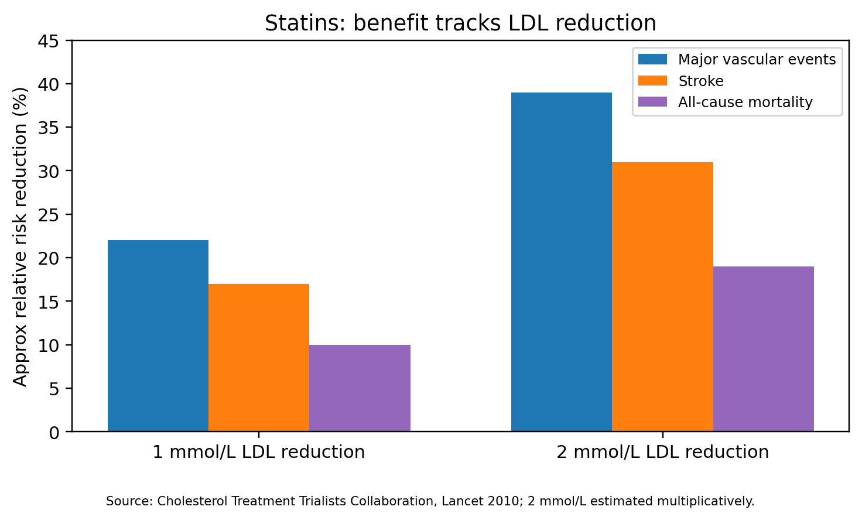
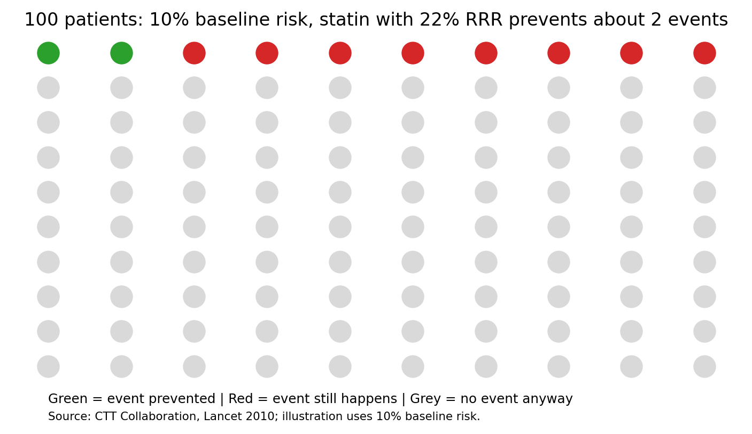

Source: CTT Collaboration, Lancet 2010; pictogram illustrates absolute benefit at 10% baseline risk.
Starting 10-year risk | With no statin | With 22% RRR statin | Absolute benefit | Approx NNT over 5-10y | Source
5% | 5 in 100 | 3.9 in 100 | 1.1 in 100 | 91 | CTT 2010; illustration
10% | 10 in 100 | 7.8 in 100 | 2.2 in 100 | 45 | CTT 2010; illustration
20% | 20 in 100 | 15.6 in 100 | 4.4 in 100 | 23 | CTT 2010; illustration
30% | 30 in 100 | 23.4 in 100 | 6.6 in 100 | 15 | CTT 2010; illustration

But Let Me Blow Your Mind Further…
It’s not just about reducing the risk of heart attacks and strokes. Putting someone on a statin also offers…
- Plaque stabilisation – Strong evidence.
- Reduced vascular inflammation – CRP reduction and anti-inflammatory effects.
- Possible vascular dementia reduction – Likely indirect vascular protection.
- Improved endothelial function – Improved arterial function.

Exercise & Fitness
Regular physical activity is associated with roughly 20–35% lower all-cause mortality (PURE Study 2017; WHO evidence reviews).
Best simple phrase: “You do not have to become an athlete. Moving more lowers risk. The biggest gain is going from doing very little to doing something.”
Outcome | Approx Reduction | Evidence Type | Source
All-cause mortality | ~20–35% | Observational | PURE 2017
CV disease | ~20–30% | Observational | WHO/PURE
Type 2 diabetes | ~30–40% | Mixed evidence | Prevention studies

UK guidance recommends at least 150 minutes of moderate activity per week, or 75 minutes of vigorous activity, plus strengthening activity on 2 days per week. (UK Chief Medical Officers, 2019; NHS physical activity guidance)
In the PURE study, moderate activity compared with low activity was associated with about 20% lower mortality and about 14% lower major CVD risk over a median follow-up of around 6.9 years. This is observational evidence, not a blinded tablet-style trial. (Lear et al., Lancet, 2017)
Change | Major CVD | All-cause mortality | Evidence type | Source
Moderate activity vs low activity | 14% lower relative risk | 20% lower relative risk | Large prospective cohort; observational | Lear et al., Lancet 2017
High activity vs low activity | Noted graded lower risk | 35% lower relative mortality risk | Large prospective cohort; observational | Lear et al., Lancet 2017
150 minutes/week target | Recommended target | Recommended target | UK public health guidance | UK CMO 2019; NHS

But Let Me Blow Your Mind Further…
It’s not just about reducing the risk of heart attacks and strokes. Exercise also offers…
- Better mood and reduced depression
- Improved cognition
- Reduced frailty and falls
- Improved sleep
- Reduced sarcopenia (more muscle strength = less fractures when older)
- Improved insulin sensitivity

Weight Loss & Healthy Weight
Even modest weight loss can improve blood pressure, diabetes risk and cardiovascular health.
Best simple phrase: “Weight loss helps most when it improves blood pressure, glucose, cholesterol, breathlessness, sleep and mobility. The heart benefit is real, but harder to put into one clean NNT.”
Outcome | Approx Improvement | Evidence | Source
Type 2 diabetes risk | ~30–60% | Strong | Diabetes Prevention Program
Blood pressure | ~5–10 mmHg | Strong | NICE/Meta-analyses
Sleep apnoea | Often significant | Moderate | Sleep studies

The strongest message is not “thin is always better”. The best message is “move weight toward a healthier range, keep muscle, and improve metabolic health”.
A meta-analysis of 15 randomised trials in overweight or obese adults found intentional weight loss was associated with about 15% lower all-cause mortality. In trials with follow-up of at least 4 years, the estimate was also about 15% lower mortality. (Kritchevsky et al., PLOS One, 2015)
However, hard cardiovascular event reduction from lifestyle weight loss alone is less consistent than for BP tablets or statins. Some weight loss improves BP, glucose and lipids; those improvements may already be counted if we also count BP control and cholesterol control. So do not double-count the same benefit. (Kritchevsky et al., 2015; Ma et al., BMJ, 2017)
Weight change | Hard outcome signal | What to say | Source
Intentional weight loss in overweight/obese adults | About 15% lower all-cause mortality | Helpful, especially when it improves BP, diabetes, lipids and function | Kritchevsky et al., PLOS One 2015
Weight loss interventions in adults with obesity | Reduced all-cause mortality in systematic review evidence | Good, but CVD event effects vary by population and method | Ma et al., BMJ 2017
Unintentional weight loss | Can be a warning sign | Do not present all weight loss as automatically good | Kritchevsky 2015 discussion; general clinical principle

But Let Me Blow Your Mind Further…
It’s not just about reducing the risk of heart attacks and strokes. Getting to a healthy weight also offers…
- Reduced fatty liver disease
- Reduced atrial fibrillation burden
- Improved mobility and pain
- Improved fertility
- Improved sleep apnoea

Stopping Smoking
Smoking cessation is one of the most powerful interventions in medicine.
Best simple phrase: “Stopping smoking is one of the biggest single things you can do for your heart. Cutting down is better than nothing, but stopping is the big win.”
Outcome | Approx Reduction | Timeframe | Source
Coronary heart disease | ~35–50% | 5–10 years | BHF/Doll et al
Stroke | ~30–40% | ~5 years | BMJ reviews
Lung cancer risk | Major reduction | Long-term | Cancer studies

In people aged 60 and over, smoking cessation reduced cardiovascular mortality compared with continuing smoking; by 5 years after quitting, cardiovascular mortality was significantly lower, with HR about 0.84 compared with continuing smokers. (Mons et al., BMJ, 2015)
In a pooled cohort of heavy smokers, quitting within 5 years was associated with lower incident CVD risk compared with continuing smoking, HR about 0.61. Compared with never smokers, excess CVD risk took about 10-15 years to become non-significant. (Duncan et al., JAMA, 2019)
Smoking change | Major CVD / CV mortality effect | Timeframe | Evidence type | Source
Quit vs continue smoking | CV mortality HR about 0.84 after 5 years | Around 5 years | Individual participant meta-analysis | Mons et al., BMJ 2015
Heavy smokers who quit vs continue | Incident CVD HR about 0.61 | Within 5 years | Pooled cohort analysis | Duncan et al., JAMA 2019
Quit after CHD vs continue | Mortality RR about 0.64 | Secondary prevention; variable follow-up | Systematic review | Critchley & Capewell, JAMA 2003

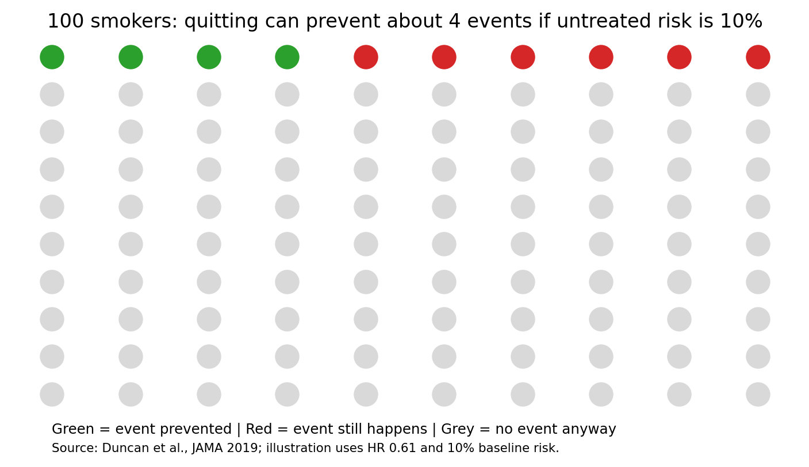

But Let Me Blow Your Mind Further…
It’s not just about reducing the risk of heart attacks and strokes. Stopping smoking also offers…
- Major reduction in lung cancer risk
- Reduced COPD progression
- Reduced erectile dysfunction
- Better wound healing
- Reduced macular degeneration
- Reduced peripheral vascular disease
- Reduced dementia risk

The Combined Effect Is Where The Magic Happens
Do not add relative risk reductions together. A 20% + 22% + 14% + 39% reduction is not a 95% reduction. Combine them multiplicatively, and say it is only an estimate.

Lifestyle comparison chart
This chart compares selected headline figures. Be careful: these numbers are not all the same type of evidence. BP and statins come mainly from randomised trials. Exercise and smoking data are often observational, though the total evidence base is strong. Weight loss is more mixed and depends on how weight is lost and who is studied.
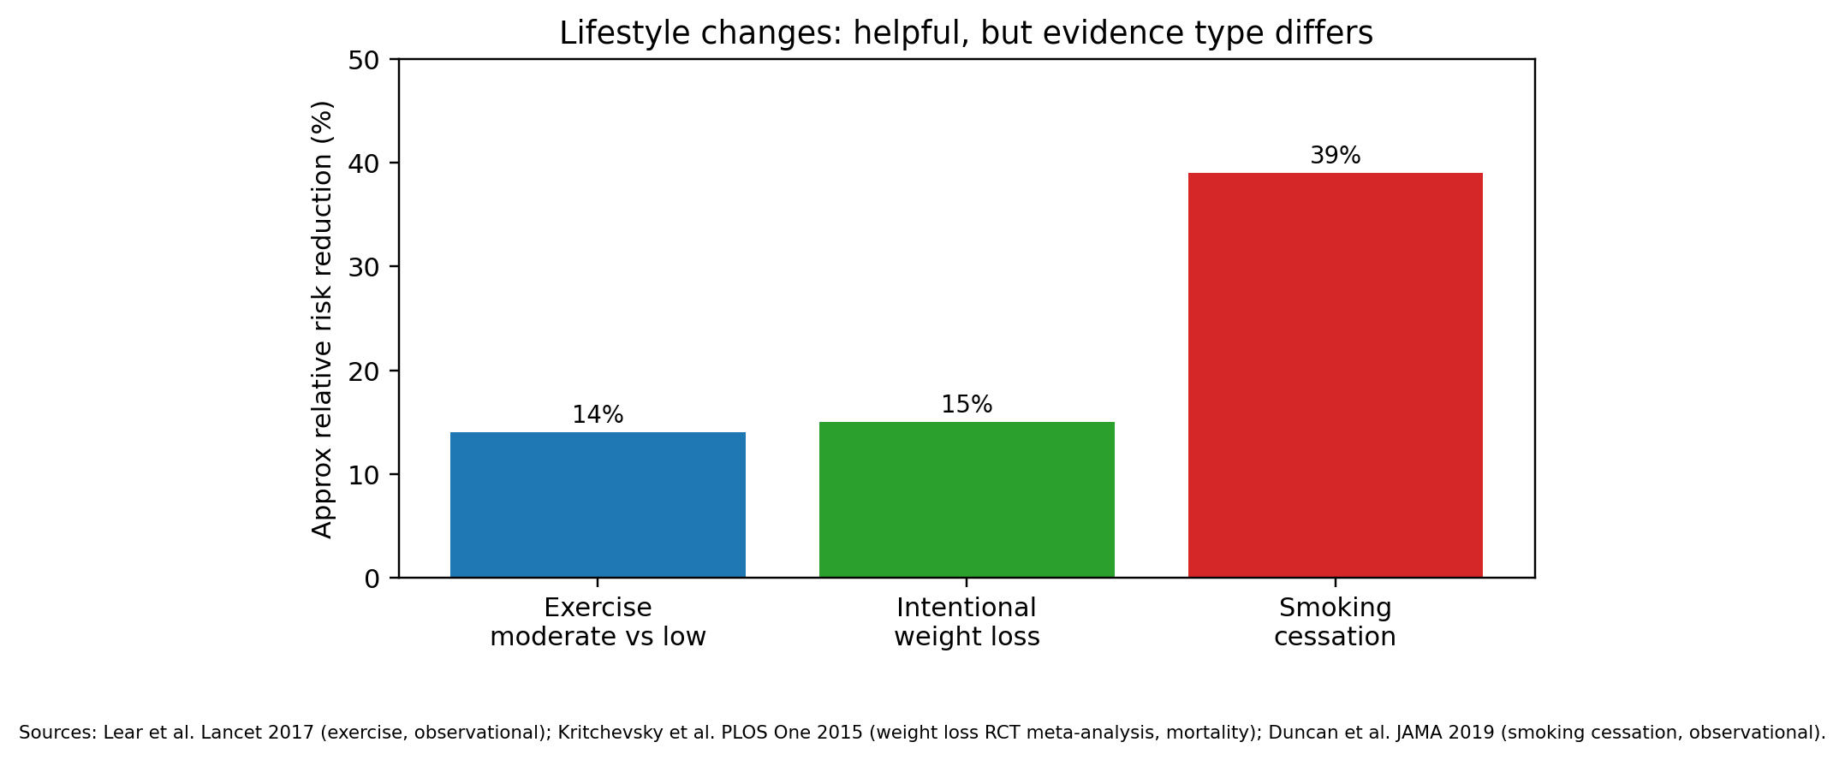
Each individual intervention may appear to give only moderate benefit. But combined together, the effects become much more powerful. Let’s look at someone who does all of the following…
- Blood pressure control
- Statin therapy
- Exercise
- Weight optimisation
- Smoking cessation
Modern preventive medicine is about TOTAL risk-factor optimisation, not just treating one number.
A realistic combined prevention plan may include: good BP control, statin/non-HDL control, stopping smoking, regular exercise, and weight moving toward a healthier range. The benefits overlap. For example, weight loss may work partly by improving BP, cholesterol and diabetes, so counting it separately can exaggerate the total effect.
For illustration only, this model multiplies four hard-outcome estimates: BP lowering 10 mmHg RR 0.80 (Ettehad 2016), LDL lowering 1 mmol/L RR 0.78 for major vascular events (CTT 2010), moderate activity RR 0.86 for major CVD (Lear 2017), and smoking cessation HR 0.61 for incident CVD in heavy smokers (Duncan 2019). Combined multiplier: about 0.33, meaning an illustrative relative risk reduction of about 67%. This is not from one single trial.
Starting 10-year major CVD risk | After combined action (illustrative) | Absolute risk reduction | Approx NNT | Sources
5% | 1.6% | 3.4% | 30 | Ettehad 2016; CTT 2010; Lear 2017; Duncan 2019
10% | 3.3% | 6.7% | 15 | Ettehad 2016; CTT 2010; Lear 2017; Duncan 2019
20% | 6.5% | 13.5% | 8 | Ettehad 2016; CTT 2010; Lear 2017; Duncan 2019
30% | 9.8% | 20.2% | 5 | Ettehad 2016; CTT 2010; Lear 2017; Duncan 2019

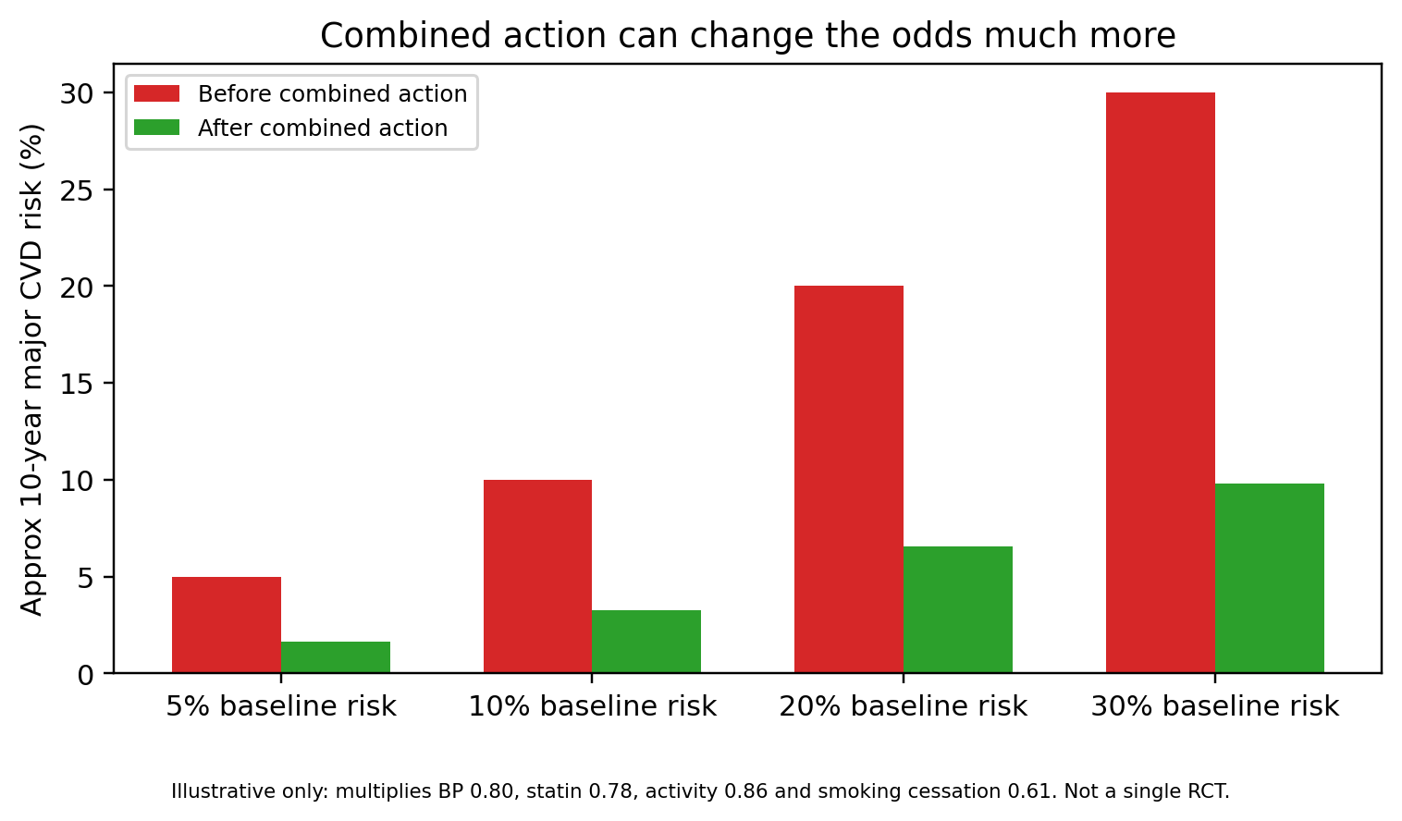
Illustrative combined model; not a single RCT. Avoid double-counting overlapping benefits.
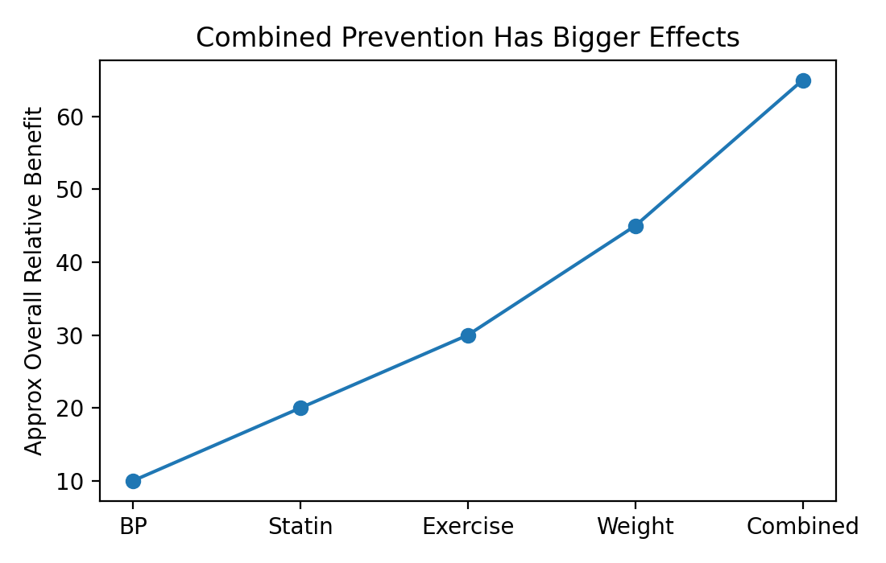

Good phrases for consultations (Good for SCA)
Avoid | Better phrase
Instead of: “This tablet will stop you having a stroke.” | Say: “This tablet lowers the chance of stroke. It does not remove the risk completely.”
Instead of: “It cuts your risk by 20%, so that is a big reduction.” | Say: “It cuts the risk by about one fifth of whatever your starting risk is. So the higher your starting risk, the more you gain.”
Instead of: “Statins prevent heart attacks.” | Say: “Statins reduce the chance of heart attack and stroke over the next few years, especially if your starting risk is higher.”
Instead of: “Just lose weight.” | Say: “Let’s aim for a healthier range while keeping muscle. Even modest weight loss can help BP, sugar and cholesterol.”
Instead of: “You must exercise.” | Say: “The biggest gain is going from inactive to a bit active. Brisk walking counts.”
Instead of: “Cutting down smoking is enough.” | Say: “Cutting down is a step, and it’s great you have managed that. The thing is stopping gives the biggest heart benefit, do you think you’re in a position where you can do that?”

Final clinical caveats
- NNT is not one fixed number. It changes with baseline risk, timeframe, outcome, adherence and treatment intensity.
- Relative risk reduction is useful for comparing treatments. Absolute risk reduction is better for explaining benefit to patients.
- Lifestyle evidence is often observational. That does not make it useless, but it means we should be honest about uncertainty.
- For shared decision-making, show the patient their starting risk first. Then show how much that risk may fall.

Papers and websites used
Source | Year | Why used
NICE NG136: Hypertension in adults: diagnosis and management | 2019; last reviewed 2026 | UK guideline for diagnosis and management of hypertension.
Ettehad D et al. Blood pressure lowering for prevention of cardiovascular disease and death. Lancet | 2016 | 123 trials, 613,815 participants; 10 mmHg SBP reduction: MCE 20%, stroke 27%, HF 28%, mortality 13% RRR.
Blood Pressure Lowering Treatment Trialists Collaboration / Rahimi K et al. Lancet | 2021 | Individual participant data; 5 mmHg SBP reduction reduced major cardiovascular events by about 10%.
NICE NG238: Cardiovascular disease risk assessment and reduction, including lipid modification | 2023; reviewed 2025 | UK guidance on lifestyle, statins and lipid lowering; >40% non-HDL reduction target.
Cholesterol Treatment Trialists Collaboration. Lancet | 2010 | Per 1 mmol/L LDL reduction: major vascular events about 22% RRR; all-cause mortality about 10% RRR.
Lear SA et al. PURE study. Lancet | 2017 | Moderate activity vs low activity: mortality HR 0.80; major CVD HR 0.86. Observational.
UK Chief Medical Officers Physical Activity Guidelines / NHS physical activity guidance | 2019 | 150 minutes moderate activity weekly or 75 minutes vigorous; strength work 2 days/week.
Kritchevsky SB et al. Intentional weight loss and all-cause mortality. PLOS One | 2015 | RCT meta-analysis; intentional weight loss in overweight/obese adults associated with about 15% lower all-cause mortality.
Ma C et al. Effects of weight loss interventions for adults who are obese. BMJ | 2017 | Systematic review of weight loss interventions; mortality benefit signal, but CVD event effects vary.
Mons U et al. Impact of smoking and smoking cessation on cardiovascular events and mortality. BMJ | 2015 | Individual participant meta-analysis in older adults; quitting reduces cardiovascular mortality vs continuing smoking.
Duncan MS et al. Association of smoking cessation with subsequent risk of cardiovascular disease. JAMA | 2019 | Heavy smokers who quit had lower incident CVD risk within 5 years; HR about 0.61 vs continuing smoking.
NICE NG209: Tobacco: preventing uptake, promoting quitting and treating dependence | 2025 | UK guidance on smoking cessation support and harm reduction.

