BRADFORD VTS TEACHING AIDS
Harm Minimisation
Information for people who use drugs
Bradford VTS · May 2026 · www.bradfordvts.co.uk

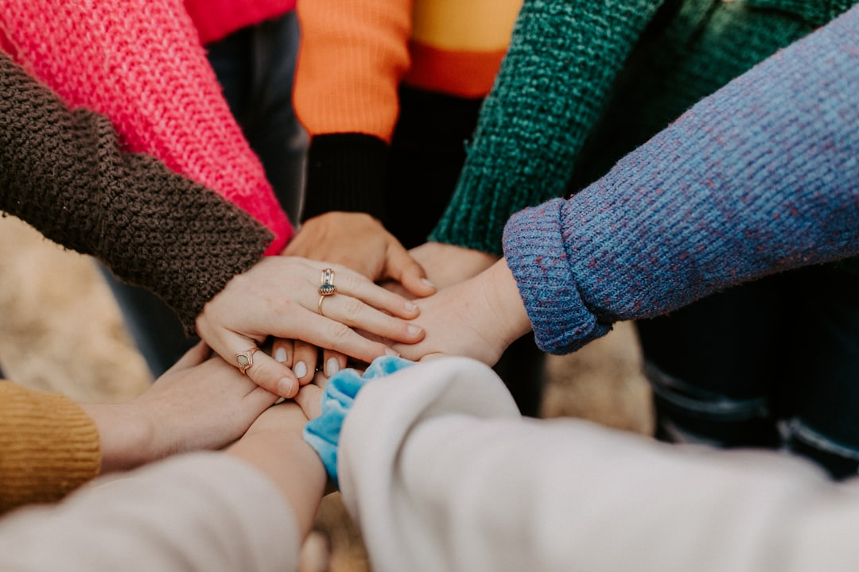
Supporting people who use drugs — every small step towards safety matters.

What is harm minimisation?
Harm minimisation means taking practical steps to reduce the health risks associated with drug use — even if someone is not yet ready to stop. It is an evidence-based approach recommended by NICE, NHS England, and Public Health England (UKHSA).
You do not have to be drug-free to get help. Services are non-judgemental. The aim is to keep you as safe and healthy as possible.
1. Key safety messages
Don't use alone
If you overdose and nobody is with you, there is nobody to call 999 or give naloxone. Try to use with someone you trust — or at least let someone know where you are.
Start with a smaller amount after a break
If you have had a break from drug use — even a few days — your tolerance will be lower. The same amount that you used before can now cause an overdose. Always start with a much smaller amount to test the strength.
Avoid mixing substances
Mixing opioids (heroin, methadone, codeine) with alcohol, benzodiazepines (diazepam, valium), or other sedatives greatly increases the risk of overdose and death. This combination slows breathing to a dangerous level.
If you inject: safer injecting
- Use a clean needle and syringe every time — free from your local needle exchange
- Never share needles, syringes, spoons, water, or filters — this spreads Hepatitis B, Hepatitis C, and HIV
- Rotate injection sites to allow skin and veins to recover
- Avoid injecting into the groin or neck — these are extremely high-risk sites with risk of major vessel injury and infection
- If you notice redness, swelling, pain, or pus at an injection site, see a GP or go to A&E — skin infections can become serious very quickly
- Smoking or snorting reduces the risks compared to injecting — consider this if you can
2. Recognising and responding to an overdose
🔴 RED FLAG — Signs of opioid overdose: Pinpoint (tiny) pupils | Blue or grey lips and fingertips | Unconscious or unresponsive | Slow, shallow, or stopped breathing | Gurgling or snoring sounds

If you think someone is overdosing:
- Call 999 immediately — say 'I think someone has overdosed'
- Put them in the recovery position if breathing (on their side, with mouth open)
- Give naloxone if available (see below)
- Stay with them until the ambulance arrives
- Do not leave them face-down or alone
3. Naloxone — the overdose antidote
Naloxone reverses opioid overdose rapidly and safely. It is not addictive and has no effect on people who have not taken opioids.
✅ New from December 2024: Naloxone (Prenoxad) is now available free from community pharmacies without a prescription. You do not need to see a GP first. Ask at your local pharmacy. Get a kit. Show the people around you how to use it.

- Nasal spray (Nyxoid): insert into one nostril and press firmly — one dose
- Auto-injector (Prenoxad): inject into outer thigh through clothing if needed
- Naloxone wears off in 30–90 minutes — opioids may last longer, so 999 must still be called
- Also available from your GP, drug treatment service, or local needle exchange

4. Vaccinations and blood-borne virus (BBV) testing
Hepatitis B vaccination
Free on the NHS for people who inject drugs. A course of 3 injections gives long-term protection against Hepatitis B. Ask your GP or drug treatment service.
Hepatitis A vaccination
Also recommended and free for people who inject drugs. Protects against a serious liver infection.
Hepatitis C testing and treatment
Hepatitis C can now be cured with a short course of tablets (direct-acting antivirals). Treatment is highly effective — over 95% cure rate. Testing is a simple blood test. Ask your drug service or GP. You can be treated even if you are still using drugs.
HIV testing
Free at your GP, sexual health clinic, or drug service. People who inject drugs are at increased risk of HIV from sharing equipment.
5. Getting help
You do not have to be ready to stop to ask for help. Drug treatment services can help with:
- Substitute prescribing (methadone or buprenorphine) to reduce withdrawal and stabilise your life
- Needle exchange and safer drug use supplies
- BBV testing and vaccinations
- Psychological support, counselling, and recovery planning
- Housing, benefits, and legal support
Service | Contact
FRANK (national helpline) | 0300 123 6600 | www.talktofrank.com — 24 hours a day, confidential
NHS 111 | 111 — for urgent health concerns at any time
Your local drug treatment service | Ask your GP or search 'find drug treatment' at www.nhs.uk
Needle exchange | Free needles, syringes, sharps bins, naloxone — ask at a local pharmacy or drug service

⚠️ Educational disclaimer: This document is for educational and information purposes only. Clinical advice should always be individualised. Always refer to the latest NICE guidelines and BNF for prescribing decisions. This document does not replace professional clinical judgement.

