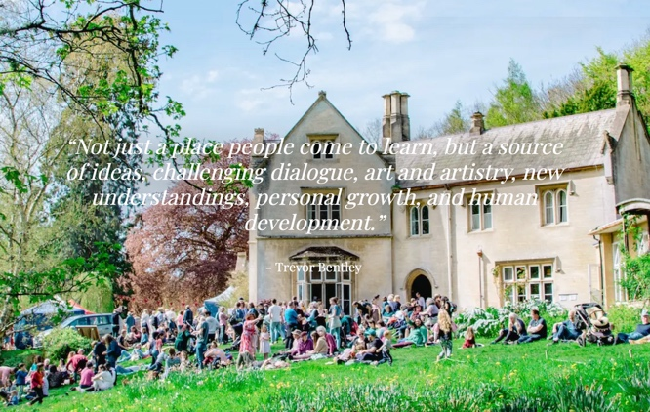  Take your education skills to the next level  Thursday 9th and Friday 10th July  Hawkwood Centre for Future Thinking | Hawkwood College, Stroud  https://www.hawkwoodcollege.co.uk/  Course Fee: £400 (including meals)  Accommodation costs: £100 per night (B&B)  Some rooms available for the night of Wednesday 8th  To book  Scaling the Heights – New Primary Care Educator Course 2026 – Fill in form  Queries to  scalingtheheights2026@gmail.com  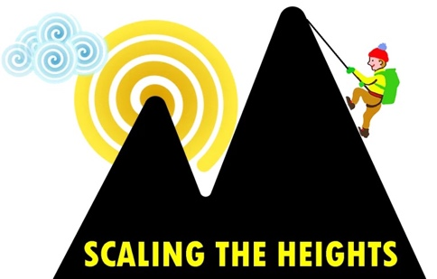 | Who is this for?  New primary care educators especially GP Training Programme Directors. We welcome healthcare educators from other professional backgrounds.  What is included ?  Focus on group facilitation skills. You will learn how to engage your participants, use techniques to energise them and increase motivation and commitment.  You will learn planning and evaluation skills to take education to new levels  AND you get to take home a detailed handbook of educational methods  What is Scaling the Heights?- a group of like minded medical educators. See https://scalingtheheights.com/about/  Why should I come?  You will expand your skills, make new friends, increase your confidence in teaching and have a great two days in beautiful Gloucestershire countryside.  What do previous participants say?  “The facilitators are super experienced and skilled. They were a joy to work with and learn from. I left very inspired and energised.”

