BRADFORD VTS TEACHING AIDS
Date: July 2026
“Mini-Counselling”
Tips for GPs

Practical counselling skills for the everyday consultation — problem solving, goal setting, the three-stage helping model, and how to really listen.
A CONSULTATION SKILLS TEACHING RESOURCE
For GP registrars, foundation doctors and primary care teams

Bradford Vocational Training Scheme • Redesigned edition
Modernised from the original Bradford VTS teaching handout; content preserved, layout redesigned.

DISCLAIMER
This document is provided exclusively for educational and training purposes as a teaching aid. It does not constitute formal clinical guidance. Clinicians must independently verify all medical information, prescribing guidance, procedural protocols, and legal requirements against current national guidance, local policies, and relevant regulatory bodies before applying in practice.

• | AT A GLANCE — WHAT’S INSIDE
Nine short, teachable segments. Use them as a whole-session handout or lift individual pages for tutorials on consultation skills, mental health follow-up, or communication teaching.
1 | Stages of Problem Solving | A six-step structure the patient works through — not you
2 | Goal Setting | Negotiating change the patient actually wants — and can measure
3 | Stage 1 – Exploration | Relationship building and active listening skills
4 | Stage 2 – New Understanding | Challenging skills: helping the patient see things afresh
5 | Stage 3 – Action | Planning, implementing and evaluating change
6 | Counselling Don’ts | Six traps — and why each one undermines the patient
7 | My Skill as a Listener | A 15-item self-rating quiz to profile your listening
8 | Barriers to Good Listening | Ten everyday listening pitfalls, named and explained
9 | Counselling Books for GPs | A short classic reading list

Why “mini-counselling”?
Very few GP consultations allow a formal fifty-minute counselling hour. But the core skills of counselling — listening well, exploring before advising, setting goals the patient owns — fit remarkably well into general practice, a few minutes at a time, visit after visit.

1 | STAGES OF PROBLEM SOLVING
A structured sequence to work through with the patient. Your job is to enable each step — the patient does the thinking.
Enable the patient to…
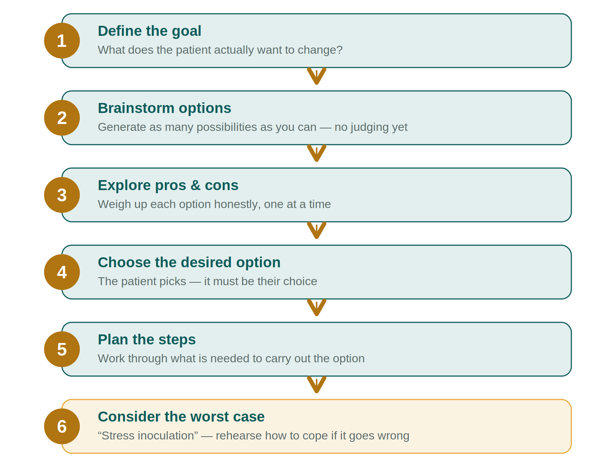
Keeping it patient-centred
- Get the patient to do the work — this is patient-centred problem solving, not prescription.
- If they cannot think of options, try to avoid suggesting alternatives yourself — hold the silence and keep prompting.
- If the patient is severely depressed, problem solving may be easier once they are established on treatment for the depression itself.
Pearl
Problems may not be soluble. Some difficulties cannot be fixed — only lived with. When that is the case, shift the conversation from problem solving to coping strategies.

“MINI-COUNSELLING” TO ADAPT TO GENERAL PRACTICE
Goal setting, then the three-stage helping model (after Gerard Egan’s The Skilled Helper) — each stage builds on the skills of the one before.

2 | GOAL SETTING
Negotiating with the patient for changes in feeling and behaviour that are desired by the patient — and to whose achievement they are motivated.
Goals must be…
Realistic  achievable from where the patient actually is |  | Under the patient’s control  not dependent on someone else changing
Appropriate  fitting the problem and the person |  | Measurable  you can both tell whether it happened
Worthwhile  meaningful enough to be worth the effort |  | Behavioural  framed as something the patient will do
Time-limited
with a clear point to review progress
Making goals stick — in practice
- Agree with the patient the methods for dealing with hindering forces — what might get in the way, and what to do about it.
- Write down the agreed tasks — for the patient (and for yourself).
- Ask the patient to work in small steps.
- Ask the patient to note their progress.
- Ask the patient to reward themselves for their achievements.
- You reward the patient by praise, encouragement and interest.

The three-stage helping model — overview
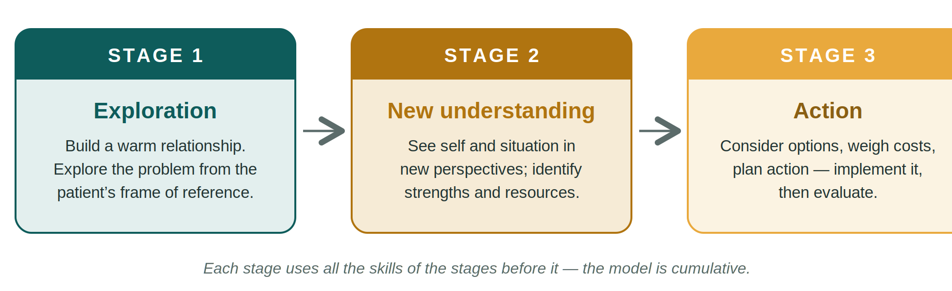
3 | STAGE 1 — EXPLORATION
The helper, by developing a warm relationship, enables the patient to explore “the problem” from their own frame of reference — and then to focus on specific concerns.
Relationship-building skills
Three foundations, in order:
- Attention giving — the patient can see they have your full attention.
- Listening — taking in what is actually said.
- Active listening — communicating back that you have heard and understood:
Active listening skill | What it looks like
Empathic understanding | conveying that you grasp how it feels from their side
Non-critical acceptance | the patient can say anything without being judged
Genuineness | shown by paraphrasing — in your own honest words
Reflecting feelings | naming the emotion you are hearing
Summarising | pulling the threads together at intervals
Focusing | gently steering towards what matters most
Helping the patient be specific | moving from the general to the particular

4 | STAGE 2 — NEW UNDERSTANDING
The patient is helped to see themselves and their situation in new perspectives, and to focus on what they might do to cope more effectively. They are helped to see what strengths and resources they might use.
Remember
All the skills of Stage 1, plus… the model is cumulative — you never stop exploring and listening.

Challenging skills
- Communicating deeper empathic understanding — “hunches”; hearing “the music behind the words”.
- Helping the patient recognise themes, inconsistencies and patterns in what they say.
- Giving information.
- Sharing the helper’s feelings — judiciously, in the patient’s interest.
- “You–me talk” — what is happening between us, right now (immediacy).
- Goal setting — as set out in Section 2.
5 | STAGE 3 — ACTION
The patient is helped to consider possible ways to act, to look at costs and consequences, to plan action — then to implement it and evaluate it.
Remember
All the skills of Stages 1 and 2, plus…

Action skills
- Creative thinking — brainstorming without premature judgement.
- Problem solving and decision making — see Section 1.
- Action planning — who, what, when, in small steps.
- Evaluating — reviewing what happened and adjusting the plan.

6 | COUNSELLING DON’TS
Six traps that feel helpful in the moment — and quietly undermine the patient. Each is worth teaching with examples from real consultations.
1. Don’t try to give advice
“If I were in your position, I would…” — but you never are in their position. Your solution might be right for you, but probably would not be for the patient. Any friend can adopt the “if I were you” approach; patients rightly expect more from you. The only exception is advice of a practical or factual nature — how to apply for benefits, or at what age a young person can leave home without consent — and only give this if you know the answer, or can tell the patient where to find out.

2. Don’t try to solve their problems
The problems belong to the patient. Even if you could solve a problem for them, this would not really help in the long run. Patients need to learn to solve their own problems, and to develop the will, energy and initiative to do just that. They also need to feel they have worked out their own solution — perhaps with your help. This matters for self-respect.

3. Don’t break confidentiality
Crucial if you are counselling someone, as opposed to writing reports about them or discussing their progress with colleagues. If it is important to check information with others — perhaps another professional or an employer — the patient’s consent must be obtained first. If you tell someone that what they say is confidential, keep your word.

4. Don’t leave the relationship vague — fix boundaries
Both counsellor and patient should know the limits of the counselling relationship. Set a fixed time and place where the conversations happen. Think very carefully before offering to counsel in your home, or theirs — a neutral room is best. Be wary of giving out your personal phone number.

5. If you don’t know what to say — don’t say anything
No one ever did any harm by staying silent. You can still show the patient that you are warm and caring by your general attitude.

6. Don’t assume you are the only person who can help
Specialist counsellors, therapists, lawyers and doctors exist — know when, and to whom, to refer on.

7 | MY SKILL AS A LISTENER
A short self-rating quiz: 15 statements about your ability to listen. Mark the box that fits best — candidly — then join your marks with a straight edge: the line is a profile of your listening. A profile drifting to the right shows where to focus; pick one or two items to practise deliberately, then re-rate yourself in a month.
# | Statement | Always | Usually | Sometimes | Rarely | Never
1 | Do I listen for feelings, attitudes, perceptions and values as well as for facts? | ○ | ○ | ○ | ○ | ○
2 | Do I try to listen for what is not said? | ○ | ○ | ○ | ○ | ○
3 | Do I avoid interrupting the person who is speaking to me? | ○ | ○ | ○ | ○ | ○
4 | Do I actually pay attention to who is speaking, as opposed to “faking” attention? | ○ | ○ | ○ | ○ | ○
5 | Do I refrain from “tuning people out” because I don’t like them, disagree with them, or find them dull? | ○ | ○ | ○ | ○ | ○
6 | Do I work hard to avoid being distracted by the speaker’s style, mannerisms, clothing, voice quality or pace? | ○ | ○ | ○ | ○ | ○
7 | Do I make certain that a person’s status has no bearing on how well I listen to them? | ○ | ○ | ○ | ○ | ○
8 | Do I avoid letting my expectations — hearing what I want to hear — influence my listening? | ○ | ○ | ○ | ○ | ○
9 | Do I try to read the “non-verbals” — inflections, gestures, mood, posture, eye contact, facial expressions? | ○ | ○ | ○ | ○ | ○
10 | Do I work hard at overcoming distractions (sound, noise, movement, outside scenes) that may interfere with good listening? | ○ | ○ | ○ | ○ | ○
11 | Do I tend to “stay with” speakers who are hard to follow — slow, poorly organised, or repetitive? | ○ | ○ | ○ | ○ | ○
12 | As a listener, do I use non-verbal communication (eye contact, smiles, occasional head nods) to indicate that I wish to hear more? | ○ | ○ | ○ | ○ | ○
13 | Do I tend to restate or rephrase the other person’s statements when necessary, so they know I have understood? | ○ | ○ | ○ | ○ | ○
14 | If I have not understood, do I candidly admit it and ask for a restatement? | ○ | ○ | ○ | ○ | ○
15 | Do I avoid framing my response while the other person is still speaking? | ○ | ○ | ○ | ○ | ○

8 | BARRIERS TO GOOD LISTENING
Ten everyday listening pitfalls. Most of us do several of them daily — the names make them easy to spot, in ourselves and in learners.
The pitfall | What happens
“On–off” listening | Most of us think about four times faster than the average person speaks, leaving roughly three-quarters of a minute of spare thinking time in every listening minute. Sometimes we spend that spare time on our own affairs, concerns or interests — instead of listening.
“Red rag” listening | Certain words are like a red rag to a bull: when we hear them we become upset or irritated and stop listening. The trigger words vary between individuals, but terms like should, must, unfaithful, police, discipline, school, management and unions commonly produce an automatic response — and the speaker gets switched off.
“Open ears, closed mind” listening | Sometimes we decide quickly that the subject or the speaker is boring, and that nothing said will make sense. We jump to the conclusion that we can predict what they know or will say — so we conclude there is no reason to listen, because we will hear nothing new.
“Glassy-eyed” listening | We look at a person intently and seem to be listening, though our minds are elsewhere. We drop back into the comfort of our own thoughts, become glassy-eyed, and a dreamy expression appears. We can tell when people look at us this way — and they can see the same in us. Nobody is fooled.
“Too deep for me” listening | When we are listening to ideas that feel too complex or complicated, there is a danger we simply shut off — rather than asking for clarification.
“Matter over mind” listening | We do not like having our pet ideas, prejudices and points of view overturned, or our opinions and judgements challenged. When a speaker says something that clashes with what we think and believe, we may unconsciously stop listening — or become defensive and start planning a counter-attack.
Subject-centred, not speaker-centred | We concentrate on the problem rather than the person. The details and facts of an incident become more important than what the person is telling us about themselves.
“Facts” listening | We try to memorise the facts, repeating them over and over to drive them home. While we do, the speaker moves on to new facts — and we lose those in the process.
“Pencil” listening | Trying to write down everything the speaker says means we are bound to lose some of it — words come faster than we can write, and eye contact becomes difficult.
“Hubbub” listening | Sometimes there are simply too many distractions — noise, movement of people, or other matters clamouring for our attention.
An awareness of these pitfalls is the first step to avoiding them.

9 | COUNSELLING BOOKS FOR GENERAL PRACTITIONERS
Suggested reading — a short list of classics. Most remain in print or are easily found second-hand, and all have shaped how counselling skills are taught in general practice.
Author(s) | Title | Publisher
Pamela Quiver | The Trouble Sharers | National Marriage Guidance Council (now Relate)
E. A. Munro, R. J. Manthei & J. J. Small | Counselling: A Skills Approach | Methuen
Robin Skynner & John Cleese | Families and How to Survive Them | Methuen
Enid Balint & J. S. Norell (eds) | Six Minutes for the Patient | Tavistock
Gerard Egan | The Skilled Helper | Brooks/Cole (USA)
Steve Murgatroyd | Counselling and Helping | Methuen

A modern companion
For readers who want a current, structured overview of psychological skills in the consultation, NICE-recommended low-intensity approaches (problem-solving, behavioural activation, guided self-help) are summarised in NICE NG222 (Depression in adults, 2022) — the same territory this handout covers, forty years on.

A | APPENDIX — EDITORIAL & UPDATE LOG
What was changed in this redesign, and why. Original section order, titles and teaching content have been preserved throughout.
Item | Change made | Source / basis
Layout & typography | Complete visual redesign in the Bradford VTS house style (Arial; teal/ochre palette; callouts; zebra tables; two new original flow diagrams). No teaching content was removed. | —
Language | “Client” retained where it reflects the original counselling voice in explanatory text but standardised to “patient” in the practical GP-facing sections; “he/she” modernised to “they”. | Style only
OCR/typo corrections | Numerous scanning artefacts corrected (e.g. “sotmd” → sound; “USTENING” → listening; “We do riot like” → do not; stray “why?????????” annotation removed). | —
Listener quiz | The original rating grid (lost in the legacy file) has been reconstructed as a 5-point scale table (Always → Never) so the “join the dots” profile exercise works again. | Reconstruction, faithful to original instructions
Three-stage model | Attribution added: the Exploration → New Understanding → Action framework is Gerard Egan’s Skilled Helper model (already cited in the original reading list). | Egan, The Skilled Helper
Reading list | Author corrections: “R. Skinner” → Robin Skynner (Families and How to Survive Them, with John Cleese); “Michael Ballint – Six Minutes for the Patient” → edited by Enid Balint & J. S. Norell (Tavistock, 1973). NMGC noted as now Relate. “Pamela Quiver – The Trouble Sharers” retained as printed in the original (could not be independently verified). | Publisher records
Depression note (Section 1) | The original point that problem solving “may be easier if the severely depressed patient is on medication” has been retained and lightly rephrased; it remains consistent with NICE NG222 (2022), which recommends combining antidepressant medication with psychological approaches in more severe depression. | NICE NG222 (2022)
Closing note (Section 9) | A signpost to NICE NG222 low-intensity psychological interventions added as a modern companion reference. This is the only content addition. | NICE NG222 (2022)

This is a communication-skills teaching resource; it contains no prescribing information. Where clinical context is mentioned (depression), it has been checked against NICE NG222: Depression in adults — treatment and management (2022).

