BRADFORD VTS TEACHING AIDS
Date: July 2026
EMERGENCIES
In
PSYCHIATRY

A teaching session guide for GP trainees
Recognising, assessing and managing acute mental health crises in primary care
PRESENTATIONS | ASSESSMENT | MANAGEMENT | THE MHA

1 | POTENTIAL SCENARIOS

Trainee led. Open the session by asking trainees to describe psychiatric emergencies they have encountered or fear encountering — in surgery, on a home visit, or out of hours. Use their scenarios as the working material for the rest of the session.
FACILITATOR PROMPTS — IF THE GROUP NEEDS A STARTER
A call from a family: their son has stopped sleeping, is barricaded in his room and says the neighbours are transmitting thoughts into his head.
A patient attends surgery having taken an overdose two hours ago “just to make it stop”.
A new mother, two weeks postnatal, whose partner reports she believes the baby is possessed.
An elderly man living alone, found by a neighbour in squalor, refusing all help.
An angry, intoxicated patient demanding benzodiazepines and refusing to leave the waiting room.

2 | PRESENTATIONS

PRESENTATION | INCLUDES / THINK OF
I. Psychoses | Schizophrenia • drug-related psychoses • paranoid psychosis • severe depression with psychotic features • puerperal (postpartum) psychosis • mania (bipolar disorder) • acute confusional states (delirium — always exclude an organic cause)
II. Suicide | Suicidal ideation, plans or acts • self-harm and overdose • the aftermath of an attempt
III. Self neglect | Severe self-neglect from depression, psychosis, dementia or frailty • refusal of essential care
IV. Risk to a third party | Threats or violence driven by mental disorder • risk to children, partners, carers or the public

GO PREPARED FOR THE AGGRESSIVE PSYCHIATRIC PATIENT
Aggression is a presentation, not a diagnosis. It may signal psychosis, intoxication, delirium, fear — or all four. Plan every urgent contact with your own safety, and that of your team, explicitly in mind (see Assessment).

3 | ASSESSMENT

Before you see the patient
- Triage — is this for you at all? Consider whether the Crisis Resolution and Home Treatment Team (CRHTT) should attend, jointly or instead. Patients, carers or the GP can reach the local crisis service 24/7 via NHS 111 (select the mental health option).
- Be prepared — delegate. Gather the notes, past psychiatric history, medication and any risk flags. Ask reception to hold your calls; delegate what can wait.
- Personal safety and risk. Tell someone where you are going and when to expect you back. Do not visit alone if violence is a realistic possibility — involve the crisis team or police. In the room: sit nearest the door, keep an exit clear, remove obvious weapons/hazards.
Assessing the patient
A focused mental state examination in an emergency should establish:
- Suicide risk — ideation, plans, means, intent, previous attempts, protective factors
- Depressed or elevated mood
- Insight — does the patient recognise they are unwell and will they accept help?
- Paranoia
- Thought disorder
- Hallucinations or delusions — especially command hallucinations
- Risk to themselves or others — including any children or dependants at home
A NOTE ON “RISK SCORING” (NICE NG225, 2022)
For people who have self-harmed, NICE now explicitly says: do not use risk assessment tools, scales or low/medium/high risk stratification to predict suicide or to decide who gets treatment. Assess the person — their needs, circumstances and safety — not a score.
DON'T MISS THE ORGANIC MIMIC
Acute confusion is delirium until proven otherwise. Check for hypoglycaemia, sepsis, hypoxia, head injury, drug or alcohol intoxication/withdrawal, and medication toxicity before attributing everything to psychiatric illness — especially in older people and anyone with fluctuating consciousness.

4 | MANAGEMENT

a) Defuse the situation if possible
De-escalation comes first (NICE NG10): a calm voice, space, one person talking, listening to the grievance, offering choices. Physical restraint and rapid tranquillisation are interventions for appropriately staffed and monitored settings — not for a GP alone in the community. If de-escalation fails and there is immediate danger, withdraw and call the police (999).
b) Try to admit informally if admission is required
Voluntary (informal) admission is always preferable where the patient agrees and it is safe. Compulsion is a last resort, not a starting point.
c) If required, use the Mental Health Act for compulsory admission
Under the Mental Health Act 1983 (as amended 2007), the application for compulsory admission is made by an Approved Mental Health Professional (AMHP) — the role that replaced the approved social worker in 2007 (or, rarely, the nearest relative), usually under Sections 2, 3 or 4. Two medical recommendations are needed, one from a section 12 approved doctor; where practicable the other doctor should have previous acquaintance with the patient — which is exactly why the GP’s recommendation is so valued. Section 4 (genuine emergency) needs only one doctor.

SECTION | PURPOSE | DURATION | WHO IS NEEDED
2 | Admission for assessment (± treatment) | Up to 28 days (not renewable) | AMHP application + 2 doctors, at least one section 12 approved; one should ideally know the patient (often the GP)
3 | Admission for treatment | Up to 6 months (renewable) | As for Section 2; the treatment plan must be clear and appropriate treatment available
4 | Emergency admission when waiting for a second doctor would cause undesirable delay | Up to 72 hours | AMHP application + 1 doctor (ideally one who knows the patient); converted to Section 2 by a second recommendation in hospital
5(2) | Doctor's holding power for a patient already admitted informally | Up to 72 hours | One doctor in hospital — cannot be used in A&E or the community
135 | Warrant to enter private premises to remove a person to a place of safety | Up to 24 hours | Magistrate's warrant obtained by an AMHP; executed by police
136 | Police power to take a person from a public place to a place of safety | Up to 24 hours (+12-hour extension) | Police officer; assessment then by doctor and AMHP

d) Where to look things up
A fuller summary of the Act and the rules on compulsory admission is in the Mental Health Act 1983 Code of Practice (2015) and the companion Bradford VTS guide “A Guide to the Mental Health Act — Compulsory Admission to Hospital”. Note: the Mental Health Act 2025 received Royal Assent in 2025 and will change some of these arrangements as it is phased in — check current guidance.
e) Arrangements — how to contact the AMHP
Know your local route before you need it: AMHPs are contacted through the local authority AMHP/duty service, usually via the mental health trust switchboard or the crisis team (CRHTT). Out of hours this is typically the emergency duty team. Keep the numbers where you can find them.
The pathway at a glance
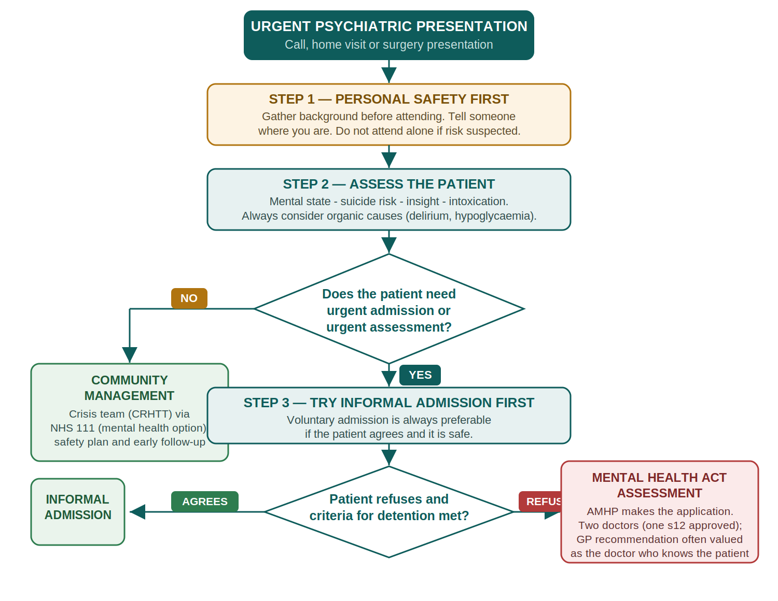

5 | PATIENTS' RIGHTS

Discussion points for the group:
- Detained patients must be told their rights (Section 132): why they are detained, for how long, and how to appeal to the Mental Health Tribunal
- Every detained patient has a right to an Independent Mental Health Advocate (IMHA)
- The nearest relative has defined powers, including (in some circumstances) to object to Section 3 or request discharge
- Informal patients keep the right to refuse treatment and to leave — detention powers exist precisely because informal status is voluntary

6 | DOCTOR / PATIENT RELATIONSHIP ISSUES

Discussion points for the group:
- How does being party to a section affect the ongoing GP–patient relationship — and how do you repair trust afterwards?
- Confidentiality versus safety: when can (and should) you share information with family, the crisis team or the police?
- Managing your own feelings — fear, guilt, frustration — and debriefing with colleagues
- The patient who refuses everything but lacks nothing in capacity: respecting autonomy while managing risk

7 | SECTIONING ARRANGEMENTS

- Place. Where will the assessment happen — home, surgery, place of safety? If entry to private premises is refused, the AMHP can obtain a Section 135 warrant so police can gain entry.
- Who will be present. AMHP, section 12 doctor, second doctor (often the GP), family — agree roles before you arrive.
- Need for ambulance, police etc. Conveyance to hospital is organised by the AMHP, normally by ambulance; police attend only where there is significant risk of violence or resistance.
- A bed. The application must name a hospital — confirming the bed is part of the arrangements, not an afterthought.

8 | SUBSEQUENT FOLLOW-UP

- Ensure the practice is told of admission, leave (Section 17) and discharge — and read the discharge summary and care plan
- Patients discharged from mental health inpatient care should be followed up within 72 hours — know who is doing it
- Review physical health, medication (and its monitoring) and safeguarding at the first GP contact after discharge
- Support the family and carers — they were part of the emergency too, and often hold the early-warning signs of relapse
- Reflect and debrief as a practice: what would you do differently next time?

9 | WORTH ADDING TO THE SESSION (NEW)

The following topics were not in the original teaching aid but are now core knowledge for UK general practice, so they have been added.
MENTAL HEALTH ACT vs MENTAL CAPACITY ACT
The MHA authorises assessment and treatment of mental disorder, even in someone with capacity who refuses. The Mental Capacity Act 2005 covers decisions for people who lack capacity, and only allows treatment in their best interests — it cannot be used simply to treat mental illness compulsorily. If the objection is to psychiatric admission and treatment for mental disorder, think MHA.
GETTING URGENT HELP — NHS 111 ‘SELECT MENTAL HEALTH OPTION’
Since April 2024, anyone in England — patients, carers or professionals — can access the local 24/7 crisis service by calling NHS 111 and selecting the mental health option. It covers all ages, including children. Life-threatening emergencies still go to 999 / A&E.
FIRST-EPISODE PSYCHOSIS — WHAT THE GP SHOULD (AND SHOULDN'T) DO
Refer urgently to the Early Intervention in Psychosis (EIP) service — the national standard is that treatment starts within 2 weeks of referral. Do not start an antipsychotic for a first presentation of sustained psychotic symptoms in primary care unless it is done in consultation with a consultant psychiatrist (NICE CG178).
SAFEGUARDING — THINK BEYOND THE PATIENT
In every psychiatric emergency ask: who else is at home? Children of a parent in crisis, dependent adults, and carers may all need a safeguarding referral. Puerperal psychosis is a psychiatric emergency in its own right — same-day specialist (perinatal) assessment, and never leave mother and baby unsupervised while acutely psychotic.

A | WHAT WAS UPDATED, AND WHY

This teaching aid keeps the structure, section order and teaching intent of the original document. The clinical and legal content below was corrected or updated against current UK guidance (verified July 2026).
ORIGINAL | UPDATED TO — AND SOURCE
“Application must be made by an approved social worker” | Applications are made by an Approved Mental Health Professional (AMHP) — the ASW role was abolished in 2007. Source: MHA 1983 (as amended 2007); Code of Practice 2015.
“Usually two doctors… one of whom must be approved” (unqualified) | Clarified: two doctors for Sections 2 and 3 (one section 12 approved, one ideally knowing the patient); Section 4 needs only one doctor. Source: MHA 1983 ss.2–4, 12.
“Triage — ?Crisis Response Team” | Updated to Crisis Resolution and Home Treatment Team (CRHTT), now accessed 24/7 via NHS 111 ‘select mental health option’ (national since April 2024). Source: NHS England.
“Hypomania” listed among emergency psychoses | Reworded to mania (bipolar disorder): mania — especially with psychotic features — is the emergency; hypomania by definition lacks psychotic features and severe impairment. Source: NICE CG185 / ICD-11.
“Toxic confusional states” | Updated to current terminology — delirium (acute confusional state) — with an explicit ‘exclude organic causes’ warning. Source: NICE CG103 (delirium).
“If not possible ?restraint ?chemical” | Corrected: de-escalation comes first; restraint and rapid tranquillisation belong in staffed, monitored settings — not GP-alone community care. Source: NICE NG10 (2015).
Risk assessment (implicit checklist approach) | Added: do not use risk tools/scales or low–medium–high stratification to predict suicide or allocate care — use person-centred psychosocial assessment. Source: NICE NG225 (2022).
New content (Section 9) | MHA vs MCA; NHS 111 mental health option; first-episode psychosis — EIP 2-week standard, no antipsychotic initiation in primary care without consultant advice (NICE CG178/QS80); safeguarding and puerperal psychosis (NICE CG192).
Legal horizon: the Mental Health Act 2025 will amend detention criteria and roles as it is phased in — check implementation updates (GOV.UK / DHSC).

DISCLAIMER
This document is provided exclusively for educational and training purposes as a teaching aid. It does not constitute formal clinical guidance. Clinicians must independently verify all medical information, prescribing guidance, procedural protocols, and legal requirements against current national guidance, local policies, and relevant regulatory bodies before applying in practice.

