  BRADFORD VTS TEACHING AIDS
  JULY 2026

PRESCRIBING · COMMUNICATION · SHARED DECISION-MAKING
The Nocebo Effect
Worked examples with statins & antidepressants — and what our words may be doing to tolerability
A teaching & discussion piece by Dr Ramesh Mehay · Programme Director, Bradford VTS · originally written December 2020

A great deal of the side-effect burden attributed to prescribed medication may be down to the nocebo effect — where patients experience the very side-effects they have been warned about, even when the drug is an inactive placebo. And this is backed up by good evidence.

1 | Let’s start by looking at statins

Statins are among the most commonly prescribed drugs in the UK. Did you know that up to a fifth (20%) of people stop taking them because of side-effects — things like tiredness, muscle pains, joint discomfort, nausea and vomiting? Yet the research says the true incidence of side-effects is much lower. So why the gap between what patients perceive and what the trials tell us is real?

THE EVIDENCE · N-OF-1 RANDOMISED TRIAL
The SAMSON Trial
Wood & Howard et al., Imperial College London · New England Journal of Medicine, 2020

Researchers recruited 60 patients who had started statins but stopped within two weeks because of side-effects, and persuaded them to take part. Over 12 months, each patient cycled — in random order — through three types of month:
×4  Atorvastatin 20 mg | ×4  Identical-looking placebo | ×4  Empty — no tablet at all
Mean daily symptom score (0–100)
No tablet
  8.0
Placebo
  15.4
Statin
  16.3
The placebo and statin months were statistically indistinguishable (p = 0.39); both were markedly worse than the no-tablet months (p < 0.001).
90% | The nocebo ratio was 0.90 — 90% of the symptom burden patients experienced on the statin was also produced by the placebo. Across the trial there were 71 occasions when patients stopped tablets because symptoms felt overwhelming — and stopping was no more frequent on the statin than on the placebo.

The trial convincingly showed that although patients had genuine symptoms they attributed to statins, their symptom scores were no higher during statin months than during placebo months. This is powerful proof that the nocebo effect plays a major role in the negative side-effects credited to statins. Reassuringly, once the results were explained, half of the participants (30 of 60) successfully restarted a statin.

2 | Now let’s look at antidepressants

Of course, the statin trial doesn’t tell us exactly how this plays out across every type of patient. But thinking logically — is it possible the nocebo effect works across all drugs? Why should it be confined to statins?
? With antidepressants: should we really tell patients that, on starting, they may get worse before they get better? Are we not planting that very thought — sowing an idea the patient then goes on to fertilise and water over the following weeks?

The tension in the numbers
Perhaps around 15% of people genuinely feel worse before they feel better. Yet a large proportion of patients stop their antidepressant within the first month (estimates vary widely, from around 40% up to 80%). Both are striking figures.

My question is this: is it possible that many patients stop within a month precisely because they experience what we told them to expect? And here is the crucial point — many of them may be experiencing the nocebo effect in response to our words, rather than a true pharmacological symptom.
We already know the words we use as doctors have a massive impact on patients — numerous studies confirm it, and it has rightly changed how we practise and refine our communication. But usually the learning point is a rephrasing of how we say things. I am not suggesting a rephrasing here. I am suggesting a complete omission.

Why omission, not rephrasing
Imagine saying it in a “balanced” way: “a very small number of people might get…” You will still get several patients who reply, “I bet I’ll be one of them.” And you know as well as I do that, at that point, the self-fulfilling prophecy is already halfway to being fulfilled.

If we stopped saying things like “you might feel worse before you get better”, might that prevent the nocebo effect from taking hold — and improve tolerability and concordance? I understand why we inform patients: we want them in the know, able to anticipate, ready to persevere. But does it sometimes achieve the opposite? When a patient stops an antidepressant that might otherwise have done real good, does our warning become a disservice? We all know depression is a serious illness that, left untreated, can cause enormous distress for a patient, their family and their friends.

And finally — time to move from subjectivity to objectivity. Let’s close with some figures.

Thinking in tens: what really happens with 10 patients
Around 60% of people respond to an antidepressant by about two months, with roughly a 50% reduction in symptoms.
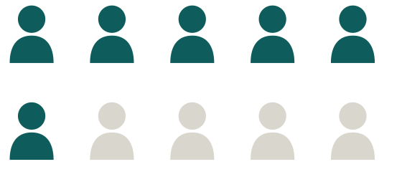  6 of 10 are better by two months. The other 4 may not be. |   2 of 10 truly experience an early dip. | 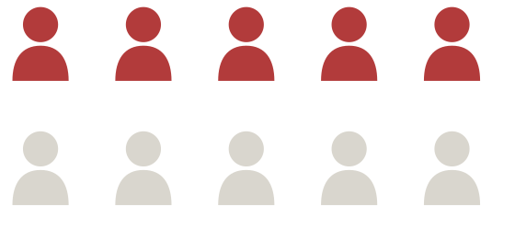  up to 4–6 of 10 now report it — the nocebo effect kicking in.
  Response by ~2 months
  “Worse before better” — the reality
  …once we highlight it

The provocation
So why warn all 10 patients? Why put the other 8 at risk of the nocebo effect when only about 2 will experience the real symptom? Why not simply work with the 2 — if and when it actually happens?

3 | An interesting 2018 study

SYSTEMATIC REVIEW & NETWORK META-ANALYSIS
Comparative efficacy & acceptability of 21 antidepressants
Cipriani et al., University of Oxford · The Lancet, 2018

522  double-blind RCTs | 116,477  patients in total | ≥50%  symptom improvement = a “response”

Key results
● For most drugs, people were roughly as likely to stop the antidepressant as to stop placebo — clomipramine being the notable exception, with more dropouts than placebo. Once again: how much does the nocebo effect have to answer for?
● Best tolerated (fewer dropouts): agomelatine, citalopram, escitalopram, fluoxetine, sertraline and vortioxetine.
● Most effective in head-to-head data included amitriptyline, mirtazapine, paroxetine, venlafaxine and escitalopram — though all 21 beat placebo.

Efficacy of selected antidepressants
Odds ratio for treatment response vs placebo — a value of 1.0 means no better than placebo. Higher = more effective.
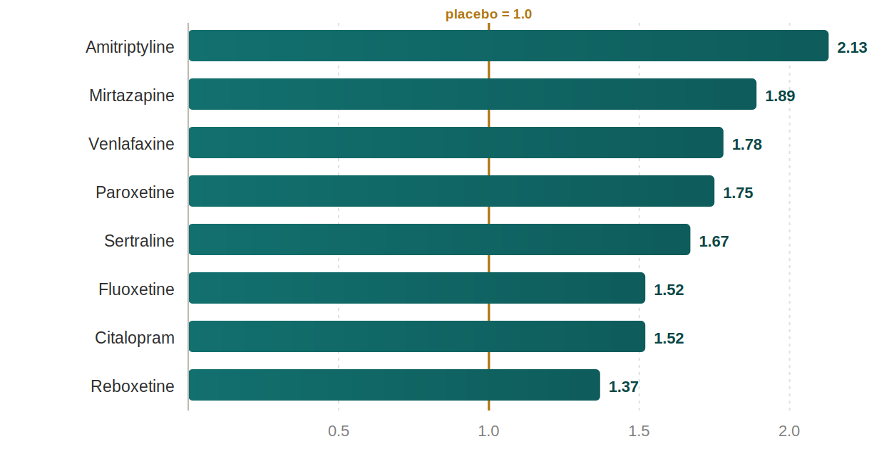
Source: Cipriani et al., The Lancet 2018 (efficacy / response odds ratios vs placebo).

⚑ PLEASE NOTE
This is deliberately a provocative discussion piece, and its central suggestion — to omit the “you may feel worse before you feel better” warning — sits in tension with current NICE guidance on depression (NG222), which emphasises informed consent and shared decision-making about likely benefits and harms before starting treatment.

The phrase I am more likely to use in practice is… “The majority of people do well with this medication. A few people may feel worse before they feel getting better, so bear with it if that happens to you” seems a more balanced way of doing it.

DISCLAIMER. This document is provided exclusively for educational and training purposes as a teaching aid. It does not constitute formal clinical guidance. Clinicians must independently verify all medical information, prescribing guidance, procedural protocols, and legal requirements against current national guidance, local policies, and relevant regulatory bodies before applying in practice.

