BRADFORD VTS TEACHING AIDS
Adapted from an original article by Dr Maggie Eisner (Bradford 2012)
New Version: July 2026
CONSULTATION & RELATIONSHIP SKILLS
Understanding Systemic Family Therapy & Geneograms
Three practical small-group exercises for GP training
Experiencing family systems • Building a geneogram • Interviewing for family history
HOW TO USE THIS TEACHING AID
This session pack introduces the ideas behind systemic family therapy and shows how a geneogram (family tree with added detail — now more commonly spelled “genogram”) can be used as a practical tool in everyday general practice.
It contains three stand-alone group exercises. Each can be run separately; you are unlikely to fit all three into a single half-day session.

DISCLAIMER: This document is provided exclusively for educational and training purposes as a teaching aid. It does not constitute formal clinical guidance. Clinicians must independently verify all medical information, prescribing guidance, procedural protocols, and legal requirements against current national guidance, local policies, and relevant regulatory bodies before applying in practice.

● | Understanding Systemic Family Therapy & Geneograms

- Systemic family therapy is a method of psychotherapy which acknowledges that people’s difficulties are interrelated with those of the groups they belong to — usually their families.
- It sees families (and groups) as interactive systems.
- A useful tool is a family tree which includes information about the family members (personal characteristics, occupations etc.) — this is called a geneogram (more commonly spelled “genogram” in current literature).
- The approach can be applied in ordinary general practice situations.

WHY THIS MATTERS IN GENERAL PRACTICE
Patients rarely present in isolation. Understanding who else is in the system — and how family members react to one another — often explains why symptoms persist, why plans fail, and why illness in one person changes the behaviour of everyone around them.

GENEOGRAM NOTATION AT A GLANCE
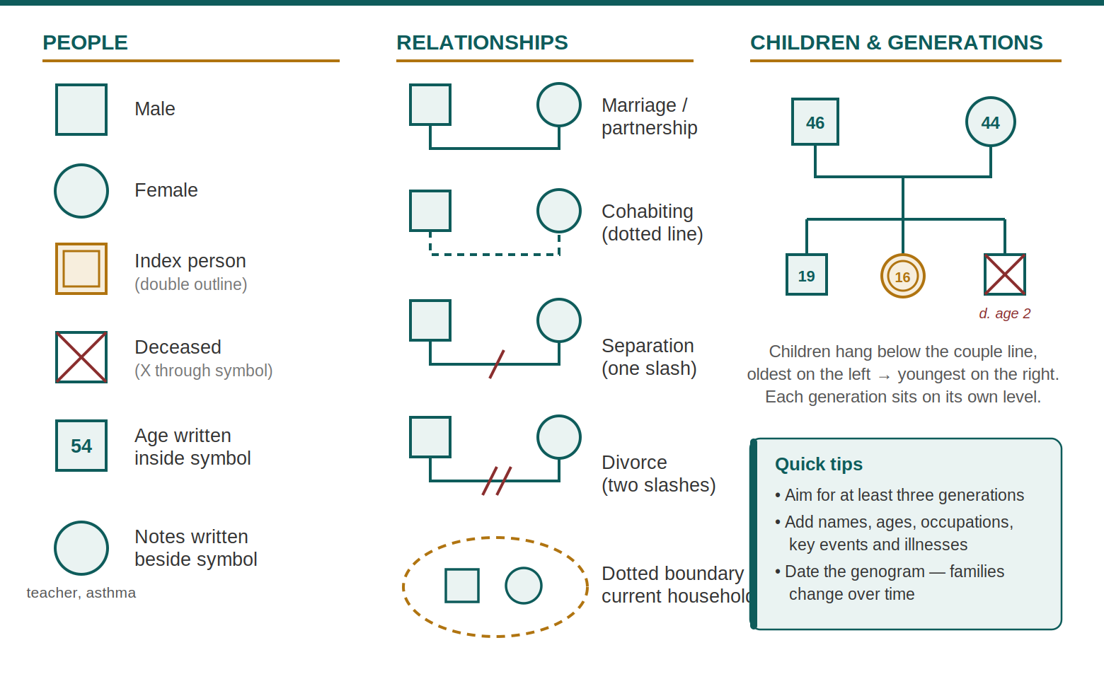
Figure 1. Standard genogram notation (McGoldrick & Gerson conventions). Original illustration — created for this teaching aid.

1 | Exercise 1 — Being Part of an Interactive System

OBJECTIVE
To gain experience of what it feels like to be part of an interactive system.
METHOD
- Four members of the group go outside and turn themselves into an imaginary family (2 parents and 2 children; a single parent and 3 children; members of 3 generations; etc.).
- Everyone else makes a list of possible roles/characteristics that members of a family might have (e.g. helpless, assertive, efficient, depressed, joking, tolerant, vulnerable, adventurous, greedy, peace-maker, wise, discontented, delinquent, provocative, generous, etc.).
- Arrange chairs in a fishbowl, with the “family” group in the middle.
- The group returns and explains who they are to the observers.
- Each member of the group secretly chooses one of the characteristics.
- Discussion: in role, A says “I am going to …”; one of the others responds “If you do that, I will …”. Go round a few times, with each person responding to the previous statement by explaining what action they will take as a consequence.
- Finally — choose one person to become ill. They choose an appropriate illness and announce it to the others. Each gives their response in the same way: “In that case, I am going to …”
- If time allows, extend the exercise into a full role play in which the family can speak in any order and say what they wish.
DISCUSSION / DEBRIEFING
Participants and observers discuss what they have experienced or observed, and its relevance for general practice.
VALUE
Shows the power of interaction in determining behaviour.
Gives a vivid example of how a family might fall into a rigid pattern of relationships which is very hard for them to unfreeze (though NB most people/families aren’t fixed into roles as rigidly as this).
TIME REQUIRED
30–45 minutes, according to the article this was drawn from.
FACILITATOR NOTE (ORIGINAL AUTHOR)
“It also struck me that this could be applied to other systems, e.g. practice teams.”

2 | Exercise 2 — Constructing an Extended Geneogram

OBJECTIVE
To learn how to construct an extended geneogram, and to notice patterns of family interaction and behaviour.
METHOD
The group makes a geneogram of the British Royal Family. In the course of this, participants can notice intergenerational effects, patterns of interaction, repetitive behaviour, etc.
RUNNING IT WELL
Use a flipchart or whiteboard and the standard notation on page 2. Work across at least three generations, and invite the group to annotate relationships (closeness, conflict, separation) as they go — the patterns, not the facts, are the learning point.
TIME REQUIRED
30–60 minutes.
FACILITATOR NOTE (ORIGINAL AUTHOR)
“I’m a bit less sure of the value of the above, as I’m not knowledgeable about, or interested in, the Royal Family — but it may illustrate the material well and be a non-threatening introduction to it.”

3 | Exercise 3 — Eliciting a Geneogram by Interview

OBJECTIVE
Learning to elicit a geneogram by interview, and to reflect — or help someone else reflect — on the effect of personal family background.
METHOD
- Work in pairs.
- Each interviews the other about their family of origin (not necessarily partner and children, as people may not want to share everything about those if things have gone wrong in their lives). Explore major processes, themes and connections for this family in the past (not necessarily anything about illness, causes of death etc.) and what may have led the interviewee into a medical career.
- It is important to allow time to change roles and interview the other person.
- Reflective discussion in groups of 4.
- Possibly, a discussion about general issues in the whole group.
SAFETY & SENSITIVITY
This exercise touches on personal material. Make participation in any disclosure explicitly voluntary, remind pairs that the interviewee controls what they share, and agree confidentiality ground rules before starting.
TIME REQUIRED
Not stated in the source material.
FACILITATOR NOTE (ORIGINAL AUTHOR)
“They don’t say — I’m sure we couldn’t do all three of the exercises in an afternoon though.”

A | Appendix — Transparency: What Was Changed & Why

This document is a visual and editorial redesign of the original Bradford VTS teaching sheet. The section order, titles and teaching content have been preserved. The following changes were made:
Change | Detail & rationale
Typographical corrections | “diffficulties” → “difficulties”; “arre” → “are”; “vivd” → “vivid”; “e g” → “e.g.”; minor punctuation and abbreviation tidy-ups (“v hard” → “very hard”). No change to meaning.
Spelling note: geneogram / genogram | The original spelling “geneogram” has been retained throughout (including the title). A note has been added that “genogram” is the more common spelling in current literature (after McGoldrick & Gerson, Genograms: Assessment and Intervention).
Added: Figure 1 (genogram notation key) | An original illustration of standard genogram symbols was created for this teaching aid, since the document teaches genogram construction but the source contained no visual key. Based on the widely used McGoldrick & Gerson notation conventions. No copyrighted imagery used.
Added: facilitation callouts | “Why this matters in general practice”, “Running it well” (Exercise 2) and “Safety & sensitivity” (Exercise 3) were added as clearly boxed facilitator aids. They add no clinical claims; the safety note reflects standard good practice for experiential small-group work with personal material.
Author voice preserved | The original author’s first-person asides are retained verbatim in “Facilitator note (original author)” boxes.
Clinical verification | This document contains no drug, dose, investigation, referral or management guidance, so no NICE/BNF verification was applicable. The description of systemic family therapy is definitional and remains accurate.

DISCLAIMER: This document is provided exclusively for educational and training purposes as a teaching aid. It does not constitute formal clinical guidance. Clinicians must independently verify all medical information, prescribing guidance, procedural protocols, and legal requirements against current national guidance, local policies, and relevant regulatory bodies before applying in practice.

