The Pituitary & Hypothalamus
The hypothalamus and pituitary sit at the base of the brain and act as the body's control centre for most hormone glands. Think of a chain of command in an army.
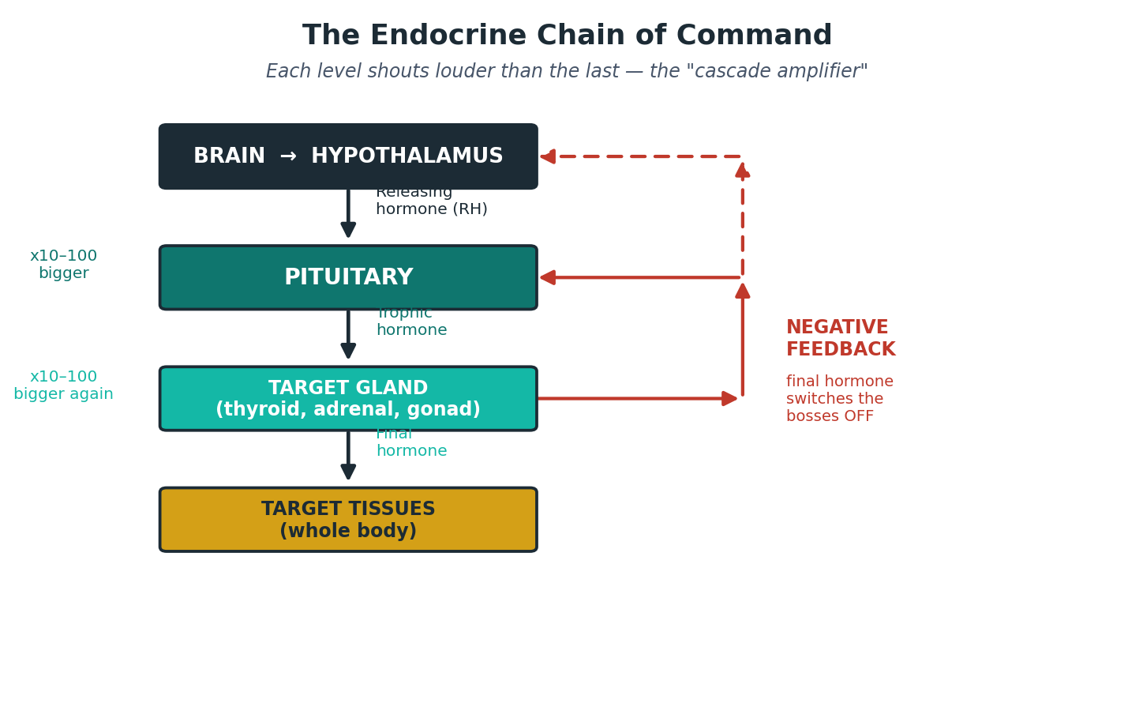
Figure 1. The endocrine chain of command and negative feedback.
MEMORY HOOK
The army analogy: the hypothalamus is the general (sends a small order = a releasing hormone). The pituitary is the officer (passes a louder order to the troops = a trophic hormone). The target gland is the troops (does the actual work = the final hormone). Each level shouts louder — a tiny signal at the top becomes a big hormone response at the bottom (the “cascade amplifier”).
Negative feedback: when there is enough final hormone, it tells the general and officer to be quiet. Like a thermostat turning the heating off once the room is warm.

Anterior pituitary hormones
The front (anterior) pituitary makes six main hormones. A classic way to remember them:
MEMORY HOOK
“FLAT PiG” — FSH, LH, ACTH, TSH (the “tropic” ones that boss other glands), then Prolactin and GH (the “direct” ones that act on the body themselves).
Hormone |  | What it does | Too much causes | Too little causes
GH (growth hormone) |  | Growth & metabolism | Acromegaly / gigantism | Short stature (children)
Prolactin |  | Milk production | Galactorrhoea, low libido, infertility | Failure of lactation
TSH |  | Drives the thyroid | Rare pituitary hyperthyroidism | Secondary hypothyroidism
ACTH |  | Drives the adrenal cortex | Cushing’s disease | Secondary adrenal failure
LH & FSH |  | Drive ovaries / testes | (context-dependent) | Low sex hormones, infertility
The back (posterior) pituitary is different — it stores and releases ADH and oxytocin made by the hypothalamus. These are covered in Part 8.

Hypopituitarism (an underactive pituitary)
This means the pituitary fails to make enough of its hormones. It usually comes on slowly, so symptoms are vague and easily missed.
Causes: pituitary tumour (commonest), surgery or radiotherapy, head injury, infarction (including Sheehan’s syndrome — pituitary death after major blood loss in childbirth), infection, and infiltration (e.g. sarcoidosis).
MEMORY HOOK
Order the hormones tend to fail: “Go Look For The Adenoma” — GH first, then LH/FSH, then TSH, then ACTH last. So growth and sex hormones go before thyroid and steroid hormones.
Features: tiredness, loss of libido, absent periods, infertility, pale skin, and (if severe) low cortisol — low blood pressure, low sodium and collapse.
Investigation: measure the pituitary hormones and the gland hormones together (e.g. low T4 with a low or normal TSH points to the pituitary, not the thyroid). Dynamic tests and an MRI of the pituitary may be needed. ⚠
RED FLAG / SAFETY
When replacing hormones, give hydrocortisone (steroid) BEFORE levothyroxine. Starting thyroid hormone first in someone who also lacks cortisol can trigger an adrenal crisis. ⚠

Pituitary tumours
Almost always benign adenomas. They cause problems in two ways:
- Pressure (mass effect): bitemporal hemianopia (“tunnel-like” side-vision loss).
- Hormones: either too much of one hormone, or hypopituitarism from squashing the rest of the gland.

Acromegaly (too much GH in adults)
Features: large hands and feet (rings/shoes stop fitting), coarse facial features, sweating, headaches; can cause diabetes and high blood pressure. In children, before the growth plates close, excess GH causes gigantism.
Treatment today: first-line is trans-sphenoidal surgery (through the nose). Medicines — somatostatin analogues (octreotide, lanreotide), the GH-receptor blocker pegvisomant, or cabergoline — and radiotherapy are used when surgery is not enough. The original handbook’s reliance on bromocriptine is outdated. ⚠

Prolactinoma (too much prolactin)
Features: women — absent periods, milk from the breasts (galactorrhoea), infertility; men — low libido, impotence; plus headaches/visual loss if large.
First-line treatment is a dopamine agonist — now usually cabergoline (better tolerated and more effective than the older bromocriptine). Tablets often shrink the tumour, so surgery is rarely needed first. ⚠
CLINICAL / EXAM PEARL
Always exclude simple causes of a raised prolactin first: pregnancy, and drugs (antipsychotics, metoclopramide). A very high prolactin (e.g. >5000) strongly suggests a true prolactinoma.
(Cushing’s disease — an ACTH-secreting pituitary tumour — is covered with the adrenal gland in Part 3.)

