The Parathyroids, Calcium & Bone
Blood calcium must stay in a tight range — too high or too low both cause trouble. Three players control it: PTH (parathyroid hormone), vitamin D, and (minor) calcitonin.
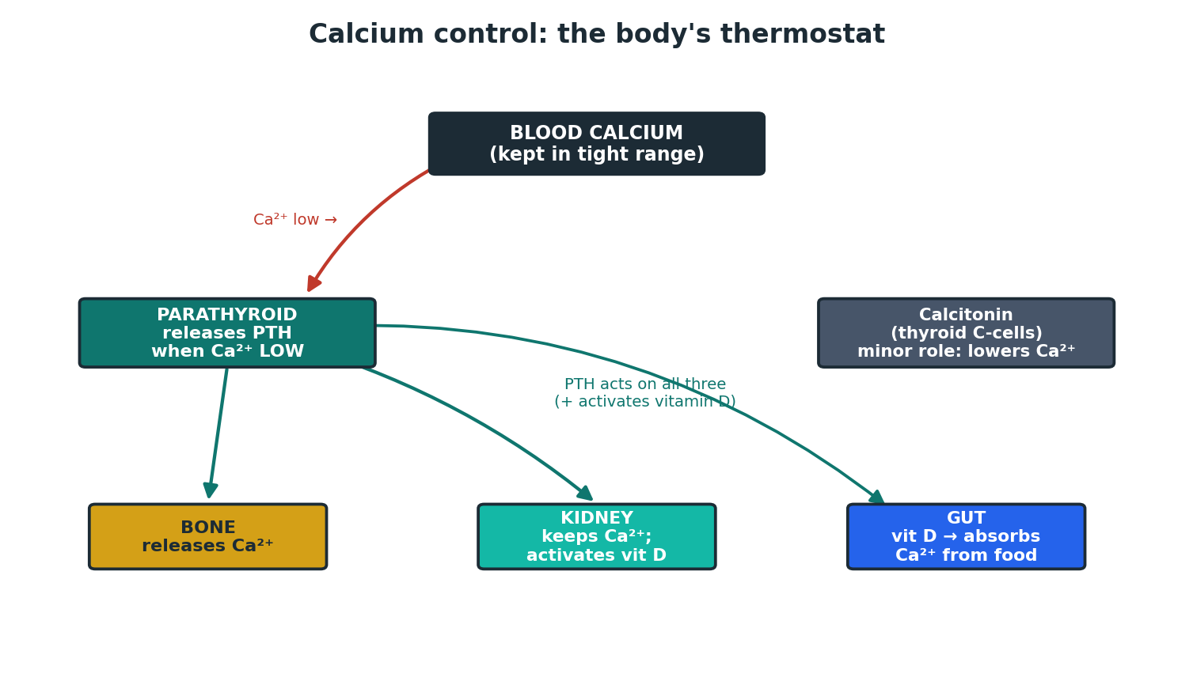
Figure 3. How the body keeps blood calcium steady.
MEMORY HOOK
PTH = “Phone-To-Help when calcium is low.” When calcium drops, the parathyroids release PTH, which RAISES calcium by: pulling it from Bone, keeping it in the Kidney, and activating vitamin D so the Gut absorbs more. PTH also dumps phosphate in the urine — so high PTH → high calcium, low phosphate.

Parathyroid disorders
Disorder | What happens | Calcium / PTH / phosphate
Primary hyperparathyroidism | Overactive parathyroid (usually a small adenoma). Common in older women. | Ca high, PTH high/inappropriate, phosphate low
Secondary hyperparathyroidism | PTH rises to defend a low calcium (vitamin D deficiency or kidney failure). | Ca low/normal, PTH high
Tertiary hyperparathyroidism | After long-standing secondary disease the glands become autonomous. | Ca high, PTH very high (e.g. in CKD)
Hypoparathyroidism | Too little PTH (often after neck surgery). | Ca low, phosphate high

Hypercalcaemia (high calcium) — high-yield
MEMORY HOOK
Causes — “think 2 big ones first”: the two commonest by far are malignancy (cancer) and primary hyperparathyroidism.
Symptoms — “Stones, Bones, abdominal Groans, and psychic Moans”: kidney stones; bone pain; tummy pain, nausea, constipation; and tiredness, low mood or confusion. Plus thirst and lots of urine.
CLINICAL / EXAM PEARL
A quick rule for the cause: PTH high or normal → parathyroid problem; PTH low (suppressed) → think malignancy or another non-parathyroid cause. ⚠

Vitamin D deficiency: osteomalacia & rickets
Too little vitamin D means calcium is poorly absorbed and bone does not harden properly — soft bones. In children this bends growing bones (rickets); in adults it causes bone pain and muscle weakness (osteomalacia). Treat with vitamin D (± calcium). ⚠

Osteoporosis (thin, fragile bone)
Different from osteomalacia: here the bone is normal quality but reduced quantity — it breaks easily (fragility fractures of wrist, spine, hip). Common after the menopause and with steroid use.
Modern assessment & treatment (NOGG 2024 / NICE): ✓
- Estimate fracture risk with a tool such as FRAX or QFracture; measure bone density with a DXA scan (osteoporosis = T-score ≤ −2.5).
- First-line drug: an oral bisphosphonate (alendronate or risedronate), or IV zoledronate. Denosumab is an alternative; HRT is an option in younger post-menopausal women.
- Ensure enough calcium and vitamin D, plus weight-bearing exercise and falls prevention.
RED FLAG / SAFETY
Counsel oral bisphosphonates carefully: take the tablet with a full glass of water, on an empty stomach, and stay upright for 30 minutes (to avoid oesophagitis). ⚠

