The Thyroid Gland
The thyroid is a butterfly-shaped gland in the neck. It makes thyroid hormone, which sets the speed of the body’s metabolism — like the accelerator pedal of a car.

Quick physiology (the bits worth keeping)
- The thyroid needs iodine to make its hormones. It makes mostly T4 (thyroxine) and a little T3.
- T4 is really a pro-hormone: tissues convert it into T3, the active form. Most hormone in blood is carried by proteins (mainly TBG); only the tiny free fraction is active.
- Control: the pituitary releases TSH to drive the thyroid; thyroid hormone then feeds back to switch TSH off (the thermostat again).

Reading thyroid function tests (TFTs)
TSH is the single most useful test. Picture TSH as the boss’s order and T4 as the worker’s output:
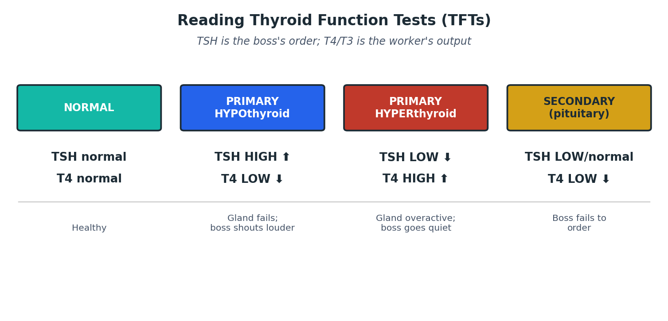
Figure 2. The four common TFT patterns.
MEMORY HOOK
“TSH and T4 move in OPPOSITE directions in primary thyroid disease.” Failing gland → boss shouts louder → TSH high, T4 low. Overactive gland → boss goes quiet → TSH low, T4 high. If BOTH are low, the problem is higher up (pituitary).
RED FLAG / SAFETY
Reference ranges differ between laboratories. Always use your own lab’s ranges

Hyperthyroidism / thyrotoxicosis (an overactive thyroid)
Too much thyroid hormone speeds everything up.
Causes |  | Key clues
Graves’ disease (commonest) |  | Autoimmune (TRAb antibodies). Eye signs (bulging eyes), diffuse goitre. Often younger women.
Toxic multinodular goitre |  | Older patients; lumpy gland; no eye signs.
Toxic adenoma (“hot nodule”) |  | Single overactive lump.
Thyroiditis |  | Temporary; e.g. after a viral illness or after pregnancy.
MEMORY HOOK
Symptoms — “everything goes FAST and HOT”: weight loss despite good appetite, heat intolerance and sweating, palpitations / fast pulse (watch for atrial fibrillation), tremor, anxiety, diarrhoea, and in women lighter/absent periods.
Treatment today (NICE NG145): ✓
- Antithyroid drug — carbimazole is first-line, usually as a titration regimen (adjust dose to the TFTs) for 12–18 months. A “block and replace” regimen (fixed high carbimazole + levothyroxine) is an alternative.
- Propylthiouracil (PTU) is second-line (used first in early pregnancy because carbimazole carries a small risk of birth defects).
- Beta-blocker (e.g. propranolol) for fast pulse, tremor and anxiety while waiting for the drugs to work.
- Radioactive iodine or surgery for those who relapse or prefer a definitive cure. Both often cause life-long hypothyroidism afterwards — a planned trade-off, treated with levothyroxine.
RED FLAG / SAFETY
Carbimazole + sore throat/fever = STOP the drug and check FBC the same day. Carbimazole can rarely wipe out white cells (agranulocytosis), which is life-threatening. Warn every patient. ✓
CLINICAL / EXAM PEARL
Thyroid storm is a rare emergency (very high fever, fast/irregular heart, agitation, vomiting). Treat in hospital with supportive care, a beta-blocker, antithyroid drugs, iodine (given after the antithyroid drug) and steroids. ⚠

Hypothyroidism (an underactive thyroid)
Too little thyroid hormone slows everything down. It is common (about 1–2% of adults) and very treatable — so do not miss it.
Causes: autoimmune (Hashimoto’s and “atrophic” thyroiditis) is commonest in the UK; also after thyroid surgery or radioiodine, certain drugs (lithium, amiodarone), and worldwide — iodine deficiency.
MEMORY HOOK
Symptoms — “everything goes SLOW and COLD”: tiredness, weight gain, feeling cold, constipation, dry skin and hair, low mood, slow thinking, heavy periods, and slow-relaxing reflexes.
Treatment (NICE NG145): levothyroxine once daily, taken on an empty stomach. Adjust the dose to bring TSH back into the normal range. ✓
- Start low and go slow in older people and anyone with heart disease (a big starting dose can trigger angina or a fast heart). ✓
- The original handbook gives doses in milligrams (0.05–0.15 mg). In modern UK practice levothyroxine is prescribed in micrograms (50–150 micrograms) — always check the current BNF. ⚠
CLINICAL / EXAM PEARL
Myxoedema coma is the rare, severe end of hypothyroidism (very cold, drowsy/unconscious, slow heart). It is a medical emergency needing hospital care and IV thyroid hormone + steroids. ⚠

Subclinical thyroid disease = abnormal TSH but normal T4. Managed by repeating tests and treating selectively (e.g. higher TSH, symptoms, antibodies, or pregnancy). ⚠

