BRADFORD VTS TEACHING AIDS
Vitamin D — What You Need to Know
Patient Information Leaflet · Bradford VTS · May 2026

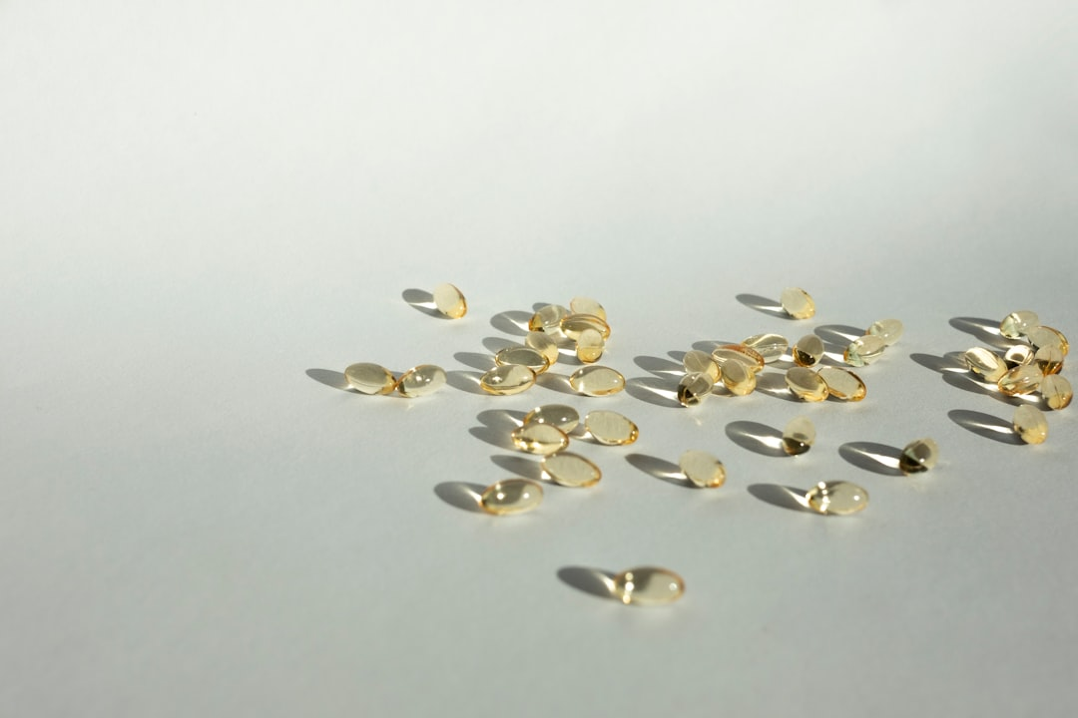
Vitamin D capsules — widely available at pharmacies and supermarkets
Why do we need vitamin D?
Vitamin D is essential for healthy bones, muscles, and your immune system. It helps your body absorb calcium from food. Without enough vitamin D, bones can become thin, weak, and painful — a condition called osteomalacia in adults, or rickets in children.
What are the symptoms of low vitamin D?
- Bone pain and tenderness — often back, hips, or legs
- Muscle weakness — difficulty getting up from a chair, climbing stairs
- Tiredness and fatigue
- General aches and pains
Many people with low vitamin D have no symptoms at all.
Who might have low vitamin D?
You are more likely to have low vitamin D if you:
✔ Have darker skin (South Asian, African, African-Caribbean, Middle Eastern)
✔ Are over 65 years old
✔ Are pregnant or breastfeeding
✔ Cover your body when outside (e.g. wear a niqab or burqa)
✔ Spend most of your time indoors (housebound, care home, hospital)
✔ Are a baby or young child
✔ Have a medical condition that affects how you absorb food (e.g. coeliac disease)
✔ Eat a vegan or vegetarian diet with little oily fish or eggs
✔ Take certain medicines (e.g. epilepsy medicines, steroids, rifampicin)

How do we get vitamin D from sunlight?
About 90% of the vitamin D our bodies need is made by the skin when exposed to sunlight. In the UK, from October to March, there is not enough sunlight to make vitamin D. This is why so many people in the UK have low levels.
Getting vitamin D from sunlight (April to September):
✔ Go outside on most days between 11am and 3pm
✔ Expose your face and forearms to sunlight — no sunscreen needed for a short time
✔ Aim for 15–20 minutes — but always cover up before your skin starts to go red
✔ People with darker skin need longer exposure to make the same amount of vitamin D
✔ Never let your skin burn — skin cancer risk outweighs the vitamin D benefit if you burn

Which foods contain vitamin D?
It is very difficult to get enough vitamin D from food alone. Only a small amount is found in foods. Good sources include:
- Oily fish — salmon, mackerel, sardines, herrings, pilchards
- Egg yolks
- Fortified foods — some breakfast cereals, margarine, fortified plant milks (check the label)
- Some powdered milks and infant formula milk
Who should take vitamin D supplements?
The NHS recommends that everyone considers taking a vitamin D supplement, especially from October to March when sunlight is too weak to make enough vitamin D.
Current UK recommendations (NHS / NICE NG247 2025):
✔ All adults: 400 IU (10 micrograms) daily — especially October to March
✔ Over 65s: 400 IU daily all year round
✔ Pregnant and breastfeeding women: 400 IU daily all year round
✔ Babies 0–1 year (breastfed): 340–400 IU daily from birth
✔ Children 1–4 years: 400 IU daily all year round
✔ Children 5+ years: 400 IU daily, October to March (year-round if high risk)
✔ If you are at high risk (dark skin, housebound, covered clothing): 400–1,000 IU daily all year

Where can I get vitamin D supplements?
- Pharmacies, supermarkets, or online — look for colecalciferol (vitamin D3)
- A year's supply usually costs around £10–20 (less than £2 per month)
- If you are pregnant or have a young child, you may be eligible for FREE Healthy Start vitamins
- Healthy Start vitamins contain vitamin D — ask your midwife, health visitor, or GP
- Find out more: www.healthystart.nhs.uk
What if I am diagnosed with vitamin D deficiency?
Your GP will prescribe a short course of high-dose vitamin D to restore your levels — this is called a loading dose. After this, you will take a lower maintenance dose long-term. Your GP may also check your calcium levels during treatment.
Important safety information:
✔ Tell your doctor if you have kidney disease, kidney stones, or have had raised calcium in the past
✔ Tell your doctor if you have sarcoidosis, tuberculosis (TB), or lymphoma
✔ If you develop nausea, vomiting, excessive thirst, or pass urine more than usual — contact your GP
✔ These could be signs of too much calcium (hypercalcaemia)
✔ Do not take more than 4,000 IU (100 micrograms) per day without your doctor's advice

Remember…
- Enjoy being outside in summer sunshine — but never burn
- Take a vitamin D supplement in winter, and year-round if you are at risk
- Include vitamin D-rich foods in your diet regularly
- All breastfed babies need vitamin D drops from birth
- Talk to your GP, midwife or health visitor if you have any questions
- More information: www.nhs.uk | www.healthystart.nhs.uk | www.bradfordvts.co.uk

⚠ This leaflet is for educational purposes only. Always ask your GP for advice about your individual health needs. | www.bradfordvts.co.uk

