BRADFORD VTS TEACHING AIDS
Vitamin D Deficiency in Adults
GP Quick Reference Handout · Bradford VTS · May 2026

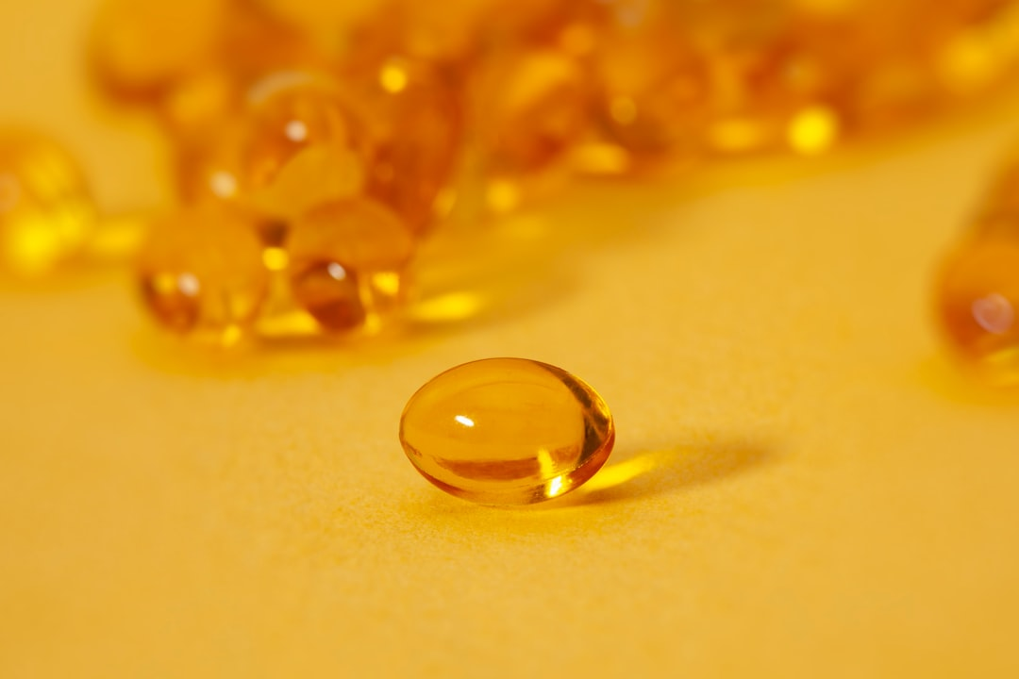
Vitamin D supplementation — a cornerstone of preventive care in UK general practice
1. Overview & Prevalence
- >50% of UK adults have insufficient vitamin D during winter/spring
- Vitamin D deficiency is one of the most common nutritional deficiencies in UK primary care
- Bradford/Yorkshire: high rates in South Asian, African-Caribbean communities — darker skin needs more UVB
- Consequences: osteomalacia, osteoporosis, fractures, falls, proximal myopathy
Pathophysiology (simplified)
- Sunlight (UVB) → skin converts 7-dehydrocholesterol → Vitamin D3 (colecalciferol)
- Liver: D3 → 25(OH)D [calcidiol] — the MEASURED form in blood tests
- Kidney: 25(OH)D → 1,25(OH)₂D [calcitriol] — the ACTIVE form
- ↓ 25(OH)D → ↑ PTH → secondary hyperparathyroidism → ↑ bone resorption → osteomalacia

2. Who is at Risk? (NICE CKS 2022)
🔍 HIGH-RISK GROUPS — Know for AKT
• Reduced sun exposure: housebound, institutionalised, covering clothing (niqab/burqa), high SPF use year-round
• Darker skin pigmentation (South Asian, African, African-Caribbean, Middle Eastern)
• Age ≥65 years — skin synthesis ×4 less efficient
• Pregnancy and breastfeeding
• Malabsorption syndromes: coeliac, Crohn's, gastric bypass, short bowel, gastrectomy
• Chronic liver disease (↓ 25-hydroxylation) or CKD stage 3b+ (↓ 1α-hydroxylation)
• Medications: anticonvulsants, rifampicin, long-term steroids, HAART
• Obesity (BMI >30) — vitamin D sequestered in adipose tissue
• Vegetarian/vegan — limited oily fish and eggs

3. Symptoms & Presentation
Insufficiency (25–50 nmol/L)
- Often asymptomatic; vague fatigue and musculoskeletal aches
- May be labelled fibromyalgia or somatisation — consider checking vitamin D
Deficiency (<25 nmol/L)
- Bone pain: deep, persistent aching — lower back, hips, ribs (classic osteomalacic pattern)
- Proximal muscle weakness: difficulty rising from chair, waddling gait
- Statin-induced myopathy worsened by vitamin D deficiency — check 25(OH)D
- Fractures: femoral neck, pubic rami, scapula, ribs
- Pseudo-fractures (Looser zones) on X-ray — pathognomonic of osteomalacia
4. Who to Test (NICE CKS 2022)
⚠ Do NOT routinely screen asymptomatic individuals
• Test ONLY when: ≥1 risk factor(s) AND symptomatic (bone pain, proximal muscle weakness)
• OR clinical suspicion of osteomalacia/osteoporosis
• OR before starting parenteral antiresorptive agents (denosumab, zoledronate)
• Do NOT test for general fatigue or non-specific symptoms alone

Investigation panel
- 25(OH)D [NOT 1,25(OH)₂D — the active form is not the screening test]
- Adjusted serum calcium (baseline; exclude hypercalcaemia)
- ALP (raised in osteomalacia)
- Phosphate, LFTs, U&Es/eGFR
- FBC (anaemia may suggest malabsorption)
- Consider: magnesium, TTG antibodies (coeliac), immunoglobulins

5. Interpreting Results (SACN 2016 / NICE CKS 2022)
Serum 25(OH)D | Status | Action
<25 nmol/L | ⚠ DEFICIENCY | Loading dose colecalciferol — see Section 6
25–50 nmol/L | INSUFFICIENCY | OTC supplementation; loading dose if symptomatic or high-risk
>50 nmol/L | ADEQUATE | No treatment; advise universal Oct–Mar supplementation

6. Treatment — Loading Dose (BNF 2024, NICE CKS 2022)
For deficiency (<25 nmol/L) — Colecalciferol loading
Total loading dose: 300,000 IU colecalciferol over 6–10 weeks
Regimen | Dose | Duration | Total
Preferred (Regimen A) | 50,000 IU once weekly | 6 weeks | 300,000 IU
Alternative (Regimen B) | 20,000 IU twice weekly | 7 weeks | ~280,000 IU

7. Maintenance Dose (BNF 2024)
- Start 1 month after completing loading dose
- Dose: 800–2,000 IU colecalciferol daily (lifelong in most at-risk patients)
- Alternative for adherence: 25,000 IU once monthly
- Maximum without specialist monitoring: 4,000 IU/day (100 mcg)
- Higher doses may be needed: malabsorption, obesity, very dark skin, severe deficiency

8. Ergocalciferol IM — Current Status (2024–2026)
⚠ NOW SPECIALIST-INITIATION ONLY — Do not prescribe in primary care
• Ergocalciferol 300,000 IU IM injection = reserved for severe malabsorption or complete oral intolerance
• Supply shortages widely reported (UK formularies 2024–2025; many discontinued)
• Bradford 2012 pathway listed ergocalciferol IM as second-line — this is now OUTDATED
• Use oral colecalciferol (D3) as first-line in all primary care settings

9. Special Circumstances
Pregnancy & Breastfeeding (NICE NG247, Jan 2025)
- 10 mcg (400 IU) colecalciferol daily throughout pregnancy and breastfeeding
- Do NOT use high bolus loading doses in pregnancy — safe upper limit: 4,000 IU/day
- Healthy Start vitamins: 10 mcg vitamin D per tablet — all pregnant women eligible
Osteoporosis
- Must be vitamin D replete BEFORE starting bisphosphonates/denosumab
- Standard: 800–1,000 IU/day colecalciferol + 1,000–1,200 mg/day elemental calcium
- Combined preparations: Adcal-D3, Calcichew D3 Forte, Calceos
CKD Stage 3b+ (eGFR <45 ml/min)
- Do NOT initiate colecalciferol loading in primary care — REFER to renal services
- May require alfacalcidol or calcitriol (active analogues) under specialist supervision
10. Monitoring (NICE CKS 2022)
- Check adjusted serum calcium at 1 MONTH post-loading (exclude primary hyperparathyroidism)
- Routine re-testing of 25(OH)D is NOT recommended unless symptoms persist
- If symptoms persist at 3 months: recheck compliance, consider malabsorption, repeat 25(OH)D
- If 25(OH)D still <25 nmol/L despite compliance → refer endocrinology
11. When to Refer
🔴 REFER TO ENDOCRINOLOGY / APPROPRIATE SPECIALIST IF:
• No response at 3–6 months (confirmed compliance)
• Hypercalcaemia (>2.65 mmol/L) — check PTH and 24-hr urine calcium
• Primary hyperparathyroidism
• Renal stones, severe hypercalciuria, metastatic calcification
• CKD stage 3b+ (eGFR <45 ml/min)
• TB, sarcoidosis, lymphoma (granulomatous disease — risk of hypercalcaemia with supplementation)
• Suspected anticonvulsant/rifampicin cause
• Focal bone pain (exclude metastases)
• Unexplained weight loss/anaemia (exclude coeliac/malabsorption)

12. Universal Supplementation Recommendations (UK 2024–2026)
Group | Dose | Duration
All adults | 400 IU (10 mcg)/day | Oct–Mar; year-round if high risk
Over 65s | 400 IU (10 mcg)/day | Year-round
Pregnant women | 400 IU (10 mcg)/day (NICE NG247 2025) | Year-round
Breastfeeding women | 400 IU (10 mcg)/day | Year-round
Infants 0–1 yr (breastfed) | 340–400 IU (8.5–10 mcg)/day | Year-round from birth
Children 1–4 yrs | 400 IU (10 mcg)/day | Year-round
Children 5+ yrs | 400 IU (10 mcg)/day | Oct–Mar min; year-round if high risk

13. Vitamin D Toxicity
- Toxicity threshold: serum 25(OH)D >375 nmol/L [CORRECTED: old sources stated 500 nmol/L]
- Risk at sustained doses >4,000 IU/day without monitoring
- Features: hypercalcaemia — nausea, vomiting, polyuria, polydipsia, confusion, constipation
- Management: stop supplements, check serum calcium, refer endocrinology
- Safe upper limit: 4,000 IU/day (MHRA/SACN 2024)

14. Key Points — AKT & SCA Quick Revision
🟣 AKT HIGH-YIELD FACTS
• Deficiency = <25 nmol/L (SACN 2016) — NOT <20 nmol/L (Bradford 2012 outdated)
• Test: 25(OH)D — NOT 1,25(OH)₂D (active form)
• Loading dose: 300,000 IU total (50,000 IU weekly × 6 weeks, BNF 2024)
• Maintenance: 800–2,000 IU/day — NOT 400 IU/day (that's the general supplement dose)
• Ergocalciferol IM = specialist-only, supply shortage — wrong in primary care
• Statins + myalgia = always check vitamin D
• Contraindications: hypercalcaemia, sarcoidosis, active TB, lymphoma
• CKD 3b+ = refer, not treat with colecalciferol

🟦 SCA PATIENT COMMUNICATION
• Explaining supplementation: 'I recommend taking a vitamin D supplement every day, especially in winter — you can buy it cheaply at the pharmacy for about £1 a month.'
• Safety-netting: 'If you develop nausea, vomiting, or feel unusually thirsty while on treatment, please come back — it could mean calcium is too high.'
• Explaining the test: 'We test a form called 25-hydroxy vitamin D — this tells us how much is stored in your body.'
• Non-compliance: 'We can try a larger dose once a week if daily tablets are difficult to remember.'
• Cultural sensitivity: Offer halal/gelatine-free preparations; discuss clothing and sun exposure sensitively

⚠ Disclaimer: Always double check this advice and drug doses with the latest NICE/BNF guidance. This document is for educational purposes only. | www.bradfordvts.co.uk

