BRADFORD VTS TEACHING AIDS | UPDATED  June 2026

MUSCULOSKELETAL · CLINICAL EXAMINATION
Examination of the Lumbar Spine
A step-by-step examination guide for GP trainees and IMGs. Work through each step and record it as you go.
i Start with the symptoms
If the patient has leg symptoms, use the dermatomes to estimate the level of the lesion — for example, lateral calf numbness, pins-and-needles or pain ≈ the L5 nerve root. Remember that a high lesion can still affect lower nerve roots.

! Before you examine — a safety reminder
Pair the examination with a red-flag history. If there is any suggestion of cauda equina — bladder or bowel change, saddle or genital numbness, or bilateral leg symptoms — you must check perianal sensation and anal tone and arrange same-day emergency assessment.

A |  | Subjective examination | History
• What the patient tells you
The lumbar spine normally gives pain during prolonged sitting, lifting and stooping. Pain on walking tends to come from the hip, spinal stenosis or a circulatory disorder — keep these in mind.
For objective markers of progress, use functional levels — for example, how long the patient can sit, or the time it takes to dress, without pain.

B |  | Objective examination | Technique
  1 Leg length  Leg-length discrepancies are best judged in standing. Use different-sized heel raises or arch supports to correct any inequality, and re-assess. |  | 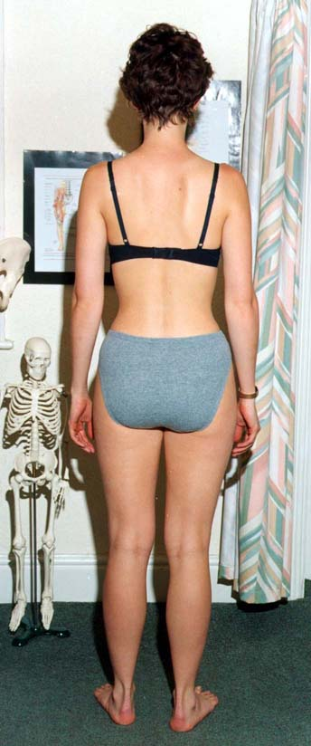  Assess in standing

2 Inspection — posture  Look for correctable scoliosis, increased thoracic kyphosis, loss of muscle tone or bulk, and general posture. Inspect from behind and from the side.
  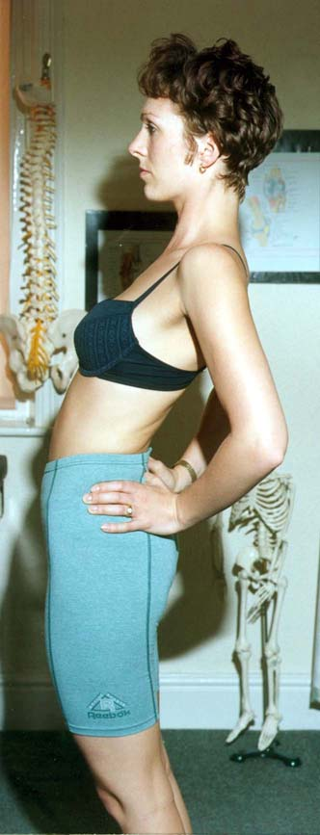  From the side |  | 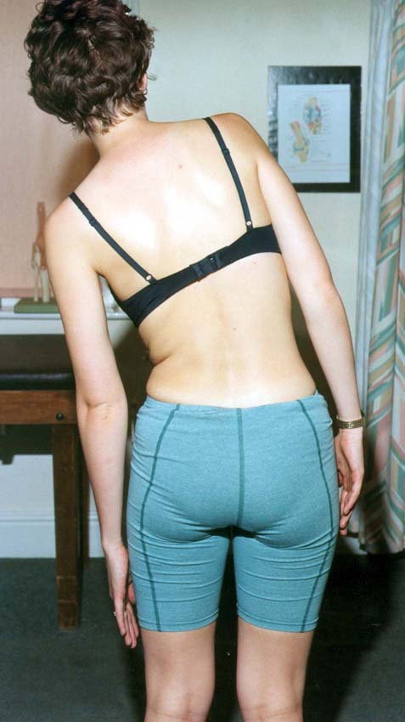  From behind

3 Flexion  Asking the patient to touch their toes measures hip and neural flexibility, not lumbar movement. For a more accurate measure, palpate individual segmental movement.  Also check: correct pelvic tilting rhythm. |  | 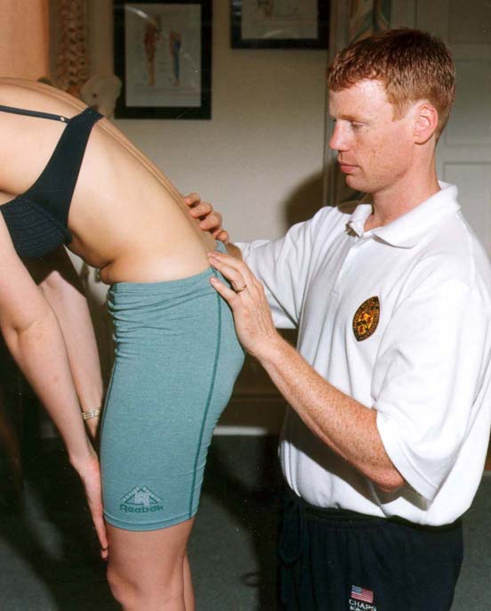  Palpate segmental movement

4 Side flexion
Measure the hand-to-knee distance on each side.
Also check: the quality of each segmental movement.

5 Extension
Extension is often restricted — but note that it sometimes relieves the patient's symptoms, which is itself a useful clue.

6 Rotation  Best measured sitting, to eliminate leg and hip rotation.  Also check: asymmetry between the two sides. |  | 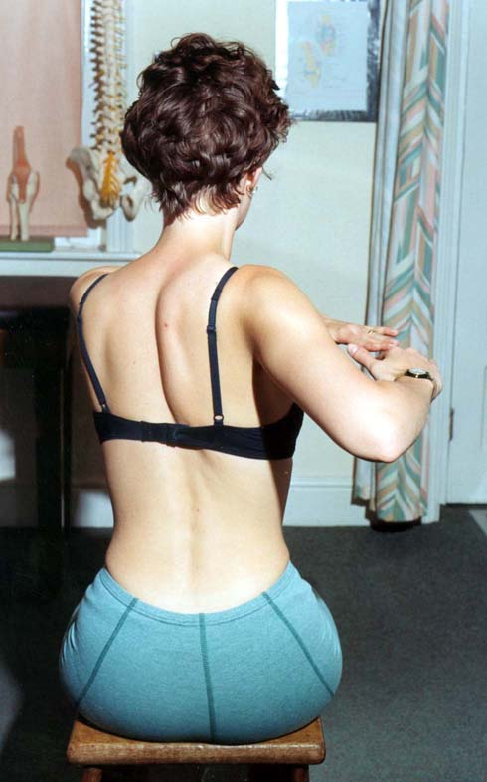  Tested seated

7 Slump test  A fairly provocative test of neural length — patients who have trouble driving often have their symptoms reproduced. Test the good side first, then the affected side; add ankle dorsiflexion and knee extension slowly.  Compare with the SLR — for example, a slump test may be negative while the SLR is positive at 30°. |  | 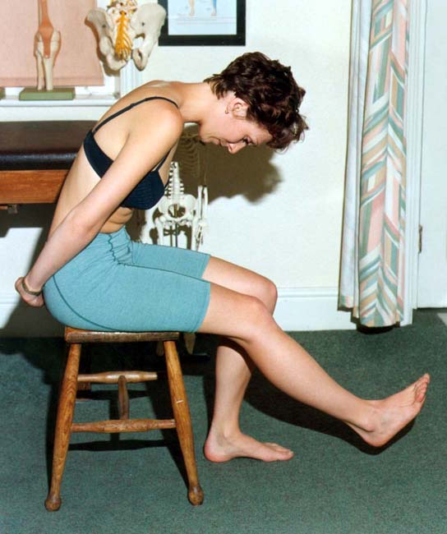  Seated slump position

8 Straight leg raise (SLR)  Measure heel-to-plinth with the knee locked in extension and the ankle plantargrade. |  | 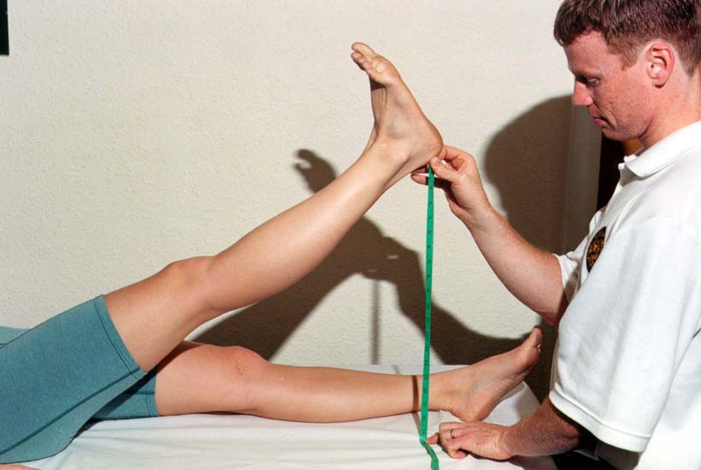  Knee extended, ankle relaxed

9 Passive knee bend  Used to check femoral nerve length. With the patient prone, flex the knee; add foot movements to reproduce the patient's pain. |  | 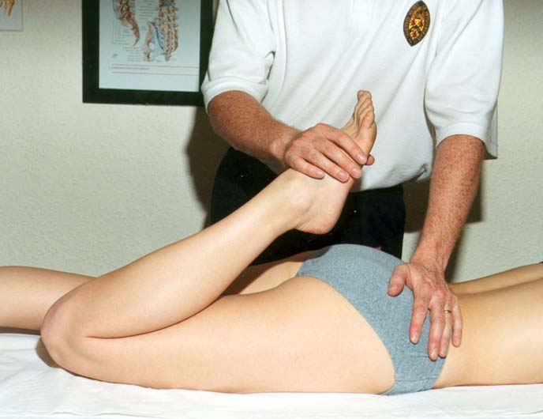  Prone knee bend

10 Palpation  Finally, palpate to pinpoint the local lesion — start lightly and build up. |  | 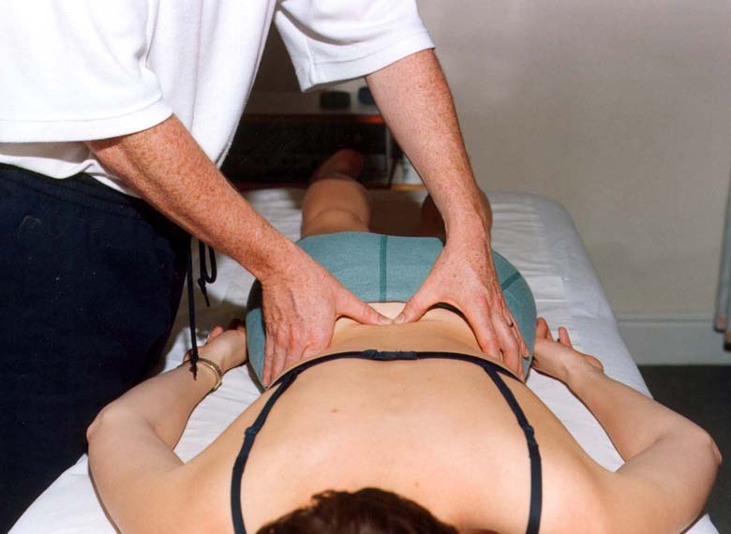  Palpate prone

§ Disclaimer
This document is provided exclusively for education and training as a teaching aid. It does not constitute formal clinical guidance. Clinicians must independently verify all medical information, examination technique and procedural protocols against current national guidance and local policies before applying in practice.

Source: This teaching aid reproduces the original Bradford VTS lumbar-spine examination method, beautified and with all photographs preserved; the examination technique is unchanged. A brief cauda-equina safety reminder has been added in line with NICE NG59 / NICE CKS Sciatica. Verify against current guidance and local pathways before use.

