BRADFORD VTS TEACHING AIDS | UPDATED  June 2026

MUSCULOSKELETAL · CLINICAL EXAMINATION
Examination of the Lumbar Spine
A structured, safe approach for GP trainees and IMGs — Look, Feel, Move, Test, and never skip the neurology.
✓ Before you begin — three rules
- Examination is essential — patients expect to be examined, and it guides your management more than any scan.
- Always pair the exam with a history and a red-flag screen. A back examination is incomplete without checking power, sensation and reflexes in the legs.
- If there are leg symptoms, use the dermatomes to localise the level — e.g. lateral calf numbness ≈ L5. Remember a high lesion can still affect lower roots.

1 | What the patient tells you | Subjective
Typical mechanical pattern  - Worse with prolonged sitting, lifting and stooping  - Eases with rest or position change  - No leg-dominant pain, no red flags |  | Pain on walking — think wider  Pain that comes on with walking may not be from the spine. Consider the hip, spinal stenosis (neurogenic claudication) or a circulatory cause (vascular claudication). Examine pulses.

i Track recovery with function, not just pain scores
Use simple functional markers the patient can report back on — how long they can sit, how long it takes to dress, whether they can put on socks — to judge whether they are improving.
2 | Look — inspection & posture | Recognise
Inspect the whole spine with the patient standing, suitably undressed. Look from behind and from the side.
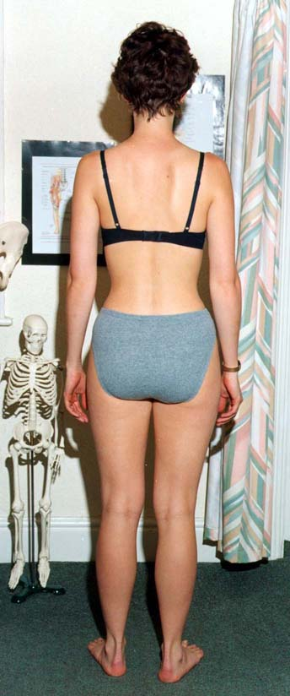  Inspect from behind — symmetry, muscle bulk, skin |  | 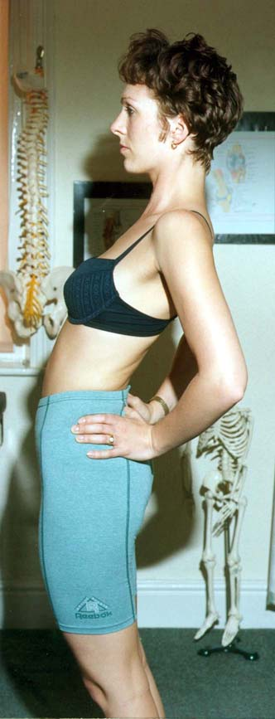  Inspect from the side — lordosis & thoracic kyphosis |  | 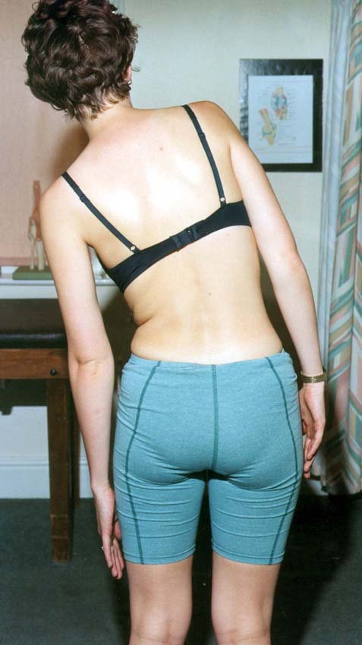  Check symmetry & level — shoulders, pelvis, leg length

✓ What to look for  - Correctable scoliosis and any increased thoracic kyphosis  - Loss of muscle bulk or tone, and general posture  - Skin changes (scars, café-au-lait, midline tufts) |  | Leg-length discrepancy  Best judged standing. A true discrepancy can be corrected with a heel raise or arch support and re-assessed.
3 | Feel — palpation | Recognise
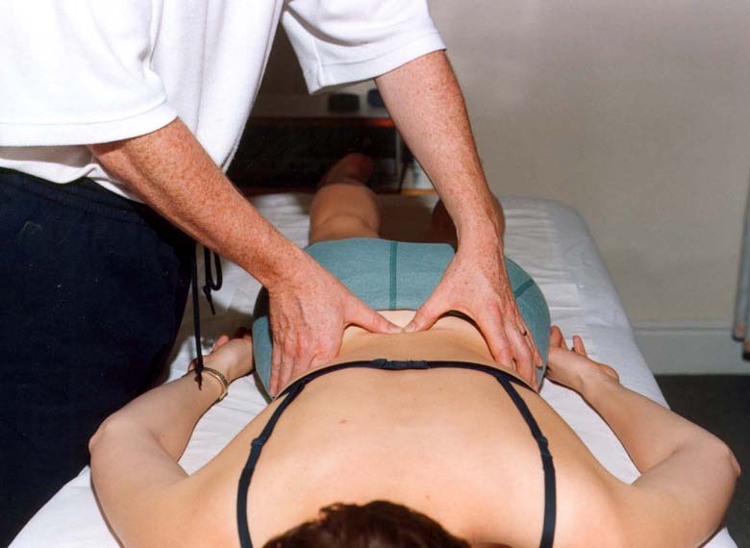  Palpate prone — start lightly. | Palpate to pinpoint the local lesion — but start lightly and build up; a heavy hand on a painful back loses the patient's trust and guards the muscles.  - Feel for a step (suggests spondylolisthesis) and focal bony tenderness (think fracture or, with red flags, infection or tumour)  - Assess paraspinal tone and localised muscle spasm
4 | Move — active movements | Recognise
Ask the patient to move actively. The pattern of restriction and what reproduces or relieves the pain is more useful than the absolute range.
Movement | How to test it well | What it tells you
Flexion | Toe-touch measures hip & neural flexibility, not lumbar movement — palpate segmental movement and watch pelvic rhythm | Quality & level of restriction
Extension | Often restricted; note if it reproduces or relieves symptoms | Relief on extension can point to discogenic pain; pain on extension to facet/stenosis
Side flexion | Measure hand-to-knee distance each side; judge segmental quality | Asymmetry & local restriction
Rotation | Test seated to remove hip and leg rotation | True thoraco-lumbar rotation; note asymmetry

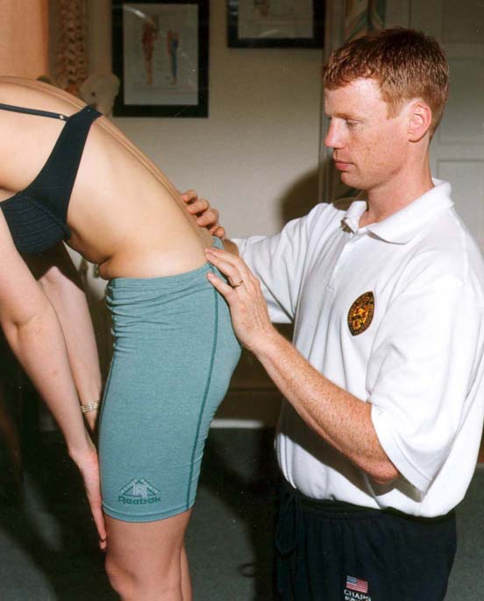  Segmental movement & pelvic rhythm |  | 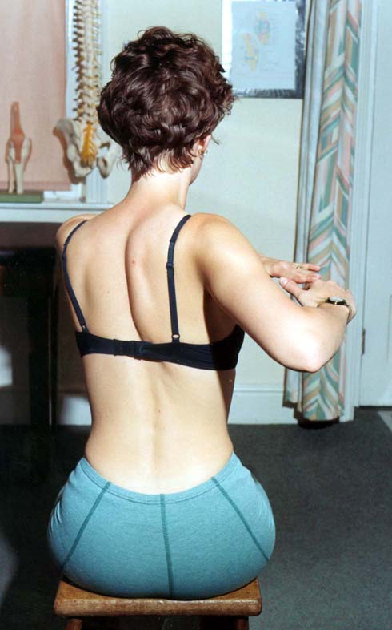  Rotation tested seated |  | 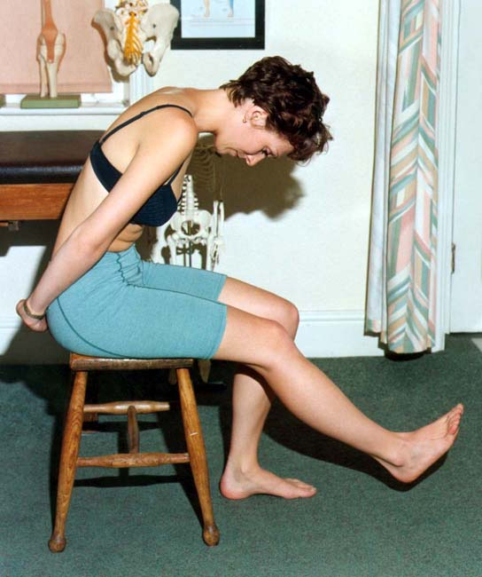  Seated flexion / start of the slump
5 | The neurological examination — never skip it | Act
A lumbar examination is not complete without a focused neurological assessment of the legs. Back-pain nerve problems almost always involve L4, L5 and S1 — so test those three roots for power, sensation and reflexes.
Root | Power (test this) | Sensation | Reflex
L4 | Ankle dorsiflexion | Medial calf / shin | Knee jerk
L5 | Big-toe extension; heel walking | Dorsum of foot, lateral calf | —
S1 | Plantarflexion; toe walking | Sole, lateral foot | Ankle jerk

! Cauda equina screen — ask and examine if any suggestion
If the history hints at bladder or bowel change, bilateral leg symptoms, or saddle / genital numbness, you must check perianal sensation and anal tone and arrange same-day emergency assessment for urgent MRI. Reduced tone, saddle anaesthesia or post-void residual are late signs — do not wait for them.
6 | Nerve-tension (special) tests | Recognise
Straight leg raise (SLR) — for lower lumbar roots (L4–S1)
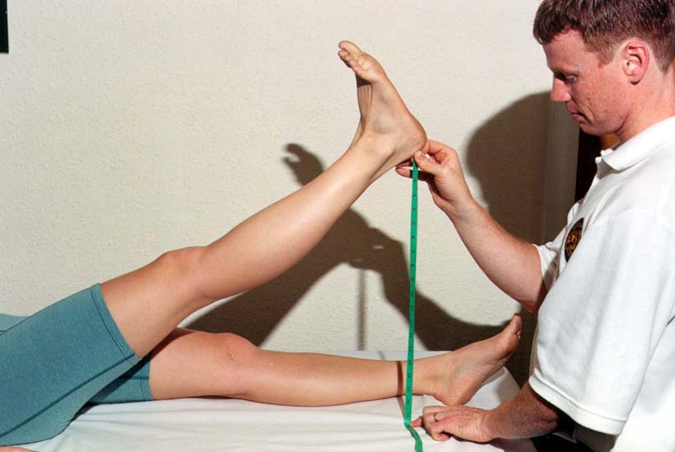  SLR — knee extended, ankle relaxed; raise gently. | With the patient supine and the knee fully extended, raise the straight leg slowly. The test is positive when it reproduces the patient's radicular leg pain below the knee, classically between 30° and 70°.  - Pain above 70° usually means tight hamstrings or hip/SIJ — not nerve root  - Add ankle dorsiflexion at the painful point (Bragard's) — extra radicular pain confirms a neural cause  - SLR is sensitive but not specific — a negative test does not exclude a problem; interpret with the whole picture

Crossed SLR — the specific one  Raising the good leg reproduces pain in the affected leg. Far less common, but highly specific — it points to a large or central disc herniation. Take it seriously. |  | Slump test — seated neural tension  A more sensitive (and more provocative) neural test. Patients who struggle with driving often have it reproduced. Add ankle dorsiflexion and knee extension slowly, and compare with the SLR.

Femoral nerve stretch (prone knee bend) — for upper lumbar roots (L2–L4)
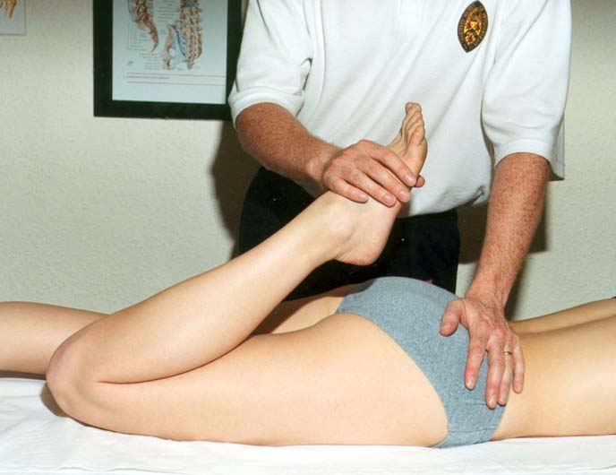  Prone knee bend / femoral stretch. | With the patient prone, flex the knee (and gently extend the hip). Reproduction of anterior thigh or back pain suggests an upper lumbar (L2–L4) nerve-root problem — a different pattern from sciatica. Add foot movements to reproduce the pain.
7 | Function & gait | Recognise
✓ Two moves that test power and function together
Watching the patient walk on their heels (L4–L5 dorsiflexion) and walk on their toes (S1 plantarflexion) screens leg power quickly and shows you how the back behaves in real movement. An antalgic, stooped or list-to-one-side gait is itself a clue.
✓ | Examination checklist (proforma) | Record
Use this as a quick competency / record sheet. Tick each step as performed.
Examination step | Done | Partial | Not done
History + red-flag screen completed
Inspection — standing, from behind and the side
Posture, scoliosis, kyphosis, muscle bulk noted
Leg length assessed in standing
Palpation — tenderness, step, paraspinal tone
Active movements — flexion, extension, side flexion, rotation
Neurology — power, sensation, reflexes (L4, L5, S1)
Cauda equina screen if indicated
SLR (± Bragard's) and crossed SLR
Slump test
Femoral stretch (prone knee bend)
Gait — heel and toe walking

§ Disclaimer
This document is provided exclusively for education and training as a teaching aid. It does not constitute formal clinical guidance. Clinicians must independently verify all medical information, examination technique and procedural protocols against current national guidance and local policies before applying in practice.

Sources: NICE NG59 and NICE CKS Sciatica (lumbar radiculopathy) for assessment and red flags; standard clinical examination technique (Look–Feel–Move–neurology–nerve-tension tests). SLR / crossed-SLR / femoral-stretch interpretation per published examination evidence (sensitive-not-specific; crossed SLR specific for central disc; femoral stretch for L2–L4). This teaching aid modernises an earlier Bradford VTS lumbar-examination resource. Verify against current guidance and local pathways before use.

