BRADFORD VTS TEACHING AIDS
Knee Problems —
Sussing It Out in 10 Minutes
A Quick-Reference Consultation Guide · Bradford VTS · June 2026

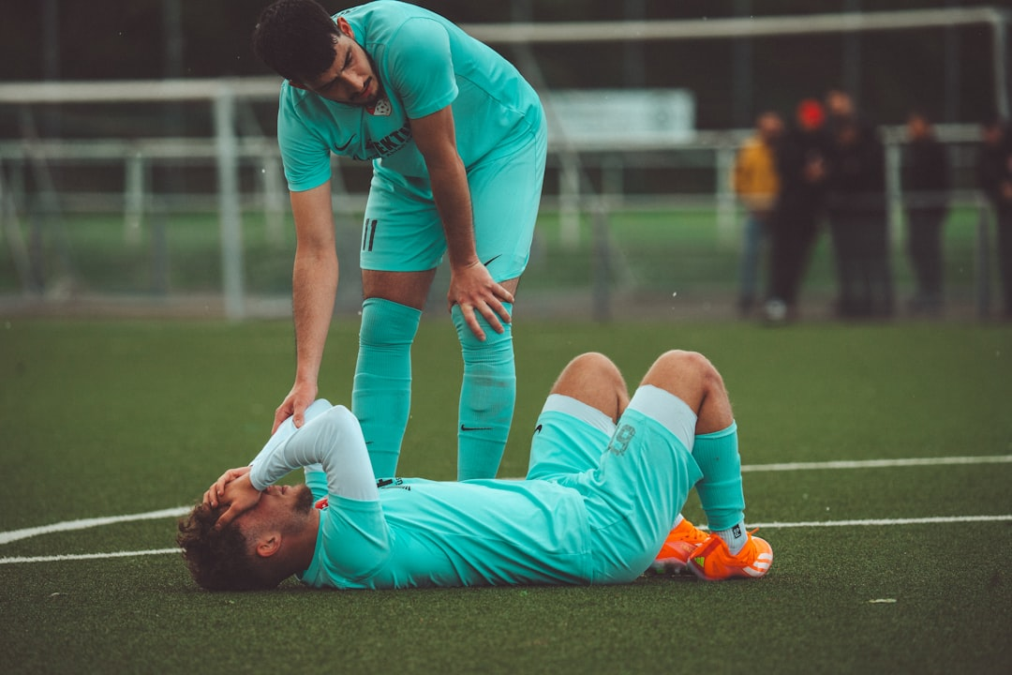
Most GPs have 10–15 minutes — this guide helps you identify the three commonest traumatic knee problems using history-first reasoning.

Specific examination tests (McMurray, Lachman) require skill and a relaxed patient — unreliable in inexperienced hands. This guide helps you differentiate the three commonest knee conditions and decide on referral using history alone.

The RTA Analogy — Match Symptoms to Diagnosis
• ACL rupture = Major RTA → dramatic presentation, major symptoms and exam findings
• Meniscal tear = Moderate RTA → less dramatic, moderate symptoms, moderate exam findings
• Patellofemoral syndrome = Minor RTA/near miss → minor or no dramatic findings
Always use the COMBINATION of symptoms — not any single feature in isolation.

History — The Diagnostic Tool
Timing of presentation after injury
• < 24 hours → think ACL rupture
• 24–48 hours → think meniscal tear
• Days/weeks later → patellofemoral syndrome (no acute injury)
Swelling — timing is diagnostic
• < 8 hours (large haemarthrosis) → ACL rupture (70%) or osteochondral fracture
• 24–48 hours (moderate effusion) → meniscal tear
• Very minor or no swelling → patellofemoral syndrome
Pain location
• All over knee (large haemarthrosis) → ACL
• Medial joint line → meniscal tear
• Anterolateral/peri-patellar → patellofemoral syndrome
What to ask — mechanism clues
• 'Did you hear a snap, crack or pop?' → ACL rupture
• 'Was it a twisting injury?' → meniscal tear.
• 'Did your knee give way completely?' → ACL
• 'Did it lock — couldn't you straighten it?' → meniscal tear
• 'What could you do after injury?': Unable to continue → ACL; could hobble → meniscal

TWISTING & SWELLING ARE IMPORTANT QUESTIONS TO ASK
- Twisting alone = 25% likelihood of internal knee damage
- Twisting + Swelling = 90% likelihood of internal knee damage.
Patellofemoral syndrome — recognise quickly
• Anterior knee pain, worse going DOWN stairs (not up)
• 'Cinema sign': pain in prolonged knee flexion (cinema, driving)
• Common in prepubertal girls; adults taking up hill walking/running
• Worse squatting, crouching, cycling — NO acute injury history

Brief Examination Findings
• ACL: very large swollen knee, major distress, can hardly walk
• Meniscal: overnight swelling (moderate), medial joint line pain, can just about hobble
• Patellofemoral: anterolateral knee pain; pushing patella laterally reproduces pain; no effusion
Key: In the acute setting, swelling and pain prevent reliable special test performance. Trust the history.

Referral — What to Do
• ACL tears: urgent referral to orthopaedics/sports medicine (within days)
• Meniscal tears: refer within the week to acute knee clinic
• Locked knee: refer urgently — early meniscal repair possible
• Patellofemoral syndrome: refer to physiotherapy; avoid orthopaedic referral initially

🟣 AKT Exam Focus
• Haemarthrosis < 8h → ACL (70%) or osteochondral fracture
• Meniscal swelling: 24–48h effusion (NOT haemarthrosis)
• McMurray sensitivity only 53% — composite examination preferred (sensitivity 77%, specificity 91%)
• Lachman LR+ 25.0 vs Anterior Drawer LR+ 3.8 — Lachman far more reliable
• Knee never locks in full extension — always in partial flexion

🟢 SCA Consultation Tips
• Acknowledge impact: 'I can see this has really affected your sport/daily life.'
• Safety-netting ACL: 'Your knee may give way again — if it does, go to A&E or ring us straight away.'
• Safety-netting meniscal: 'If your knee locks and you can't straighten it, go straight to A&E.'
• Don't over-promise: 'I want to be certain, so I'm going to refer you to a specialist.'

🔴 Red Flags
• Hot joint + fever → septic arthritis — emergency
• Acute haemarthrosis < 8h → refer urgently (ACL/osteochondral fracture)
• True locking (can't straighten) → refer urgently (meniscal flap)
• Neurovascular compromise → A&E immediately

💡 Top Tips
• Trust history over examination — textbook ACL history = refer even if exam is normal
• Aspirate an acute haemarthrosis: therapeutic AND diagnostic
• Composite examination (all tests together): sensitivity 77%, specificity 91%
• Patellofemoral syndrome: patellar taping + VMO exercises. Drugs don't help.
• Never recommend glucosamine for OA — NOT recommended by NICE NG226

⚠ Always double check this advice and drug doses with the latest NICE/BNF guidance. This document is for educational purposes only.

