BRADFORD VTS TEACHING AIDS
Hips, Knees, Ankles & Feet for GPs
A Practical Clinical Guide · Bradford VTS · June 2026

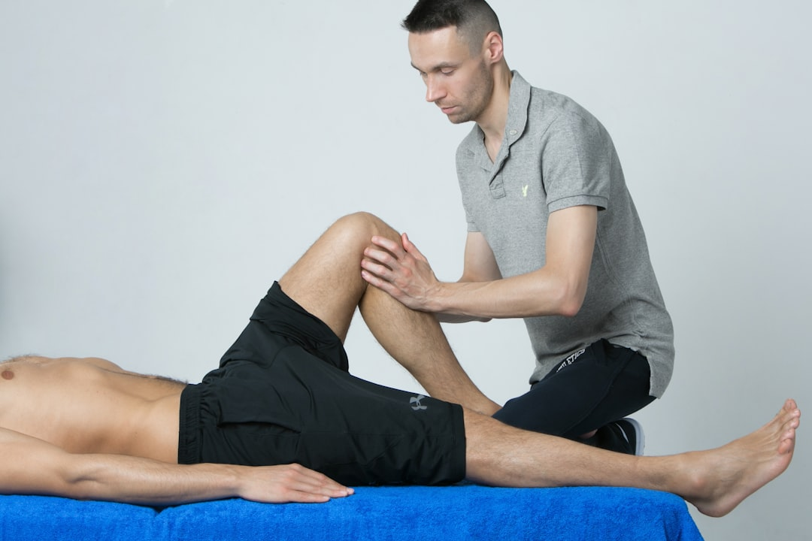
A systematic guide to lower limb problems in primary care, updated to current NICE guidance.

1. Greater Trochanteric Pain Syndrome (GTPS)
Previously called 'trochanteric bursitis'. NICE CKS now uses GTPS — encompasses gluteal tendinopathy, IT band pathology and bursitis. Common in women aged 40–60 years. Also associated with leg length discrepancy and post-THR.
Presentation
• Pain over lateral hip near greater trochanter — tender on palpation
• May radiate down outer thigh — but NOT to foot (differentiates from sciatica)
• Worse lying on affected side; aggravated by running, walking and crossing legs
Differentials
• OA hip: passive internal rotation of hip (in flexion) → pain in OA, not in GTPS
• Sciatica: pain radiates to foot + pain on SLR — not on hip flexion with knee flexed
• Gluteus medius tendon tear: pain on resisted hip abduction
Management (NICE CKS)
• Activity modification — avoid lying on affected side; avoid crossing legs
• Physiotherapy — hip abductor stretching and load management programme
• NSAIDs (topical first; oral if insufficient) — short course
• Ultrasound-guided corticosteroid injection — best evidence
• Surgery (IT band release/bursectomy) — rarely needed
⚠ Pitfall
• Don't diagnose GTPS as 'hip OA' — test passive internal rotation. If normal → GTPS. If restricted/painful → likely OA or serious hip pathology.

2. Patellofemoral Pain Syndrome (PFPS)
= Anterior knee pain. Caused by patellar maltracking — VMO weakness allows lateral drift. Very common (20% students). Women > Men. Physically active people. No acute trauma.
Diagnosis
• Sharp anterior/retropatellar knee pain on knee flexion activities
• 'Cinema sign': pain worsens sitting with knees flexed (cinema, driving)
• Worse going DOWN stairs than up (eccentric quadriceps overload)
• No effusion — if effusion present, rethink the diagnosis
• Examination: patellar grind; lateral patellar glide at 20° reproduces pain; check foot pronation
Management
• Activity modification — avoid squatting; aisle seat in cinema; raise bicycle saddle
• VMO strengthening + physiotherapy (most effective intervention)
• McConnell patellar taping — RCT evidence: 73% improvement vs 10% no-tape (Hinman, BMJ 2003)
• Foot orthoses (arch supports) if foot overpronation present
• Drugs play MINIMAL role — avoid NSAIDs long-term

3. Ankle Injuries — Lateral Ligament Sprain
• Grade 1: pain + tenderness, no tear, stable
• Grade 2: partial tear, pain ++, ± instability
• Grade 3: complete tear, cannot weight-bear, gross instability
Ottawa Ankle Rules (NICE CKS, June 2025 — still current)
X-ray ANKLE if pain in malleolar zone AND:
• Bony tenderness at posterior tip/edge of lateral OR medial malleolus
• Inability to weight-bear 4 steps immediately AND in clinic
X-ray FOOT if pain in midfoot zone AND:
• Bony tenderness at base of 5th metatarsal OR navicular
• Inability to weight-bear 4 steps immediately AND in clinic
Management — POLICE (replaces RICE, NICE CKS June 2025)
• Protection: functional brace/support 4–6 weeks (grade 3 until pain-free walking)
• Optimal Loading: early mobilisation preferred over immobilisation
• Ice: 15–20 min QDS in damp towel for first 48h
• Compression: elastic bandage — snug, remove before sleep
• Elevation: first 48h
• Analgesia: paracetamol ± codeine; NSAIDs after first 48h only (early use may impair healing)
• Physiotherapy: alphabet exercises, balance board, Achilles stretching
• Grade 3: orthopaedic referral if no improvement after 6 weeks
⚠ Don't Miss Achilles Tendon Rupture
• Thompson (Simmonds) test: squeeze calf — absent passive plantarflexion = rupture
• May have near-normal active movement via other flexors — do NOT be falsely reassured
• Refer immediately to orthopaedics

4. Plantar Fasciitis (NICE CKS, December 2024)
Inflammation/degeneration of plantar fascia at calcaneal insertion. Common (10% of population). Risk factors: overweight, standing occupations, overpronation, age 40–60. Often bilateral in 30%.
Diagnosis
• 'Start-up pain' — intense heel pain on first steps after waking or after rest
• Tender at medial calcaneal tuberosity
• Windlass test: passive dorsiflexion of toes reproduces pain
• Tip-toe walk causes pain +++ (diagnostic)
• Heel spurs on X-ray: common and INCIDENTAL — do not treat
Management (NICE CKS December 2024)
• Reassurance: 90% resolve within 12 months
• Stretching exercises (first-line): plantar fascia + calf stretches before first step in morning
• Footwear: cushioned heels; avoid barefoot on hard surfaces
• Foot orthoses: arch supports for overpronation
• Analgesia: paracetamol; topical NSAIDs; oral NSAIDs if needed
• Corticosteroid injection: >70% effective but risk of fascia rupture (~5–10%) + fat pad atrophy
• ESWT: for persistent cases (>3–6 months); surgery rarely needed

🟣 AKT Exam Focus
• GTPS (not 'trochanteric bursitis') — correct NICE CKS terminology
• Ottawa Ankle Rules: posterior tip malleolus tenderness OR unable WB → X-ray
• POLICE has replaced RICE — NICE CKS June 2025
• Plantar fasciitis: stretching first-line (NICE CKS Dec 2024); steroid injection → risk of rupture
• NSAIDs: avoid in first 48h ankle injury
• Heel spurs: incidental on X-ray — no treatment needed

🟢 SCA Exam Focus
• ICE for ankle: 'What are you worried has happened — are you concerned about a fracture?'
• Safety-netting plantar fasciitis: '90% get better within a year. Come back at 3 months if still bad.'
• Shared decision-making steroid injection: 'Small risk of tendon tear — worth knowing before deciding.'
• GTPS safety-net: 'If pain goes to your foot or you develop weakness, come back urgently.'

🔴 Red Flags — Immediate Action
• Hot swollen joint + fever → septic arthritis (emergency admission)
• Suspected Achilles tendon rupture → refer immediately
• Neurovascular compromise → emergency
• Child with hip pain + fever/non-WB → septic arthritis of hip (emergency)

⚠ Always double check this advice and drug doses with the latest NICE/BNF guidance. This document is for educational purposes only.

