BRADFORD VTS TEACHING AIDS

Osteoarthritis

MSK Teaching Series · For GP Trainees & IMGs June 2026
✓ In a nutshell
Osteoarthritis (OA) is the commonest joint condition you will see — and primary care owns almost all of it.
The single biggest shift: exercise and weight management are not just lifestyle advice — they ARE the core treatment, offered to everyone, and they work.
Diagnose it clinically. No blood test, no X-ray needed in the typical patient. Drugs are an add-on, not the foundation.
Recognise · A clinical diagnosis
NICE (NG226) lets you diagnose OA clinically — without any investigations — when all of the following are present:
- Aged 45 or over, and
- Activity-related joint pain, and
- Either no morning joint stiffness, or morning stiffness lasting no longer than 30 minutes.
▸ Imaging — usually unnecessary
- Do not request X-rays routinely. X-ray changes correlate poorly with symptoms — many painful joints look normal, and many painful-free joints look terrible.
- Investigate only to exclude an alternative diagnosis (e.g. atypical features, suspected inflammatory arthritis, red flags, or a possible alternative cause).
Act · Core treatment for everyone
Offer therapeutic exercise and weight management to every person with OA. These are the foundation of care — not optional extras tried after drugs fail.
Core element | What to say and do
Therapeutic exercise | Offer it as a core treatment whatever the person's age, severity or comorbidity. Combine muscle strengthening and aerobic fitness. Expect a short-term flare in pain — coach the patient that this is normal and that benefit builds over weeks.
Weight management | For those living with overweight or obesity, support weight loss. Any loss helps; a larger loss helps more (a 10% reduction beats 5%). Frame it as one of the most effective treatments available.
Manual therapy | Consider as an adjunct — but only ALONGSIDE therapeutic exercise — for hip or knee OA.
Information & support | Explain the diagnosis, dispel the 'wear and tear / inevitable decline' myth, and agree a self-management plan. Signpost Versus Arthritis (versusarthritis.org).

▍ The evidence — why exercise earns its place
Therapeutic exercise meaningfully reduces pain and improves function in knee OA. The chart below is a Cates plot for a typical group of 100 people: green = improved, red = did not. Exercise converts roughly one extra person in ten from 'no better' to 'better' — a number-needed-to-treat of about 9, comparable to many drugs we prescribe without hesitation.
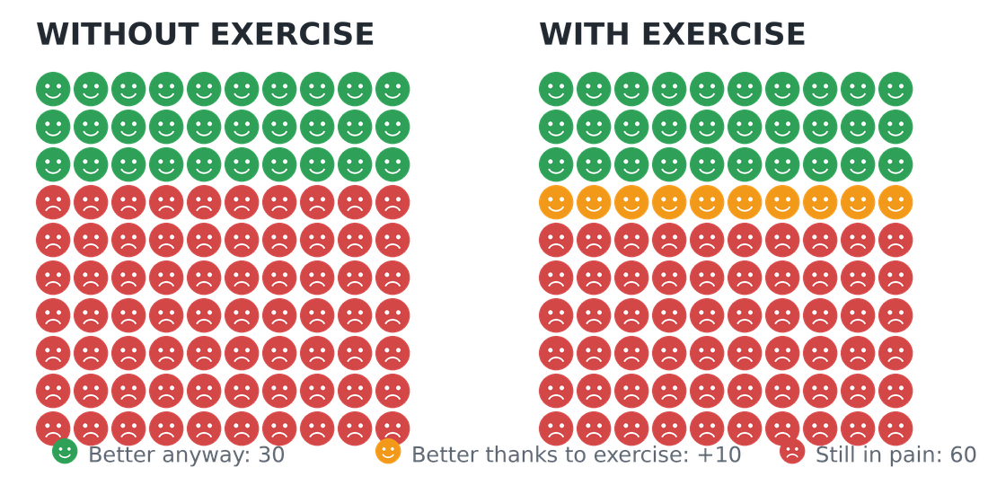
Illustrative Cates plot: benefit of therapeutic exercise in knee osteoarthritis (each figure ≈ one person in 100).
Act · Medicines — an adjunct, used by the ladder
Pharmacological options support the core treatment; they do not replace it. Use the lowest effective dose for the shortest time, and review.
Step |  | Detail & cautions
Topical NSAID |  | First-line drug for knee OA (consider for other joints). Try this before any oral agent.
Oral NSAID |  | Use the lowest effective dose for the shortest time, and co-prescribe a proton-pump inhibitor (PPI). Weigh GI, renal and cardiovascular risk — review regularly.
Intra-articular steroid |  | Consider when other treatments are ineffective or unsuitable, and the patient needs short-term symptom relief (e.g. to enable exercise/rehab). The effect is short-lived.
◆ What's changed — and what NICE now says NOT to offer
This is the part most likely to differ from older teaching and from habit:
- Do not routinely offer paracetamol or weak opioids — there is no strong evidence of benefit in OA, and possible harms. Only consider paracetamol short-term, infrequently, e.g. if other options are contraindicated.
- Do not offer strong opioids.
- Do not offer glucosamine or chondroitin.
- Do not offer acupuncture, dry needling, or electrotherapy (including TENS and ultrasound).
- Exercise and weight management moved from 'advice' to core treatment offered to all.

Refer · When to consider joint surgery
Most OA never needs an operation. Consider referral for joint replacement when:
- Joint symptoms (pain, stiffness, reduced function) are substantially affecting quality of life, and
- Non-surgical treatment has been ineffective or is unsuitable.
▸ Referral — practical points
- Do not exclude someone from referral on age, sex, smoking, comorbidity or weight alone. Decisions are individual.
- Do not wait for prolonged conservative treatment, or for a specific X-ray severity, before referring.
■ Disclaimer & verification
Key sources used for this update: NICE NG226 Osteoarthritis in over 16s: diagnosis and management (2022); NICE CKS Osteoarthritis; BNF (topical/oral NSAIDs, PPIs, intra-articular corticosteroids).
This document is provided exclusively for educational and training purposes as a teaching aid. It does not constitute formal clinical guidance. Clinicians must independently verify all medical information, prescribing guidance, procedural protocols and legal requirements against current national guidance (e.g. NICE, NICE CKS, BNF), local policies and the relevant regulatory bodies before applying anything in practice.

