BRADFORD VTS TEACHING AIDS | UPDATED  June 2026

MUSCULOSKELETAL · RCGP CURRICULUM
Back & Neck Pain
A practical guide for GP trainees and IMGs — how to sort it, what to do, and when to worry. Aligned with NICE NG59.
✓ The one big idea
You do not need an exact tissue diagnosis. Most back pain has no single identifiable structure to blame — even experts often cannot name it. Your real job is to do two things well: sort the patient into one of three groups, and never miss a red flag. Get those right and the management plan writes itself.

~60%  of adults have significant back pain at some point in life |  | No.1  leading cause of disability & lost working days worldwide |  | Most  acute episodes settle within weeks — but recurrence is common

Back pain is one of the commonest reasons people see a GP. The good news: most is mechanical and self-limiting. The skill is spotting the small number who need more — and resisting the urge to over-investigate everyone else.
1 | A quick anatomy refresher |  | Foundations
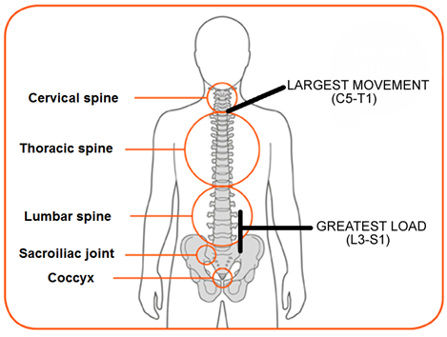  The spinal column: 7 cervical · 12 thoracic · 5 lumbar · 5 fused sacral · 4 fused coccygeal (≈33 bones). |  | Two facts explain where pain usually comes from:  - The greatest range of movement is around the neck (C5–T1).  - The greatest load passes through the lower lumbar spine (L3–S1).  So neck pain and low back pain are by far the most common — these segments work hardest.
  Memory hook
  Think of the lower back like the hinge of a heavy gate: it carries the load and moves the most, so it wears the most.

The myotome & reflex shortcut
Back-pain nerve problems almost always involve L3–S1. Rather than memorising every level, test just three roots in the leg:
 | 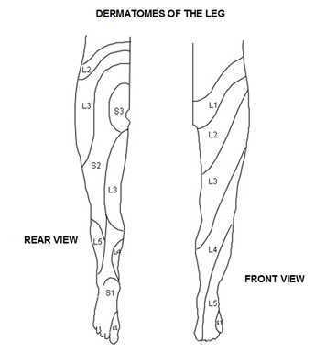  Leg dermatomes. Leg symptoms point to the level: e.g. lateral calf numbness ≈ L5.
  Root | Test | Reflex
  L4 | Ankle dorsiflexion | Knee jerk
  L5 | Big-toe extension; walk on heels | —
  S1 | Plantarflexion; walk on tip-toes | Ankle jerk

i For the neck
Cervical roots are tested in the arm: C5 shoulder abduction (biceps jerk), C6 elbow flexion / wrist extension (supinator jerk), C7 elbow extension / wrist flexion (triceps jerk), C8 finger flexion, T1 finger abduction. A high lesion can still affect lower roots.
2 |  | Diagnostic triage — the three groups | Recognise
Every patient with back pain falls into one of three groups. First rule out a problem coming from elsewhere (abdomen, pelvis, kidney, a leaking aneurysm) — then triage the spine itself.
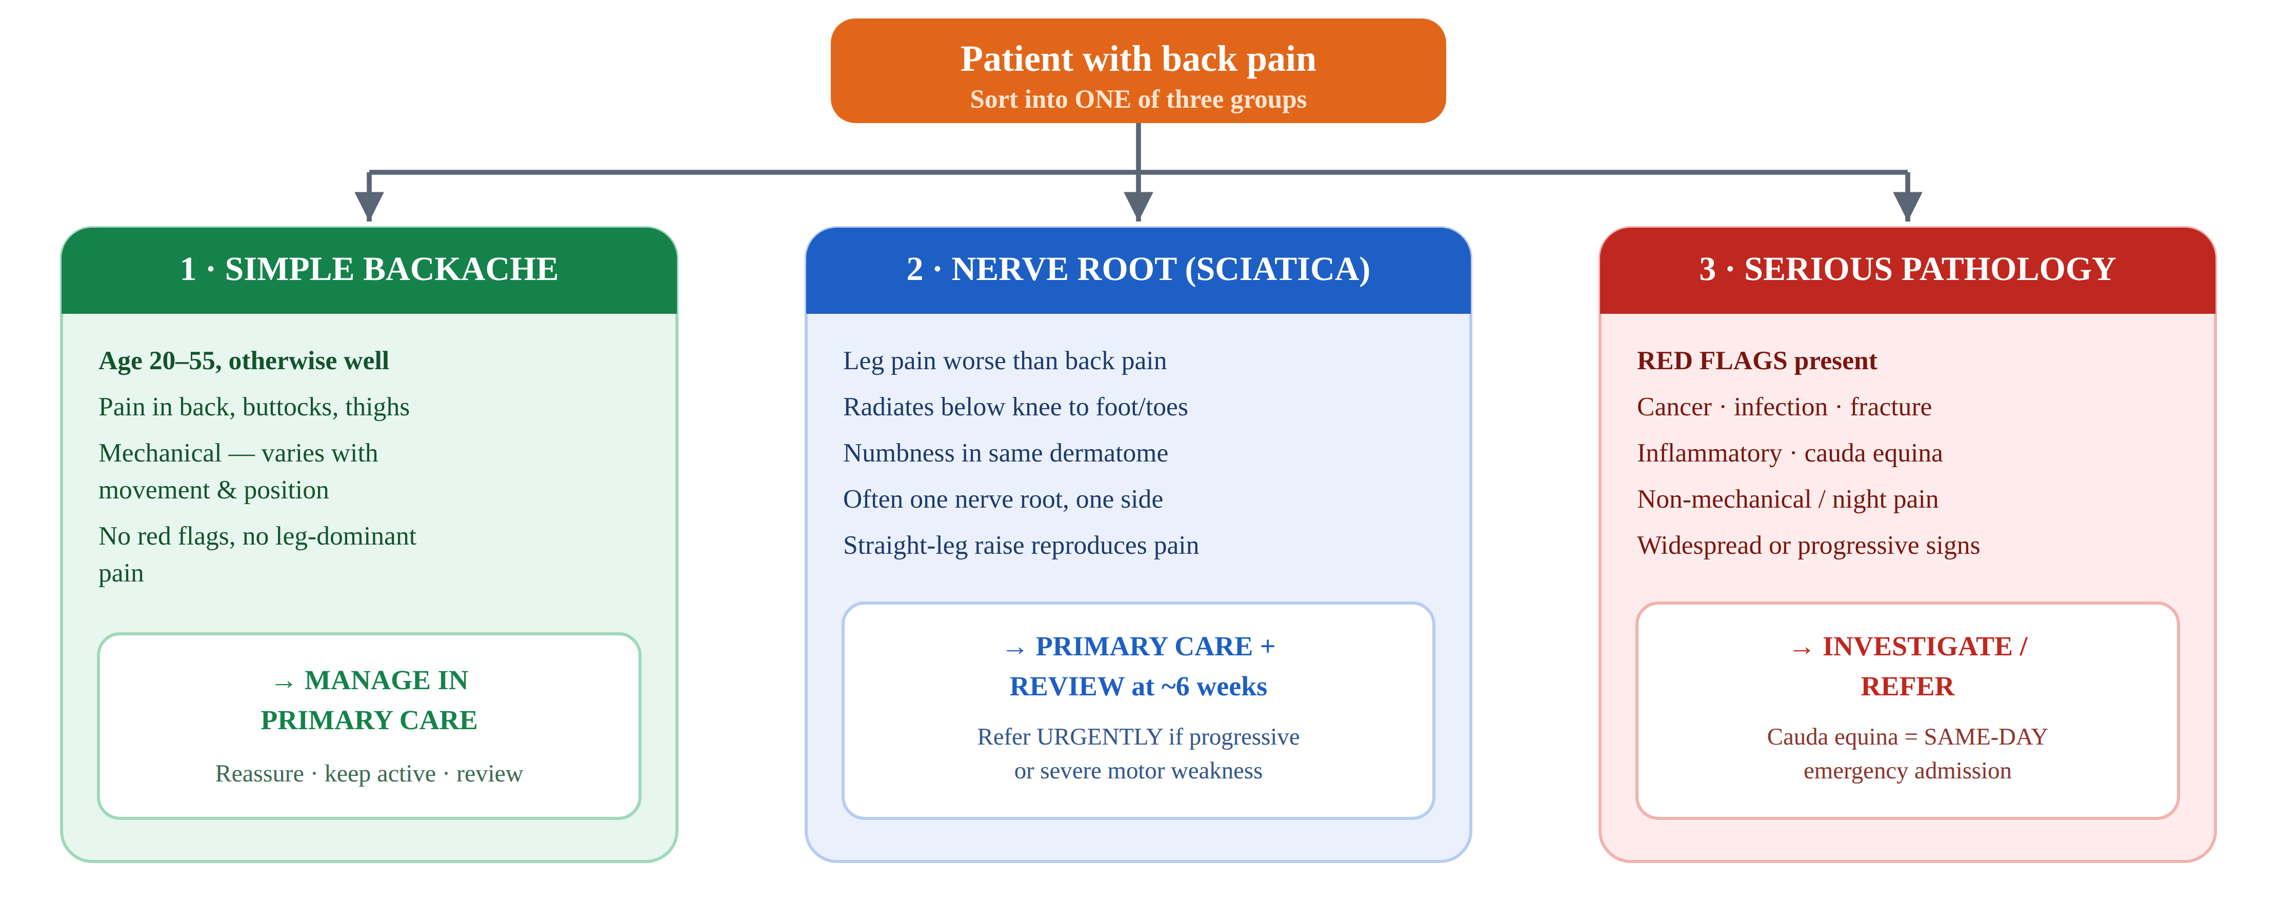

! What changed
Older tools treated age alone (under 20 or over 55) as a red flag. Modern practice is more careful: do not act on a single feature in isolation. Age and other features matter as part of a pattern — weigh them together, not one at a time.
3 |  | Red flags — the serious causes | Don't miss
Why “red flags”
Red flags are smoke detectors, not a diagnosis. One beep doesn't mean a fire — but it means stop, look carefully, and decide whether to act.

Serious cause | Spot it — features that should worry you | Act
Cancer (metastatic / myeloma) | Past history of cancer; unexplained weight loss; new pain over 50; pain worse at night or at rest; thoracic pain; pain not settling | Refer on a suspected-cancer pathway (NICE NG12)
Infection (discitis, abscess) | Fever, rigors, systemically unwell; IV drug use; immunosuppression / HIV; recent bacteraemia; severe unremitting pain | Refer urgently for assessment & imaging
Fracture | Significant trauma; or minor trauma with osteoporosis, age or steroid use; sudden severe central pain relieved by lying down | Assess; image & refer as appropriate
Inflammatory (axial SpA) | Onset under 40, gradual; morning stiffness > 30 min; improves with exercise not rest; waking in the second half of the night; psoriasis, IBD or uveitis | Refer to rheumatology (NICE NG65)
Cauda equina | See the emergency box below | SAME-DAY emergency admission
Problem elsewhere | Pulsatile abdominal mass + cardiovascular risk (AAA); renal, pancreatic, gynae or GI pain referred to the back | Diagnose & manage the underlying cause

! Cauda equina syndrome — a neurosurgical emergency
Compression of the lumbosacral nerve roots, usually from a large central disc herniation (often L4/5 or L5/S1). Missed or delayed, it causes permanent bladder, bowel, sexual and leg dysfunction. You must keep a high index of suspicion and act before the classic signs are fully developed. Ask directly about and examine for:
- New bladder dysfunction — difficulty passing urine, loss of the urge to go, retention or incontinence
- New bowel incontinence or loss of control
- Saddle, perineal or genital numbness or altered sensation (uni- or bilateral)
- Bilateral leg pain, numbness or weakness; sexual dysfunction; reduced anal tone
If suspected, you must arrange same-day emergency hospital admission for urgent MRI — do not wait, do not “watch and review”. Document the questions you asked, including in telephone consultations.

! Also refer urgently (not same-day, but soon)
Severe or progressive motor weakness, or signs pointing to more than one nerve root (widespread / bilateral neurology), need urgent specialist assessment (typically within 1–2 weeks) for MRI and a spinal or neurology opinion.
4 |  | Investigations — less is more | Act
✓ The headline rule
Do not routinely offer imaging (X-ray or MRI) in primary care for back pain with or without sciatica. Tell patients that even if they are referred, they may not need a scan.

Why scanning everyone backfires  Imaging findings are like grey hairs — they appear with age and usually mean nothing. Most people over 60 show “degeneration” or a bulging disc on MRI with no pain at all. Showing these to a well patient can convince them their back is crumbling and make them worse. |  | When MRI is justified  - A red flag suggesting serious pathology (admission may be better than an outpatient scan)  - Progressive neurological symptoms or signs  - Radicular pain or neurological signs not improving after about 6 weeks, where the result would change management

i A note on bloods
Don't order a routine panel. If you suspect a specific serious cause, choose tests by that suspicion: FBC, ESR/CRP, bone profile (calcium, ALP), and a myeloma screen if indicated. Plasma viscosity has been superseded by CRP/ESR. A lumbar X-ray series carries radiation roughly equal to many chest films — for little gain in non-specific pain.
5 |  | Management — what actually helps | Act
For simple backache and most sciatica, the foundation is the same: keep moving, stay positive, stay at work. Match the intensity of support to the patient's risk of a poor outcome.
Stratify the risk — the STarT Back tool
We think we are good at exploring patients' ideas, concerns and the psychosocial picture — but the evidence says we often miss it. The Keele STarT Back tool (9 questions) sorts patients into low, medium or high risk so you can target your effort where it counts.
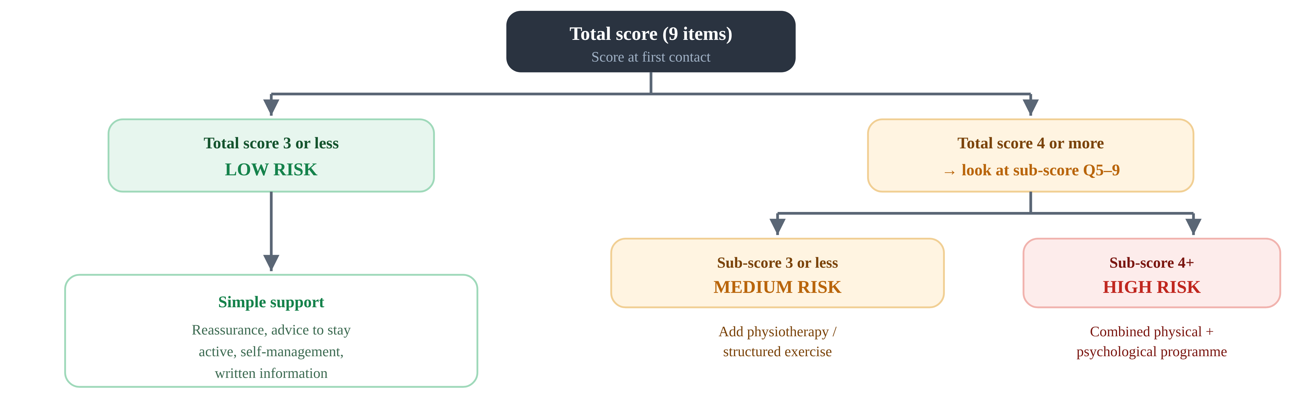

What to offer — and what to avoid
✓ Offer / consider  - Advice and information so the patient can self-manage; encourage normal activity  - A group exercise programme (aerobic, biomechanical or mind–body)  - Manual therapy — only as part of a package that includes exercise  - Psychological therapy (CBT-based) — only within an exercise package  - A combined physical + psychological programme if there are significant psychosocial obstacles or previous treatments failed  - Promote and facilitate return to work |  | ✕ Do not offer  - Routine imaging in primary care  - Belts, corsets, foot orthotics or rocker-sole shoes  - Traction  - Acupuncture  - Ultrasound, PENS, TENS or interferential therapy  - Spinal injections for low back pain  - Spinal fusion (except in a trial) or disc replacement
Source: NICE NG59 §1.1–1.3. STarT Back tool © Keele University — use the official version, free for clinical use.
6 |  | Medication — the modern approach | Prescribe safely
! This is where guidance has changed most
The old “analgesic ladder” — paracetamol first, then weak opioids, then amitriptyline, with diazepam for spasm — is out of date and partly unsafe. NICE NG59 now puts NSAIDs first and removes most of the old steps.

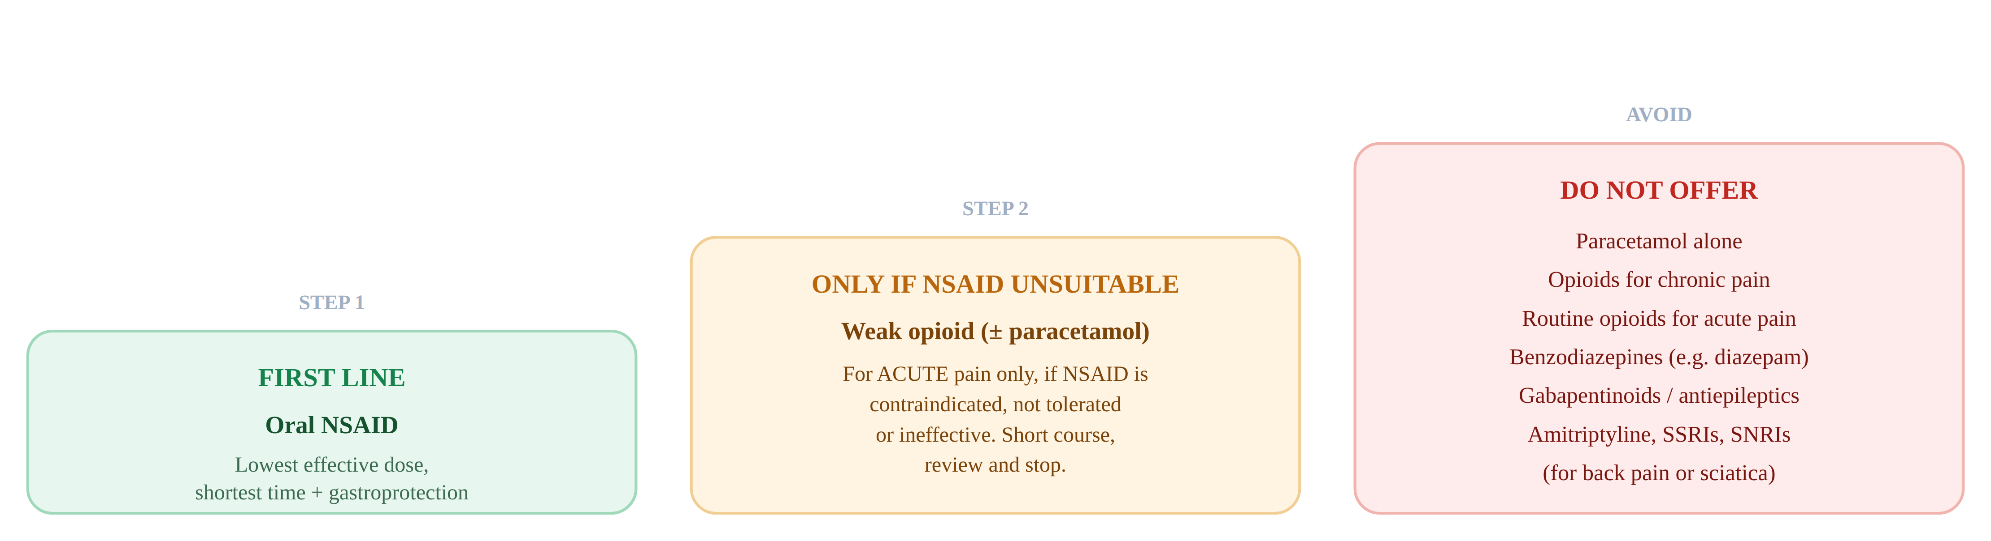

Old teaching | What NICE says now | Why
Paracetamol 1g QDS as first line | Don't offer paracetamol alone | No evidence of benefit on its own
Step up to weak opioids routinely | Weak opioid only for acute pain, if an NSAID is unsuitable; never for chronic pain | Poor long-term benefit; dependence & harm
Diazepam for muscle spasm | Don't offer benzodiazepines | No benefit; sedation, falls, dependence
Amitriptyline / antidepressants for back pain | Don't offer SSRIs, SNRIs or tricyclics | No evidence of benefit for back pain
Gabapentin / pregabalin for sciatica | Don't offer gabapentinoids or antiepileptics | No benefit in sciatica; evidence of harm

i Practical prescribing
- First line: an oral NSAID at the lowest effective dose for the shortest time. Weigh GI, liver and cardio-renal risk; add gastroprotection (e.g. a PPI) where risk factors are present. Check the BNF for the specific drug, dose and cautions.
- Sciatica: evidence for NSAIDs is limited; if used, the same lowest-dose / shortest-time / monitoring rules apply. NICE specifically does not recommend gabapentinoids, oral steroids, benzodiazepines or opioids for sciatica.
- Injections & procedures: no spinal injections for non-specific low back pain. An epidural (LA + steroid) is a specialist option for acute, severe sciatica; radiofrequency denervation is reserved for selected chronic cases after a positive diagnostic block.

! Be cautious with opioids — quick risk check
Before any opioid, weigh dependence risk. Take extra care with a personal or family history of substance misuse, significant mental-health problems, or younger age. If you must use one, prescribe a scheduled short course with a clear stop plan — not open-ended “as required”.
Source: NICE NG59 §1.2.16–1.2.30 (pharmacological management). All doses must be checked against the BNF before prescribing.
7 | How you explain it changes the outcome | Communicate
The words you use shape how a patient sees their back. Frightening language can create chronic pain on its own.
✕ Avoid frightening words  “Ruptured” · “torn” · “crumbling” · “worn out” · “degenerative” · “bone-on-bone”. These suggest permanent damage and make people protect and stop moving. |  | ✓ Give positive, true messages  - Pain does not equal damage  - Movement is safe and helps recovery  - Most back pain settles without treatment  - Staying active speeds things up

An analogy that lands
If I told you I was selling you a house and one part was “a bit crumbly”, you'd panic. That's exactly how “degenerative disc” sounds to a patient who actually feels fine. Choose words that describe a strong, capable back having a temporary flare.

i A script you can use
“From listening to you and examining you, I can reassure you there's no serious injury to your back. Back pain happens to most people at some point, and for most it gets better without treatment. Our plan is to ease the pain and get you back to normal activities as soon as possible — the more you keep moving, the faster you'll recover.”
8 |  | Getting back to work |  |  | Act
Work is part of recovery, not a reward for it. The longer someone is off, the harder return becomes. |  |  |  | How to help them back  - Myth-bust: you don't need to be 100% better to return  - Focus on what they can do, not what they can't  - Encourage them to speak to their employer early  - Use the fit note to suggest adjustments — phased return, lighter duties  - Involve occupational health where available
  ! The time-off trap
  Evidence (Waddell) shows that once someone is off work for around 6 weeks, the chance of still being off at a year rises sharply; by 6–12 months off, the great majority never return to any work. Act early.
9 |  | Sciatica & specific patterns |  |  | Refer
✓ The sciatica timeline
Manage conservatively for about 6 weeks — most improve. Review at 6 weeks: if not better, consider MRI (and a possible nerve-root block). Refer urgently at any point for progressive motor weakness or severe / multi-level neurology. Most common levels: lumbar L4/5 & L5/S1 (sciatica); cervical C6/7 & C7/T1 (brachialgia).

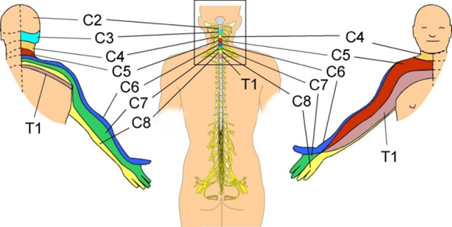
Cervical dermatomes — useful when leg-equivalent symptoms appear in the arm (brachialgia).

Central disc / cauda equina  Often sudden; bilateral leg pain, gait or sphincter disturbance, saddle anaesthesia. Back pain may be absent. Neurosurgical emergency — refer immediately. |  | Nerve-root compression (radiculopathy)  Dermatomal pain / numbness with myotomal weakness or lost reflexes, usually one level. Leg pain > back pain. More than one level → urgent assessment.
Referred myofascial pain  Deep, aching pain in proximal muscle groups (thighs, shoulders). Does not reach hands or feet. Straight-leg raise does not reproduce it. |  | Piriformis syndrome  Sciatica-like pain, worse during or after exercise. Reflexes, power and sensation normal; straight-leg raise negative.

Spinal (canal) stenosis — think of it in the older patient
Narrowing of the canal causes neurogenic claudication: leg pain / numbness / weakness after walking a predictable distance, eased by sitting or leaning forward. Patients often find walking uphill easier than downhill. Always exclude peripheral vascular disease as the cause.

★ THE ONE-MINUTE RECAP — if you remember nothing else
- Sort, don't diagnose. Three groups: simple backache · nerve root (sciatica) · serious pathology.
- Red flags are smoke detectors. Cancer, infection, fracture, inflammatory, cauda equina — never act on a single flag in isolation.
- Cauda equina = same-day emergency. Ask about bladder, bowel, saddle / genital numbness and bilateral leg symptoms — even on the phone.
- Don't scan routinely. MRI findings are common and usually harmless; image only if it will change management.
- NSAID first, not paracetamol; no opioids, benzos, gabapentinoids or antidepressants for back pain or sciatica. Check the BNF.
- Keep them moving, talking positively, and at work. Words and early activity change the outcome.

§ Disclaimer
This document is provided exclusively for education and training as a teaching aid. It does not constitute formal clinical guidance. Clinicians must independently verify all medical information, prescribing guidance, procedural protocols and legal requirements against current national guidance, the BNF, and local policies before applying in practice.

Key sources: NICE NG59 Low back pain and sciatica in over 16s (2016, updated 2020); NICE CKS Sciatica (lumbar radiculopathy) and Back pain; NICE NG12, NG65, CG75; BNF for all prescribing. This teaching aid modernises an earlier Bradford VTS back-pain resource. Verify all content against current national guidance and local pathways before use.

