BRADFORD VTS TEACHING AID
28 June 2026 · GP Specialty Training resource

Reading the Bone Density (DXA) Scan
T-scores and Z-scores made simple — what they mean, and what to do next
This teaching aid is for GP trainees, including International Medical Graduates (IMGs) new to UK practice. All clinical guidance is based on NICE (UK). A short source list is given at the end so every figure can be cross-checked.
⭐ If you only read one thing
A DXA scan gives two numbers. The T-score compares your patient with a healthy 30-year-old and is used to diagnose osteoporosis. The Z-score compares them with people their own age and is used to spot an unexpected, possibly secondary, cause. Remember the two cut-offs: −1 and −2.5.

This lesson at a glance
- What a DXA (DEXA) scan and “BMD” actually measure.
- What a T-score is — with a simple analogy and a memory hook.
- What a Z-score is — and why it is a different question.
- The WHO bands NICE uses: Normal, Osteopenia, Osteoporosis.
- When to read the T-score and when to read the Z-score.
- Worked examples: real scores and what to do next.
- Where the scan fits in the NICE assessment pathway.
- First-line treatment and the safety checks around it (NICE).
- Quick self-test questions to lock it in.

Why this matters
Fragility fractures are common and serious — they cause pain, loss of independence, and in the case of hip fracture, significant mortality. As a GP you will order DXA scans, receive the reports, and decide what to do. Reading the scan confidently means you treat the right people, avoid over-treating the worried-well, and catch the younger patient whose low bone density is a clue to a hidden disease. It is also high-yield for the AKT and a realistic scenario for the SCA.

1 What the scan measures: BMD, DXA and the two scores
🔎 Background: the plain-English version
DXA (or DEXA) stands for dual-energy X-ray absorptiometry. It is a quick, low-dose X-ray scan, usually of the hip and lower spine.
It measures bone mineral density (BMD) — how tightly packed the minerals (mainly calcium) are in the bone. More packing = stronger bone.
The raw BMD number is hard to interpret alone, so the scanner compares it with a reference population and reports the difference as a T-score and a Z-score.

📌 Key learning points
DXA measures bone mineral density (BMD) — bone strength, roughly.
It reports two comparison scores from the same scan: a T-score and a Z-score.
Both are measured in “standard deviations” (steps away from an average) — see the curve below.

A standard deviation, in one picture
Both scores are counted in “standard deviations” (SD). Think of an SD as one step away from the average. A score of 0 is bang on average; −1 is one step below; −2.5 is two-and-a-half steps below. The further left, the weaker the bone compared with the group.
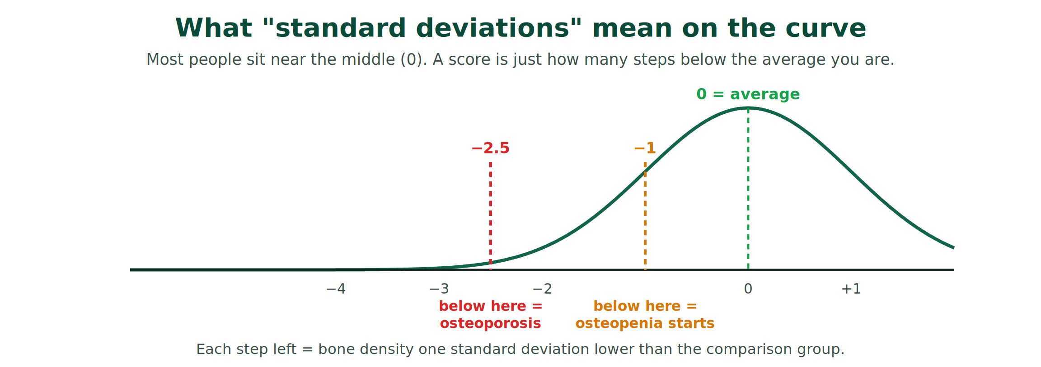
Source: WHO diagnostic categories for BMD, as used by NICE CKS “Osteoporosis – prevention of fragility fractures.”

2 The T-score: your patient versus a healthy 30-year-old
Lead idea: the T-score asks one question — “How does this bone compare with bone at its lifetime best?” The reference is a healthy young adult of the same sex, around age 30, when bone is at peak strength.
🟣 Cross-cultural analogy
Imagine grading a runner against the all-time record for their event. The T-score does the same: it grades today’s bone against the “personal best” a healthy 30-year-old would have. Falling well short of that record is what defines osteoporosis — regardless of how old the patient is now.
🧠 Memory hook
T = THIRTY. The T-score compares your patient with a healthy adult of about thirty.

The T-score scale — three colour-coded zones
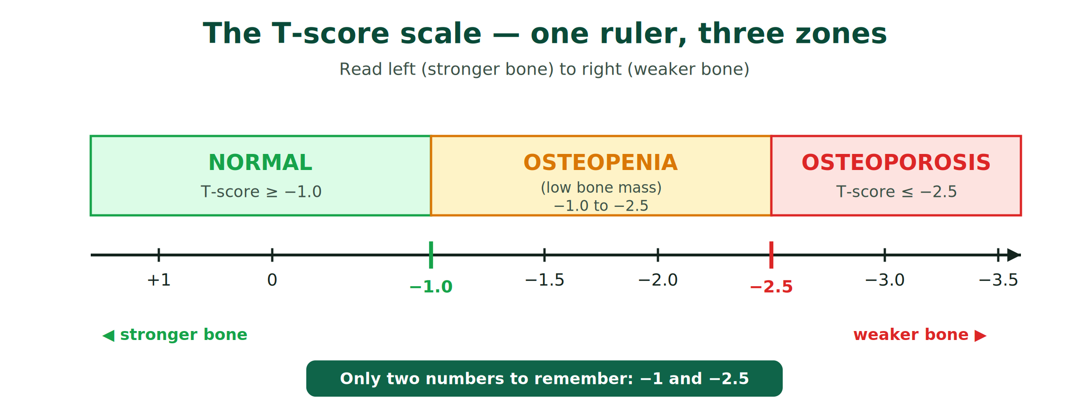
These three bands are the World Health Organization (WHO) categories that NICE uses. Notice you only need two numbers — −1 and −2.5 — to place any T-score.
T-score | What it means | Plain English
−1.0 or higher | Normal bone density | Bone is healthy.
−1.0 to −2.5 | Osteopenia (low bone mass) | Thinner than ideal — a warning zone.
−2.5 or lower | Osteoporosis | Fragile bone — higher fracture risk.
−2.5 or lower + a fragility fracture | Severe (established) osteoporosis | Fragile bone that has already broken.
Source: WHO BMD classification, as applied in NICE CKS “Osteoporosis – prevention of fragility fractures.” A fragility fracture is one from a fall at standing height or less.

📌 Key learning points
The T-score is the number used to DIAGNOSE osteoporosis.
Normal ≥ −1.0 · Osteopenia −1.0 to −2.5 · Osteoporosis ≤ −2.5.
≤ −2.5 plus a fragility fracture = severe (established) osteoporosis.

3 The Z-score: your patient versus their own age group
Lead idea: the Z-score asks a different question — “Is this bone weaker than I would expect for someone this age and sex?” The reference here is people the same age, sex and (usually) ethnicity as your patient.
🟣 Cross-cultural analogy
Think of a school report that compares a child only with their own classmates, not with the cleverest pupil in the school’s history. If a child is far below their classmates, the teacher asks “why is this one different?” The Z-score works the same way: a low Z-score says “this is unusual for the age — look for a reason.”
🧠 Memory hook
Z = your own aZe (age). The Z-score compares your patient with people their own age.
⚠️ Why a low Z-score matters
A Z-score of −2.0 or lower is described as “below the expected range for age.” It does not diagnose osteoporosis — instead it is a flag to look for a secondary cause of bone loss, such as steroid use, early menopause, coeliac disease, hyperthyroidism, hyperparathyroidism, chronic kidney disease, myeloma or excess alcohol.
Source: WHO / ISCD position that a Z-score ≤ −2.0 is “below the expected range for age,” consistent with NICE CKS guidance to consider underlying causes in younger patients.

📌 Key learning points
The Z-score is age-matched — it asks whether bone loss is more than expected for that age.
Z ≤ −2.0 = “below the expected range for age” → hunt for a secondary cause.
The Z-score INVESTIGATES; it does not, by itself, diagnose osteoporosis.

4 T versus Z: same scan, two different comparisons
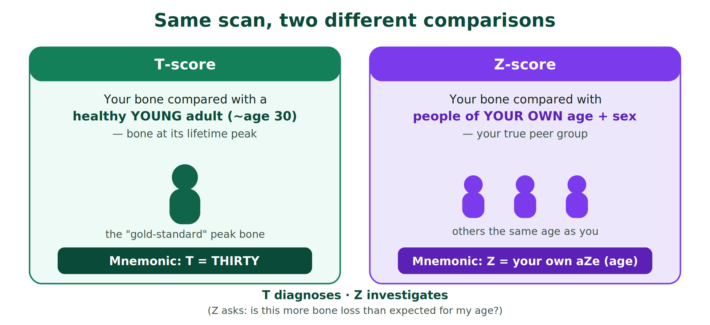
 | T-score | Z-score
Compared with | A healthy young adult (~30), same sex | People of the same age, sex (and ethnicity)
Main question | Has bone fallen below its lifetime peak? | Is bone weaker than expected for this age?
Used to | Diagnose osteoporosis | Flag a secondary cause
Key number | ≤ −2.5 = osteoporosis | ≤ −2.0 = below expected for age

Which score do I read? It depends on the patient
Patient group | Read this score | Why
Postmenopausal women & men aged ≥ 50 | T-score | Comparing with peak bone is meaningful and guides treatment.
Premenopausal women, men < 50 | Z-score | A young person should not be judged against a 30-year-old peak; a low Z-score prompts a search for a cause.
Children & adolescents | Z-score | Bones are still growing — only an age-matched comparison makes sense.
Source: WHO / ISCD reporting conventions, consistent with NICE CKS “Osteoporosis – prevention of fragility fractures.”

📌 Key learning points
Both scores appear on every report — choose the right one for the patient.
T-score for postmenopausal women and men ≥ 50.
Z-score for younger adults and children — and always look for a secondary cause if it is low.

5 Worked examples: reading the score and deciding what to do
Now we apply it. For each example, decide the band first, then the next step. The “next step” follows the NICE pathway shown in Section 6.
Example 1
Patient: 68-year-old woman, no fractures, on a routine scan after a FRAX score near the treatment threshold.
Score: Femoral neck T-score −1.3 (Z-score −0.2).
Reading: Osteopenia (low bone mass).
What to do next: Put the T-score back into FRAX and recalculate. Treat only if the recalculated risk crosses the local/NOGG intervention threshold; otherwise give lifestyle advice and plan a review.

Example 2
Patient: 74-year-old man with a recent low-trauma wrist fracture.
Score: Spine T-score −2.7 (Z-score −1.1).
Reading: Osteoporosis — and, with the fracture, established (severe) osteoporosis.
What to do next: Offer treatment: first-line oral bisphosphonate if suitable. Check calcium and vitamin D, address falls risk, and screen for secondary causes.

Example 3
Patient: 70-year-old woman, fully fit, scan done as part of risk assessment.
Score: T-score −0.4 (Z-score +0.6).
Reading: Normal.
What to do next: No drug treatment for bone density. Give lifestyle advice (weight-bearing exercise, adequate calcium and vitamin D, stop smoking, reduce alcohol) and re-assess risk in future.

Example 4
Patient: 34-year-old woman with no obvious risk factors, scanned after two low-trauma fractures.
Score: Z-score −2.4 (a T-score may also be quoted but is not the right tool here).
Reading: “Below the expected range for age” — a red flag, not a label of osteoporosis.
What to do next: In a young patient, use the Z-score. Investigate for a secondary cause (steroids, coeliac disease, early menopause, thyroid/parathyroid disease, CKD, myeloma, alcohol) and consider specialist referral.

📌 Key learning points
Band the score first, then act — the score never decides treatment on its own.
In older patients, the T-score sits inside a FRAX/QFracture risk decision.
A low Z-score in a young patient means investigate, not simply treat.

6 Where the scan fits: the NICE pathway
A common trap is to scan first and ask questions later. NICE works the other way round: you estimate fracture risk first, and the DXA scan is used to sharpen the decision — not to start it.
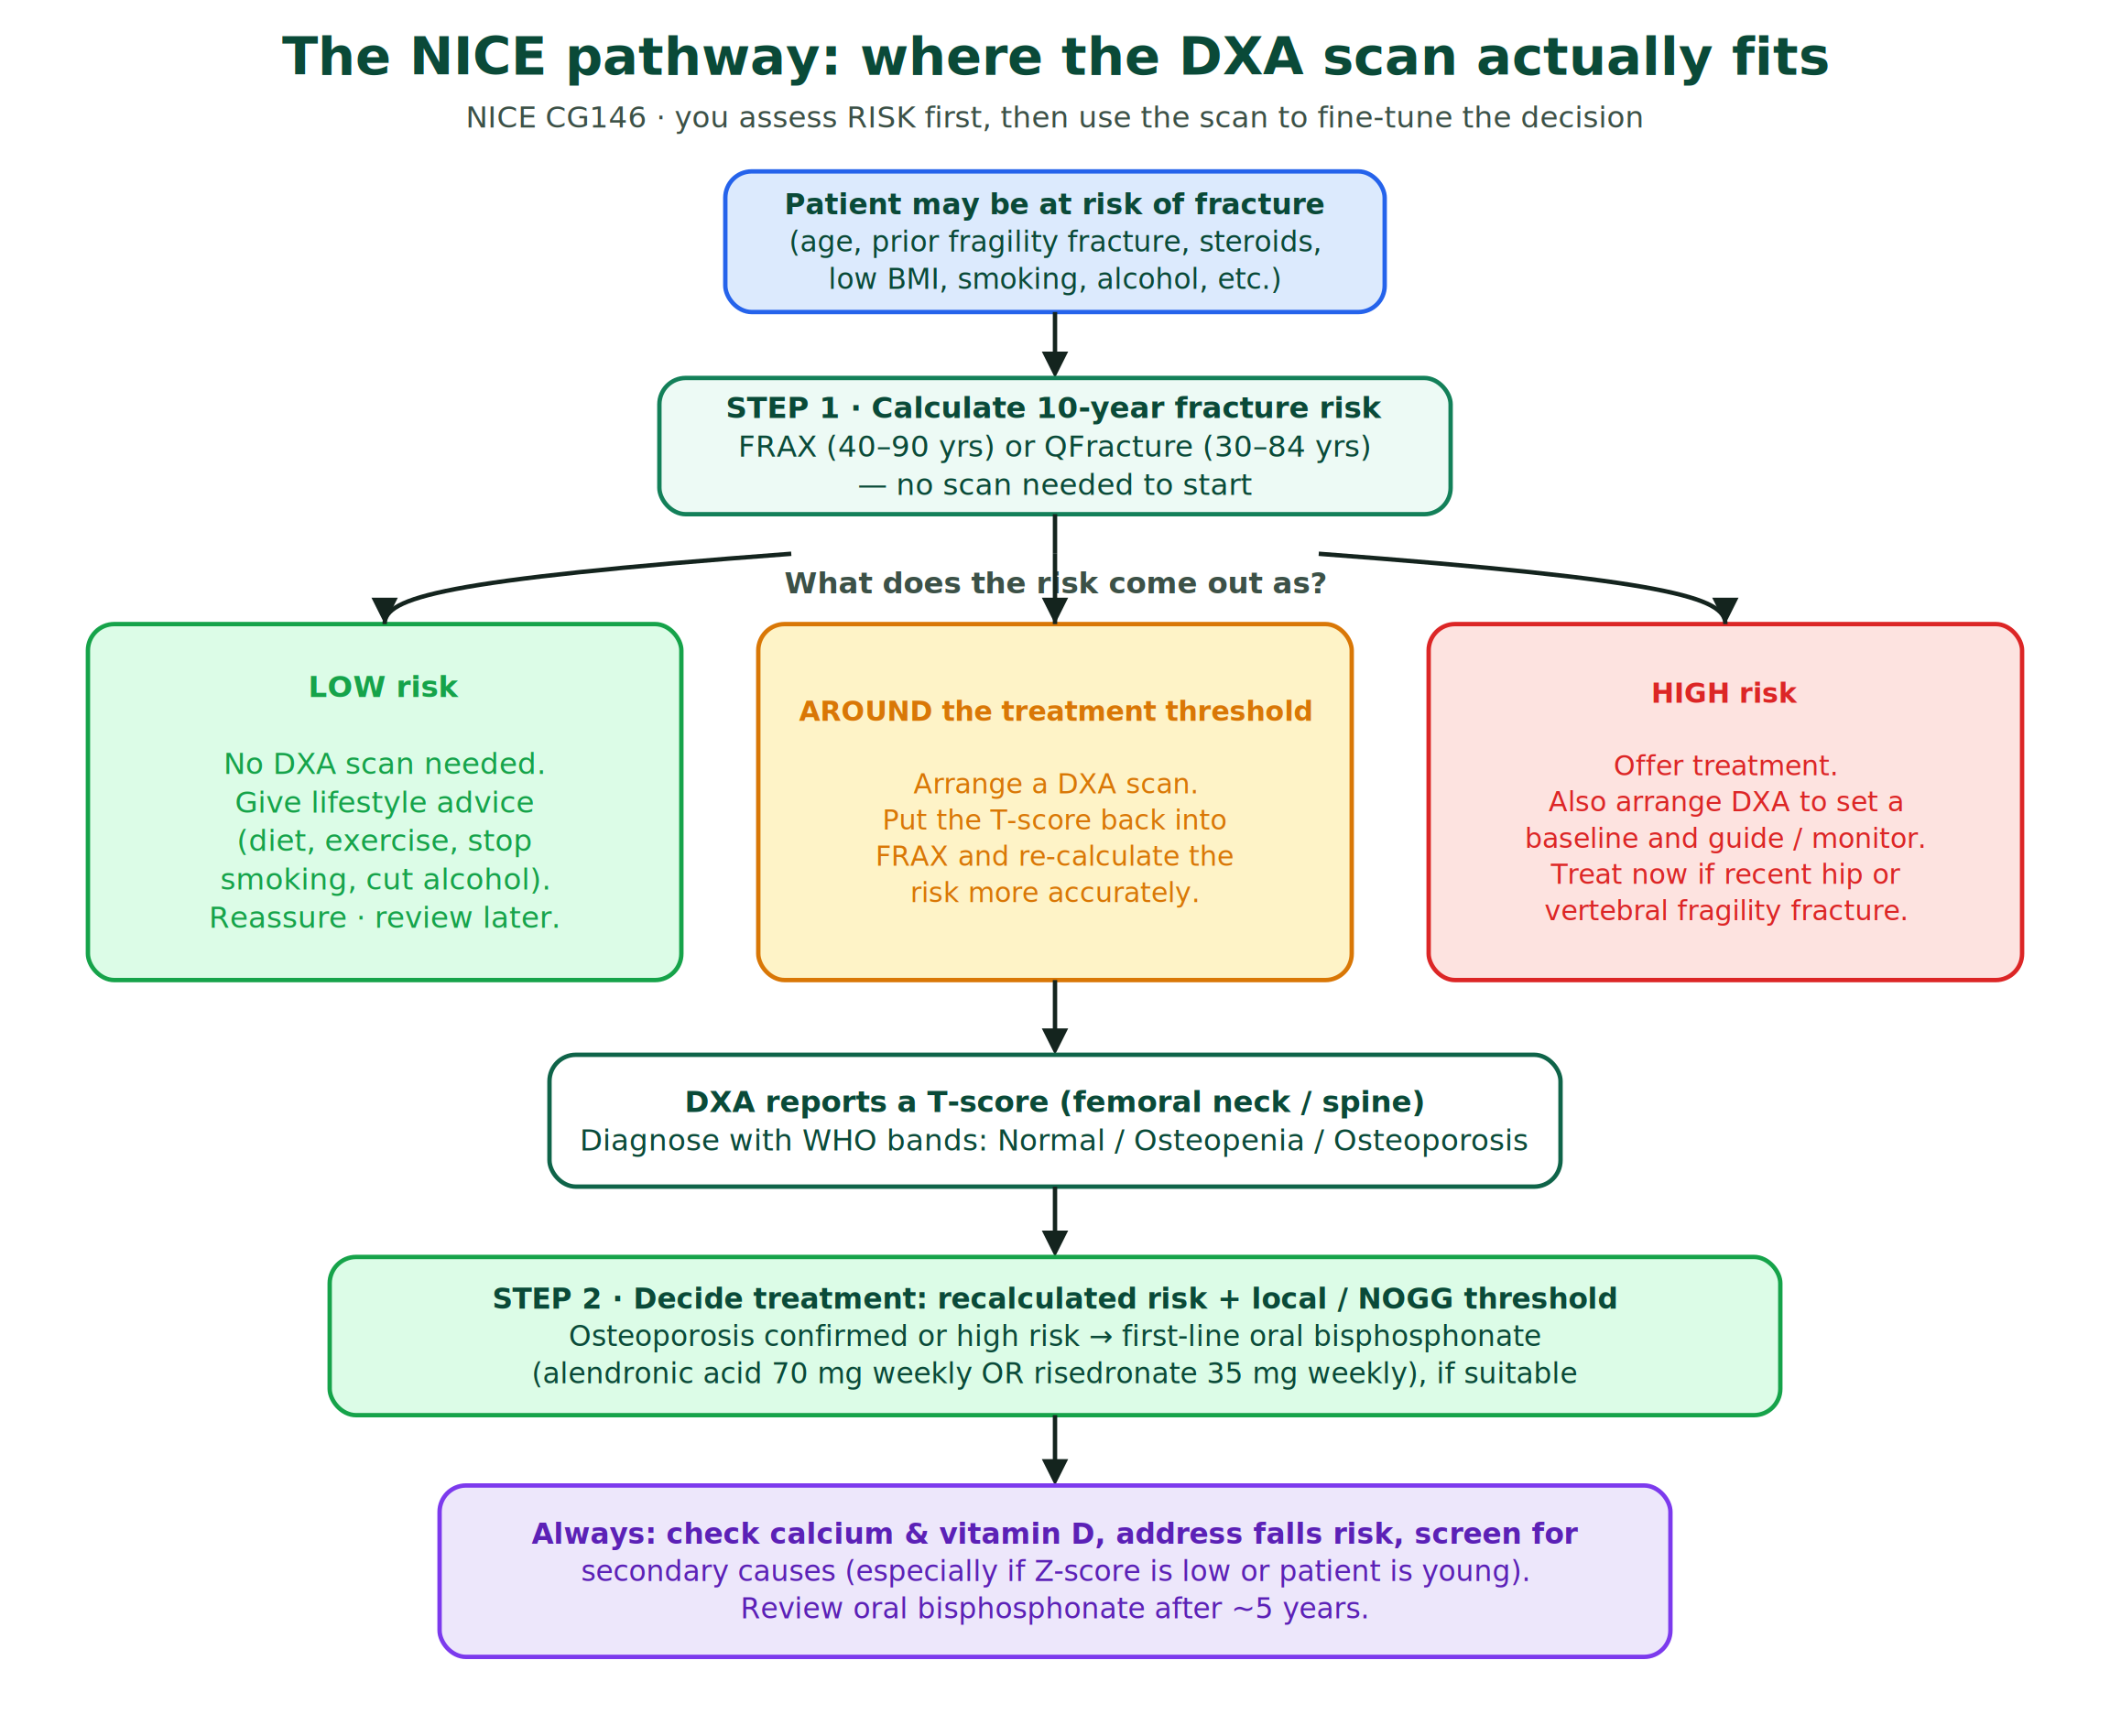
🟦 The rules that surround the scan (NICE CG146)
Estimate 10-year fracture risk with FRAX (ages 40–90) or QFracture (ages 30–84) before arranging a scan.
Do not routinely measure BMD without a prior FRAX/QFracture assessment.
Arrange DXA when the risk sits around the intervention threshold, then recalculate FRAX with the BMD value.
NICE does not set the intervention threshold itself — follow your local / NOGG guidance.
Do not routinely assess risk under 50 unless there are major risk factors (e.g. steroids, early menopause, previous fragility fracture). In people under 40, measure BMD to assess risk where indicated.
Source: NICE CG146 “Osteoporosis: assessing the risk of fragility fracture” (recommendations 1.4–1.7); NICE Quality Standard QS149.

7 What to do next: first-line treatment and safety checks
Once risk and BMD point to treatment, the NICE-based steps are straightforward. Always pair the drug with the surrounding safety checks.
✅ The correct approach (NICE)
First-line: an oral bisphosphonate if suitable — alendronic acid 70 mg once weekly or risedronate sodium 35 mg once weekly.
Counsel on administration: take on an empty stomach with a full glass of plain water, stay upright for at least 30 minutes, and wait before food or other drinks.
Treat without delay after a hip or vertebral fragility fracture, alongside falls prevention.
Always check calcium and vitamin D status and correct deficiency; address falls risk.
Review the need to continue an oral bisphosphonate after about 5 years (a “drug holiday” may be considered in lower-risk patients, per local protocol).
Source: NICE TA464 “Bisphosphonates for treating osteoporosis”; NICE Quality Standard QS149 (long-term review); doses confirmed against the BNF. Choice and dosing must follow your local formulary and check renal function and contraindications.
🛑 Common mistakes to avoid
Treating an isolated osteopenic T-score without recalculating fracture risk.
Scanning before doing a FRAX/QFracture assessment.
Reading the T-score in a young patient instead of the Z-score.
Seeing a low Z-score and starting a bisphosphonate without looking for a secondary cause.
Forgetting calcium/vitamin D status and falls risk.
💬 A phrase you can use with patients
“The scan compares your bones in two ways — against a healthy young adult, and against people your own age. That tells us both how strong your bones are now and whether anything unusual is going on. Let’s talk about what we can do to keep them strong.”

8 Quick self-test: cover the answers and try first
Q1. A T-score of −2.5 or lower means…
Answer: Osteoporosis. With a fragility fracture, it is severe (established) osteoporosis.

Q2. Which score do you read for a 40-year-old premenopausal woman?
Answer: The Z-score — and if it is ≤ −2.0, look for a secondary cause.

Q3. True or false: you should arrange a DXA scan before doing a FRAX or QFracture assessment.
Answer: False. NICE says assess fracture risk first; arrange DXA when the risk is around the intervention threshold.

Q4. What does a T-score of −1.4 represent, and what is the next step?
Answer: Osteopenia. Recalculate FRAX with the BMD value and act on the recalculated risk against the local/NOGG threshold.

Q5. First-line drug treatment for osteoporosis on the NICE pathway?
Answer: An oral bisphosphonate if suitable — alendronic acid 70 mg weekly or risedronate 35 mg weekly — with calcium/vitamin D checks and falls assessment.

Take-home points
📌 The whole lesson in nine lines
DXA measures bone density (BMD) and reports two scores from one scan.
T = THIRTY: compared with a healthy young adult; used to DIAGNOSE.
Z = your own aZe: compared with same-age peers; used to INVESTIGATE.
T-score bands: Normal ≥ −1 · Osteopenia −1 to −2.5 · Osteoporosis ≤ −2.5.
≤ −2.5 plus a fragility fracture = severe osteoporosis.
Z ≤ −2.0 = below expected for age → look for a secondary cause.
Use the T-score for older adults; the Z-score for younger patients and children.
Assess risk with FRAX/QFracture first; the scan sharpens the decision.
First-line treatment is an oral bisphosphonate, with calcium/vitamin D and falls checks.

⭐ One sentence to keep
T-score diagnoses (versus a 30-year-old), Z-score investigates (versus your own age) — and the two numbers that matter are −1 and −2.5.

Sources (NICE-based)
- NICE CKS. Osteoporosis – prevention of fragility fractures (WHO BMD categories; risk assessment).
- NICE CG146. Osteoporosis: assessing the risk of fragility fracture (FRAX/QFracture; when to measure BMD with DXA; recommendations 1.4–1.7).
- NICE Quality Standard QS149. Osteoporosis (risk assessment and long-term review).
- NICE TA464. Bisphosphonates for treating osteoporosis (first-line treatment options).
- BNF. Alendronic acid and risedronate sodium (doses, administration advice).
- WHO / ISCD reporting conventions for T-scores and Z-scores (which score to use, and the “below expected range for age” cut-off).

Always check the current NICE guidance and your local formulary before prescribing. This aid summarises principles for teaching; it does not replace the full guidance.

