BRADFORD VTS TEACHING AIDS
Musculoskeletal Medicine for General Practice
Assessment of
Acute Knee Pain
A practical, evidence-based guide for GPs and GP registrars
THE ONE RULE TO REMEMBER
The history makes the diagnosis.
The examination only confirms it — it can never rule it out.
Updated and verified against current UK guidance • June 2026
NICE CKS · Ottawa Knee Rules · NHS specialist guidance

How to use this guide
Most GP consultations last 10–15 minutes. That is not long enough to perform every special knee test — and even in expert hands, many of those tests are unreliable. So this guide does something different. It teaches you to reach a safe working diagnosis mainly from the story the patient tells you, and to know exactly who needs referring and how quickly.
It works in two layers. First, learn the patterns — three classic pictures that cover most acute knee problems you will meet. Then, when you need the detail, the later sections give you the deeper clinical picture for each condition, the cases to cement it, and a clear referral map.
What you will be able to do after reading this
- Sort most acute knee injuries into one of a few clear patterns — fast.
- Ask the handful of history questions that actually change your diagnosis.
- Decide confidently when a knee needs an X-ray, using the Ottawa Knee Rules.
- Examine the knee in a simple, structured way — and know which signs to trust.
- Refer the right patient, to the right place, at the right speed.

1 | Start Here — The Big Picture

Before any tests or special manoeuvres, hold three simple ideas in your head. They shape everything that follows.
Three facts about the knee
- It is the largest joint in the body — and one of the most commonly injured, especially in sport.
- It has almost no bony stability. The bones barely lock together, so the ligaments and menisci do nearly all the work of holding it together.
- Because soft tissue does the work, the most important injuries are soft-tissue injuries — and these often do not show up on an X-ray.
The golden rule: listen first
A good history gives you most of the diagnosis. As a rough guide, the story tells you roughly 70–80% of what you need to know. The examination usually adds only the final 10–20% — it confirms your idea, but rarely overturns it.
Why this matters so much
In a swollen, painful, freshly injured knee, the muscles guard the joint and will not relax. This makes many examination tests impossible to perform — and easy to misread.
So if the examination is unhelpful, that is normal. Trust the history.

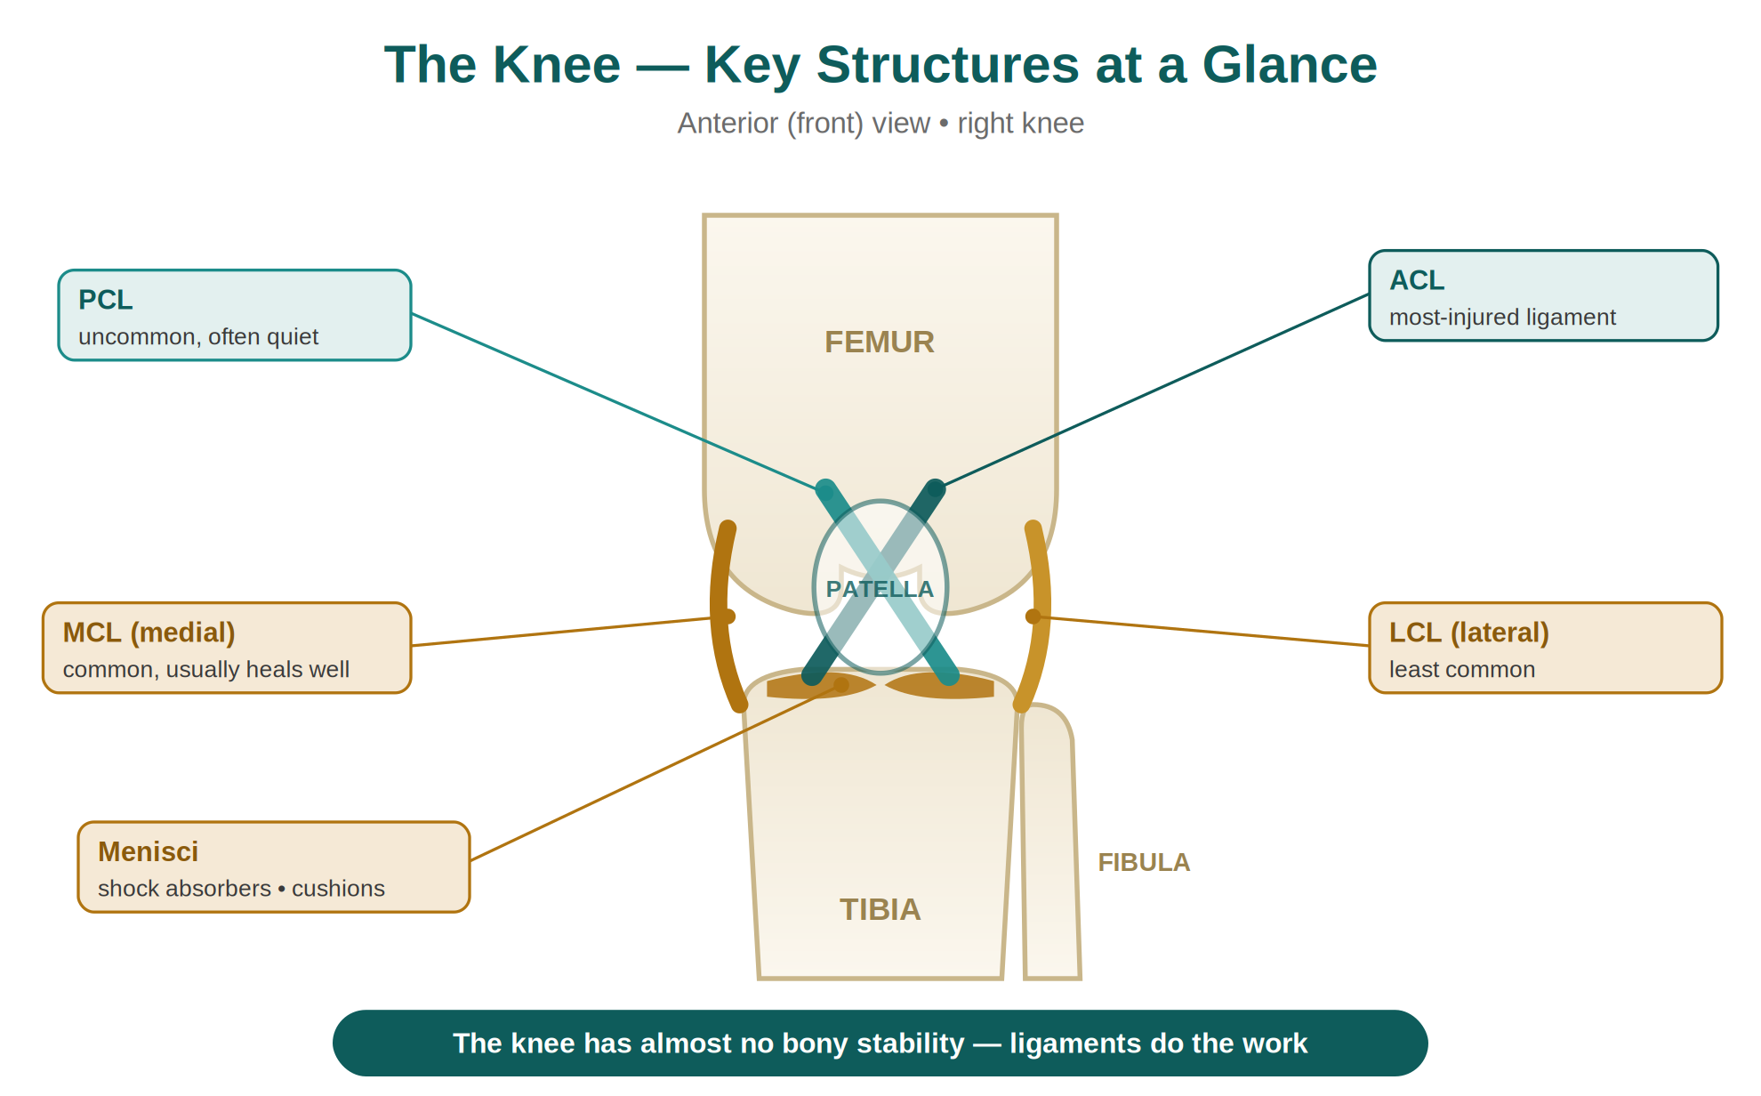
Figure — The key stabilising structures of the knee. With little bony support, the ligaments and menisci are what keep the joint stable.

A cautionary tale you must not repeat
Some serious knee injuries — the anterior cruciate ligament (ACL) rupture above all — are missed again and again. Studies have shown that ACL injuries are often diagnosed many months after they happen, and frequently not by the first clinician the patient sees. The usual reason is simple: the knee looked normal on examination, so the worrying history was ignored.
The mistake to avoid
A normal-looking knee does NOT cancel a worrying story. If the history sounds serious, act on the history — even when you can find nothing on examination.

2 | The Common Problems — Learn the Patterns

Four problems make up most acute and sub-acute knee presentations in general practice: ACL rupture, meniscal tears, patellofemoral pain, and osteoarthritis. This guide focuses on the first three — the ones where getting the assessment right early really changes outcomes.
Here is the trick that makes them easy to remember. Picture each one as a road traffic accident of a different size. The bigger the “crash”, the more dramatic the symptoms — and the more obvious the signs.

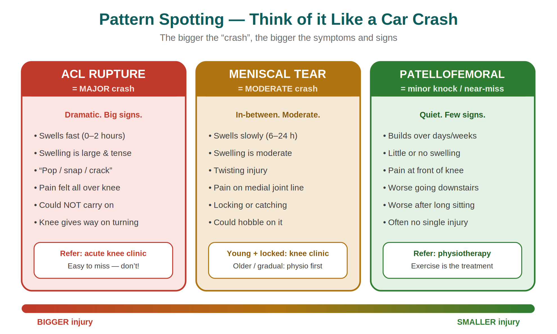
Figure — The car-crash analogy: match the size of the story to the size of the injury.

Read the patterns as a whole, not piece by piece
No single symptom proves a diagnosis. It is the combination — speed of swelling, the sound, the pain site, what they could do afterwards — that points you to the answer.

The three patterns at a glance
 | ACL rupture | Meniscal tear | Patellofemoral pain
Size of “crash” | Major | Moderate | Minor / near-miss
Onset | Seconds — dramatic | Sudden, with a twist | Gradual, over days–weeks
Swelling | Fast (0–2 h), large, tense | Slower (6–24 h), moderate | Little or none
Tell-tale sound | “Pop / snap / crack” | Sometimes a click | None
Pain site | All over the knee | Medial joint line | Front of the knee
Could they continue? | No — had to stop | Hobbled on | Yes, but it aches
Classic extra clue | Gives way on turning | Locking / catching | Worse downstairs & after sitting

3 | The 10-Minute History — Your Most Powerful Tool

This is the engine room of the whole assessment. Ask these questions well and the diagnosis usually falls into your lap.
Start with the mechanism — but do not rely on it
Common settings are football, rugby, hockey and skiing, plus road traffic accidents. It is worth asking how the injury happened. But be realistic: in the heat of a game, most people genuinely cannot recall the exact movement. Do not waste the consultation chasing it.
Instead, ask about a few specific things that patients can usually remember. These are the questions that move the diagnosis.
The 6 S’s of the acute knee history
Sound — a “pop”, “snap” or “crack” as it went? → think ACL.
Swelling — how fast did it swell? (the single most useful clue — see below)
Stop or stay on — could they carry on, hobble, or not move at all?
Stability — does it give way? On turning especially → think ACL.
Stuck — does it lock or catch? → think meniscus.
Site — where exactly is the pain? (medial, lateral, or front)
Swelling: the clock tells the story
How quickly the knee swelled is one of your most powerful clues. The speed points to what is inside the joint.
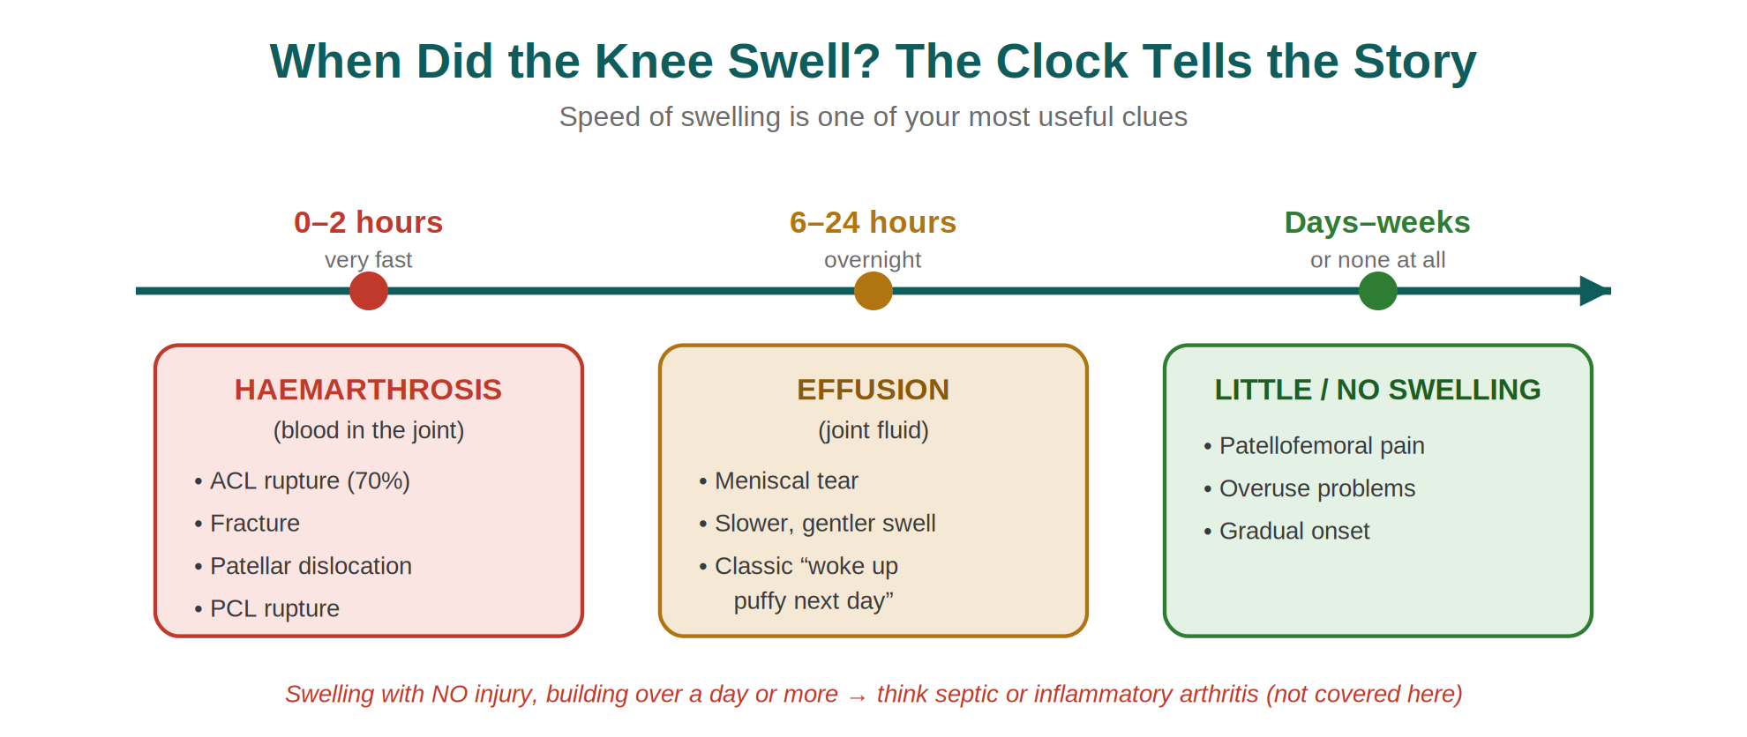
Figure — Speed of swelling. Fast = blood (serious); overnight = fluid; slow or none = an overuse problem.
In plain terms
- Swells within 0–2 hours, large and tense → blood in the joint (haemarthrosis). Around 70% of these are an ACL rupture; also think fracture, patellar dislocation or PCL rupture.
- Swells overnight (about 6–24 hours), moderate → joint fluid (an effusion). Classic for a meniscal tear.
- Little or no swelling, coming on over days → think patellofemoral or overuse pain.
Pain site — a quick map
Where is the pain? | What it suggests
Medial or lateral (the joint line) | Ligament or meniscus injury
Front of the knee (anterior) | Patellofemoral pain
All over the knee | Usually a large, tense effusion (e.g. after ACL rupture)
Two pairs of words worth getting right
Locking vs pseudo-locking
True locking — the knee gets stuck and cannot be straightened. Suggests a loose body, often a torn piece of meniscus. Needs a look inside.
Pseudo-locking — the knee cannot be bent comfortably because of anterior pain. Points to a patellofemoral problem, not a loose body.
Giving way — two kinds
Partial / reflex — anterior pain switches off the quadriceps for a moment, so the knee dips. Common and less worrying.
Complete collapse — especially when turning. This is an unstable knee, and means ACL injury until proven otherwise.
Do not forget
Always keep these in mind
- Referred pain from the hip can present as knee pain — examine the hip if the knee seems normal. This is especially true in children.
- A hot, red, swollen knee with no clear injury, or someone who is systemically unwell, may have septic or inflammatory arthritis — a different, urgent pathway.
- Night pain, rest pain or weight loss are red flags that need separate thought.

4 | When to X-ray — The Ottawa Knee Rules

Not every injured knee needs an X-ray. The Ottawa Knee Rules are a simple, well-validated way to decide who does — sparing patients unnecessary radiation and keeping imaging for those who need it.
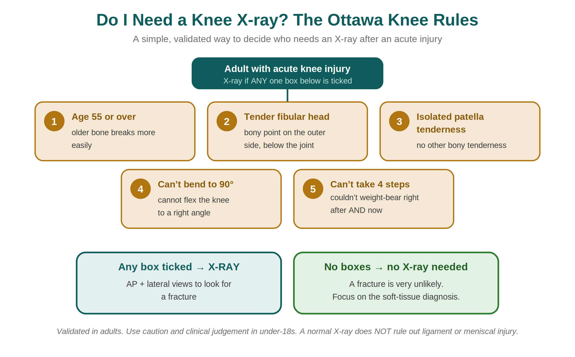
Figure — The Ottawa Knee Rules: X-ray if any one criterion is present.
How to use them
In an adult with an acute knee injury, request an X-ray if ANY ONE of the five criteria is present. If none is present, a fracture is very unlikely and you can focus on the soft-tissue diagnosis.
The rules are very good at not missing fractures. They are designed to be safe, not precise — so some people who meet the rules will have a normal X-ray, and that is expected.
Two cautions
- The rules are validated in adults. Use extra care and clinical judgement in under-18s.
- A normal X-ray does NOT rule out an ACL, meniscal or other soft-tissue injury. Keep trusting the history.

5 | The Focused Examination — Look, Feel, Move

Keep the examination simple and structured. Start the moment the patient walks in, and always compare the injured knee with the good one.
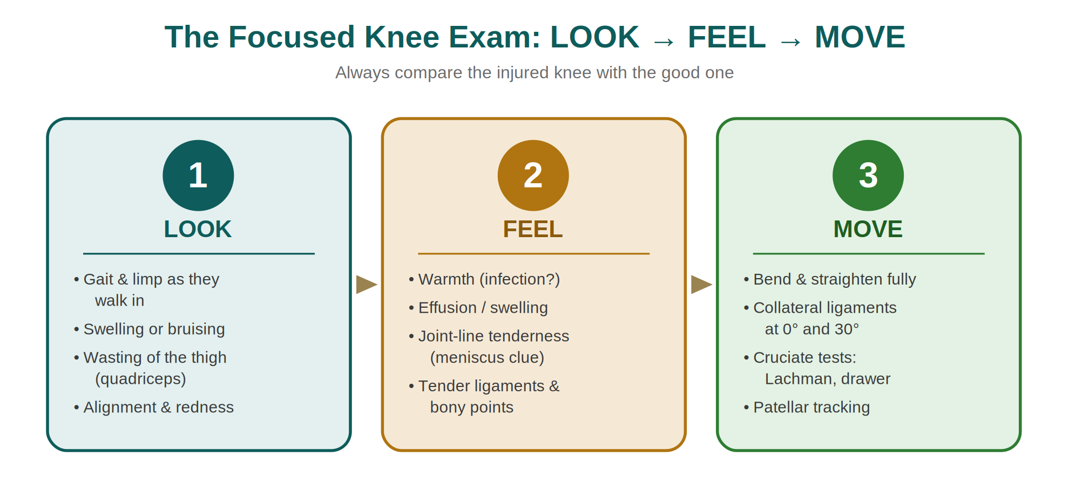
Figure — A simple, repeatable structure: Look, then Feel, then Move.
Be honest about what the tests can and cannot do
The special ligament tests — Lachman’s test and the pivot-shift test for the ACL, and the drawer tests — are genuinely difficult. They need an experienced examiner and a relaxed patient. In a sore, swollen, freshly injured knee the muscles will not relax enough for a reliable result.
Most GPs — and most A&E doctors — do not perform these reliably
That is not a criticism. You need to use these tests almost daily to develop the feel for them. So expect to find either a few soft signs or nothing at all — and let the history lead.
Note: McMurray’s test for the meniscus is no longer recommended in UK practice because its diagnostic accuracy is poor. Medial joint-line tenderness plus a good history is far more useful.
The one sign you must never ignore
An effusion always means joint disease
A genuine effusion is never normal. Even if you can find nothing else, a swollen joint tells you something real has happened inside the knee — take it seriously and follow the history.

What each step looks for
Step |  | Look / feel / test for
LOOK |  | Gait and limp on entry; swelling, bruising or redness; wasting of the quadriceps; alignment (varus/valgus).
FEEL |  | Warmth (infection?); an effusion; tenderness — especially the joint line (meniscus) and over the ligaments and bony points.
MOVE |  | Full bend and straighten; collateral ligaments at 0° and 30°; cruciate tests if able; patellar tracking and crepitus.
A useful examination detail
Test the collateral ligaments both fully straight (at 0°) and at 30° of flexion. Looseness when fully straight suggests major damage — more than just the collateral ligament. Looseness only at 30° points to an isolated collateral ligament injury.

6 | The Conditions Up Close

Now the detail. Each condition below builds on the patterns you have already learned — so you are filling in a picture, not starting from scratch.
6.1 Anterior cruciate ligament (ACL) rupture
This is the big one — the most commonly injured knee ligament, and the one most often missed. Get into the habit of thinking of it whenever the story fits.
What the ACL does
Like all ligaments, the ACL has two jobs. The obvious one is stability — it controls the small amount of rotation in the knee and stops the tibia sliding forward. The less obvious one is proprioception: it helps the brain sense where the joint is in space. When the ACL is gone, the knee tends to collapse as the person turns — and that proprioceptive loss is part of why rehabilitation is so important.
The classic ACL story
- A dynamic injury — happened at speed, often with a twist or awkward landing.
- A “pop”, “snap” or “crack”, with a moment of severe pain.
- Could not carry on — often helped off the pitch.
- Rapid, large swelling within a couple of hours (haemarthrosis).
- Later, the knee gives way — especially on turning.
What happens if it is missed?
That depends on the person’s demands. The risk of an unstable knee is repeated giving way, and each episode can cause further damage — torn menisci are a common way a missed ACL finally reaches orthopaedic attention. Over the long term, an ACL-deficient knee is more likely to develop early osteoarthritis.
How it is managed today
Modern ACL management — verified against current UK practice
- Surgery is NOT automatic. Management is individualised between structured rehabilitation and surgical reconstruction.
- Many people — especially those not doing pivoting sport — do well with intensive, physiotherapy-led rehabilitation that builds hamstring and quadriceps control and retrains proprioception.
- Reconstruction tends to be offered to those with ongoing instability despite rehab, or whose work or sport depends on a stable, pivoting knee.
- When reconstruction is done, the graft is usually taken from the patient’s own hamstring tendons (semitendinosus ± gracilis) or the patellar tendon. There is no single “gold-standard” graft — the choice is individualised.
- Whatever the route, rehabilitation is the part that determines the result.
The bottom line on ACL
For an elite athlete this can be a career-defining injury. For everyone else it can still cause real, lasting limitation and early joint damage. If the story fits — refer. Do not let a normal-looking knee talk you out of it.

6.2 Posterior cruciate ligament (PCL) rupture
The PCL is injured far less often than the ACL, and the consequences are usually less dramatic. It is hurt either by forced hyperextension or — more often — a direct blow to the front of the shin with the knee bent. Classic settings are the dashboard in a head-on car crash, and contact sport.
Why the PCL is easy to miss
- Once the initial injury settles, it can be almost silent.
- Symptoms, if any, are vague: a dull ache, sometimes anterior (patellofemoral) pain, occasionally a sense of giving way.
- It is less important for everyday stability than the ACL, so the knee often copes surprisingly well.
Management is usually conservative, focused on building the quadriceps, which help provide front-to-back stability. As with the ACL, the long-term concern is early degenerative change.
6.3 Medial collateral ligament (MCL) injury
The MCL is a commonly injured single ligament. The typical story is a valgus force (a blow to the outside that pushes the knee inward) on a partly bent knee — again, contact sport and downhill skiing are classic. A helpful clue: MCL tenderness is over the medial femoral condyle, not the joint line. Joint-line tenderness points to the meniscus instead.
Grading the injury
Grade |  | What you find | Laxity on valgus stress at 30°
Grade 1 |  | Medial pain and tenderness over the medial femoral condyle | Pain, but NO laxity
Grade 2 |  | Some swelling over the condyle; pain on stressing | Pain WITH some laxity
Grade 3 |  | Complete tear; a “wobbly” feeling; sometimes little pain | Gross laxity
Good news on the MCL
The outlook is excellent — much better than the ACL. Conservative treatment with early mobilisation and rehabilitation works just as well as surgery at any grade. A brace that still allows movement may help the more unstable injuries.
Early mobilisation matters: it prevents the stiffness and rapid muscle loss that knee injuries otherwise cause.
6.4 Lateral collateral ligament (LCL) injury
The LCL is the least commonly injured of the four ligaments. It takes a varus force (a blow to the inside pushing the knee outward), which is simply less common in sport. Grading and management mirror the MCL. One examination tip: relax the iliotibial tract by abducting the hip before testing the LCL.

6.5 Meniscal injury
The menisci are crescent-shaped cartilage pads that cushion the joint, spread load and add stability. They matter — which is why modern surgery tries hard to preserve them.
The classic meniscal story
- A twisting injury, often on a bent and loaded knee (think turning to cross a ball).
- Pain on the medial joint line.
- Swelling that comes on slowly — typically overnight (an effusion).
- Locking, catching or a sense of giving way.
- Could usually hobble on it afterwards.
Traumatic vs degenerate — a key modern distinction
Acute, traumatic tear (often younger patients): a clear twisting injury, locking or a young patient with a true mechanical block → refer to the acute knee clinic. Tears in the outer rim have a blood supply and may be repaired if caught early; central tears may need a small trim. Complete removal of a meniscus is now avoided wherever possible.
Degenerate tear (often older patients): a gradual onset with little or no clear injury — pain after activities like gardening or squatting, then swelling the next day. Current UK guidance is to manage these conservatively first, with physiotherapy and exercise, and reassess. Do not send these straight to the acute knee clinic; refer if symptoms persist despite rehabilitation.
Why we no longer “just take it out”
Many former athletes who had whole menisci removed decades ago now have early osteoarthritis. We now know how important the menisci are — so the modern aim is to repair or preserve, not remove.
6.6 Patellofemoral pain
This is the gentlest of the patterns — the “near-miss” — but it is very common and worth recognising. It is non-specific pain at the front of the knee, from the way the kneecap (patella) loads against the femur.
Who gets it and how it feels
- Most common in adolescents and active young to middle-aged adults; more common in females.
- Often no single injury — it builds with overuse, such as taking up running or hill-walking.
- Pain at the front of the knee, worse going DOWN stairs or downhill (patients often say they must rest going down, not up).
- Worse with prolonged knee bending — squatting, crouching, driving, or a long sit at the cinema (the “cinema sign”).
- Little or no swelling.
How it is managed
- Exercise is the treatment. Physiotherapy-led, progressive strengthening of the quadriceps and hip muscles is first-line and the most effective approach.
- Activity and load modification, plus clear explanation and reassurance, are central — especially in adolescents.
- Patellar taping may be used by physiotherapists as a short-term adjunct, but it is not a stand-alone fix.
- Refer to physiotherapy rather than to surgery.

7 | Investigations & Referral

Keep investigations purposeful and refer with a clear question in mind.
Investigations
Test |  | When and why
X-ray (AP + lateral) |  | Use the Ottawa Knee Rules to decide. Looks for a fracture — not for soft-tissue injury.
MRI |  | The imaging of choice for ligament and meniscal injury, but arranged as part of specialist assessment — not a routine first-line GP test.
Blood tests |  | Consider if infection or inflammatory/crystal arthritis is possible (e.g. FBC/CRP, urate). Not routine for a clear sports injury.
Joint aspiration |  | Mainly a secondary-care procedure, under strict aseptic technique. Send fluid for microscopy and culture if infection is suspected.
Two safety points on imaging
- A normal X-ray reassures you about bone only. It says nothing about the ACL or menisci.
- Swelling with no injury that builds over a day or more — think septic or inflammatory arthritis and act urgently.
Referral — who goes where
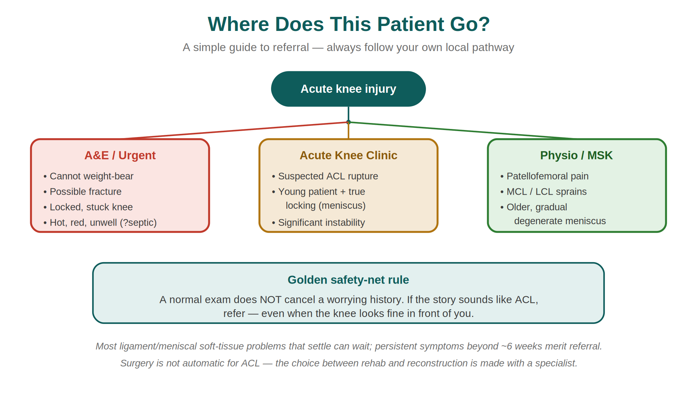
Figure — A simple referral map. Always follow your own local pathway.
Rough urgency guide
- Urgent / A&E: cannot weight-bear, possible fracture, a truly locked knee, or a hot, unwell patient (?septic).
- Acute knee clinic: suspected ACL rupture, a young patient with true locking, or significant instability.
- Physiotherapy / MSK: patellofemoral pain, collateral ligament sprains, and older patients with degenerate meniscal symptoms.
- Soft-tissue problems that settle can be watched; persistent symptoms beyond about six weeks merit referral.

8 | Two Teaching Cases — Bring It Together

These two stories are worth committing to memory. Read each one, decide what you think before the answer, and notice how the history alone gives the diagnosis.
Case 1 — Sally, a 25-year-old hockey player

One month ago, running at speed in a match, Sally was tackled. She fell, felt a moment of severe pain in her right knee, and heard a loud crack. She was helped off the pitch. After the match the knee had swollen a lot, so a friend took her to A&E. The X-ray was normal. The knee was bandaged, settled over a week, and she went back to walking normally. Last night, at her first training session, the knee gave way as she went into a tackle and she fell. Overnight it swelled again — more slowly this time.
The features that matter
- A dynamic injury, at speed.
- A moment of severe pain with a “crack”.
- Could not continue.
- Rapid swelling at the time (a haemarthrosis).
- A normal X-ray — and no follow-up.
- A month later, the knee gives way; then a slower, overnight swelling.
Diagnosis until proven otherwise: ACL rupture
This is the classic late presentation of a missed ACL injury, with a secondary meniscal injury at the moment of giving way. Whatever you do or do not find on examination, this knee needs a knee specialist. Between the two swelling episodes you may find only some quadriceps wasting and little else — and that must not reassure you.

Case 2 — a 35-year-old man, Monday-morning surgery

He played football yesterday. As he turned to cross the ball, he felt severe pain on the inside of his left knee and collapsed. For a while the knee felt stuck and he could not stand. It then “unlocked” and he managed to hobble around. Later in the day it began to swell, and overnight it swelled considerably.
The features that matter
- A twisting injury on a bent knee.
- Severe medial knee pain.
- The knee locked for a time.
- Slow, overnight swelling (an effusion).
- Could hobble afterwards.
Diagnosis: medial meniscal tear
A knee that truly locks suggests a loose body — here, very likely a torn flap of medial meniscus. On examination you may find only the effusion and medial joint-line tenderness. Refer to the acute knee clinic: caught early, some meniscal tears can be repaired with good results.
A saying worth remembering
Among sports clinicians there is a phrase: football is not so much a sport as a knee disease. Many activities injure the knee, but football provides more than its share.

9 | Remember This — Key Takeaways

If you remember nothing else, remember these.
The five golden points
- The history makes the diagnosis. The examination only confirms it.
- A normal-looking knee never cancels a worrying story. If it sounds like an ACL, refer.
- Speed of swelling is your best single clue: fast = blood (serious); overnight = fluid (meniscus); slow/none = overuse.
- Use the Ottawa Knee Rules to decide on an X-ray — and remember it only checks the bone.
- An effusion is never normal — it always means something happened inside the joint.

Quick-recall mnemonics
Carry these two with you
The 6 S’s of the history: Sound · Swelling · Stop-or-stay · Stability · Stuck · Site.
The car-crash sizes: ACL = major · Meniscus = moderate · Patellofemoral = minor.

One-line summaries
Pattern | Remember it as…
ACL rupture | Pop, fast swell, couldn’t continue, gives way on turning → acute knee clinic.
Meniscal tear | Twist, lock, medial line, overnight swell → knee clinic if young/locked; physio if older/gradual.
Patellofemoral | Front-of-knee ache, worse downstairs and after sitting → physiotherapy and exercise.
MCL injury | Valgus blow, tender over the condyle (not the joint line), heals well → conservative.

10 | Appendix — What We Updated, and Why

This guide combines and modernises two older Bradford VTS knee documents. In line with our standard of clinical transparency, every change made for clinical accuracy is listed here with its source, so it can be checked.
Original content | Update made | Source
Haemarthrosis = rapid swelling “< 8 hours” (and “< 24 h” in the second document) | Standardised to NICE timings: rapid swelling 0–2 h = haemarthrosis; gradual 6–24 h = effusion | NICE CKS, Knee pain – assessment (2022)
No guidance on when to X-ray | Added the Ottawa Knee Rules as a validated decision aid | Stiell et al.; widely adopted UK emergency / MSK practice
Relied on McMurray’s test for the meniscus | Noted that McMurray’s is no longer recommended in the UK (poor accuracy); emphasis on joint-line tenderness + history | NICE CKS, Knee pain – assessment (2022)
ACL “gold standard repair = middle third of the patellar tendon” | Updated: no single gold-standard graft; hamstring (semitendinosus ± gracilis) or patellar tendon, choice individualised | NHS specialist guidance (e.g. Leeds Teaching Hospitals; London Sports Orthopaedics)
“ACL tears need urgent referral for repair” | Clarified: refer promptly to a specialist; management individualised between rehabilitation and reconstruction — surgery is not automatic | Current UK orthopaedic practice; ACL rehab vs reconstruction evidence
Meniscal tears treated as a single entity | Separated acute traumatic (→ knee clinic) from degenerate tears (→ conservative/physio first) | BASK guidance; NICE CKS; ESCAPE trial (JAMA 2018)
Patellofemoral pain described as mainly “prepubescent girls”; taping with “duck tape” | Updated to adolescents and active young/middle-aged adults (more common in females); first-line is physiotherapy-led exercise; taping is a physiotherapy adjunct | NICE CKS; patellofemoral pain consensus statements
Dead link to arc.org.uk (Arthritis Research Campaign) | Organisation is now Versus Arthritis; older links replaced with current resources | versusarthritis.org
Precise historical figures (e.g. 21-month delay; diagnosis in 9%) | Kept the teaching message (ACL is frequently missed and diagnosed late) and framed the figures as findings from older studies | Editorial — preserves author’s teaching point

Trusted resources for further reading
UK sources used to verify this guide
- NICE Clinical Knowledge Summaries — Knee pain (assessment): cks.nice.org.uk/topics/knee-pain-assessment
- Ottawa Knee Rules — original derivation by Stiell et al.; widely validated.
- Versus Arthritis (formerly Arthritis Research UK): versusarthritis.org
- BASK — British Association for Surgery of the Knee (meniscal guidance).
- Always follow your own local MSK and orthopaedic referral pathways.

Bradford VTS Teaching Aids
This resource supports teaching and learning and does not replace clinical judgement or local guidelines.

