BRADFORD VTS TEACHING AIDS | June 2026
MUSCULOSKELETAL OSCE · STATION 1
Back Examination
A ready-to-run teaching station: briefings, marking checklist and clinical notes for GP trainees and IMGs

★ WHAT THIS STATION TESTS
Can the trainee examine a lumbar spine fluently and safely, pick up the signs of nerve-root irritation, and — above all — recognise the red flags that demand urgent action? The focus is examination technique and clinical reasoning, not history-taking.
How to run the station
Element | Detail
Format | One trainee, one assessor, one volunteer “patient”. 7–10 minutes for the examination, then 5–7 minutes of feedback.
You will need | Examination couch, tape measure, pin or monofilament for sensation, a chair for the slump test, and a tendon hammer.
Important | Do NOT ask the trainee to test for saddle (perianal) sensation on a volunteer — it is asked about, never performed, for reasons of dignity.
The task | The trainee examines the lumbar spine. No history is required; the briefing supplies it.
Trainee briefing sheet
📋 GIVE THIS TO THE TRAINEE
Your patient is a 48-year-old dentist with back pain and what he believes is sciatica.
Over the spring he has been landscaping a new garden, including digging a pond. Each day of gardening, his back ached more by evening. Last weekend, after a bike ride, he developed unpleasant pain down the back of his left thigh.
He is worse sitting — driving and sitting on the toilet are excruciating — and would rather stand. He is comfortable standing and lying (preferably on his front). He has pins and needles along the outer border of his left foot.
Your task: examine the patient’s lumbar spine, explaining what you do as you go. You do not need to take a further history.
Patient briefing sheet
🧑 GIVE THIS TO THE VOLUNTEER PATIENT
You are a 48-year-old dentist with back pain and suspected sciatica, after weeks of heavy gardening and a recent bike ride. Sitting is very painful, so you prefer to stand; lying on your front is comfortable. You have pins and needles along the outer border of your left foot.
Findings to demonstrate when examined:
• Left straight-leg raise limited to about 50–60° by pain in the thigh.
• Reduced sensation along the outer border of the left foot.
• Tenderness on firm pressure over the L5 area.
• Forward flexion only slightly restricted (finger-tips reach mid-shin), with soreness around L5 and pain in the left thigh.
• The slump test reproduces severe left-sided pain — show reluctance to do it. Practise this with the assessor beforehand.

The examination, in order
A fixed sequence means nothing is missed under exam pressure: Look → Move → Neuro → Stretch tests → Feel. Crucially, you palpate LAST — once you already know where the problem is.
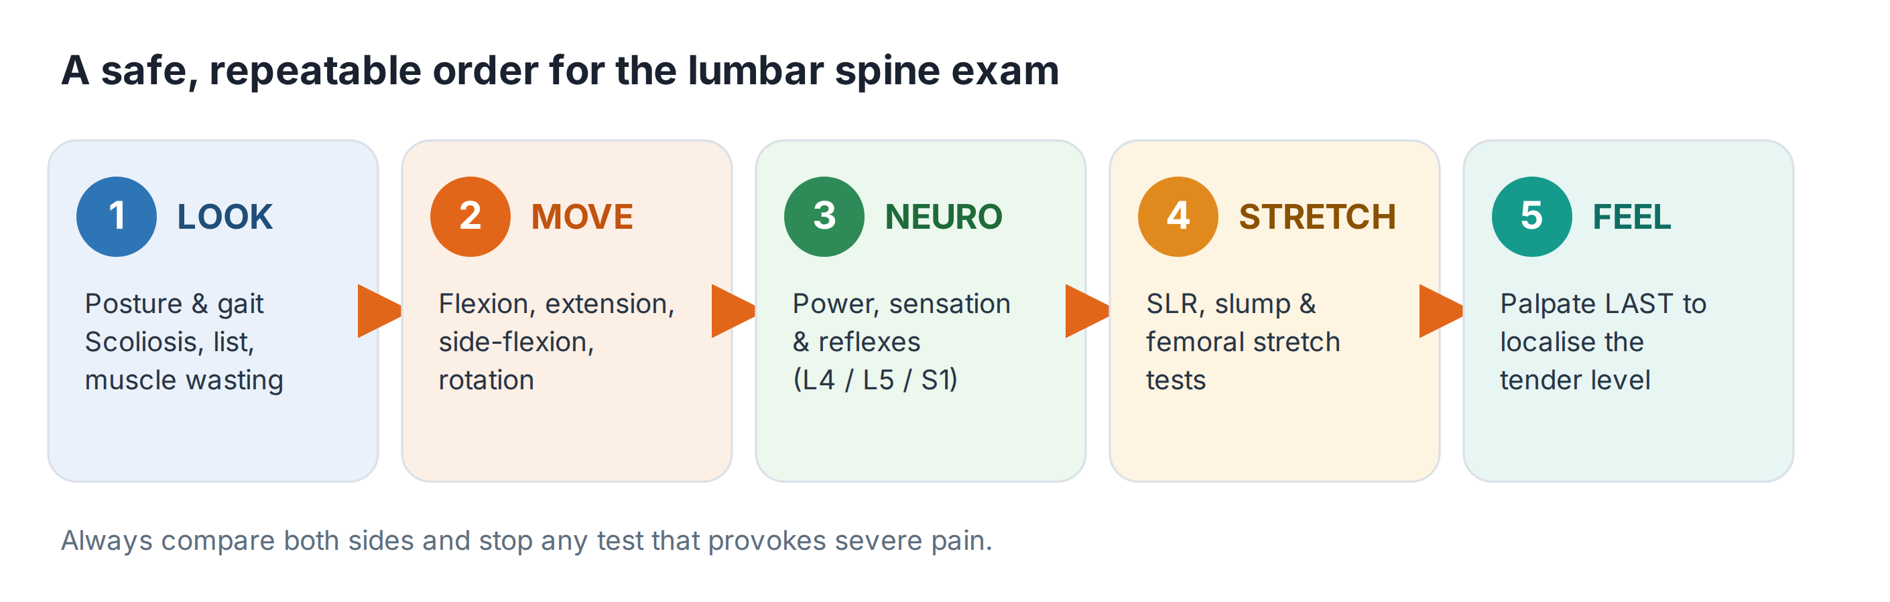
1 · Look
- Posture and curves: loss of the normal lumbar lordosis, a list to one side, increased thoracic kyphosis.
- Skin and contour: scars, muscle wasting, asymmetry. Watch the patient walk — note any limp or guarding.
2 · Move
- Flexion, extension, lateral flexion and rotation. Asking the patient to touch their toes mainly measures hip and hamstring flexibility — watch instead for how each spinal segment moves.
- Rotation is best assessed seated, which fixes the pelvis and removes hip movement.
3 · Neuro — power, sensation, reflexes
- Map any weakness or sensory loss to a nerve root. Outer-foot symptoms point to L5/S1. Check the ankle and knee reflexes.
4 · Stretch tests — the heart of the station
- Straight-leg raise (SLR): lift the straightened leg until limited by pain. Reproduction of pain below the knee suggests L5/S1 nerve-root irritation. Adding ankle dorsiflexion that worsens the pain confirms a neural cause.
- Slump test: a more sensitive test of neural tension — it often reproduces the exact pain felt when driving.
- Femoral nerve stretch (prone knee bend): tests the higher roots (L2–L4).
5 · Feel
- Palpate last. Start gently over the spinous processes and paraspinal muscles to pinpoint the tender level — here, around L5.
💡 A USEFUL RULE OF THUMB
Match the symptom to the root: outer calf / foot numbness or pain = L5/S1. But a higher lesion can affect lower roots, so always confirm with the full neurological picture rather than the dermatome alone.

Red flags — never miss cauda equina syndrome
Most back pain is mechanical and self-limiting. The one diagnosis you must never miss is cauda equina syndrome — a surgical emergency where delay causes permanent harm.
⚠ SAME-DAY EMERGENCY REFERRAL FOR URGENT MRI
Suspect cauda equina syndrome and act immediately if any of the following appear:
• Bilateral sciatica or new bilateral leg symptoms.
• Saddle or genital numbness (perineal, perianal).
• Difficulty starting to pass urine, or reduced awareness of the urinary stream.
• Loss of the sensation of a full bladder, or loss of the urge to open the bowels.
• A lax anal sphincter or new faecal incontinence.
You must refer the same day for emergency assessment and urgent MRI. Do not wait to see how symptoms evolve.
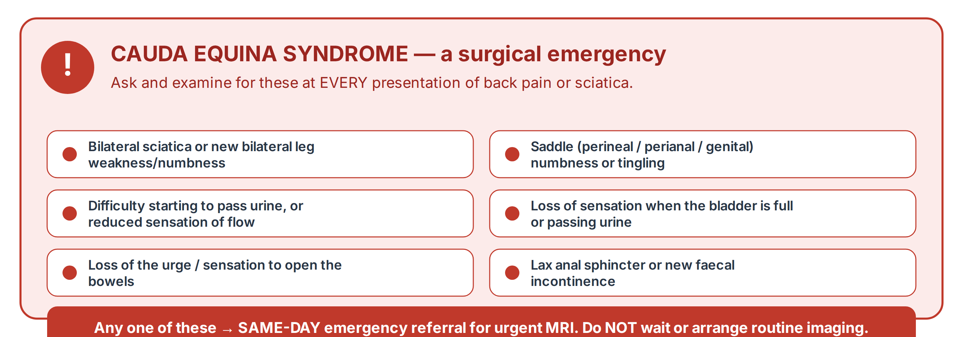
⚠ OTHER SERIOUS CAUSES TO CONSIDER
Cancer or infection: age over 50 with new pain, a history of cancer, unexplained weight loss, fever, night pain, or pain unrelieved by rest or position.
Fracture: major trauma, or minor trauma in someone with osteoporosis or on long-term steroids.
Inflammatory back pain: a younger adult with insidious pain, marked morning stiffness, and improvement with exercise.

Marking checklist
Score each item: ✓ done well · – partial · ✗ not attempted.
Skill | Score
Introduces self, gains consent, positions and exposes the patient appropriately
Inspects posture, gait and contour
Tests active movement: flexion, extension, side flexion, rotation
Performs straight-leg raise correctly
Performs the slump test correctly
Performs femoral nerve stretch (prone knee bend)
Assesses power, reflexes and sensation; maps to a nerve root
Palpates last to localise the tender level
ASKS about red-flag / cauda equina symptoms
Considerate of the patient’s pain throughout
Explains technique and findings clearly; offers a sensible interpretation
Recognise → Act → Refer
Recognise | Act | Refer
Mechanical low back pain ± sciatica, no red flags | Reassure, keep active, simple analgesia, self-management advice | Only if not settling, or for structured support
Sciatica with a clear single nerve root affected | Continue activity, exercise, analgesia per guidance | Consider specialist / imaging if severe or persistent
Any cauda equina red flag | Do NOT delay | SAME-DAY emergency referral for urgent MRI
Suspected cancer, infection or fracture | Arrange urgent investigation | Urgent / suspected-cancer pathway as appropriate

🔎 SOURCES & FURTHER READING
Verified against the following UK sources at the date of publication:
- NICE NG59 — Low back pain and sciatica in over 16s: assessment and management.
- NICE CKS — Sciatica (lumbar radiculopathy): red flags and cauda equina syndrome.
- NICE CKS — Back pain – low (without radiculopathy): assessment and red flags.

⚠ IMPORTANT — EDUCATIONAL DISCLAIMER
This document is provided exclusively for educational and training purposes as a Bradford VTS teaching aid. It does not constitute formal clinical guidance.
Clinicians must independently verify all medical information, prescribing guidance, procedural protocols, and legal requirements against current national guidance (NICE, NICE CKS, BNF, MHRA and relevant Royal Colleges), local policies, and regulatory bodies before applying any of it in practice. Information is correct to the best of our knowledge at the date of publication but guidance changes — the responsibility for safe, up-to-date practice rests with the individual clinician.

