BRADFORD VTS TEACHING AIDS | June 2026
MUSCULOSKELETAL OSCE · STATION 2
Knee Examination
A teaching station on the painful knee, built around patellofemoral pain — for GP trainees and IMGs

★ WHAT THIS STATION TESTS
Can the trainee examine a knee competently and reason from the findings? The patient has patellofemoral pain — the trainee must examine well, reach the right diagnosis, and safely exclude the serious injuries that present with a painful knee.
How to run the station
Element | Detail
Format | One trainee, one assessor, one volunteer “patient”. 7–10 minutes for the examination, then 5–7 minutes of feedback.
You will need | Examination couch and a patella (tendon) hammer.
The patient | A volunteer with no knee problem, briefed to play a 30-year-old PE teacher with patellofemoral pain.
The task | Examine the knee, explaining as you go. The trainee may ask brief questions during the examination.
Trainee briefing sheet
📋 GIVE THIS TO THE TRAINEE
Ms A Jones is a 30-year-old PE teacher. She has had pain at the front and outer side of her knee for two years, worse over the last two months.
It comes on with high-impact activity that loads a bent knee — for example, playing volleyball — and aches after any energetic activity. There is no locking and no giving way.
Your task: examine the knee, explaining what you do. You may ask brief questions as you go.
Recognising patellofemoral pain
Patellofemoral pain is the commonest cause of anterior knee pain in young, active adults — especially women. The pattern is distinctive once you know it.
Feature | Typical pattern
Site | Diffuse pain at the FRONT of the knee, around or behind the kneecap — hard to point to with one finger.
Triggers | Loaded knee flexion: stairs (especially down), squatting, running, jumping.
The “cinema sign” | Aching after sitting with the knee bent for a long time.
What is ABSENT | No true locking, no giving way, no history of a single significant injury.
💡 PSEUDO-LOCKING vs TRUE LOCKING
Patellofemoral pain can cause a knee to feel as though it catches or “gives” from pain (pseudo-locking). This is NOT the true mechanical locking of a meniscal tear or loose body, where the knee physically cannot straighten. Distinguishing the two changes the diagnosis.

Examining this knee
Examine in the usual order — Look, Feel, Move — comparing with the other side.
- Look: quadriceps wasting (especially the inner VMO), alignment, and how the kneecap tracks as the knee bends and straightens.
- Feel: tenderness around the patellar edges; no effusion and no joint-line tenderness in straightforward patellofemoral pain.
- Move: a good range of movement; pain or crepitus on loading the patellofemoral joint (for example, a squat or a step-down).
- Always screen the rest: collateral and cruciate ligaments and the menisci, to exclude the injuries below — and remember referred pain from the hip.
Managing patellofemoral pain
✓ FIRST-LINE: EXERCISE AND EDUCATION
• Exercise therapy is the cornerstone — progressive strengthening of the quadriceps and the hip muscles (glutes), guided by physiotherapy.
• Activity modification: reduce, don’t stop. Cut back the aggravating loaded-flexion activities while keeping active overall.
• Education and reassurance: explain the diagnosis and that recovery is gradual and depends on consistent rehab.
• Simple analgesia for symptom relief if needed — check the BNF for choice, dose and duration.
⚠ SET EXPECTATIONS HONESTLY
Patellofemoral pain often settles with good rehabilitation, but it can be slow and may persist in some people. Consistent exercise and realistic expectations matter more than any quick fix.
The safety net — don’t mistake a serious injury for “just” anterior knee pain
A painful knee in a young athlete is usually benign, but the same clinic sees the injuries you must not miss. The history separates them.
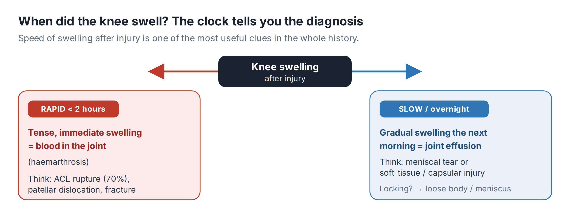
⚠ REFER — DO NOT RELY ON A NORMAL EXAM OR X-RAY
A “pop”, rapid swelling, and later giving way = suspected ACL rupture → knee specialist.
A twist, true locking, and slow (overnight) swelling = likely meniscal tear → acute knee clinic.
A hot, red, very painful knee with fever = possible septic joint → same-day emergency assessment.

When to X-ray — the Ottawa Knee Rules
Patellofemoral pain needs no X-ray. After an acute injury, use the Ottawa rules to decide.
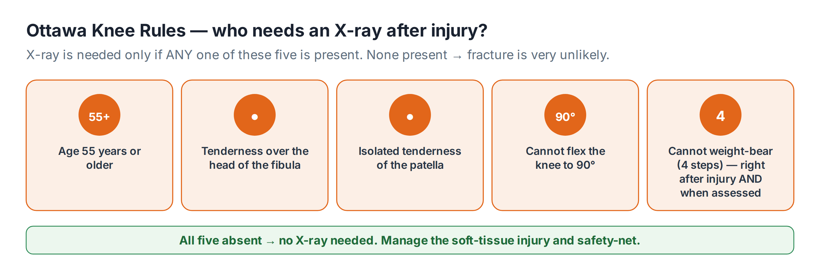
Marking checklist
Score each item: ✓ done well · – partial · ✗ not attempted.
Skill | Score
Introduces self, gains consent, exposes both knees, compares sides
Inspects for wasting, alignment and patellar tracking
Feels for effusion, patellar and joint-line tenderness
Tests range of movement; loads the patellofemoral joint
Screens collateral and cruciate ligaments and menisci
Reaches the diagnosis of patellofemoral pain
Outlines exercise-based management and realistic expectations
Knows the red-flag histories that need referral
Considerate of the patient; explains findings clearly

🔎 SOURCES & FURTHER READING
Verified against the following UK sources at the date of publication:
- NICE CKS — Knee pain – assessment (anterior knee / patellofemoral pain).
- Stiell IG et al. — Ottawa Knee Rules.
- BNF — for analgesia choice, dose and duration.
- Refer to local physiotherapy and acute knee / orthopaedic pathways.

⚠ IMPORTANT — EDUCATIONAL DISCLAIMER
This document is provided exclusively for educational and training purposes as a Bradford VTS teaching aid. It does not constitute formal clinical guidance.
Clinicians must independently verify all medical information, prescribing guidance, procedural protocols, and legal requirements against current national guidance (NICE, NICE CKS, BNF, MHRA and relevant Royal Colleges), local policies, and regulatory bodies before applying any of it in practice. Information is correct to the best of our knowledge at the date of publication but guidance changes — the responsibility for safe, up-to-date practice rests with the individual clinician.

