BRADFORD VTS TEACHING AIDS | June 2026
PHYSICAL EXAMINATION SKILLS · OSCE STATION
Shoulder Examination
A teaching station and clinical guide for GP trainees and IMGs

★ WHAT THIS STATION TESTS
Can you examine a shoulder fluently, safely and in a logical order — talking the patient through it, spotting the key signs, and knowing what is urgent? You are being assessed on technique, not on taking a history.
The station at a glance
Element | Detail
Scenario | You have decided to examine a patient’s shoulder. Examine the right shoulder, explaining what you are doing and why as you go.
Your task | Perform a competent shoulder examination. No history is required, but talk to the patient and keep the usual courtesies as in a real consultation.
Timing | 7–10 minutes for the examination, then 5–7 minutes of structured feedback.
You are marked on | Approach to the patient · inspection · palpation · movement & stability · special tests · logical sequence · interpreting your findings.
Examine every shoulder the same way
A fixed routine means you never miss a step under pressure. Use Look → Feel → Move → Special tests, and always compare with the other side.
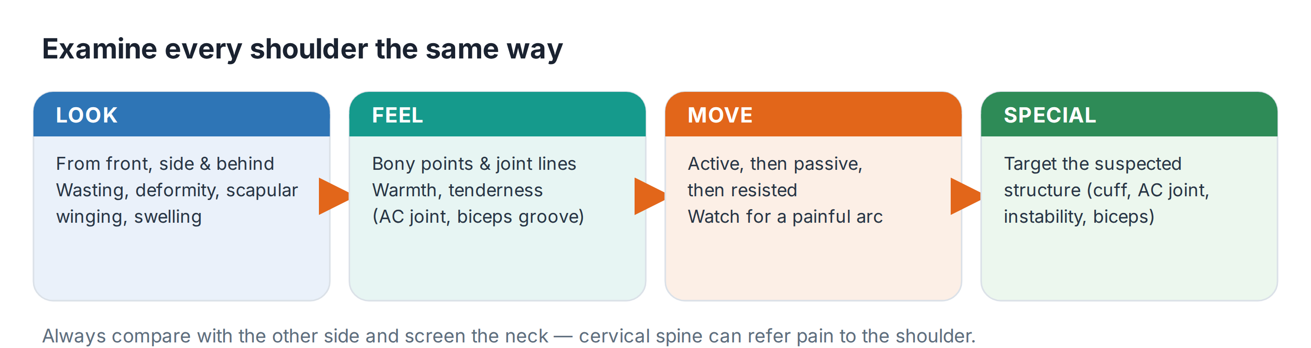
1 · Look
- Expose both shoulders properly and inspect from the front, the side and behind.
- Skin & contour: scars, swelling, redness, deltoid wasting, or the “squared-off” look of a dislocation.
- Bones & posture: asymmetry, prominent acromioclavicular (AC) joint, winging of the scapula.
2 · Feel
- Palpate methodically along the bony landmarks: sternoclavicular joint → clavicle → AC joint → acromion → greater tuberosity → biceps groove → spine of scapula.
- Note warmth, tenderness and swelling. Localised AC-joint tenderness with high-arc pain points to AC-joint pathology.
3 · Move
Test in the order active → passive → resisted. Active movement screens the whole shoulder; passive movement separates a stiff joint from a weak one; resisted movement isolates the muscle or tendon at fault.
Movement | How to test | What it suggests
Flexion / extension | Arm forward then back | Global glenohumeral movement
Abduction | Arm out to the side, watch the arc | Painful arc 60–120° = subacromial / cuff
External & internal rotation | Elbows tucked in, rotate out; hand up the back | Early loss of external rotation = frozen shoulder / OA
Hand-behind-back & behind-head | Apley scratch test | Quick functional screen of rotation

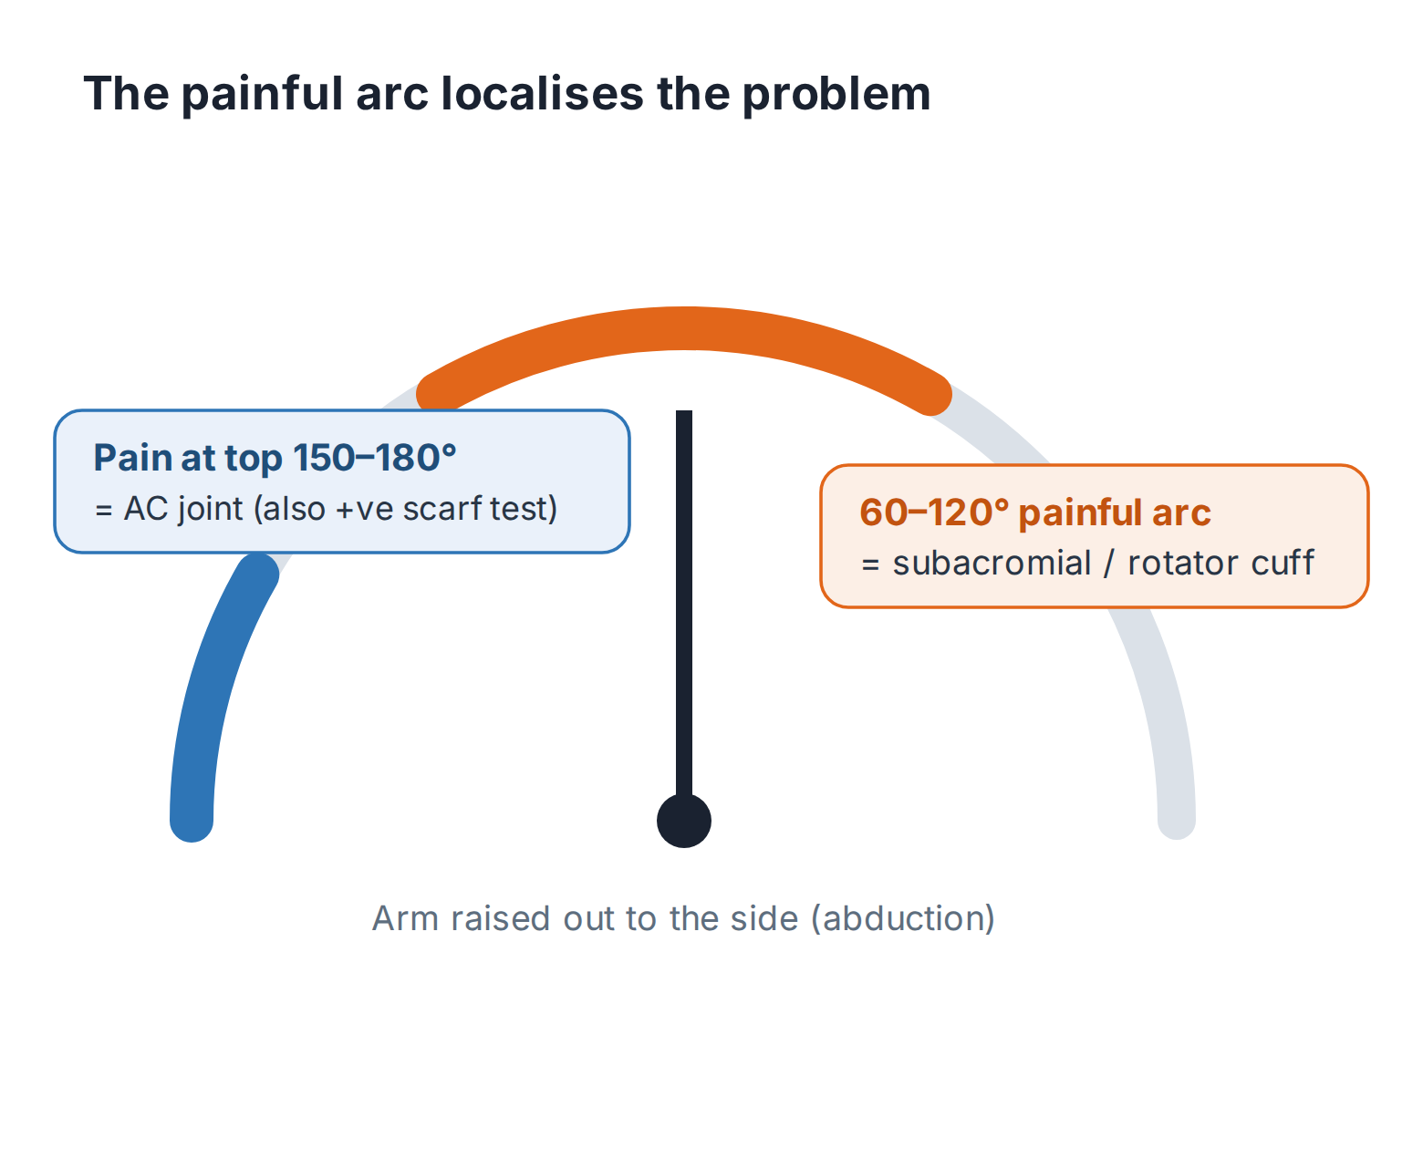
The level of the painful arc tells you where to look.
4 · Special tests — target the suspected structure
Don’t fire off every test. Choose the ones that confirm or exclude what the history and basic exam suggest.
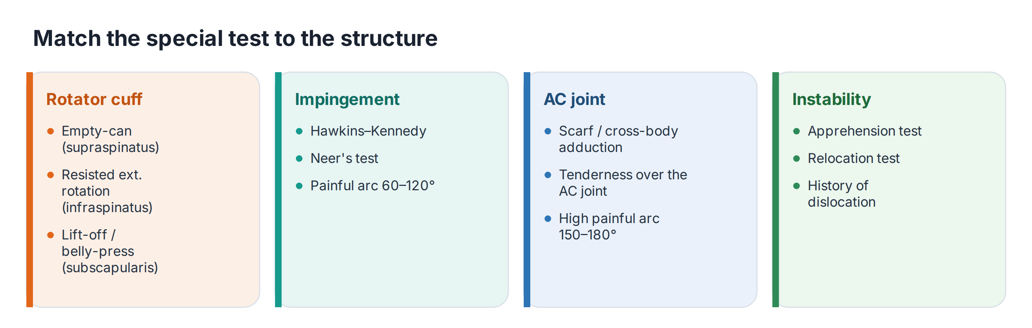
⚠ INTERPRET TESTS WITH CARE
Individual shoulder special tests have modest accuracy. Use them in combination, alongside the history and the painful arc, rather than relying on any single positive test.

Red flags — when a shoulder needs urgent action
Most shoulder pain is benign and mechanical. Your job in the exam — and in clinic — is to actively exclude the few presentations that are not.
⚠ REFER URGENTLY / SAME DAY
Unreduced dislocation (abnormal shape, loss of rotation after trauma, a fit or an electric shock) → same-day emergency assessment.
Acute rotator cuff tear (trauma, pain and weakness, or sudden inability to actively lift the arm) → urgent referral. Do not be reassured by a normal X-ray.
Suspected infection (hot, red, painful joint with fever or systemic upset) → treat as septic arthritis: emergency.
Suspected malignancy (unexplained mass, swelling or deformity; night pain; previous cancer; consider referred pain from an apical lung tumour) → urgent / suspected-cancer pathway.
Sudden major neurological deficit of the arm → urgent assessment.
Investigations — keep them targeted
- Most cases need no imaging. Diagnose subacromial pain and frozen shoulder clinically.
- X-ray if you suspect fracture, dislocation, calcific tendinitis or glenohumeral / AC-joint osteoarthritis.
- Ultrasound is the test of choice when a rotator cuff tear is suspected. Remember: symptom-free cuff tears are common in older people, so correlate with the clinical picture.
- Bloods (ESR / CRP) only if inflammatory disease, polymyalgia rheumatica or infection is possible.
Recognise → Act → Refer
Recognise | Act | Refer
Painful arc, pain on overhead use — subacromial / cuff pain | Analgesia, activity modification, physiotherapy / exercise | If no improvement, or for guided injection / specialist opinion
Global stiffness, early loss of external rotation — frozen shoulder | Reassure (self-limiting but slow), analgesia, exercises | Consider physio ± specialist if function is severely limited
Trauma + weakness / can’t lift arm — acute cuff tear | Analgesia, sling for comfort, arrange imaging | URGENT orthopaedic / shoulder referral
Abnormal shape after trauma — dislocation | Do not force movement | SAME-DAY emergency department

🔎 SOURCES & FURTHER READING
Verified against the following UK sources at the date of publication:
- NICE CKS — Shoulder pain (assessment, red flags and referral).
- BESS / BOA — Subacromial shoulder pain commissioning guidance.
- JOSPT (2025) — Rotator cuff tendinopathy clinical practice guideline.
- NICE CKS — Shoulder pain: investigations (ultrasound for suspected cuff tear).

⚠ IMPORTANT — EDUCATIONAL DISCLAIMER
This document is provided exclusively for educational and training purposes as a Bradford VTS teaching aid. It does not constitute formal clinical guidance.
Clinicians must independently verify all medical information, prescribing guidance, procedural protocols, and legal requirements against current national guidance (NICE, NICE CKS, BNF, MHRA and relevant Royal Colleges), local policies, and regulatory bodies before applying any of it in practice. Information is correct to the best of our knowledge at the date of publication but guidance changes — the responsibility for safe, up-to-date practice rests with the individual clinician.

