BRADFORD VTS TEACHING AIDS | June 2026
MUSCULOSKELETAL OSCE · STATION 5
Managing Tennis Elbow
A shared-decision station built on current evidence — for GP trainees and IMGs

⚠ WHAT HAS CHANGED — READ THIS FIRST
Older teaching treated the steroid injection as the answer for tennis elbow. The evidence has moved on. Injections relieve pain for a few weeks but lead to WORSE outcomes and far higher recurrence at 6–12 months than leaving it alone. This station is now about load management and honest shared decision-making — not about agreeing to inject.
★ WHAT THIS STATION TESTS
Can the trainee confirm the diagnosis, explain the modern evidence clearly, and guide the patient — who is asking for “another injection” — towards the treatment most likely to help in the long run?
The scenario
Element | Detail
The patient | A 45-year-old plasterer presents asking for ANOTHER steroid injection, because his tennis elbow has come back.
The task | Confirm the diagnosis, discuss the management options, reach a shared decision, and — if injection is genuinely chosen after a full discussion — describe how it would be done and the aftercare.
Timing | 7–10 minutes, then 5–7 minutes of feedback.
Confirm the diagnosis
- History: pain over the outer elbow, brought on by gripping and lifting. Note the occupational and leisure load — plastering is a classic cause.
- Tennis elbow is an overuse tendinopathy of the common extensor origin — the muscles that extend the wrist and fingers.
- Provocation tests: pain over the lateral epicondyle on resisted wrist (or middle-finger) extension with the elbow straight. The common extensor origin is tender.
ℹ THE REASSURING TRUTH TO SHARE
Tennis elbow is self-limiting. Around 80–90% of people recover within a year with a simple “wait-and-see” approach and the right exercises. This fact is the heart of the consultation.

The management ladder — load first, inject rarely
Work from the bottom up. The simple measures do the most good; the interventions at the top do least, and the injection carries a long-term penalty.
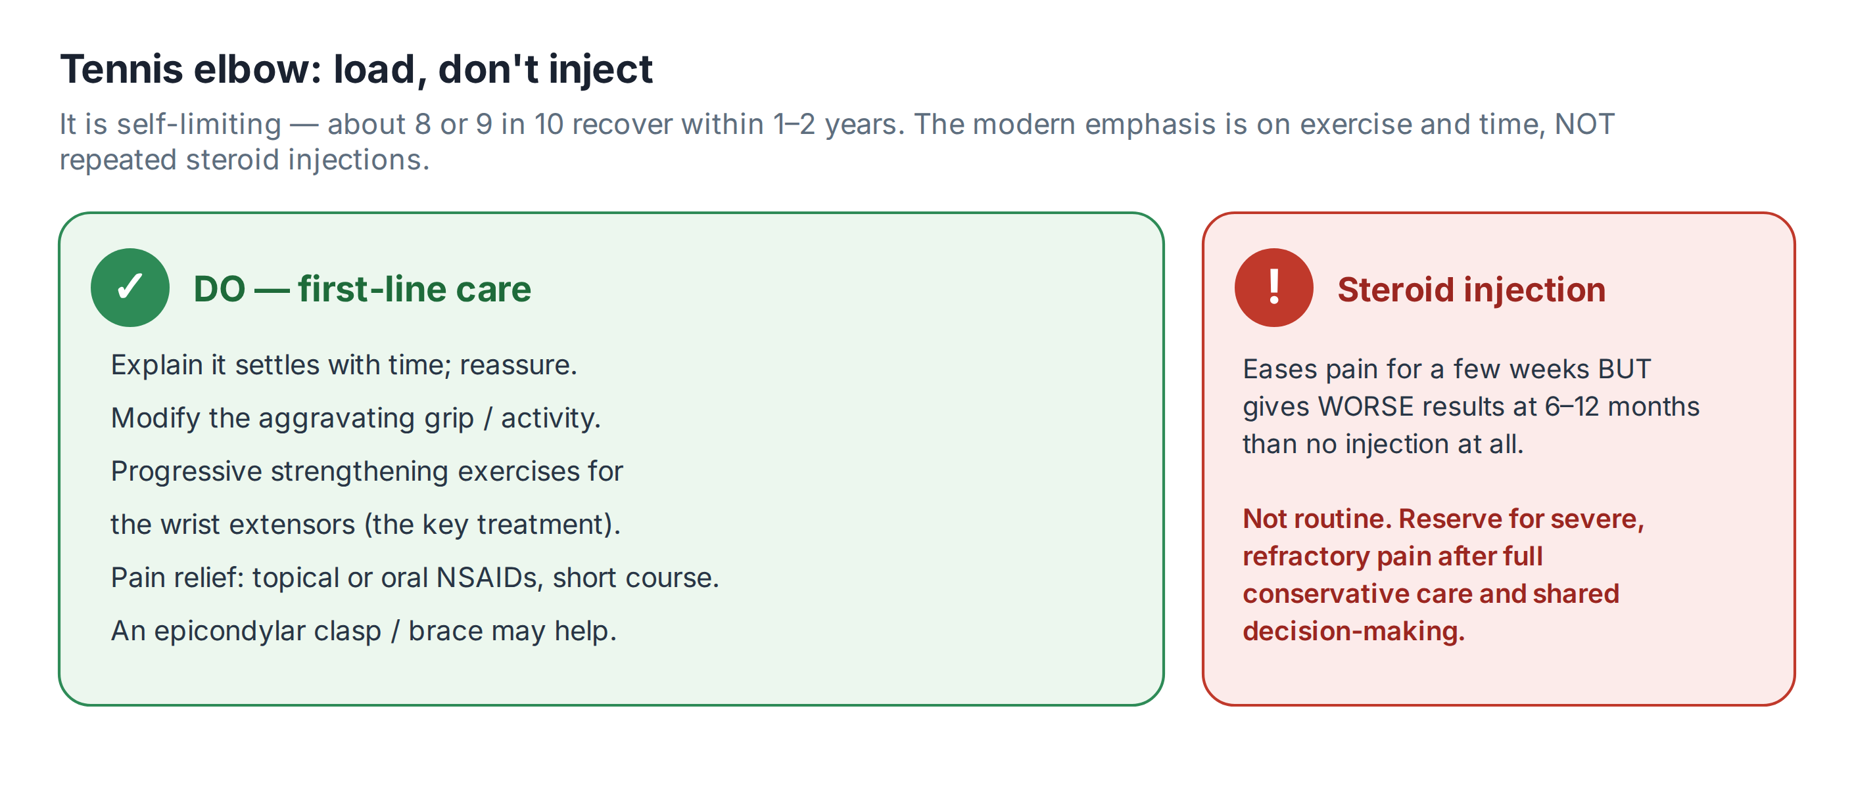
✓ FIRST-LINE — DO THESE FOR EVERYONE
• Reassure and explain the natural history (most settle within a year).
• Modify the load: reduce or change the aggravating gripping and lifting; adjust tools and technique where possible.
• Progressive strengthening: graded wrist-extensor exercises are the most effective single measure — refer to physiotherapy.
• An epicondylar clasp (brace) can help offload the tendon.
• Short course of a topical or oral NSAID for pain — check choice, dose and duration in the BNF; weigh gastrointestinal, cardiac and renal risk.
⚠ CORTICOSTEROID INJECTION — NOT ROUTINE
Do NOT offer a steroid injection as routine or first-line treatment. It eases pain for a few weeks but, at 6–12 months, produces WORSE outcomes and much higher recurrence than no injection.
Reserve it for severe, persistent symptoms after conservative care has been tried, and only after a frank shared-decision conversation about the short-term gain versus the long-term penalty. In this scenario, the patient’s recurrence after a previous injection is itself a reason to move towards load management instead of repeating it.

If injection is chosen — the safe procedure
Kept here for reference and for the rare, fully-informed case. It is no longer the default answer.
Step | What good practice looks like
Consent | Explain the realistic benefit (short-term pain relief only), the risks (skin and fat atrophy, depigmentation, tendon weakening, higher long-term recurrence), and that it does not speed true recovery. Document the discussion.
Equipment & drug | A small syringe and fine needle; a corticosteroid (with or without local anaesthetic). Check the agent, dose and dilution against the BNF and your local guidance — never from memory.
Technique | Aseptic skin preparation; locate and mark the point of maximal tenderness at the lateral epicondyle; inject at that site.
Documentation | Record the agent, dose, batch number and expiry, any adverse event, the advice given, and the follow-up plan.
Aftercare
- Analgesia for any post-procedure soreness.
- Activity: relative rest initially, then a graded return guided by symptoms.
- Rehabilitation: continue the wrist-extensor strengthening programme — this is what drives lasting recovery, with or without an injection.
- Safety-net and follow-up: tell the patient how to seek help if symptoms worsen, and arrange review.
Recognise → Act → Refer
Recognise | Act | Refer
Typical lateral elbow pain on resisted wrist extension | Reassure; load management; physiotherapy exercises; brace; short NSAID course | Not usually needed
Patient requesting a repeat injection | Explain the long-term evidence; steer towards load management; shared decision | Only if severe and refractory
Severe, persistent despite good conservative care | Review the diagnosis; discuss reserve options | Specialist / physiotherapy-led service
Atypical features (e.g. neurological signs, locking, night pain) | Reconsider the diagnosis | Refer to exclude another cause

🔎 SOURCES & FURTHER READING
Verified against the following UK sources at the date of publication:
- NICE CKS — Tennis elbow (lateral epicondylitis): management.
- Coombes BK et al., JAMA 2013 — corticosteroid injection worsens 1-year outcomes and recurrence.
- Smidt N et al., Lancet — “wait-and-see” vs injection vs physiotherapy.
- BNF — for NSAID and any injectable corticosteroid choice, dose and duration.

⚠ IMPORTANT — EDUCATIONAL DISCLAIMER
This document is provided exclusively for educational and training purposes as a Bradford VTS teaching aid. It does not constitute formal clinical guidance.
Clinicians must independently verify all medical information, prescribing guidance, procedural protocols, and legal requirements against current national guidance (NICE, NICE CKS, BNF, MHRA and relevant Royal Colleges), local policies, and regulatory bodies before applying any of it in practice. Information is correct to the best of our knowledge at the date of publication but guidance changes — the responsibility for safe, up-to-date practice rests with the individual clinician.

