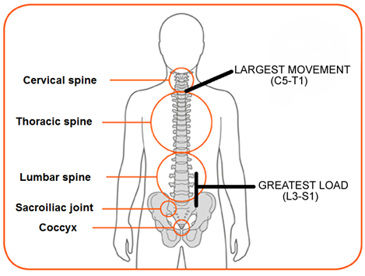
Anatomy
There are 32 vertebrae in the spine:
- 7 cervical
- 12 thoracic
- 5 lumbar
- 5 sacral (fused)
- 3 coccyx (fused)
Each vertebra has 4 facet joint articulations and an intervertebral disc between the end plates of the vertebral bodies. The greatest range of motion in the spine is between C5-T1 and the greatest load passes through the lower lumbar segments L3-S1. These are the most common regions where pain is felt.

Dermatomes
Aide memore: you stand on S1, Sit on S2 and you sh*t through S3
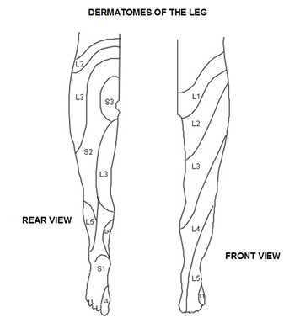
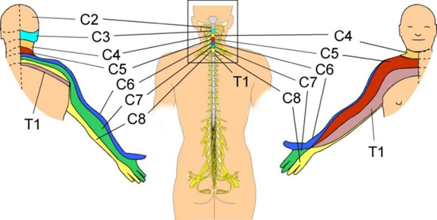

Myotomes
Root | Myotome | Reflex
C5 | Shoulder abduction | Biceps
C6 | Elbow flexion, wrist extension | Brachioradialis
C7 | Elbow extension, wrist flexion | Triceps
C8 | Finger flexion
T1 | Finger abduction | Fingers
L4 | Ankle dorsiflexion | Knee
L5 | Hallux extension (walk on heels)
S1 | Plantarflexion (walk on tip-toes) | Ankle
Top tip: Back pain pathology (if any), is going to be related to L3-S1. Therefore, rather than remembering all the myotomes, just test for L4, L5 and S1 = ankle dorsiflexion, plantar flexion (walk tip toe), hallux extension (walk on heels).

BACK PAIN
- 5% of all GP consultations. Prevalence 20-30% of the population at any one time.
- 70% of the population will experience significant back pain at some time in their lives.
- Costs a lot in terms of working days lost and health care costs/incapacity payments etc.
- £1billion for NHS cost, £3 billion for DHS benefit, 8 billion lost work days.

Risk Factors
- Age – increases with age up to age 50. Then decreases in men but increases in women!
- Gender – multiparous women 3x risk
- Smoking – strong link with it and sciatica
- Physical Work
- Occupation – standing sedentary jobs or where exposure to vibration
- Decreased fitness

Prognosis
Most is mechanical or self-limiting. And most stop consulting GP within 3m. But 60% can still have pain thereafter and just not come back – GPs need to identify these and get them going again.

What sort of back pain happens when?

<18 | 18-45 | 45-65 | 65+
Scoliosis  Spina bifida | Ankylosing spondylosis  whiplash | Non-specific back pain  Non-specific neck pain  Sciatica | Spinal canal stenosis  Cancer  Crush fracture

Red flags
- Aortic aneurysm - Pulsating abdominal mass, presence of cardiovascular risk factors
- Cancer - Previous history of malignancy, night pain, intractable pain, unable to find position of comfort, weight loss, widespread neurological symptoms or signs, thoracic pain
- Infection - Fever, malaise, rigors, systemically unwell, IVDU/HIV, thoracic pain
- Inflammation eg Ank Spond - Gradual onset (usually aged less than 40), marked morning stiffness (i.e better in afternoon), improves with activity/exercise, family history, history of psoriasis or inflammatory bowel disease
- Trauma/Fracture - Significant mechanism of injury, known previous fragility fracture, systemic steroid use, structural deformity, thoracic pain
- Significant neural compromise/cauda equina - Saddle anaesthesia, urinary retention/incontinence, sphincter disturbance, bilateral referred leg pain, priapism, gait disturbance

Diagnosis
Exact tissue diagnosis IS NOT required – most experts don’t even know. You need an idea of what is going on – eg is it a muscle, joint, red flags etc. This is what helps you develop a competent management plan, not a tissue diagnosis!
- First work out if there is serious spinal pathology always need referral
Age <20 or >55, non-mechanical pain, thoracic pain, PH carcinoma, steroid use, HIV+, constitutional symptoms (unwell, weight loss), widespread neurology, structural deforming, cauda equina symptoms/signs (incontinence, saddle anaesthesia – anal sensation loss), severe progressive motor weakness
- Second work out if there is a Nerve Root Problem may need referral
Unilateral leg pain > LBP, radiates to foot/toes, numbness in same distribution, SLR leg pain +++, localised neurology,
Otherwise, it is likely to be simple back ache manage in primary care
Presentation 20-55y, lumbosacral, buttocks & thighs, mechanical pain, patient otherwise well.

Investigations
Only if there are red flags. Otherwise, avoid bloods, x-ray and MRI.
Abnormal findings on x-rays and MRIs are common – and often mean nothing!
- The dose of radiation from a set of lumbar spine x-rays is equivalent to 120 chest x-rays.
- Minor abnormalities are common on x-ray films even in subjects without pain, but their presence may be damaging to patients in the way they think about their pain. How would you feel if you were told you had moderate levels of degenerative back disease but functionally felt fine?
- There is a poor correlation between findings on imaging and the level of functional deficit or pain. For instance, a lot of people over the age of 65 will have degenerative disease of their spines. But a large majority of these have no back pain and carry on with life as normal. As for MRI scanning, abnormalities are found on 80% of scans which have no impact on the individual’s real life! 100% of people aged >60 will have evidence of degeneration and 80% will have a bulging disc, even if they are asymptomatic (compared to 33% of asymptomatic people aged <60). 20% of asymptomatic people aged over 60 have spinal stenosis, which does not need treatment. The presence of 'incidental' abnormalities may be damaging to patients in the way they think about their pain.
When should you do an MRI?
- Red flags (though an admission may be more appropriate)
- Progressive neurological symptoms
- Radicular pain (referred pain e.g. brachalgia or sciatica) not improving at 6 weeks
- Neurological signs (weakness, numbness etc) not improving at 6 weeks

Management - Explore ICE & psycho-social
Identify psychosocial barriers to recovery - if psychosocial flags are present, the person is at higher risk of developing chronic pain or having a prolonged period of absence from work. So explore the person, their social context, work context in a NEUTRAL way (i.e. without judging the patient or apportioning blame). You are trying to work out additional contributors to the back pain problem, and thus where you might help them additionally. We as GPs think we are good at exploring ICE and the psychosocial, but we aren’t. The Keele Start Back 9 item tool has been developed to help us.
Early identification and early intervention on psychosocial and physical barriers is what makes a big difference to back pain outcome. Impairment - how it is affecting activities of daily living or working.. Distress - the effect the impairment is having on the individual (e.g. change in mood, irritability, depression, anxiety, bad thoughts, catastrophising, abnormal perceptions).. Expectations - what the patient is hoping for.
Examination is an essential part of the assessment of patients with back pain and patients expect to be examined by their GP.
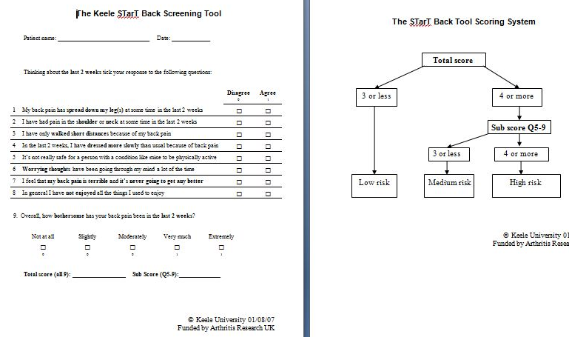

Management - Explanation
When explaining the diagnosis to patients with musculoskeletal pain, the language used has significant implications on how patients perceive their problem. Avoid damaging terms which carry connotations of erosion, destruction and inevitable chronic pain like Ruptured disc, Torn muscle, Crumbly spine, Degenerative, Knackered, Worn Out. How would you feel if you had been told you had torn a muscle? Or what if I decided to sell you my house and told you that most of it was okay except one bit was a bit crumbly? You’d be horrified, and this is no different for patients when we use these sort of terms. Give positive messages instead, rather than using such negative language. So, explain that
- Pain does not mean more damage
- Encourage to try and engage in activity and build up to what they did before – it is achievable.
- Promote a positive outlook (but don’t lie)
- Patients are empowered by explanations. Empathise.
‘Having listened to you telling me what happened and from examining you I can tell you that, even though it is causing you a lot of pain, there is no serious injury to your back. Back pain happens to most people during their life and for most people the pain will get better without needing treatment. What we need to do is manage the pain and get you more comfortable so that you can get back to normal activities as soon as possible. The less pain you are in the quicker you will get better.'

Management - medication
- If v severe and muscle spasm +++ short term diazepam 2-5mg tds for 2-5 days (note in doses above 5mg significant deterioration in alertness)
- Otherwise, most patients should be started on Paracetamol 1g qds
- If that fails then…. NSAID (Naproxen 500mg bd) or COX2 inhibitor OR weak opioid (Cocodamol 8-30/500 2 qds; DF118 30mg od or tramadol low dose). For NSAIDS/COX2, give PPI if over age 45
- If that fails then try NSAID PLUS tramadol
- If that fails, add Amitriptyline – taken 2h before bedtime, no later than 8pm. Start 10mg and titrate upwards to 75mg. Effect on sleep usually immediate, but effect on pain/mood takes 2-6w.
- If all of this fails, review diagnosis. Discuss with other docs whether referral (physio, MSK) or stronger opioid indicated for the SHORT TERM (like tramadol high dose, buprenorphine, oxycodone, fentanyl – for say acute disc herniation)- do not prescribe PRN, prescribe a scheduled dose (*and remember, short term!)
Facet joint injections, epidurals, trigger point and sclerosant injections have not been shown to be effective for back pain and sciatica. NICE guidelines do not recommend injections for non-specific back pain.
Opioid Risk Tool
Be careful prescribing opioids if….
- FH of substance use (alcohol, illegal drugs, prescription drugs)
- Personal history of substance misuse (alcohol, illegal drugs, prescription drugs)
- History preadolescent sexual abuse
- Psychological problems – OCD, anxiety, depression, schizophrenia, bipolar
- Age 16-45 years

Nerve Root symptoms present
If a patient of yours has symptoms of nerve root irritation (pain, numbness, paraesthesia or neurological signs; usually single and unilateral, limb pain worse than LBP/neck pain)….
- Conservative Mx for 6w.
- After 6w….
  - 50% of patients will have improved.
  - For the 50% that have NOT improved: consider MRI (with consideration of x-ray guided nerve root block)
  - If progressive motor weakness, refer urgently to specialist (1-2w)
  - If severe neurological symptoms (e.g. more than one nerve root or myotome affected) – again, refer urgently to specialist (1-2w).

- In the cervical spine, C5/6-C7/T1 are the most common places for nerve root compromise (brachialgia).
- In the lumbar spine, L4/5-L5/S1 are the most common places for nerve root compromise (sciatica).
- Multi-level or bilateral neurological signs are a red flag and if present, warrant an urgent onward referral for MRI scan and spinal/neurology assessment.

Review your patient!
Always arrange follow up. 1 w if the pain is v bad. Aim for symptomatic relief of pain. Maintain activity levels. Revisit psychosocial factors and address. If patient not getting better, review diagnosis and re-examine.

Surgery
- Generally isn’t v good.
- Microdiscectomy helps with reducing pain than more invasive surgery. Tends to relieve limb pain rather than spinal pain.

Work
Try and get people back to work. Facilitate the return. Be sensitive. Get them to come up with suggestions.‘What can be done at work to help?’ The longer a patient is off work, the greater the risk of developing chronic pain and disability and less likely they are to ever return to work. If a patient is off work for six weeks, there is a 10-40% chance they will be off work in one year. If a patient is off work for 6 to 12 months, there is a 90% chance that they might never return to any form of work (Waddell, 2002).
You can facilitate return to work in the following ways:
- Mythbusting: You don’t have to be 100% better to return to work
- Ask the patient to focus on what they can do, not what they can’t
- Make sure the patient has spoken to their employer
- Use the fit note to communicate with employers. The worker knows best and can suggest workplace modifications. Consider return to work part-time if possible
- Think about using a tool such as the ‘fit note decision aid’ (see resources) to help identify obstacles to return to work
- Use occupational health at work.

Specific conditions
Central disc protrusion/Cauda equina – Usually (but not always) sudden onset, Bilateral leg pain, gait or sphincter disturbance, saddle anaesthesia. Back pain may or may not be present. This is a neurosurgical emergency - refer immediately. Usually from L4/L5 and L5/S1 disc herniation.
Nerve root irritation/compression - There is a dermatomal distribution of pain, numbness or paraesthesia with loss of reflexes or weakness in corrresponding myotomes. It is usually single level. If more than one level is affected, the patient needs urgent assessment. Often, pain in the limbs is greater than pain in the back or neck
Referred myofascial pain (trapezius, gluteal muscles, paraspinal muscles) - The pattern of pain is often deep or aching, usually involving proximal muscle groups (thighs/shoulders). It doesn’t usually extend to hands or feet. Nerve stretch tests such as straight leg raise are not provocative of pain
Piriformis syndrome - The sciatic nerve passes through the piriformis muscle (a hip external rotator) in less than 10% of the population. Pain distribution is similar to sciatica but tends to be worse during or after exercise. Reflexes, motor and sensory testing are usually normal and nerve stretch tests such as the straight leg raise are negative
Spinal canal stenosis - Caused by narrowing of the spinal canal or neural foramina producing root ischaemia and neurogenic claudication. Stenosis of the spinal canal is most often caused by a combination of loss of disc space, osteophytes and a hypertrophic ligamentum flavum. Patients are usually aged over 60 and present with spinal claudication – unilateral or bilateral leg pain, +/- back pain, numbness and weakness which develop after the patient walks a predictable distance. Patients often report it is easier to walk uphill rather than down. It is important to rule out peripheral vascular disease as a differential diagnosis

Don’t blame the patient if your treatments aren’t making much of a difference!

