(Hips) Trochanteric Bursitis
Pain over hip abductors – near greater trochanter – it’s tender there too. May radiate down thigh, but NOT to foot. Pain worse when patient lies on affected side. Walking running painful. Common Women> Men. Also in those with leg length discrepancy and post THR.

Diagnosis
- Tender greater troch area ?Swelling
- Pain on hip flexion with flexed knee.

Differentials
- OA – passive internal rotation of hip in flexion causes no pain in trochanteric bursitis but it does in OA
- Sciatica – pain goes down to foot in sciatica but not in Troch Bursiitis. In Sciatica, pain on SLR, not in Troch B. In Troch B pain on hip flexion with flexed knee (but not in sciatica)
- Gluteus medius tendon injury – pain on resisted abduction.

Investigations
Nil required. Confirm diagnosis – USS (but not necessary).

Management
- Rest – most settle. Activity modification – avoid lying on affected side.
- Exercises/physio – stretching hip exercises. Not much worth in referring to physio.
- NSAIDs might help.
- Local steroid injection – good results. ?Ultrasound guided? Deffo ultrasound guided if the patient has had a THR (re: risk of infection)
- Surgery – not really worth it. (iliotibial band release/bursectomy)

(Knees) Patellofemoral Syndrome
= anterior knee pain

Diagnosis
Maltracking and misalignment of the patella – patella rubs on femur severe sharp anterior knee pain (or retropatellar) lasting few seconds but recurrent +++ on knee flexion e.g. on going up or downstairs. Pain worsens with prolonged knee flexion e.g. sat in the cinema. V common. 20% in student populations. W>M. Physically active people ++

Differential
- Patellofemoral OA (= chondromalacia patellae) = degen changes underneath the knee cap = esp in older people, with overuse or long history. Pain worse with activities such as climbing stairs or when rising from a seated position and is less obvious with activities such as walking on level surfaces.
- Pre-patellar bursitis - fluctuant swelling at the lower pole of the patella and sometimes erythema.

Examination
- Tender patella during patellar movements with the knee extended and the quadriceps relaxed
- Repetitive squatting may reproduce knee pain
- Assess for foot pronation (flat feet) as this can sometimes predispose to the condition

Investigations
- None – clinical diagnosis. If effusion present – rethink diagnosis.
- Patello femoral OA – organise x-ray (skyline views + AP and lateral views)

Management
- Rest – most settle
- Activity Modification – avoid repeated squatting
- Exercises/Physio – work on quads and vastus medialis. Physio will help.
- Patellar taping – helps. Also knee braces help.
- Orthoses – if there is foot over-pronation – vasilli inserts help +++
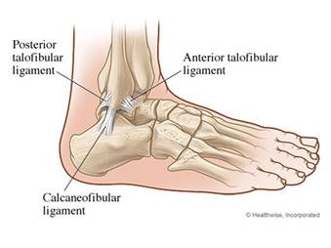
- Surgery – no! (exceptional cases may need release of lateral attachments of patella).

Ankle injuries
Inversion injury v common. And usually involves strain on anterior talofibular ligament and less commonly calcaneofibular ligament. The posterior talofibular ligament is rarely injured (only in complete dislocation of the talus).
- Grade 1 – injury with no tears. Pain +, tenderness+, no joint instability
- Grade 2 – partial tear. Pain ++, tenderness++, +/- joint instability
- Grade 3 – complete tear. Pain +++, tenderness +++, cant weight bear, instability +++

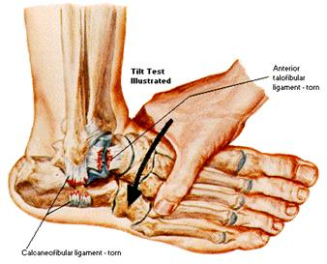
Examination
- Ligamentous laxity - If the ATFL is torn, forward motion of the foot is detected in relation to the tibia and excessive inversion when compared with the other ankle

Investigation
- If you suspect a complete ATFL tear, an ultrasound can help to make the diagnosis.

Differentials
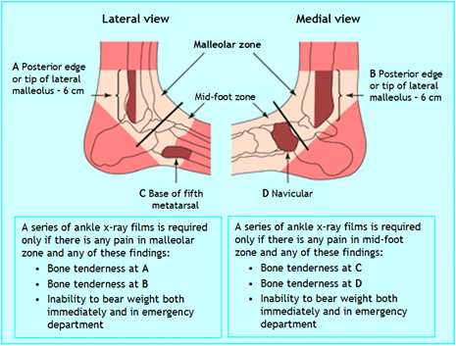
Ankle injury – use Ottawa rules
Ottawa rules:
Order an ankle x-ray if there is pain around the malleoli and if:
- There is bony tenderness at the posterior edge or
- Tip of the malleolus or Inability to bear weight for 4 steps
Order a foot x-ray if there is pain at the midfoot area and:
- Bony tenderness at the base of the 5th metatarsal or
- Bony tenderness over the navicular or
- Inability to bear weight for four steps
Make sure no Achilles tendon rupture – pain over Achilles tendon++ but can have a good range of active ankle movement. Simmond’s test – squeeze calf → passive ankle plantar flexion.

Management
- Rest - Rest (for the first 2-3 days), ice (wrapped in a damp towel – applied 20 mins qds), compression (elastic bandage—snug but not tight, remove before sleep) and elevation.
- Activity modification - no running until better, no heat & massage in the first 3 days
- Protection - Protect from further injury, e.g. using a support or high-top, lace-up shoes
- Analgesia - Paracetamol & codeine. Topical and oral NSAIDs should NOT be prescribed for first 2 days – the healing requires inflammation and so may be impeded by these drugs if they are given too early.
- Exercises/Physiotherapy - Writing the alphabet with the great toe moves the ankle through a full range of motion. Stationary biking (i.e. on an exercise bike) and stretching of the Achilles tendon are also beneficial. Balance board.
- Ankle brace - This is indicated for complete ATFL tears and should be worn until the patient can walk pain-free
- Surgery – grade three injuries if no improvement with conservative treatment after 6w.

(Foot) Plantar Fasciitis
The plantar fascia is the thick connective tissue which runs from the tuberosity of the calcaneus (heel bone) forward to the heads of the metatarsals. Plantar fasciitis is inflammation of that fascia. It is common! 10% of the general population. Can be bilateral in 30%. Overweight 40-60 y olds, those on their feet all the time, bad footwear or overpronation. W>M

Easy to diagnose
- Intense pain during the first steps after waking or a period of inactivity
- Soreness or tenderness of the heel (sometimes extends to the medial arch)
- Lessening pain with moderate foot activity but worsening later during the day
- Worsens after long periods of standing or walking, especially when walking barefoot on hard surfaces
- A limp may be present and patients may prefer to walk on their toes
- Examination – tender where plantar fascia inserts into the calcaneus (medial calcaneal tuberosity under the heal) – and possibly along plantar arch. Passive dorsiflexion of toes can increase the pain. Get patient to tiptoe walk → pain +++.

Differentials
- Achilles tendonitis and retro-calcaneal bursitis
  - Presence of a palpable gap
  - Weakness of ankle plantar flexion
  - Reduced plantar flexion using the calf squeeze test
  - Increased passive ankle dorsiflexion (Matles test) with gentle manipulation
- Morton’s neuroma
  - pain in the forefoot rather than the heel. pain on compressing together the metatarsals (not typical in plantar fasciitis)
- Calcaneal Stress Fracture
- Squeezing the calcaneus (medio-laterally) induces pain
- OA – pain all over the foot joints and not at the insertion point of the fascia at the heel.

Investigations
Note, clinical. X-ray if you suspect foot fracture or OA. Note, heel spurs on x-ray are common – and do not required treatment or removal.

Management
- Advice - The prognosis is good, most patients recover within a year
- Activity modification - avoid walking barefoot or in ill-fitting shoes. Avoid standing or walking for long periods
- Protection - Good arch support and cushioned heels - medial arch supports. Vasyli splints?
- Analgesia - Topical NSAIDs, paracetamol, codeine, oral NSAIDs
- Exercises/Physiotherapy - Stretching exercises (GP can advise rather than physio)
- Steroid injections - little consensus Injections successful in over 70% of cases but potential risk of plantar fascia rupture (10% and fat pad atrophy - this is significant because plantar fascia rupture causes chronic mid-foot pain and fat pad atrophy removes the natural cushion to heel strike)
- Orthoses - Correct foot over-pronation with insoles Vasyli splints
- Surgery - self-limiting condition, resolution occurs in up to 90% of patients. Avoid surgery.
- Prevention - Lose weight if overweight

Exercises
Ankle exercises.
- When waking up – before getting out of bed, loop a towel around the base of your foot and pull it with your knees straight – pull your feet towards you (in medical terms, we call this dorsiflex). Repeat three times for each foot.
Stair stretches for Achilles tendon and plantar fascia
- Stand on the bottom step of the stairs, facing upstairs using the stair rail for support. The feet should be positioned so that both heels are off the end of this step with the legs slightly apart. Now lower your heels keeping the knees straight until a tightly is felt in the calf. Hold this position for 20 to 60 seconds and then raise your heels back to neutral. Repeat six times twice a day.
Chair stretches for the Achilles tendon and plantar fascia
- Sit in a chair with the knees bent at right angles and your feet and heels flat on the floor. Lift the foot upwards with the heel kept on the floor (the calf muscles and the eight least tending should be felt to tighten). Hold this position for 5 to 10 seconds, then relax. Do 10 in a session. Repeat five or six times throughout the day
Dynamic stretches for the plantar fascia
- Roll the foot on a cool drink can or a tennis ball. Repeat this at least twice a day.

