Hypermobility Syndrome Scoring:

Beighton's modification of the Carter and Wilkinson scoring system
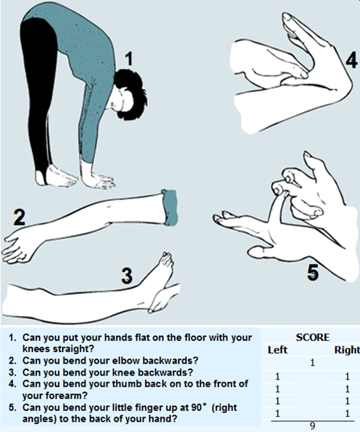
Give yourself 1 point for each of the manoeuvres you can do, up to a maximum of 9 points
Criteria
- A Beighton score of 4/9 or greater (either currently or historically)
- Arthralgia for longer than 3 months in 4 or more joints

