      - Prevalence 4% - 7x in Females Global problem. PMR is very rare under the age of 50.
- Practically, most useful to consider FMS to be a maladaptive pain response leading to bodily distress.
- Associated with Chronic Fatigue Syndrome, which is an important differential.

Diagnosis of Fibromyalgia Syndrome (FMS)
- No current diagnostic test for FMS
- Multiple somatic symptoms + classically described tender points.
- 11 out of 18 well defined tender points. American College Rheumatology guidelines (2010) says you do NOT need to do a detailed assessment of tender points greater emphasis on the patient’s pain, its severity and somatic symptoms experienced (see table below)
- If you suspect FMS, it is worth going back through the patient’s notes depression, anxiety, eating disorders and childhood abuse are all significantly associated with FMS.
Three Top tips!
- Trust your clinical instinct. 2. Look for cues of bodily distress. 3. Use chart to confirm diagnosis

Differentials
The following conditions can also cause widespread musculoskeletal pain:
- Inflammatory arthritis (including RA and spondyloarthropathies)
- Polymyalgia rheumatica
- Polymyositis/dermatomyositis
- Chronic Fatigue Syndrome
- Vit D deficiency
- Statin side effects
- Hypo/hyperthyroidism
- Multiple sclerosis
- Hypermobility syndromes (please see the diagram opposite for more information on diagnosing this condition, which often coexists with FMS)
- Malignancy
- Vasculitides, Neuropathies, Osteomalacia
-----------------------------------------------------------------------------------------------------------------------------------------------------------------
- Hypermobility is common, easy to diagnose clinically but also easy to miss if you don’t think of it. It is actually a risk factor for FMS, so a patient may have both conditions.
- Thyroid disease and statin-related pain are quite common.
- Mild vitamin D deficiency is very common and in fact 16% of the UK population will have significant vitamin D deficiency in the winter months.
- In patients presenting principally with fatigue, exclude restless leg syndrome or sleep apnoea.
- Most of the other differentials are rare as new presentations in primary care.

Beighton's modification of the Carter and Wilkinson scoring system for Hypermobility Syndrome
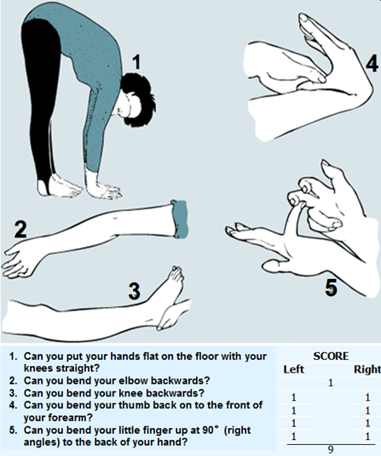
Give yourself 1 point for each of the manoeuvres you can do, up to a maximum of 9 points

Interpretation
Score of 4 or more with arthralgia for >3m = hypermobility syndrome

Investigations
- FBC, ESR, CRP
- TSH (thyroid dysfunction)
- CK (creatine kinase) – polymyositis/dermatomyositis
- Calcium, 25 hydroxyvitamin D (osteomalacia, vit D def)
- Alkaline phosphatase
- Blood glucose (or HbA1c)
- Urinalysis for protein, blood and glucose
Note: ANA and Rheumatoid Factor/anti-CCP should only be done if there are specific pointers in the history or examination which raise the suspicion of an inflammatory arthritis or connective tissue disease.

Management starts with Explanation
Knowing how to discuss FMS with patients is a key skill in determining how patients will engage. Explanations are key. Patients with FMS just want to be believed, diagnosed correctly, understood and to have a confident, positive and patient-centred management plan.
- Pejorative terms do not help: ‘it’s all in your mind’ – number needed to offend (NNO) = 2
- Pathophysiological explanation incorporating the nervous system NNO =9
Explanation must remove blame, not denigrate, incorporate psychological and the biological, enable negotiation of a constructive management plan. To do this –
- Explore ICE & the psycho-social (work, family life, dynamics, stresses).
- Look at joints to ensure joints don’t look inflamed nor synovium thickening.
- Examine – make a fist, squeeze, make a prayer, dorsum of hand to dorsum of other hand
- Feedback the blood results done.
- Explain FMS is common. Find out what they know about it – start with their starting point.
“In FMS it seems like your body thermostat for pain is wrongly set, so that pain and other sensations are amplified. Why this happens nobody knows – there have been theories, but not single cause has been found – probably because it’s not because of just one thing. We know how bad the pain can be and we know it’s not in your mind. It’s not psychological. The body, the brain, the spine, the nerve endings as well as various hormones and chemical all work together. In FMS there is disturbance in the general balance of these. To restore the balance, the first think we need to do is to ensure you understand quite a bit about FMS and keep a positive attitude otherwise it might not get better.”

Management after Explanation
- No need to see a specialist – most of these are managed in GP.
- Excellent leaflet from FMS AND on ‘Living with Chronic Pain’ from Arthritis Research UK – http://www.arthritisresearchuk.org/arthritis-information/conditions/fibromyalgia.aspx
- The pain toolkit: www.paintoolkit.org

- Try and encourage to get back to work.
- Amitriptyline? – works about 2w time. Warn: dry mouth, blurred vision - usually short lived.
- Review 4w.

What works?
Recommendation | Stronger evidence | Weaker evidence
Non-pharmacological | Heated pool treatment (balneotherapy)  Relaxation, rehabilitation, physiotherapy and psychological support  Individually tailored exercise programme, including aerobic exercise and strength training | CBT
Pharmacological | Tramadol for pain management  - Amitriptyline (TCAD)  - Fluoxetine (SSRI)  - Duloxetine (SNRI)  These drugs are used to reduce pain and often improve function  Tramadol, Pramipexole and pregabalin reduce pain | Simple analgesics and weak opioids
Note: no good evidence for analgesic effect of NSAIDS in FMS! So don’t bother using it.

