Fibromyalgia assessment
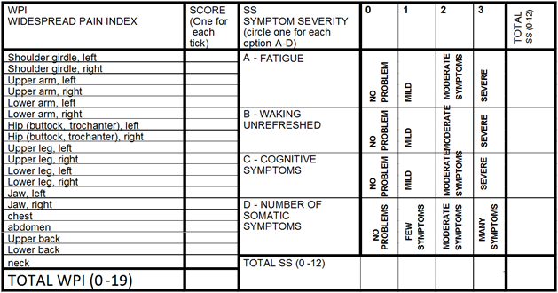
For FMS, all of 1, 2 and 3 must be satisfied.
- WPI ≥7 and SS ≥5 or WPI 3-6 and SS≥9
- Symptoms have been present for at least three months
- There is no alternative explanation for the pain

