BRADFORD VTS TEACHING AIDS
June 2026
Ocular Emergencies
The eye problems that walk into primary care and minor surgery — how to recognise them fast, what you must do, and who to refer.
For GP trainees & IMGs · Recognise → Act → Refer · Updated to current UK guidance
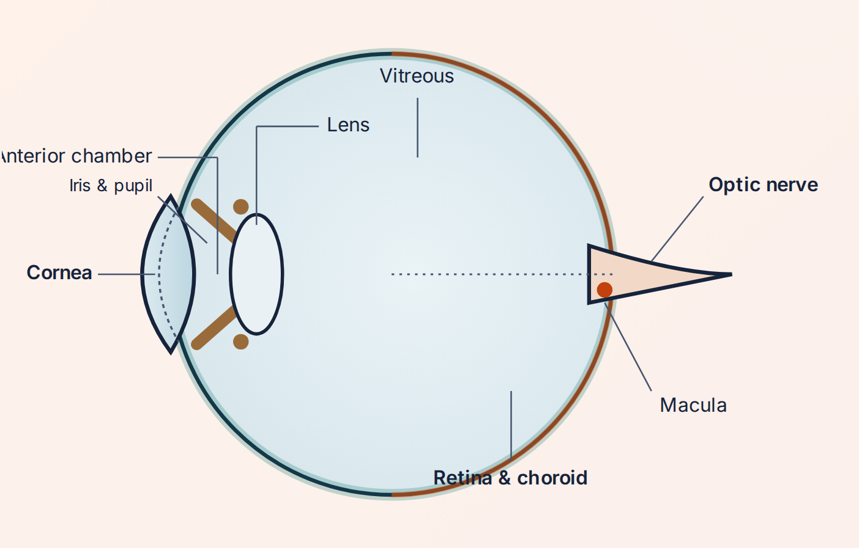
Anatomy of the eye — orient yourself before you assess
★ Start here — two questions decide everything
Before any diagnosis, anchor on these. They sort the harmless from the sight-threatening.
1 · Can the eye SEE?
Measure visual acuity in each eye separately, every time. Sudden loss of vision is an emergency until proven otherwise. Compare with the other eye.

2 · Is it PAINFUL / RED — and is the CORNEA clear?
The cornea is the eye's windscreen: the most exposed and most vulnerable surface. A cloudy cornea, deep pain, or photophobia points to a serious cause. Stain with fluorescein and view under blue light.

HOW URGENT? — A TRAFFIC-LIGHT KEY USED THROUGHOUT THIS GUIDE
EMERGENCY  Act within minutes. Phone the eye team / 999 / stroke pathway now. | SAME-DAY  Discuss with on-call ophthalmology today. | URGENT 24–48h  Urgent eye-clinic / optometry referral. | GP / OPTOMETRY  Manage in primary care; routine review.

A 60-SECOND EXAMINATION
- History first — but never delay irrigation in a chemical splash. Ask the questions that change management: metal hammering/grinding (think hidden penetrating injury), chemical, welding/UV, contact lenses, trauma, previous eye disease.
- Visual acuity — both eyes, with glasses/pinhole. The single most useful number you can record.
- Look anterior → posterior — lids, conjunctiva, cornea, anterior chamber, pupil. Use a bright pen-torch shone obliquely.
- Fluorescein + blue light — abrasions and dendritic ulcers light up green.
- Pupils & red reflex — shape, size, and the swinging-light test for a relative afferent pupillary defect (RAPD).

THE SWINGING-LIGHT TEST (RAPD)
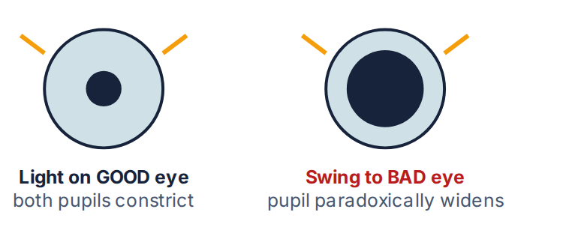
An RAPD means a problem in the retina or optic nerve of that eye (e.g. CRAO, optic neuritis, large detachment). It is one of the most valuable signs in sudden visual loss — and it does not lie.

1 Eye trauma & injuries
From a splash of bleach to a flying metal fragment — the time-critical injuries come first.
Chemical burns EMERGENCY
The one true “irrigate-before-anything-else” emergency. Alkalis (lime, cement, drain cleaner, ammonia) are worse than acids.
◉ SPOT IT
- Pain, watering, redness, blurred vision after a splash. A white, “quiet” eye is NOT reassuring — it can mean surface vessels have been burned away (limbal ischaemia): the most severe injuries.
- Acid coagulates the surface and forms a barrier (like a scab). Alkali soaks inward like water into a sponge — penetrating deeper and doing more damage.
✓ DO THIS
- Irrigate immediately — before history, before acuity, before referral. Use saline (or Hartmann's, or plain water if nothing else). A topical anaesthetic drop makes irrigation tolerable.
- Evert both lids and sweep the fornices to remove retained particles (especially cement/lime).
- Irrigate until the surface pH is neutral (7.0–7.4); recheck pH 5 minutes after stopping — a drifting pH means hidden particles remain.
- You must refer same-day to ophthalmology.
⚑ Do not delay irrigation to assess severity. Minutes of contact time change the outcome. Source: College of Optometrists CMG (Trauma – chemical, 2026); RCEMLearning.

Foreign body — subtarsal & corneal GP / OPTOMETRY
A gritty, very irritable eye after grinding, drilling or a windy day. History is usually the giveaway.
◉ SPOT IT
- Subtarsal FB hides under the upper lid and is missed on a casual look — it scratches the cornea with every blink (vertical fluorescein scratches).
- Corneal FB is visible on the cornea itself; often metallic.
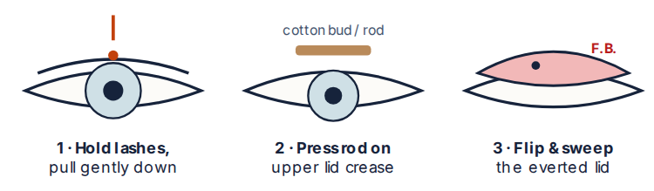
✓ DO THIS
- Evert the upper lid and sweep a moistened cotton bud across the tarsal conjunctiva — this lifts most subtarsal foreign bodies in seconds.
- For a superficial corneal FB: instil a topical anaesthetic, then lift it with the edge of a sterile needle/cotton bud. Do not dig.
- Give chloramphenicol ointment afterwards; check tetanus status for dirty/metallic injuries.
⚑ Leave a rust ring or a deeply embedded FB and refer — do not gouge the cornea. A metal-on-metal history demands you exclude a penetrating injury (see below).

Corneal abrasion · UV “arc eye” · recurrent erosion GP / OPTOMETRY
Painful, watering, photophobic eye with a fluorescein-positive surface defect — but the eye itself is structurally intact.
◉ SPOT IT
- Abrasion: history of a scratch (fingernail, twig, contact lens), gritty pain, fluorescein-staining defect.
- Arc eye / UV keratitis: welders and sunbed users; bilateral severe pain 6–12 h after exposure; diffuse punctate fluorescein uptake.
- Recurrent erosion: wakes the patient with sharp pain on opening the eyes, over a previously injured area.
✓ DO THIS
- Simple oral analgesia + lubricating drops/ointment. A short course of chloramphenicol 1% ointment QDS for ~5 days is commonly used as prophylaxis.
- Most heal in 24–72 hours. Arc eye settles within ~24–48 h.
⚑ Do NOT routinely pad the eye — patching does not speed healing and may worsen it. Do NOT send the patient home with topical anaesthetic drops — they are toxic to the cornea, abolish the protective blink reflex, and delay healing. Contact-lens wearers must be referred (cover with an anti-pseudomonal antibiotic) — assume infective keratitis. Source: NICE CKS Corneal superficial injury; RCEMLearning.

Blunt trauma — the “black eye” work-up SAME-DAY
Bruised lids do not equal a safe eye. Four quick checks decide whether the globe is in trouble.
◉ SPOT IT
- Can they see? Open swollen lids gently and check acuity.
- Is the globe intact? Look for hyphaema (blood level in the anterior chamber).
- Position & movement? A sunken eye + restricted up-gaze + double vision + cheek numbness suggests an orbital “blow-out” fracture.
- Bony margin — feel for a step.

Hyphaema — blood layered in the anterior chamber
✓ DO THIS
- Hyphaema must be referred same-day — risk of re-bleed and dangerously raised pressure over the following days. Keep the patient upright and rested.
- For a suspected blow-out fracture, request a CT of the orbits (modern practice — not plain X-ray “tomograms”) and refer.
➔ Iris/lens damage, vitreous haemorrhage and traumatic retinal detachment can all follow blunt injury — if the view in is poor or vision is reduced, refer.

Penetrating injury · open globe · intraocular FB EMERGENCY
The sight-destroyer that can look deceptively minor. Suspect it after hammering/grinding metal or any sharp, high-velocity injury.
◉ SPOT IT
- Tiny entry wound, a peaked or teardrop pupil, a soft eye, dark uveal tissue at a wound, or a shallow anterior chamber.
- The entry point for a metal fragment can be almost invisible — history carries the diagnosis.
✓ DO THIS
- Do NOT remove a protruding object. Do NOT instil any drops, pad, or press on the eye — pressure can extrude the contents.
- Protect with a rigid shield (not a soft pad). Keep nil by mouth for surgery.
- Give analgesia + an anti-emetic (vomiting/straining raises eye pressure), update tetanus, and start systemic antibiotics as advised.
- Refer as an emergency. Imaging to locate a metallic intraocular FB is by CT — never MRI (a magnet will move metal).
⚑ Urgent referral is required. Any “I was hammering metal” history with eye symptoms is an intraocular foreign body until proven otherwise. Source: RCOphth / Community Eye Health; AAO Open Globe.

Eyelid lacerations SAME-DAY
Most lid cuts are simple, but some need specialist repair to avoid lasting damage.
◉ SPOT IT
- Higher-risk wounds: those crossing the lid margin, those at the inner (medial) corner (the tear-drainage canaliculus runs here), and any with tissue loss or possible deep penetration.
✓ DO THIS
- Keep any exposed cornea protected with ointment.
- Refer lid-margin, canalicular, and tissue-loss lacerations for specialist (oculoplastic) repair — poor alignment causes notching, watering and cosmetic defects.
- Always exclude an underlying globe injury before you focus on the skin.

2 The acute red eye
Most red eyes are harmless. This section is about reliably catching the few that are not.
RED-EYE DIFFERENTIATOR — THE PATTERN THAT MATTERS
Discharge + normal vision + clear cornea is reassuring. Pain, photophobia, reduced vision, a hazy cornea, or an abnormal pupil are the danger signals.
Clue | Conjunctivitis | Anterior uveitis (iritis) | Acute angle-closure glaucoma | Microbial keratitis / ulcer
Pain | Gritty, mild | Aching, photophobic | Severe + headache, nausea | Significant, foreign-body feel
Redness | Diffuse, whole eye | Around the cornea (ciliary flush) | Around the cornea, congested | Around the cornea ± white spot
Vision | Normal | Blurred | Markedly reduced, haloes | Reduced if central
Pupil | Normal | Small / irregular | Mid-dilated, fixed, oval | Normal / small
Cornea | Clear | Clear (cells behind) | Hazy / steamy | Cloudy infiltrate, stains
Action | GP / OPTOMETRY | SAME-DAY | EMERGENCY | SAME-DAY

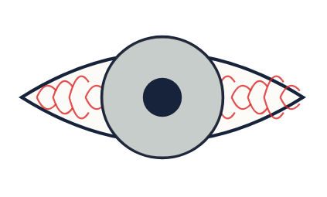
Conjunctivitis — diffuse redness, clear cornea

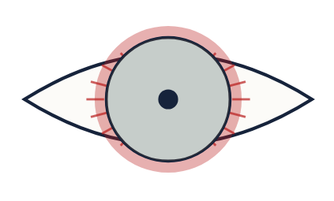
Iritis — ciliary flush, small pupil

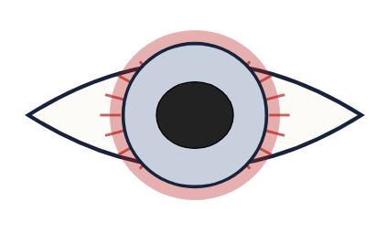
Acute glaucoma — hazy cornea, fixed mid-dilated pupil

Conjunctivitis GP / OPTOMETRY
Common, contagious, and usually self-limiting. The job is to treat hygiene and spot the few that need referral.
◉ SPOT IT
- Bacterial: sticky/purulent discharge, lids gummed in the morning. Viral: watery, often with a cold, very contagious. Allergic: itch, bilateral, watery, with swelling (chemosis).
✓ DO THIS
- Most cases need no antibiotic — advise hygiene, lubricants and that it settles in 1–2 weeks. Topical chloramphenicol is the option if treatment is wanted/severe (note recent UK supply shortages — fusidic acid is an alternative).
- Allergic: antihistamine/mast-cell stabiliser drops; avoid the allergen.
- Do not wear contact lenses until fully better.
⚑ Refer a red eye with pain, photophobia, reduced vision, contact-lens wear, a hyperacute copious-pus presentation (?gonococcal), or in a neonate — these are not simple conjunctivitis. Source: NICE CKS Conjunctivitis (infective).

Microbial keratitis & contact-lens red eye SAME-DAY
A corneal infection that can perforate the eye within days. Contact-lens wearers are the high-risk group.
◉ SPOT IT
- Painful, very red eye with photophobia, watering and a white/grey corneal infiltrate; there may be a hypopyon (a layer of pus in the anterior chamber).
- In contact-lens wearers, also think Acanthamoeba — pain out of proportion to signs.
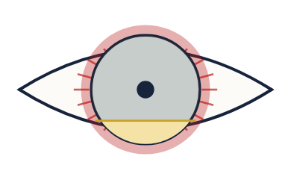
Hypopyon — pus layered in the anterior chamber
✓ DO THIS
- Refer same-day for corneal scrape, culture and intensive topical antibiotics.
- Have a very low threshold: any contact-lens wearer with a red, painful eye is referred until keratitis is excluded.
⚑ Do NOT prescribe topical steroids for an undiagnosed red/painful eye — they can accelerate infection and melt the cornea.

Herpes simplex keratitis (dendritic ulcer) SAME-DAY
The classic branching corneal ulcer — and the classic trap, because steroids make it catastrophically worse.
◉ SPOT IT
- Variable irritation, redness, watering and photophobia, often recurrent, sometimes after a cold sore.
- Fluorescein reveals a branching, tree-like (dendritic) ulcer. Corneal sensation is reduced.
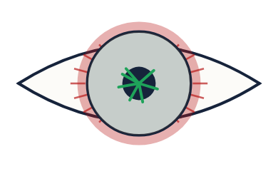
Dendritic ulcer staining with fluorescein
✓ DO THIS
- Topical antiviral: aciclovir 3% eye ointment 5×/day, or ganciclovir 0.15% gel 5×/day, until healed.
- Refer promptly for confirmation and review. (Idoxuridine, used in older texts, is obsolete.)
⚑ NEVER give topical steroids in active herpes epithelial disease — they can turn a small dendrite into a sight-threatening geographic ulcer or perforation. Source: NHS Scotland eyecare guidelines; RCEMLearning.

Anterior uveitis (iritis) SAME-DAY
A painful, photophobic, watering eye with deep redness hugging the cornea. Often recurrent and linked to systemic disease.
◉ SPOT IT
- Ciliary (circumcorneal) flush, aching pain, intense photophobia, blurred vision; the pupil is small and may be irregular (adhesions).
- Pain in the affected eye when light shines in the other eye (consensual photophobia) is a useful clue. Associations: ankylosing spondylitis and other HLA-B27 conditions.
✓ DO THIS
- Refer within 24 hours. Treatment is ophthalmology-led: topical steroid (frequent, then tapered) plus a dilating drop (cyclopentolate) to relieve spasm and prevent the iris sticking to the lens.
➔ Recurrent attacks are common; previous iritis + a red painful photophobic eye = re-refer urgently to start treatment early.

Acute angle-closure glaucoma EMERGENCY
Pressure in the eye rises suddenly and steeply. A few hours can cost the sight in that eye.
◉ SPOT IT
- Typically older, long-sighted, often in dim light/evening. Severe eye pain + headache + nausea/vomiting, blurred vision and haloes around lights.
- Red eye, a steamy/hazy cornea, a fixed mid-dilated oval pupil, and a globe that feels rock-hard (like a marble) on gentle comparison with the other eye.
✓ DO THIS
- This is an emergency — contact ophthalmology immediately (same hour). Lie the patient flat (helps the lens fall back and open the angle).
- Give analgesia and an anti-emetic. Initial pressure-lowering (the eye team's mainstay is systemic acetazolamide) is specialist-directed; definitive treatment is laser iridotomy.
⚑ Do NOT dilate the pupil if angle closure is possible. Beware: the headache, nausea and vomiting are often mistaken for a migraine or a stomach upset — always examine the eye. Source: RCOphth Angle-Closure Glaucoma guideline.

Subconjunctival haemorrhage GP / OPTOMETRY
Looks alarming, behaves benignly — a flat sheet of bright blood on the white of the eye.
◉ SPOT IT
- Painless, vision normal, no discharge. Often after a cough, sneeze, straining, or for no clear reason.
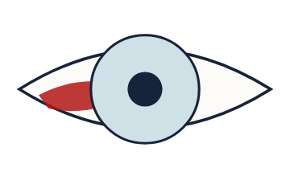
✓ DO THIS
- Reassure — it clears over 1–2 weeks like a bruise; no treatment needed.
- Check blood pressure; if recurrent or with other bruising/bleeding, review clotting/medication.
⚑ If it follows trauma and you cannot see the back edge of the blood, or vision is affected, exclude a ruptured globe and refer.

3 Eyelids, tear system & surrounds
Lumps, lashes and lid position — mostly minor, with two genuine emergencies hiding among them.
Stye (hordeolum) & chalazion GP / OPTOMETRY
Two lid lumps that get confused. One is a tender infection on the margin; the other a firm painless cyst in the lid.
◉ SPOT IT
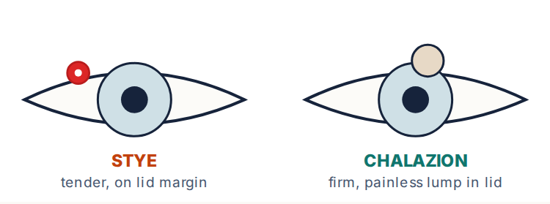
✓ DO THIS
- Stye: warm compresses; usually settles. Give topical antibiotic only if spreading; consider oral antibiotic if there is surrounding cellulitis.
- Chalazion: warm compresses + lid massage; if a firm painless lump persists, refer for incision & curettage (a minor-surgery procedure).
➔ Recurrent styes/chalazia → check for blepharitis and screen for diabetes. A persistent, hard, or atypical lid lump (especially recurring in the same spot) needs review to exclude a lid tumour.

Blepharitis GP / OPTOMETRY
Chronically sore, crusted, gritty lid margins — the commonest cause of a low-grade irritable eye.
◉ SPOT IT
- Red, crusted lid margins; burning/grittiness worse in the mornings; often with dry eye.
✓ DO THIS
- Lid hygiene is the mainstay and must be ongoing: warm compresses, gentle lid massage, and cleaning the lashes.
- Treat associated dry eye with lubricants; a topical antibiotic ointment can help if the margins are infected.

Entropion · ectropion · trichiasis GP / OPTOMETRY
Lid-position problems of older age. Entropion turns lashes IN against the cornea; ectropion turns the lid OUT.
◉ SPOT IT
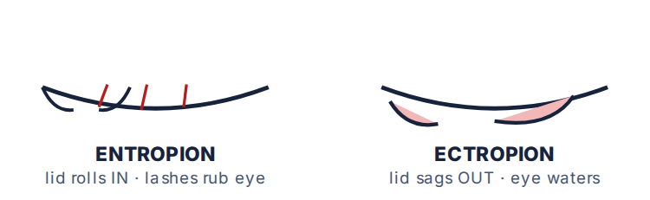
✓ DO THIS
- Entropion: lashes abrade the cornea (stains with fluorescein). As a temporising measure, tape the lower lid down and lubricate; refer for corrective surgery.
- Ectropion: watering and exposure; lubricate and refer for surgery.
- Trichiasis (misdirected lashes): epilate the offending lashes; recurrent cases need electrolysis/specialist treatment.
➔ Persistent corneal abrasion from lashes can scar and threaten sight — refer rather than repeatedly epilating.

Dacryocystitis URGENT 24–48H
Infection of the tear sac, sitting just below the inner corner of the eye, behind a blocked tear duct.
◉ SPOT IT
- A tender, red, tense swelling at the medial canthus (side of the nose), a watering eye, and sticky discharge.
✓ DO THIS
- Start systemic antibiotics. Warm compresses help.
- Avoid incising a pointing sac if possible; definitive treatment is later surgery to create a new drainage route (dacryocystorhinostomy, DCR).
➔ Spreading infection or systemic upset → escalate; in babies, refer congenital nasolacrimal obstruction if not settling.

Preseptal vs orbital cellulitis EMERGENCY
Both give a red swollen lid. The difference is whether infection has crossed the orbital septum — and that difference can be fatal.
◉ SPOT IT
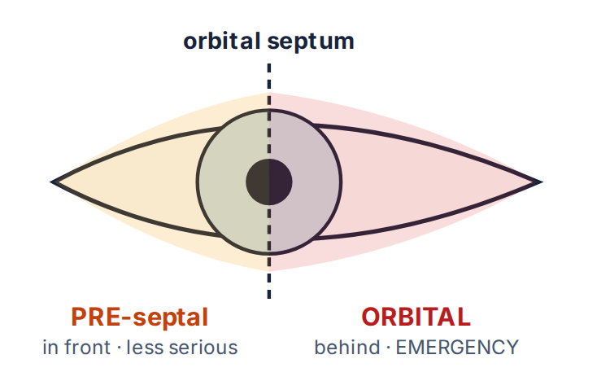
- Orbital (post-septal) red flags: proptosis (bulging eye), pain/restriction on eye movements, reduced vision, an RAPD, and a systemically unwell patient.
✓ DO THIS
- Orbital cellulitis is an emergency — admit immediately for IV antibiotics and CT of orbit/sinuses. Untreated, it can spread to a cavernous-sinus thrombosis, intracranial abscess, meningitis, or death.
- Preseptal (in front of the septum, no orbital signs): oral co-amoxiclav, but keep a low threshold to admit — especially children.
⚑ Any of proptosis, painful/limited eye movement, or reduced vision means orbital until proven otherwise → emergency admission. Source: NICE CKS; RCOphth/Community Eye Health.

Herpes zoster ophthalmicus (shingles of the eye) SAME-DAY
Shingles in the first division of the trigeminal nerve. A rash on the tip of the nose warns the eye is in danger.
◉ SPOT IT
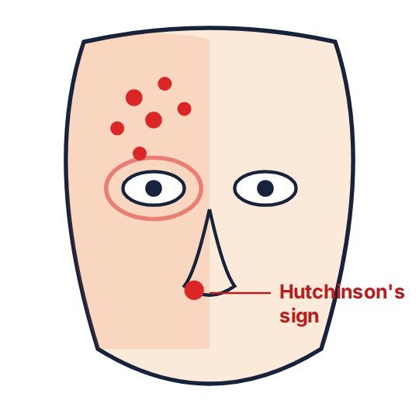
- Unilateral painful vesicular rash over the forehead/scalp/upper lid, stopping at the midline.
- Hutchinson's sign — vesicles on the side/tip of the nose — predicts a high risk of eye involvement.
✓ DO THIS
- Start oral aciclovir 800 mg five times daily for 7 days (ideally within 72 h of the rash); valaciclovir/famciclovir are alternatives.
- Refer same-day to ophthalmology if the eye is red or painful, vision is affected, or Hutchinson's sign is present. Eye inflammation is treated by the specialist with steroid/antiviral drops.
⚑ Antiviral therapy is mandatory at any age when the eye is threatened. Source: NICE CKS Shingles; NHS Scotland eyecare guidelines.

4 Sudden loss of vision
Time is retina. Sort by one question first: is the eye PAINFUL or PAINLESS?
PAINLESS SUDDEN LOSS
- Lasting: CRAO, CRVO, retinal detachment, vitreous haemorrhage, wet AMD, ischaemic optic neuropathy (GCA).
- Transient (recovers): amaurosis fugax (a TIA) — and GCA in the elderly.

PAINFUL SUDDEN LOSS
- Optic / retrobulbar neuritis (pain on eye movement), acute angle-closure glaucoma, severe keratitis/endophthalmitis.
- Always check for an RAPD and test the visual fields by confrontation.

Central retinal artery occlusion (CRAO) EMERGENCY
A “stroke of the eye.” Sudden, painless, profound loss of vision in one eye — treat with the same urgency as a brain stroke.
◉ SPOT IT
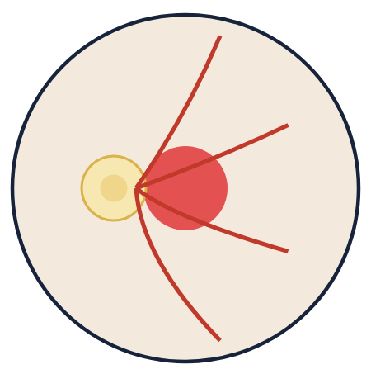
Pale retina with a cherry-red spot at the macula
- Sudden painless monocular loss; an RAPD; on fundoscopy a pale retina with a cherry-red spot.
✓ DO THIS
- Refer immediately on the acute stroke pathway AND to ophthalmology. It carries a high risk of a subsequent brain stroke.
- In anyone over 50, exclude giant cell arteritis at the same time — urgent ESR + CRP.
⚑ This is a vascular emergency. Do not arrange routine outpatient follow-up. Source: AHA Scientific Statement on CRAO; RCOphth.

Giant cell arteritis (GCA) EMERGENCY
Inflamed cranial arteries in the over-50s. Miss it and the patient can lose the sight in both eyes within days.
◉ SPOT IT
- Over 50 with a new headache, scalp tenderness (sore to comb hair), jaw claudication (ache on chewing), malaise, and visual symptoms (transient loss or sudden loss).
✓ DO THIS
- Check ESR + CRP + FBC urgently.
- Start high-dose corticosteroids immediately on clinical suspicion — do NOT wait for the temporal-artery biopsy (biopsy within ~1–2 weeks).
- Same-day specialist referral (ophthalmology/rheumatology). Treatment protects the other eye.
⚑ Visual loss in GCA can be permanent and bilateral. Steroids must not be delayed for investigations. Source: NICE CKS Giant cell arteritis.

Central retinal vein occlusion (CRVO) SAME-DAY
The artery's counterpart — blood cannot drain out, so the retina floods.
◉ SPOT IT
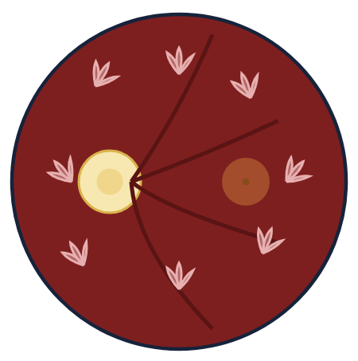
“Blood & thunder” — widespread haemorrhages, engorged veins
- Sudden, usually painless, often less complete loss; fundus shows scattered haemorrhages with dilated tortuous veins.
✓ DO THIS
- Refer. Check and address vascular risk factors — blood pressure, glucose, lipids.
- Warn that secondary glaucoma can develop weeks later (a painful eye after a CRVO needs review).

Retinal detachment & posterior vitreous detachment SAME-DAY
Like wallpaper peeling off a wall — the light-sensing layer lifts away from the back of the eye.
◉ SPOT IT
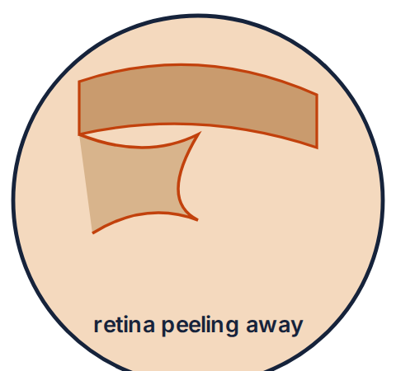
- New flashes of light + a sudden shower of floaters ± a dark curtain/shadow spreading across the vision.
- Higher risk in high myopes, after cataract surgery, and after trauma.
✓ DO THIS
- New flashes/floaters → urgent (same-day) optometry/ophthalmology to exclude a retinal tear (treatable with laser) before it detaches.
- An established curtain across the vision is an emergency — detachment needs surgery; the sooner the macula is still attached, the better the outcome.
⚑ Floaters alone in an older patient are usually a benign posterior vitreous detachment — but you cannot tell tear from no-tear without an examination, so refer.

Vitreous haemorrhage URGENT 24–48H
Bleeding into the jelly of the eye blocks the view in and the view out.
◉ SPOT IT
- Sudden floaters, cobwebs or a red/black haze; reduced or absent red reflex.
- Commonest cause: diabetic retinopathy; also tears/trauma.
✓ DO THIS
- Advise rest and refer for assessment of the cause.

Amaurosis fugax URGENT 24–48H
A transient “curtain” coming down over one eye for minutes, then lifting completely.
◉ SPOT IT
- Painless, monocular, fully recovers. It is a TIA of the eye.
✓ DO THIS
- Manage on the TIA pathway: urgent assessment, antiplatelet, carotid imaging, vascular risk factors.
- In the elderly, also consider GCA.

Optic / retrobulbar neuritis URGENT 24–48H
Inflamed optic nerve in a younger adult — and sometimes the first sign of MS.
◉ SPOT IT
- Subacute unilateral blurring + pain on eye movement, reduced colour vision (reds look washed out), an RAPD, central scotoma.
✓ DO THIS
- Refer urgently (ophthalmology/neurology); MRI to assess for demyelination. Do not dilate before specialist review.

Age-related macular degeneration — the “wet” type URGENT 24–48H
In older patients, the treatable cause of rapid central vision change. Catching it early preserves sight.
◉ SPOT IT
- Rapid distortion of central vision (straight lines look bent — metamorphopsia) or a central blur/blank spot, over days to weeks.
✓ DO THIS
- Refer urgently to the macular service. Early wet AMD responds to anti-VEGF injections — delay loses that window.

5 Neuro-ophthalmology — quick hits
Eye signs that are really brain signs. Know the four that must not be missed.
Papilloedema SAME-DAY
Swelling of both optic discs means raised intracranial pressure until proven otherwise.
◉ SPOT IT
- Bilateral blurred disc margins; vision often normal early, with brief “grey-outs”, headache (worse lying down/straining), and sometimes double vision.
✓ DO THIS
- Refer without delay for neuro-imaging. Check blood pressure (exclude malignant hypertension).
⚑ Distinguish from harmless small/crowded discs in long-sighted eyes — when in doubt, refer.

Diplopia & cranial-nerve palsies SAME-DAY
Nerves III, IV and VI move the eye. New double vision needs a cause, and one pattern is an emergency.
◉ SPOT IT
- New binocular diplopia (gone when one eye is covered).
- A painful IIIrd-nerve palsy with a dilated (“blown”) pupil suggests a posterior-communicating-artery aneurysm.
✓ DO THIS
- Painful IIIrd + dilated pupil → emergency neuro-imaging.
- Other new palsies: check BP and glucose; refer.
⚑ “Pupil-involving” third-nerve palsy = aneurysm until excluded.

Pupils & consciousness — trauma red flags EMERGENCY
After a head injury, the pupil is a window onto the brain.
◉ SPOT IT
- A fixed, dilated pupil on one side in a head-injured patient suggests a space-occupying lesion/herniation (e.g. extradural haematoma).
- Both pupils fixed and dilated indicate profound brain injury.
✓ DO THIS
- Urgent neurosurgical assessment.
- Drug effects can mimic this: dilated (cocaine, amphetamines, anticholinergics); pinpoint (opioids).

Homonymous hemianopia & stroke SAME-DAY
Losing the same half of the field in both eyes points behind the eyes — to the brain.
◉ SPOT IT
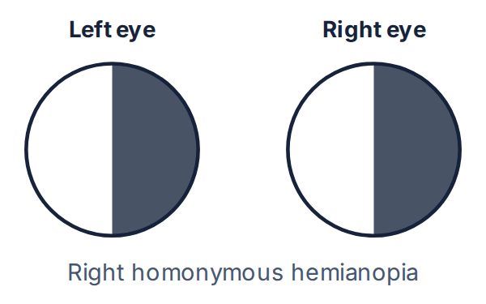
- Patients often mislabel it as “blindness in one eye” — confrontation testing reveals the true half-field loss.
✓ DO THIS
- Manage on the stroke pathway. A lesion behind the optic chiasm (commonly a stroke) is the cause.

✓ Safety-net, “never-events” & your eye kit
The page to photograph. Universal rules that keep patients — and you — safe.
REFER SAME-DAY IF ANY OF THESE
- Sudden loss of vision (painful or painless).
- Chemical splash — after immediate irrigation.
- Penetrating injury or hammering-metal history.
- Acute, severe, painful red eye with a hazy cornea or fixed mid-dilated pupil (?angle closure).
- Contact-lens wearer with a red, painful eye.
- A new flashes-and-floaters or a curtain over the vision.
- Proptosis, painful eye movements, or reduced vision with a swollen lid (?orbital cellulitis).
- Over-50 with headache + jaw/scalp symptoms + visual change (?GCA).
- Hyphaema or any reduced vision after blunt trauma.

⛔ “NEVER-EVENTS” IN THE EYE
- Never delay irrigation in a chemical injury.
- Never give topical steroids to an undiagnosed red/painful eye or a herpes dendritic ulcer.
- Never dilate the pupil if acute angle closure is possible.
- Never remove a protruding object, instil drops, pad, or press on a penetrating injury — shield it.
- Never send a patient home with topical anaesthetic drops.
- Never routinely pad a corneal abrasion.
- Never wait for a biopsy before starting steroids in suspected GCA.
- Never request MRI to find a suspected metallic intraocular foreign body — use CT.

A MODERN PRIMARY-CARE / MINOR-SURGERY EYE KIT
- Fluorescein strips + a blue light source
- Topical anaesthetic (e.g. proxymetacaine/tetracaine) — for examination only
- Saline + giving set / sterile eyewash for irrigation
- pH strips (chemical injury)
- Chloramphenicol drops & ointment
- Rigid eye shield (not a soft pad) for trauma
- Cotton buds; sterile needle (FB removal)
- Good magnification + pen-torch
- Mydriatic (tropicamide) for fundoscopy — avoid if angle-closure risk
Reflects current practice. The original 1980s booklet's list (e.g. ampicillin “Penbritin”, idoxuridine “Kerecid”, routine pilocarpine/atropine) is outdated and has been replaced.

⚠ Important — please read
This document is provided exclusively for educational and training purposes as a teaching aid. It does not constitute formal clinical guidance. Clinicians must independently verify all medical information, prescribing guidance, procedural protocols, and legal requirements against current national guidance, local policies, and the relevant regulatory bodies before applying it in practice. Information is provided as educational material and must be verified by the individual user against authoritative sources and the local policies for their area.
Key UK sources used in this edition: NICE Clinical Knowledge Summaries (Conjunctivitis – infective; Corneal superficial injury; Glaucoma; Shingles; Giant cell arteritis; Red eye); College of Optometrists Clinical Management Guidelines; The Royal College of Ophthalmologists; RCEMLearning; NHS Scotland eyecare guidelines; BNF. Verify all drug doses against the current BNF/BNFc and your local formulary.
Bradford VTS Teaching Aids · Ocular Emergencies · June 2026 · Adapted and fully updated to current UK guidance from a classic out-of-print ophthalmology teaching booklet.

