FEVER-PAIN and CENTOR for Sore Throats

When to Use
People (adults & children) with a sore throat caused by streptococcal bacteria are more likely to benefit from antibiotics. FeverPAIN or Centor criteria are clinical scoring tools that can help to identify the people in whom this is more likely.

FeverPAIN criteria

- Fever (during previous 24 hours)
- Purulence (pus on tonsils)
- Attend rapidly (within 3 days after onset of symptoms)
- Severely Inflamed tonsils
- No cough or coryza (inflammation of mucus membranes in the nose)
Each is worth 1 point.
Each of the FeverPAIN criteria score 1 point (maximum score of 5).
Higher scores suggest more severe symptoms and likely bacterial (streptococcal) cause.
- A score of 0 or 1 is thought to be associated with a 13 to 18% likelihood of isolating streptococcus.
- A score of 2 or 3 is thought to be associated with a 34 to 40% likelihood of isolating streptococcus.
- A score of 4 or 5 is thought to be associated with a 62 to 65% likelihood of isolating streptococcus.

Centor criteria

- Tonsillar exudate
- Tender anterior cervical lymphadenopathy or lymphadenitis
- History of fever (over 38°C)
- Absence of cough
Each is worth one point.
Each of the Centor criteria score 1 point (maximum score of 4).
- A score of 0, 1 or 2 is thought to be associated with a 3 to 17% likelihood of isolating streptococcus.
- A score of 3 or 4 is thought to be associated with a 32 to 56% likelihood of isolating streptococcus.

See flowchart next page
Algorithm for the management of sore throat
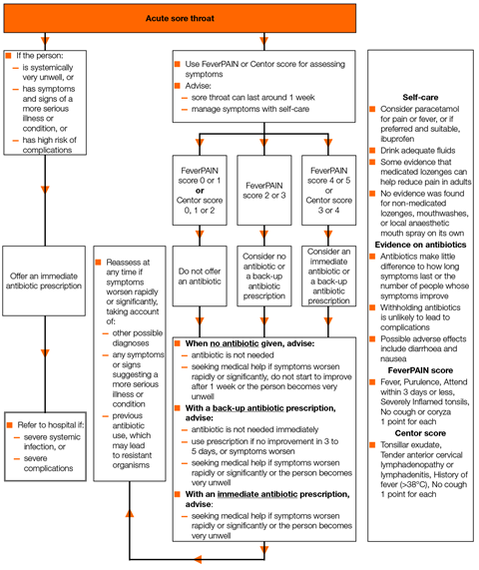

Antibiotics for children and young people under 18 years
First choice
Phenoxymethylpenicillin | 1 to 11 months, 62.5 mg four times a day or 125 mg twice a day for 5 to 10 days  1 to 5 years, 125 mg four times a day or 250 mg twice a day for 5 to 10 days  6 to 11 years, 250 mg four times a day or 500 mg twice a day for 5 to 10 days  12 to 17 years, 500 mg four times a day or 1,000 mg twice a day for 5 to 10 days
Alternative first choices for penicillin allergy or intolerance^{[F]}
Clarithromycin | 1 month to 11 years:  Under 8 kg, 7.5 mg/kg twice a day for 5 days  8 to 11 kg, 62.5 mg twice a day for 5 days  12 to 19 kg, 125 mg twice a day for 5 days  20 to 29 kg, 187.5 mg twice a day for 5 days  30 to 40 kg, 250 mg twice a day for 5 days  or  12 to 17 years, 250 mg to 500 mg twice a day for 5 days
Erythromycin | 1 month to 1 year, 125 mg four times a day or 250 mg twice a day for 5 days  2 to 7 years, 250 mg four times a day or 500 mg twice a day for 5 days  8 to 17 years, 250 mg to 500 mg four times a day or 500 mg to 1000 mg twice a day for 5 days
^{[D]} See BNF for children for appropriate use and dosing in specific populations, for example hepatic impairment and renal impairment
[E] The age bands apply to children of average size and, in practice, the prescriber will use the age bands in conjunction with other factors such as the severity of the condition and the child’s size in relation to the average size of children of the same age. Doses given are by mouth using immediate-release medicines, unless otherwise stated
^{[F]} Erythromycin is preferred in young women who are pregnant

Antibiotics for adults aged 18 years and over
First choice
Phenoxymethylpenicillin | 500 mg four times a day or 1000 mg twice a day for 5 to 10 days
Alternative first choices for penicillin allergy or intolerance^{[C]}
Clarithromycin | 250 mg to 500 mg twice a day for 5 days
Erythromycin | 250 mg to 500 mg four times a day or 500 mg to 1,000 mg twice a day for 5 days
^{[A]} See BNF for appropriate use and dosing in specific populations, for example, hepatic impairment, renal impairment, pregnancy and breastfeeding.
^{[B]} Doses given are by mouth using immediate-release medicines, unless otherwise stated.
^{[C]} Erythromycin is preferred in women who are pregnant.

See the evidence and committee discussion on
choice of antibiotic and
antibiotic course length

