TOP TIPS FOR PAEDIATRIC CARE
IN GENERAL PRACTICE 2021

History and Examination
- The carers or parents know their child best and their instinct is usually correct LISTEN to their concerns.
- Review the child’s past medical history and birth history as this gives clues to risk factors eg if premature or history of atopy may be more likely to have chronic respiratory problems. It may also inform parental developmental concerns eg. if slow to speak could this be due to ear infections?
- Are they alert and active, and resistant to examination? If not this can be a red flag.
- Ask about feeding / fluid intake and wet nappies (babies and infants can become dehydrated quickly). Red flag if not passed urine or wet nappy < 12hrs.
- Record vital observations on ALL children and have a chart accessible to refer to age related parameters (see below NICE traffic light guideline).
- In chronic problems eg behavioural or chronic illness consider the psychological, social and environmental context – this will impact upon a child’s future health and development. Are there safeguarding issues / parental mental health issues, neglect, poverty and poor housing?
- Consider parental expectations and concerns and aim to give safety net advice to reassure them and guide them as to when they need to seek further review.
- If you are unsure what is going on and whether a child needs admission for observation always speak to Paediatrics for advice. Trust your instinct!

Paediatric Emergencies and Red flags Not to be missed.
Meningococcal sepsis and Meningitis (90% occur <5yrs)
- NON blanching petechial rash or purpura in unwell child = sepsis until proven otherwise call 999 and administer Benzylpenicillin or ceftriaxime IV or IM.
- Also if irritable, poor feeding, respiratory distress, mottled skin, fever (not always seen in neonates), seizures, vomiting, headaches, photophobia, altered consciousness call 999 and if time give IM benzylpenicillin.
Withhold benzylpenicillin only in children who have a clear history of anaphylaxis after a previous dose of penicillin; a history of a rash following penicillin is not a contraindication.
Recommended doses
- in adults and children of 10 years or more : IV or IM benzylpenicillin 1.2 g
- for children 1 to 9 years : IV or IM benzylpenicillin 600 mg
- for children less than 1 year : IV or IM benzylpenicillin 300 mg

New Type I Diabetes and Diabetic Ketoacidosis
- Consider Type I diabetes in child with subacute weight loss, fatigue, thirst, polyuria and lassitude – check urine for glucose and ketones then BM if positive – Type I DM - ADMIT
- If DKA usually very unwell as illness precipitates this, with vomiting, ketotic breath and shocked – ADMIT VIA 999

Anaphylaxis
An outline anaphylaxis treatment algorithm for children for medical first responders is presented below
- consider anaphylaxis when compatible history of severe allergic-type reaction with respiratory difficulty and/or hypotension especially if skin changes present. Give oxygen and call 999
- assess for signs of stridor, wheeze, respiratory distress or clinical signs of shock.
- give adrenaline (epinephrine) 1:1000 solution. Dose is dependent on age and size of child
> 12 years: 500 micrograms IM (0.5 mL) i.e. same as adult dose > 6 – 12 years: 300 micrograms IM (0.3 mL) > 6 months – 6 years: 150 micrograms IM (0.15 mL) < 6 months 150 micrograms IM (0.15 mL)
the adrenaline dose is repeated in 5 minutes if no clinical improvement and give an antihistamine (chlorphenamine)
>12 years: 10-20 mg IM / 6-12 years: 5-10 mg IM / 1-6 years: 2.5-5 mg IM
in addition for all severe or recurrent reactions and patients with asthma give hydrocortisone
  - >12 years: 100-500 mg IM or slow IV and 6-12 years: 100 mg IM or slow IV /
  - 1-6 years: 50 mg IM or slow IV
Emergency treatment of anaphylactic reactions. Guidelines for healthcare providers. Working Group of the Resuscitation Council (UK).2008 Last reviewed 01/2018
Acute asthma in >1yr old
Ref. Management of acute asthma in children aged 1 year and over (2019 BTS / SIGN)
- Severe call 999 If SpO2 <92% place on high flow oxygen via nebuliser with salbutamol 2.5-5mg +/- ipratropium (useful especially if <2yrs).
- Admit children whose SpO2 <94% and those who are too exhausted to speak or feed. Consider admission where RR >40/min in 1-5yrs or >30/min >5yrs or where PEFR is <50% of their best. Also where recessing or using accessory muscles to breath.
- If mild to moderate symptoms and sats >94% advise up to ten puffs via spacer every 3-4hrs and advise parents/carers of children with acute asthma at home and symptoms not controlled by up to 10 puffs of salbutamol, to seek urgent medical attention.
- Aim to review within 2 days and give oral steroids early in the treatment of acute asthma. Use a dose of 10 mg prednisolone for children under 2 years of age, 20 mg for children aged 2-5 years and 30-40 mg for children >5 years (between 1-2mg / kg generally). Usually 3-5 days.
Other Paediatric problems to consider admission or discussion with Paediatrics same day.
- Kawasakis – sustained high temp for >5 days, dry lips and mouth, flaking desquamation and oedema of fingers and toes, bilateral conjunctivitis, cervical LN. Admit as common complications of coronary arteritis and aneurysm.
- Non Accidental Injury eg bruising in the non- mobile child -think safeguarding and admit for examination (check local safeguarding pathways).
- Febrile convulsion or first fit admit for investigation (give oxygen and ring 999)
- Head Injury -with any of loss of consciousness, recurrent vomiting, confusion, neurology or significant mechanism – admit (see NICE guidelines on head injury 2014).
- Bronchiolitis - <1yr due to RSV admit if poor feeding, recessing or unwell
- Dehydration due to vomiting / diarrhoea - urine output poor (dry nappies over 12hrs) / no tears / sunken anterior fontanelle or reduced capillary refill time.
- Fever or unknown origin in especially if sustained >5 days or in baby <3mnths or unwell <12mnth – consider admission will need needs a septic screen. This can often be urinary sepsis (see NICE 2019 Fever in children <5yrs).
- Transient Synovitis Unable to weight bear / acutely atraumatic immobility = irritable hip (transient synovitis) or Perthes – admit.
- Henoch Schonlein Purpura – needs BP,UES and urine dip so admit and will need follow up urine dips for several weeks (according to local protocol)
- ENT – Quinsy or mastoiditis (tender mastoid unwell with otitis media),
- Surgical
  - appendicitis (can they jump or cough without pain in RIF?) If not admit.
  - Testicular pain swollen high tender testicle – torsion.
  - Pyloric stenosis (failure to thrive, projectile vomiting and unwell/ dehydrated) presents between 2-6wks.
  - Inguinal hernias in neonate

NICE traffic light system <5yrs useful to assess the sick child and guide admission
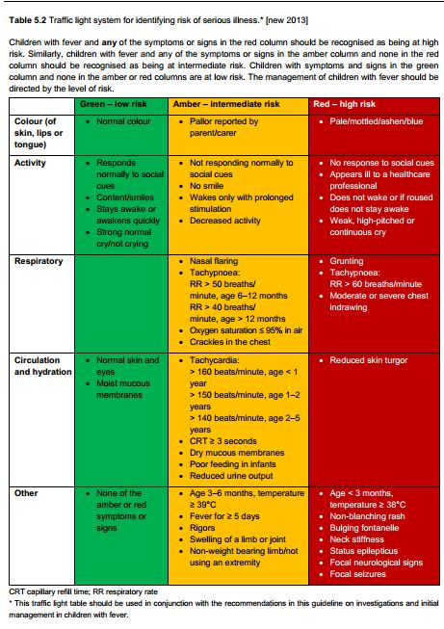
Dr Jenny Wright August 2021

