BRADFORD VTS TEACHING AIDS
Date: June 2026
Switching Oral Contraception
What to give, and when a problem arises
A practical, up-to-date guide for GP trainees and international medical graduates in UK primary care.

1. The big picture — two families of pill
Every oral contraceptive belongs to one of two families. Knowing the family tells you how it works, what can go wrong, and what to switch to.
Combined pill (COC) | Mini-pill — progestogen-only (POP)
Oestrogen + progestogen  Stops ovulation reliably; controls the cycle. | Progestogen only  Thickens cervical mucus; newer types also stop ovulation.
Carries a small blood-clot (VTE) risk.  Not for those who must avoid oestrogen. | No extra clot risk.  Safe in breastfeeding, smokers over 35, migraine with aura, higher BMI.
First-line: a lower-clot-risk pill  e.g. Microgynon 30, Rigevidon, Levest, Ovranette. | First-line: any POP by preference  desogestrel is often chosen for its forgiving 12-hour window.

The one rule that runs through this whole guide
When a patient has a problem, work down in order: Danger → Time → Basics → Switch.
Rule out danger first, give minor effects time to settle, check the simple causes, and only then change the pill.

2. Starting the combined pill — pick the lower tier first
Any combined pill may be offered according to a woman's preference. However, you should start with a lower-clot-risk (“lower-tier”) pill — a monophasic pill containing 30 micrograms of ethinylestradiol with levonorgestrel or norethisterone (NICE CKS; FSRH).
First-line choice (do this)
- Examples of lower-tier pills: Microgynon 30, Rigevidon, Levest, Ovranette (levonorgestrel); norethisterone-containing pills such as Norimin.
- Higher-tier pills (desogestrel, gestodene or drospirenone) carry roughly double the clot risk. Keep them for a specific reason or a clear patient preference, not as a default.
Always weigh this against pregnancy itself, which carries a far higher clot risk than any pill.
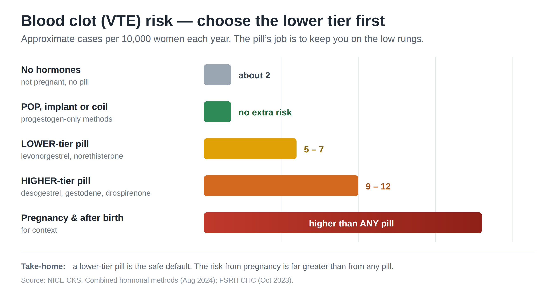

3. A problem on the combined pill — the modern approach
Bust the old myth
There is no single “perfect” pill with the fewest side effects for everyone (FSRH). The old habit of finely “balancing oestrogen against progestogen” is not well supported by evidence. Switching is largely trial and error — so do it sensibly, not endlessly.
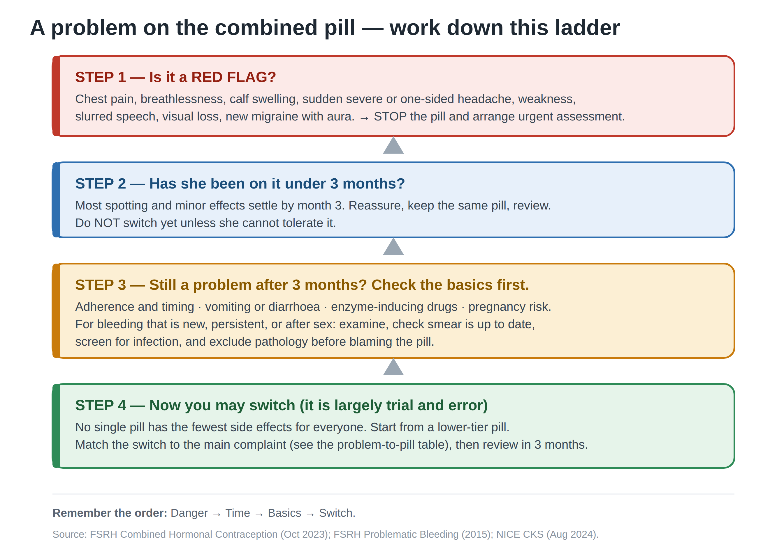
Think of side effects like a new pair of shoes: most rubbing settles once they are worn in. Encourage persisting with minor effects for about three months before changing, as they usually settle (NICE CKS).

4. Problem-to-pill — a practical switching table
Use this once danger is excluded and the basics are checked. The evidence behind switching for side effects is limited, so review the result after three months.
Main complaint | Reasonable switch | Why / cautions
Persistent spotting / breakthrough bleeding | Use the lowest oestrogen dose that gives good cycle control; the dose may be raised up to a maximum of 35 micrograms. | Changing the progestogen may help some women. The old 50-microgram pill is no longer used (FSRH Problematic Bleeding).
Oestrogen-type effects: nausea, breast tenderness, bloating, fluid | Try a lower-oestrogen pill (20 micrograms), e.g. Gedarel 20/150, Mercilon, Loestrin 20. | Lower oestrogen tends to ease these. Spotting can increase at lower doses.
Acne or greasy skin | Switch to an anti-androgenic / less androgenic pill: desogestrel, norgestimate or drospirenone (all off-label for acne). | These reduce androgen effect on skin (NICE CKS Acne). They sit in the higher clot tier — counsel accordingly.
Severe acne not responding to antibiotics, or marked hirsutism | Co-cyprindiol (Dianette) may be used — under clear conditions. | You must NOT use it for contraception alone. Stop 3–4 cycles after the skin clears. Higher clot risk; do not combine with another hormonal contraceptive (BNF; MHRA).
Premenstrual mood / bloating | A drospirenone-containing pill (e.g. Yasmin), often taken continuously, may help. | Most useful for severe (PMDD) symptoms; evidence is modest (NICE CKS PMS).
Headache only in the 7-day break | Run packets together (tailored or continuous use) to shorten or drop the break. | The 7-day break has no health benefit (FSRH). New migraine with aura means STOP — see red flags.

5. Breakthrough bleeding — check, don’t just re-prescribe
Some bleeding in the first three months is normal and usually settles. If it persists, or starts after a long settled spell, look for a cause before changing the pill.
BLEED — the history check (memory aid)
- B — Behaviour of pills: missed or late pills? (the commonest cause)
- L — Lost from the gut: vomiting, diarrhoea or absorption problems?
- E — Enzyme inducers: rifampicin, some anti-epileptics, St John’s wort? (ordinary antibiotics do NOT count)
- E — Expecting? could she be pregnant? Always exclude it.
- D — Disease: infection (chlamydia), bleeding after sex, or cervical changes? Is her smear up to date?

Examine and investigate — you MUST when
- Bleeding persists beyond 3 months despite correct, consistent use; or
- Bleeding is new after a long settled pattern; or
- There is bleeding after sex, pain during sex, or abnormal discharge.
Then: perform a speculum examination, take infection swabs, ensure cervical screening is up to date, exclude pregnancy, and refer for ultrasound or gynaecology if pathology is suspected (FSRH; NICE CKS).

Red flags — STOP the combined pill and act urgently
Chest pain or breathlessness; a swollen, painful calf; sudden severe or one-sided headache; weakness, slurred speech or visual loss; or new migraine with aura.
These suggest a clot or stroke. Urgent assessment is required.

6. Drug interactions — bust the antibiotic myth
MYTH | FACT (current UK guidance)
“All antibiotics stop the pill working, so use condoms.” | Ordinary (non-enzyme-inducing) antibiotics do NOT reduce the pill’s effect. No extra precautions are needed — unless the illness or drug causes vomiting or diarrhoea (FSRH 2022).

What DOES matter — enzyme inducers. Drugs such as rifampicin and rifabutin, some anti-epileptics (e.g. carbamazepine, phenytoin), some HIV medicines, and St John’s wort speed up hormone breakdown. They reduce the effectiveness of all combined pills, all mini-pills, the implant and oral emergency contraception (FSRH 2022).
If an enzyme inducer is needed
- Short-term use: continue the method and add reliable condoms during treatment and for 4 weeks after stopping.
- Long-term use: you must switch to a method that is not affected — the copper coil, the progestogen injection, or the levonorgestrel intrauterine system (FSRH).

7. The mini-pill (progestogen-only pill)
Any mini-pill can be offered by preference. Desogestrel is commonly chosen first because of its forgiving 12-hour window. The longer the window, the more forgiving the pill.
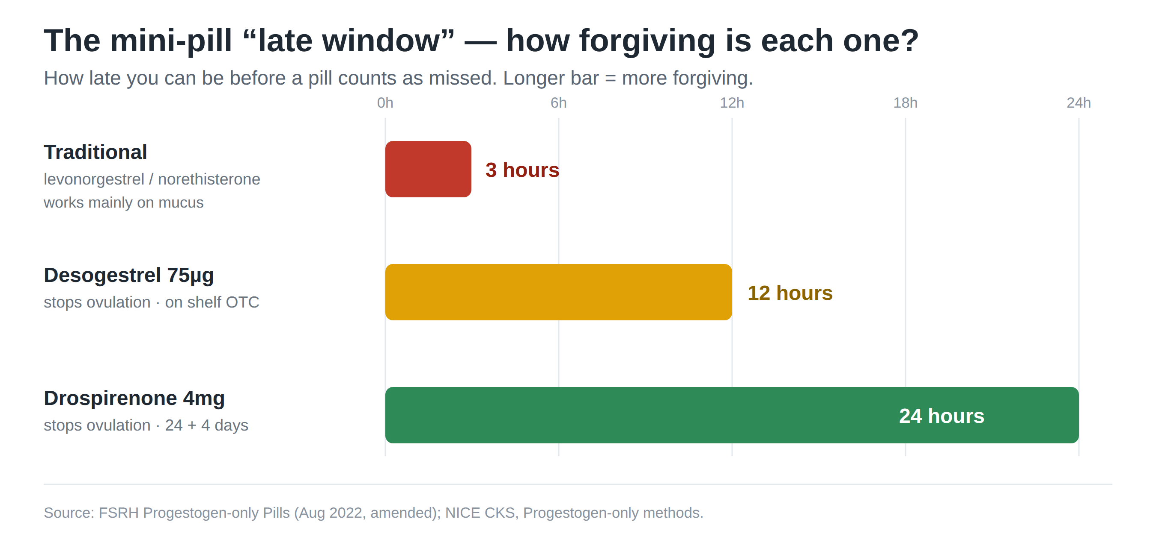
Type (examples) | Late window | How it works | Notes
Traditional — levonorgestrel or norethisterone (Norgeston, Noriday) | 3 hours | Mainly thickens mucus; stops ovulation in only about half of cycles. | Least forgiving — needs strict timing.
Desogestrel 75 mcg (Cerazette, Cerelle, Lovima, Hana) | 12 hours | Reliably stops ovulation. | Sold over the counter (Lovima, Hana) since 2021. Lovima contains soya — avoid in soya/peanut allergy; Hana does not.
Drospirenone 4 mg (Slynd) | 24 hours | Reliably stops ovulation; 24 active + 4 inactive pills. | Most forgiving window; the short break aims for more regular bleeding (available in UK from 2024).

Mini-pill practical points
- Missed (late) pill: take one as soon as remembered, continue daily, use condoms for 48 hours, and consider emergency contraception if there has been unprotected sex (FSRH).
- Irregular bleeding is common, especially early. There is no strong evidence that changing the mini-pill type improves bleeding, though it helps some women.
- Switching from combined to mini-pill: a mini-pill can usually start the day after the last active combined pill, with no gap, for continuous cover.

8. One-minute summary
Start the COC with | A lower-clot-tier pill — 30 mcg ethinylestradiol + levonorgestrel or norethisterone (e.g. Microgynon 30).
Problem on the COC | Danger → Time (3 months) → Basics → Switch. There is no perfect pill.
Breakthrough bleeding | Run the BLEED check. Examine and investigate if it persists past 3 months, is new, or follows sex.
Antibiotics | Ordinary antibiotics need NO extra precautions. Only enzyme inducers (and vomiting/diarrhoea) matter.
Avoid oestrogen? | Use a mini-pill. Desogestrel (12-hour window) is a sensible first choice.
Red flags | Clot or stroke symptoms, or new migraine with aura → STOP the combined pill and assess urgently.

Sources used to verify this guide
- NICE CKS — Contraception: combined hormonal methods
- NICE CKS — Contraception: progestogen-only methods
- NICE CKS — Acne vulgaris
- NICE CKS — Premenstrual syndrome
- FSRH — Combined Hormonal Contraception (Jan 2019, amended Oct 2023)
- FSRH — Progestogen-only Pills (Aug 2022, amended)
- FSRH — Problematic Bleeding with Hormonal Contraception (2015)
- FSRH — Drug Interactions with Hormonal Contraception (2022)
- FSRH — UK Medical Eligibility Criteria (UKMEC)
- BNF / NICE — Contraceptives, hormonal
- MHRA — Desogestrel POP reclassified to pharmacy sale (Lovima, Hana), 2021

Disclaimer
This document is provided exclusively for educational and training purposes as a teaching aid. It does not constitute formal clinical guidance. Clinicians must independently verify all medical information, prescribing guidance, procedural protocols, and legal requirements against current national guidance (NICE, FSRH, BNF), local policies, and relevant regulatory bodies before applying in practice.

