BRADFORD VTS TEACHING AIDS
Oral Contraception: What to Prescribe
A practical guide to the combined pill and the progestogen-only pill for UK primary care.
June 2026
How to use this guide
Read it in order. We build one simple framework — the UKMEC traffic light, then apply it to the combined pill (COC) and the progestogen-only pill (POP). Strong wording (“must”, “must NOT”) is used only where the guidance is absolute. Verify every drug and dose against the BNF before prescribing.
1. Start here: three steps to the right method
Choosing contraception is a conversation, not a guess. Work through the same three steps every time. Note the order — safety is checked last, against the method the patient has already chosen, not first.
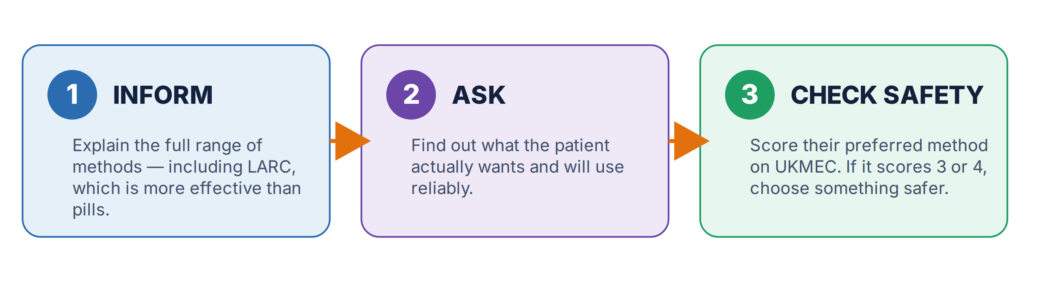
Long-acting methods (LARC) are the most effective. The implant and intrauterine methods beat every pill on typical-use effectiveness, because they do not depend on remembering a daily tablet. Always offer them first, even when the patient has come in asking for the pill.
2. The UKMEC traffic-light system
UK Medical Eligibility Criteria (UKMEC), published by the College of Sexual & Reproductive Healthcare (CoSRH, formerly the FSRH), is the gold-standard guide to contraceptive safety. Every condition is scored 1 to 4 for each method. Think of it as a traffic light.
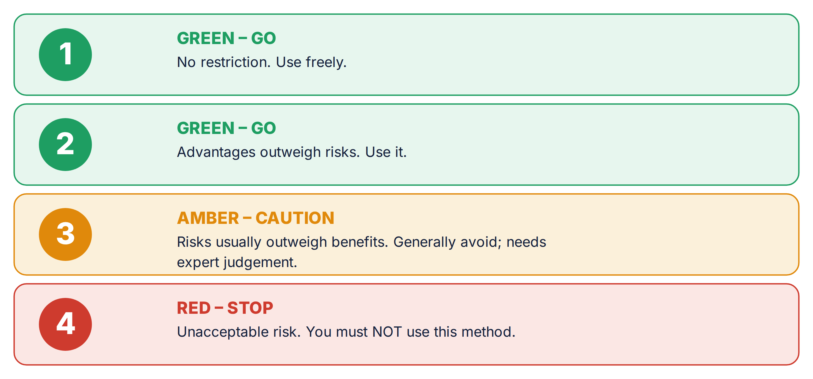
Two key rules clinicians forget
- UKMEC scores safety, not effectiveness. A method can be “safe” (green) yet a poor choice if the patient cannot use it reliably.
- 2 + 2 is not always 4 — but it is not nothing. Two category-2 conditions in the same risk area (for example, two clot-risk factors) signal cumulative risk and call for caution. Several category-3 conditions together may add up to an unacceptable risk.

3. The combined pill (COC)
The combined pill contains an oestrogen and a progestogen. It is well tolerated by most people, but the oestrogen is what creates the long list of cautions below — mainly around blood clots and the arteries.
How it is taken
- Standard pack: 21 active pills, then a 7-day break (some “everyday” packs add 7 dummy pills to keep the habit going).
- Tailored regimens are now recommended. Taking packs back-to-back, or shortening the break, is safe and reduces the riskier pill-free days. There is no health need for a monthly bleed.
- CHC can be used for contraception up to age 50 if the person remains medically eligible.
If a pill is missed
The old “12-hour” rule is out of date. The current FSRH rule turns on 48 hours. A single missed pill still leaves the person protected; trouble starts when two or more are missed, especially around the pill-free break.
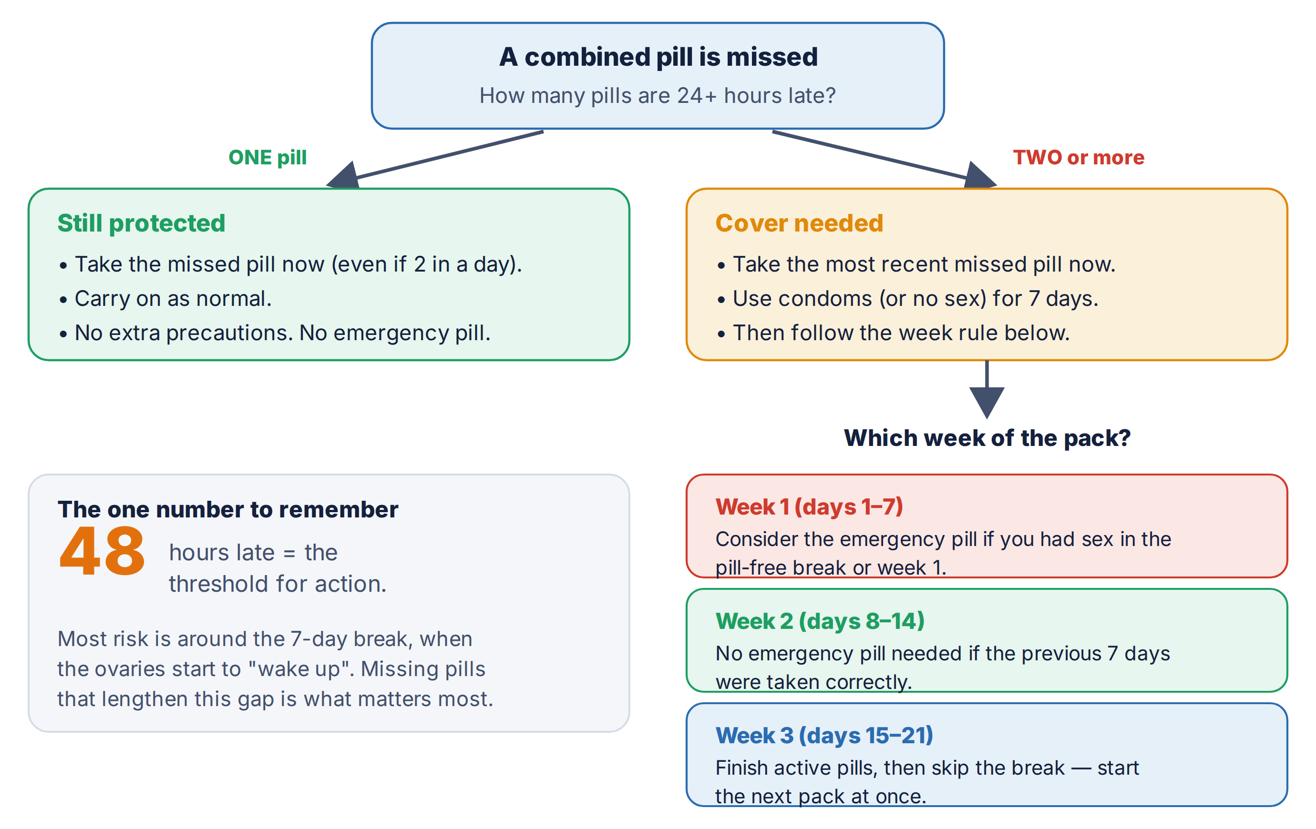
Who can use it: the UKMEC check
Score the patient before prescribing. Below are the conditions that matter most in primary care, grouped by traffic-light colour.
RED — you must NOT prescribe (UKMEC 4)
- Aged 35 or over and smoking 15+ a day
- Migraine WITH aura — at any age. (Migraine without aura is different — see green.)
- Current or past blood clot (DVT/PE), or a known clotting mutation (e.g. Factor V Leiden, prothrombin, protein C/S or antithrombin deficiency).
- Current or past stroke or ischaemic heart disease.
- Breastfeeding and under 6 weeks after birth; or under 6 weeks after birth with any other clot-risk factor.
- Blood pressure 160/100 mmHg or higher.
- Current breast cancer.
- Major surgery with prolonged immobility; antiphospholipid antibodies (e.g. in SLE); complicated valve disease; severe liver disease or liver tumour.
- Diabetes with vascular complications or for over 20 years (category 3 or 4 by severity).

AMBER — generally avoid; specialist judgement (UKMEC 3)
- Aged 35+ and smoking fewer than 15 a day, or stopped less than a year ago.
- BMI 35 kg/m² or above (this also applies after bariatric surgery until the BMI settles below 35).
- Not breastfeeding and under 3 weeks after birth; or breastfeeding from 6 weeks to 6 months.
- Controlled hypertension, or BP 140–159 / 90–99 mmHg.
- A first-degree relative who had a clot before age 45.
- Immobility (e.g. wheelchair use); familial high cholesterol.
- Past migraine with aura (5+ years ago), or migraine without aura that develops while on the pill.
- Carrier of a BRCA gene; current symptomatic gallbladder disease; mild (compensated) cirrhosis.
- Taking an enzyme-inducing drug (see Section 5).

GREEN — usually fine to prescribe (UKMEC 1–2)
- Migraine WITHOUT aura, under 35 — the pill can be started.
- Smoking under age 35; or aged 40+ and a non-smoker.
- BMI 30–34; high blood pressure only during a past pregnancy.
- A first-degree relative who had a clot at 45 or older; a superficial (surface-vein) clot.
- Uncomplicated diabetes; family history of breast cancer; CIN, cervical cancer awaiting treatment, or high-risk HPV.
- Epilepsy (but check drug interactions); most mental-health conditions.

A note on mood
Depression was removed from UKMEC in 2025. There is no clear evidence that hormonal contraception reliably worsens or improves mood. Counsel patients with existing anxiety or depression to monitor their mood, and review the method if they feel it has been affected.

Examples
Common first-choice combined pills include Microgynon, Rigevidon and Levest (all levonorgestrel-containing, which carry the lowest clot risk among combined pills). Prescribe by brand and confirm the exact preparation and dose in the BNF.
4. The progestogen-only pill (POP)
The POP contains no oestrogen. That single fact removes almost all the clot and arterial risks of the combined pill. The trade-off is that it must be taken punctually, and irregular bleeding is common.
The headline for the POP
The only absolute contraindication (UKMEC 4) is current breast cancer. Smoking, high BP, obesity, a past clot, migraine with aura, and diabetes — all of which can rule out the combined pill — are generally fine with the POP. This is why the POP is the go-to oral option when oestrogen must be avoided.

How it is taken, and the late-pill window
One pill every day, with no break (the drospirenone pill is the exception — 24 active then 4 inactive pills). How much leeway you have before a pill counts as “missed” depends on which POP it is:
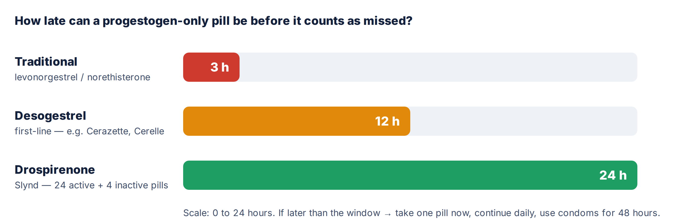
If a POP is late or missed
- Take one pill as soon as you remember, then carry on as normal.
- Use condoms for the next 48 hours (2 days).
- If you had sex during those 48 hours, the emergency pill may be needed.

Who can use it
RED — must NOT prescribe (UKMEC 4)
- Current breast cancer — the single absolute contraindication.

AMBER — generally avoid / specialist input (UKMEC 3)
- Past breast cancer (treatment completed).
- Severe (decompensated) cirrhosis or a liver tumour.
- Antiphospholipid antibodies (e.g. in SLE).
- Stroke or ischaemic heart disease that develops while already taking the POP (continuation).
- Taking an enzyme-inducing drug (use an unaffected method instead — see Section 5).

GREEN — usually fine (UKMEC 1–2)
- Smoking at any age; high blood pressure; obesity; familial high cholesterol.
- Past venous clot; migraine with or without aura; uncomplicated or complicated diabetes; epilepsy.
- Carrier of a BRCA gene (UKMEC 2).

Examples
Desogestrel pills (Cerazette, Cerelle, Feanolla) are first-line — they stop ovulation in most cycles and give the forgiving 12-hour window. Drospirenone (Slynd) offers a 24-hour window and a more predictable bleed. The older 3-hour pills (Noriday, Norgeston) are now rarely used. Prescribe by brand and confirm in the BNF.
5. Drugs that interact
Only one interaction really matters for the pill: enzyme inducers. They speed up the breakdown of contraceptive hormones, so the pill can fail.
Enzyme inducers reduce the effect of the COC, POP, implant and oral emergency pill
- Rifampicin and rifabutin (antibiotics for TB and meningococcal prophylaxis).
- Some antiepileptics: carbamazepine, phenytoin, phenobarbital, primidone, topiramate, oxcarbazepine, eslicarbazepine.
- Some antiretrovirals (e.g. efavirenz, nevirapine) and St John’s Wort.
Action: for anyone on a long-term enzyme inducer, advise a method that is not affected — the injection (DMPA), the copper coil, or the hormonal coil (LNG-IUS) — or seek specialist advice.

Myth-buster: ordinary antibiotics do NOT stop the pill working
FSRH guidance is clear: common non-enzyme-inducing antibiotics (such as amoxicillin or trimethoprim) do not reduce the effectiveness of hormonal contraception. No extra precautions are needed. The only catch is illness itself: severe vomiting or diarrhoea can stop the pill being absorbed — manage that as missed pills.

Watch: the combined pill and lamotrigine
The combined pill lowers lamotrigine levels (risk of seizures), and stopping the pill can raise them (risk of toxicity). Coordinate any change with the prescriber managing the epilepsy.

6. Troubleshooting
Side effects: what to tell patients
- Most nuisance effects settle within 3 months. Breast tenderness, mild nausea, headaches and spotting usually fade as the body adjusts. Reassure and continue.
- No single combined pill has fewer side effects than another. FSRH is explicit on this. The old idea of fine-tuning “too much oestrogen versus too much progestogen” by swapping brands is not supported by good evidence.
- If one specific effect is troublesome beyond 3 months, first exclude other causes, then it is reasonable to try a different preparation — pragmatically, not by formula.

Unscheduled (breakthrough) bleeding
Use a simple recognise → act → refer approach.
RECOGNISE
Irregular bleeding is common and expected in the first 3 months of any new hormonal method — reassure, no action needed. Look for a cause if it persists beyond 3 months, or is new after a settled pattern.

ACT
- History: missed or late pills, timing, vomiting or diarrhoea, enzyme-inducing drugs, smoking, and any chance of pregnancy.
- Risk check: ask about STI risk (test for chlamydia where relevant) and confirm cervical screening is up to date.
- Examine and test: a pregnancy test if any risk; STI tests if indicated; a speculum to inspect the cervix if bleeding persists or follows sex.
Note: unscheduled bleeding is not a reason for a cervical smear — screening follows the national programme. But a cervix that looks abnormal must be referred.

REFER
Urgent referral is required for postcoital bleeding that persists, a visibly abnormal cervix, or persistent bleeding with risk factors for cancer — send on the suspected-cancer pathway. Once serious causes are excluded, reassurance is usually enough; switching method may be tried, though evidence it helps is limited.

7. Numbers worth memorising
48 | Combined pill: hours late before action is needed. One missed pill = still protected.
3 · 12 · 24 | POP late-pill windows (hours): traditional · desogestrel · drospirenone.
35 + 15 | Combined pill is a definite NO at age 35+ and 15+ cigarettes a day.
35 | BMI 35+ pushes the combined pill into “generally avoid”.
6 wks | After birth: wait this long before a combined pill if breastfeeding or any clot-risk factor.
7 | Condom cover (days) after two or more missed combined pills — and the length of the pill-free break.

8. Before you prescribe: safety-net checklist
- Blood pressure and BMI recorded.
- Age and smoking status established.
- Asked specifically about migraine — and crucially, aura.
- Personal or family history of blood clots, and any known clotting disorder.
- Current medicines reviewed for enzyme inducers.
- Breastfeeding status and time since any recent birth.
- Pregnancy reasonably excluded; start timing and back-up cover explained.
- Method-specific missed-pill advice given (the 48-hour rule, or the POP window).
- STI risk discussed; condoms recommended for STI protection.

Sources
All clinical content has been checked against current UK guidance (accessed June 2026):
- CoSRH (formerly FSRH). UK Medical Eligibility Criteria for Contraceptive Use (UKMEC), December 2025. Link
- FSRH Clinical Guideline: Combined Hormonal Contraception (January 2019, amended October 2023). Link
- FSRH Clinical Guideline: Progestogen-only Pills (August 2022, amended July 2023); FSRH CEU Statement: Drospirenone 4mg POP (January 2024). Link
- FSRH CEU Guidance: Recommended Actions after Incorrect Use of Combined Hormonal Contraception (March 2020, amended July 2021). Link
- FSRH CEU Guidance: Drug Interactions with Hormonal Contraception (2022); FSRH CEU Statement: Antibiotics and Hormonal Contraception (February 2021). Link
- NICE CKS: Contraception – combined hormonal methods (August 2024) and progestogen-only methods (November 2024). Link
- BNF – for all drug names, doses and preparations. Link

Disclaimer
This document is provided exclusively for educational and training purposes as a teaching aid. It does not constitute formal clinical guidance. Clinicians must independently verify all medical information, prescribing guidance, procedural protocols and legal requirements against current national guidance, local policies and the relevant regulatory bodies before applying it in practice. Information is provided as educational material and must be verified by the individual user against authoritative sources and local policies for their area.

