BRADFORD VTS TEACHING AIDS
Date: June 2026
Investigating Infertility: Which Tests, and What They Mean
A primary-care teaching aid for GP trainees and IMGs · aligned with NICE NG257 (March 2026)
Three questions drive every fertility work-up: is he making healthy sperm, is she ovulating, and is the path clear for egg and sperm to meet? In primary care you can answer the first two with a few simple tests, and refer for the third. This guide covers those tests and, just as importantly, what their results mean.

STEP 1 · THE STARTING POINT
When to test, and who to test
Define infertility in practice as not conceiving after 12 months of regular unprotected vaginal sex, with no known cause. At that point you must offer assessment and investigation to both partners — and test them together, not one after the other.
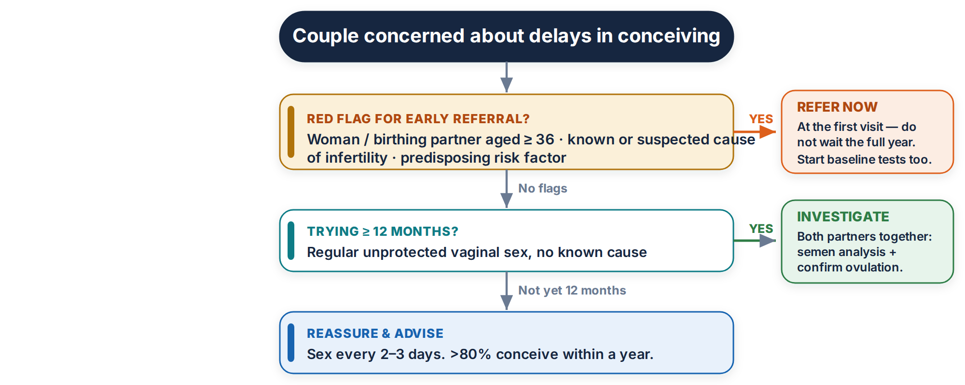
Refer at the first visit — do not wait the year — if any of these apply
• the woman, trans man or non-binary person trying to conceive is aged 36 or over
• either partner has a known or suspected cause of infertility or a predisposing risk factor
• a planned treatment may harm fertility (for example cancer therapy) — expedite the referral
Reassure while you investigate
Over 80% of couples conceive within a year of regular unprotected sex; about half of the rest conceive during the second year. Advise sex every 2–3 days. Source: NICE NG257.

STEP 2 · THE MAN
Testing the man: the semen analysis
One test answers the male question: the semen analysis. It is the single most useful investigation in the man, so arrange it early. Think of it as a stock-take of three things — how many sperm there are, how well they swim, and how well they are built.
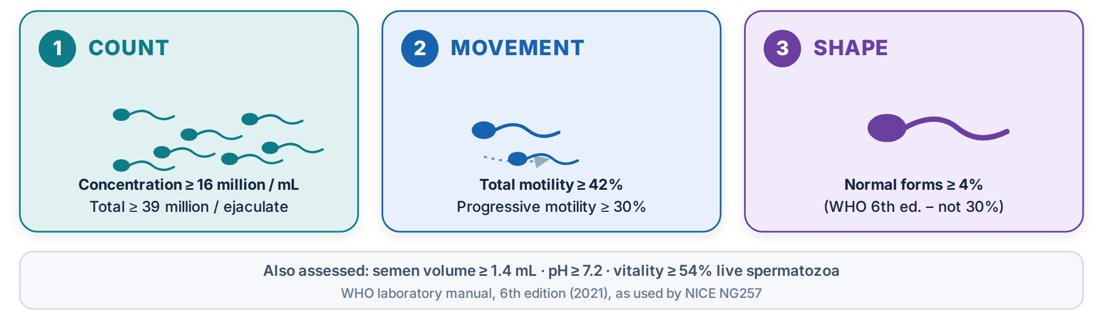
Compare the result against the World Health Organization (WHO) 6th-edition reference values — the figures NICE NG257 uses:
Parameter | Lower reference value (normal is at or above)
Semen volume | 1.4 mL
pH | 7.2
Sperm concentration | 16 million per mL
Total sperm number | 39 million per ejaculate
Total motility (progressive + non-progressive) | 42% motile
Progressive motility | 30%
Vitality | 54% live spermatozoa
Sperm morphology (normal forms) | 4% normal forms

What changed — and why it matters
Older teaching used the 1999 WHO figures: concentration >20 million/mL, motility >50%, morphology >30% normal forms. These are out of date.
The current limits are markedly lower — most strikingly morphology, now 4% (not 30%). Judging a modern sample by the old numbers wrongly labels many fertile men as abnormal and causes needless worry and referral.
Acting on the result. Treat a single result with caution — collection and timing strongly affect it.
Recognise | Act
First sample abnormal | You must offer a repeat confirmatory test. Time it about 3 months after the first, to cover one full sperm-production cycle.
Azoospermia or severe oligozoospermia | Do not wait 3 months — repeat as soon as possible and refer.
Two or more abnormal samples | Examine the scrotum and testes, consider serum testosterone and gonadotrophins, and refer to secondary care.

Do NOT
• Do not routinely test for antisperm antibodies.
• Do not request sperm DNA fragmentation testing — NICE NG257 recommends against it.
Practical tip. A common cause of a falsely abnormal result is poor collection or transport. Give every man clear written instructions from your local laboratory on abstinence and getting the sample to the lab promptly. Source: WHO laboratory manual, 6th edition (2021); NICE NG257.
STEP 3 · THE WOMAN, PART 1
Is she ovulating?
Regular monthly periods are reassuring — a woman with a regular cycle is probably ovulating. But you must still confirm it, because the answer shapes everything that follows. The key test is a mid-luteal serum progesterone.
Remember it as: “Seven days before, read it after”
Take the blood 7 days before the next expected period (day 21 of a 28-day cycle; day 28 of a 35-day cycle), and interpret the result once the next period has started. Offer this test even when cycles are regular.
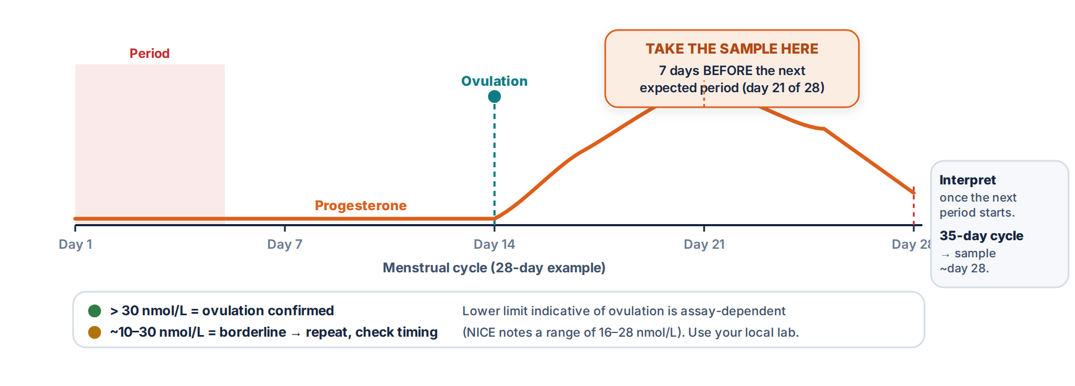
Do NOT
You must not use basal body temperature charts to confirm ovulation — they do not reliably predict it. Source: NICE NG257.
Where do urine LH kits fit?
Urine LH kits predict ovulation (the surge comes just before it), so they can help a couple time intercourse — but they do not confirm that ovulation happened. NICE advises regular sex every 2–3 days rather than timing to ovulation: it is less stressful and works just as well. LH kits are unreliable in PCOS, where LH is often persistently high.

STEP 4 · THE WOMAN, PART 2
When the cycle is irregular
Irregular or absent periods point to a problem with ovulation. Here, hormone levels help find the cause: offer serum gonadotrophins — FSH and luteinising hormone (LH).
Hormone pattern | Suggests
High FSH + low oestradiol | Primary (premature) ovarian insufficiency — the modern term for what older notes called “primary ovarian failure”.
High LH with normal FSH | Polycystic ovary syndrome (a raised LH:FSH ratio is a classic clue, though not essential for the diagnosis).
Low FSH, LH and oestradiol | Hypogonadotrophic hypogonadism — the problem lies above the ovary, in the pituitary or hypothalamus.
High prolactin | Hyperprolactinaemia — look for galactorrhoea and consider a pituitary cause.
High testosterone | Polycystic ovary syndrome (a sign of excess androgens).

Read the numbers with care
Hormone reference ranges depend on the assay, the laboratory, and where in the cycle the blood is taken. Always interpret against your local lab's ranges — never a memorised set of numbers.
NICE NG257 no longer recommends FSH as a routine predictor of natural conception or of ovarian reserve.

STEP 5 · CHOOSING WISELY
Targeted tests: test with a reason
Order a test only when its result will change what you do. Blanket hormone panels cause false alarms and delay. NICE NG257 is explicit about when not to test:
Test | Offer only when…
Prolactin | there is an ovulatory disorder, galactorrhoea, or a suspected pituitary tumour. Do not check routinely.
Thyroid function | there are symptoms of thyroid disease. Do not check routinely.
AMH / FSH for “ovarian reserve” | Do not use these to predict natural conception. AMH and antral follicle count belong in the fertility clinic, to guide IVF — not in primary care.
Coeliac serology | Consider it in unexplained subfertility (a 2026 addition to NICE guidance).

Round out the baseline screen. Around referral, also: screen for chlamydia before any uterine instrumentation; check rubella susceptibility and vaccinate if not immune (avoiding pregnancy for one month afterwards); and confirm cervical screening is up to date. For IVF, HIV and hepatitis B and C are also checked. Source: NICE NG257.

STEP 6 · PULL IT TOGETHER
The whole work-up on one page
Question | First-line test | Reassuring | Act / refer if…
Healthy sperm? | Semen analysis (WHO 6th-ed limits) | All values at or above the limits | Any abnormal value → repeat; two abnormal → examine + refer
Ovulating — regular cycles? | Mid-luteal progesterone (day 21 / 28) | >30 nmol/L | Borderline → repeat; persistently low → investigate anovulation
Ovulating — irregular cycles? | FSH + LH (± prolactin / TFT if indicated) | Pattern fits ovulation | Abnormal pattern → identify the cause and refer
Clear path for egg & sperm? | Secondary care: HSG (laparoscopy if comorbidity) | Patent tubes | Refer for imaging

Safety net — refer promptly
Refer at presentation if the woman is 36 or over, there is a known or suspected cause or risk factor, or a planned treatment may harm fertility.
Azoospermia or severe oligozoospermia needs an urgent repeat and referral — do not wait.
Throughout, offer support: infertility is stressful, and a clear plan helps as much as any test.
Sources used
• NICE NG257, Fertility problems: assessment and treatment (published 31 March 2026) — the current UK guideline, which replaced CG156.
• WHO laboratory manual for the examination and processing of human semen, 6th edition (2021).
• Progesterone interpretation thresholds: NICE; NHS clinical-biochemistry laboratory handbooks; GPnotebook.
Disclaimer
Provided exclusively as an educational teaching aid; it does not constitute formal clinical guidance. Clinicians must independently verify all information against current national guidance, local policies, and the relevant regulatory bodies before clinical use.

