BRADFORD VTS TEACHING AIDS
June 2026
Examination of the Pregnant Abdomen
A practical, hands-on guide for GP trainees and international medical graduates in UK primary care
The pregnant abdomen tells a story you can read with your hands. A calm, well-ordered examination reassures the woman, tracks how the baby is growing, and catches the few problems that need fast action. The trick is to do it the same way every time. Use one simple spine: Look, Feel, Listen.
1 LOOK  Inspect: size, shape, scars, skin, movements | 2 FEEL  Palpate: height, lie, presentation, engagement | 3 LISTEN  Auscultate the fetal heart — only if she wants it

What you are trying to achieve
- Confirm the baby is growing in line with the dates.
- Work out the baby’s lie, presentation and engagement.
- Spot the red flags early — and act on them.
1. Before you start
- Wash your hands before and after touching the woman.
- Introduce yourself, check her identity, explain what you will do and why, and gain consent first.
- Offer a chaperone and record who is present (GMC guidance).
- Ask her to empty her bladder. A full bladder is uncomfortable and pushes the fundus up, making the height measurement wrong.
- Position her semi-reclined (propped at about 45°). Expose from the bottom of the breastbone to the pubic bone; keep the rest covered for dignity and warmth.
⚠ Do not lay her flat on her back for long (after ~16–20 weeks)
The heavy uterus can press on the main vein (inferior vena cava) and drop her blood pressure — supine hypotension. If she feels faint, dizzy or nauseated, tilt her onto her left side straight away.
2. Quick checks at every visit
At each antenatal contact, measure blood pressure and test the urine with a dipstick. Together these screen for pre-eclampsia (high blood pressure plus protein in the urine). They sit alongside the abdominal examination, not instead of it.
3. LOOK — Inspection
- Size: does the bump look right for the dates?
- Shape: a first pregnancy often looks more pointed (ovoid); later pregnancies look rounder, because the abdominal muscles are looser.
- Scars: a low scar may signal a previous caesarean — always ask about it.
- Skin: a dark midline (linea nigra) and stretch marks (striae gravidarum) are normal.
- Movements: you may see the baby move.
4. FEEL — Palpation
4.1 Symphysis–fundal height (SFH)
This is the distance, in centimetres, from the top of the pubic bone to the top of the uterus (the fundus), measured with a tape. Rule of thumb: from 20 weeks the SFH in cm roughly equals the weeks of pregnancy, give or take 2 cm (for example, ~30 cm at 30 weeks).
NICE — what you must do
You must measure and plot the SFH at every antenatal appointment from 24 weeks (no more often than every 2 weeks) for a single baby, unless she is having regular growth scans. Plot each reading on a growth chart.
Source: NICE NG201, Antenatal care.
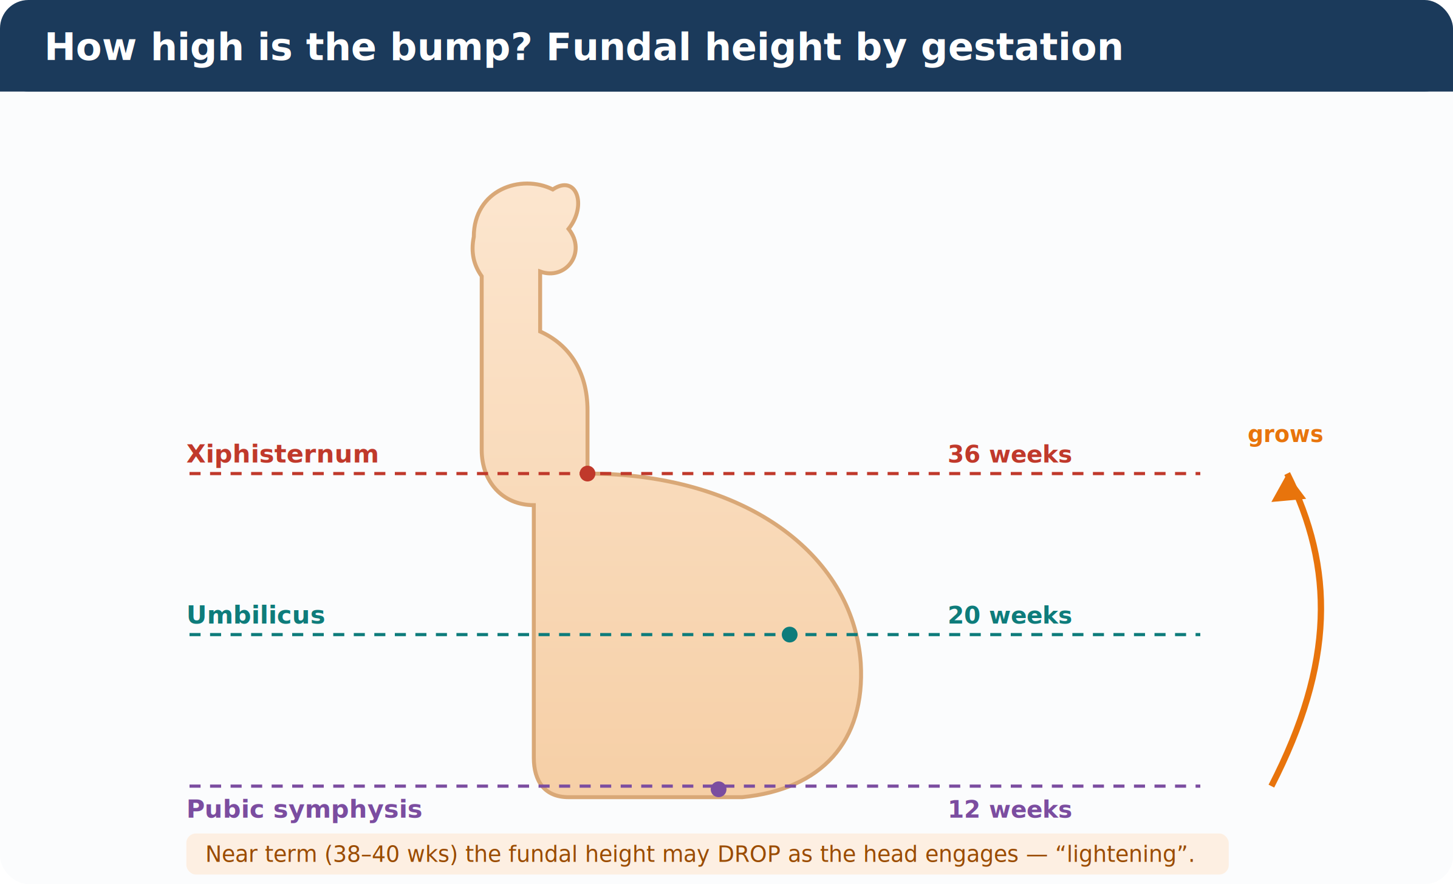
Landmark guide (approximate — use as a quick mental check, not a measurement):
Weeks | Where the top of the uterus sits
12 | Just above the pubic bone
16 | Midway between pubic bone and umbilicus
20 | At the umbilicus
24 | Just above the umbilicus
28 | Midway between umbilicus and breastbone
34 | Just below the breastbone (xiphisternum)
36 | At the breastbone
38–40 | Drops again as the head engages (“lightening”)

Good to know
These landmarks are only a rough guide. The tape-measured, plotted SFH is what NICE relies on. SFH is less reliable in obesity, twins, fibroids or excess fluid — in those cases trust the ultrasound, not the tape.
4.2 The three grips — and the question each one answers
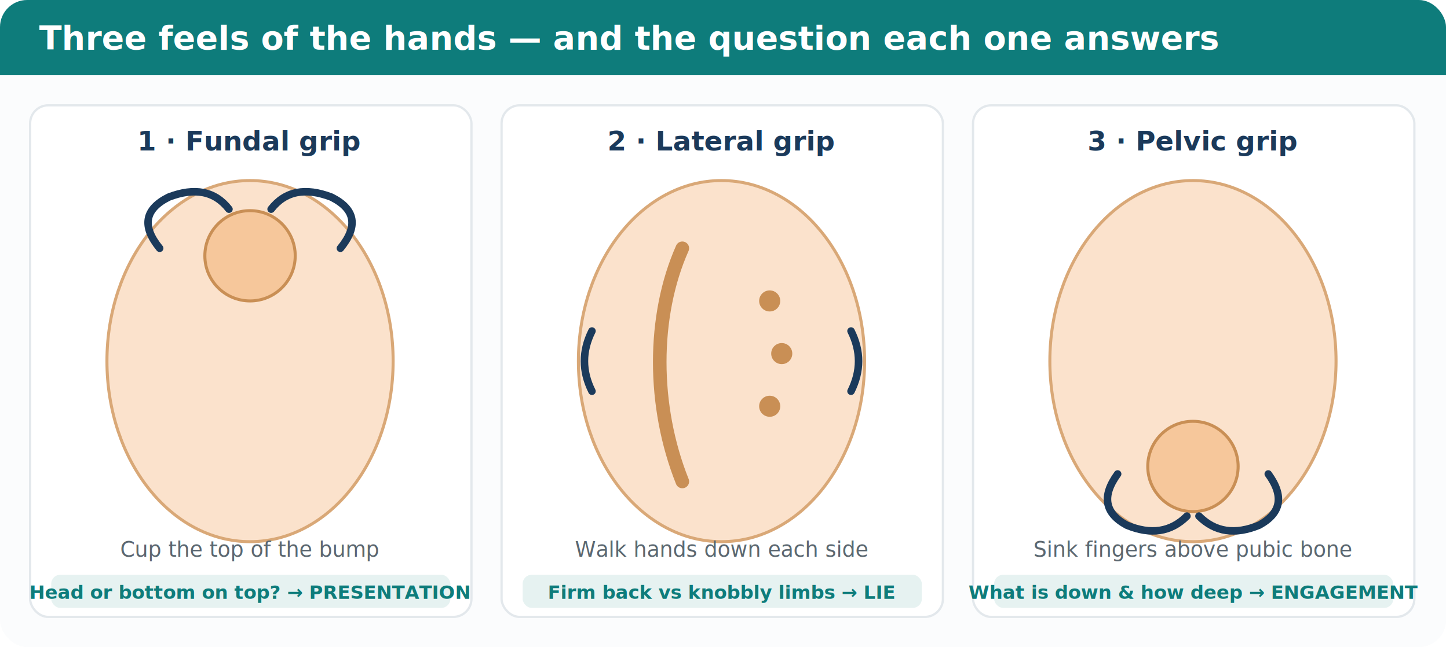
Before you interpret the grips, fix four words in your mind:
- Lie = the baby’s long axis compared with the mother’s. Picture a pencil in a tube: pointing along = longitudinal; across = transverse; diagonal = oblique.
- Presentation = the part lying over the pelvis. Usually the head (cephalic); sometimes the bottom (breech).
- Position = which way the back faces.
- Engagement = how far the head has dropped into the pelvis, judged in fifths palpable.

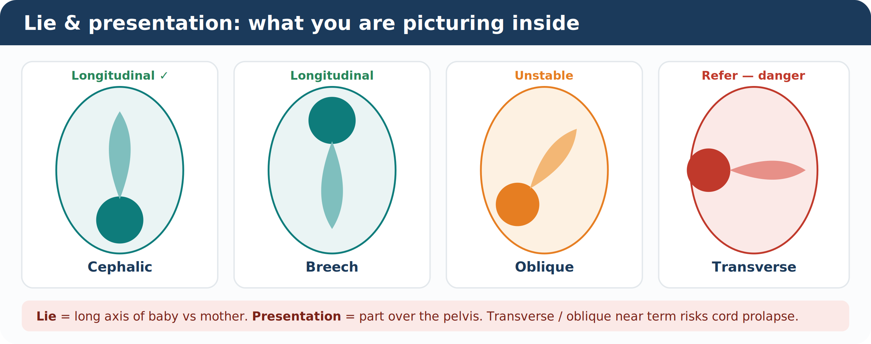
Refer — transverse or oblique lie near term
A baby lying across or diagonally near term is unsafe: the cord can slip down first (cord prolapse) and labour can obstruct. This needs obstetric referral.
4.3 Engagement — counting in fifths
Feel how much of the head you can still grip above the pubic bone. 2/5 or fewer means the head is engaged (its widest part has passed through the pelvic brim). The head usually engages around 37 weeks in a first pregnancy.
A gentle point on technique
The one-handed grasp over the lower pole (Pawlik’s grip) can be uncomfortable. Use it sparingly and gently; the two-handed pelvic grip is preferred.
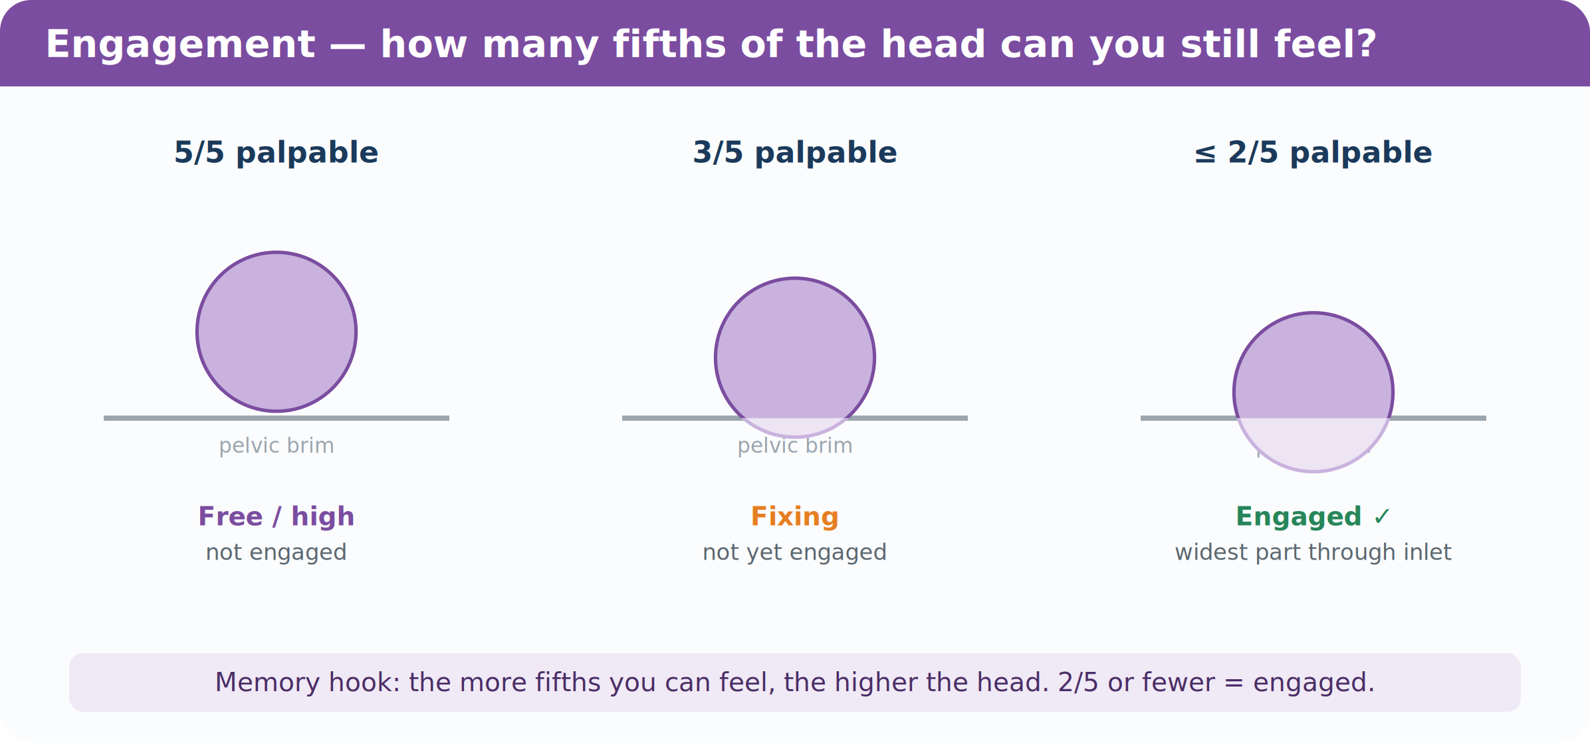
5. Liquor volume (the waters)
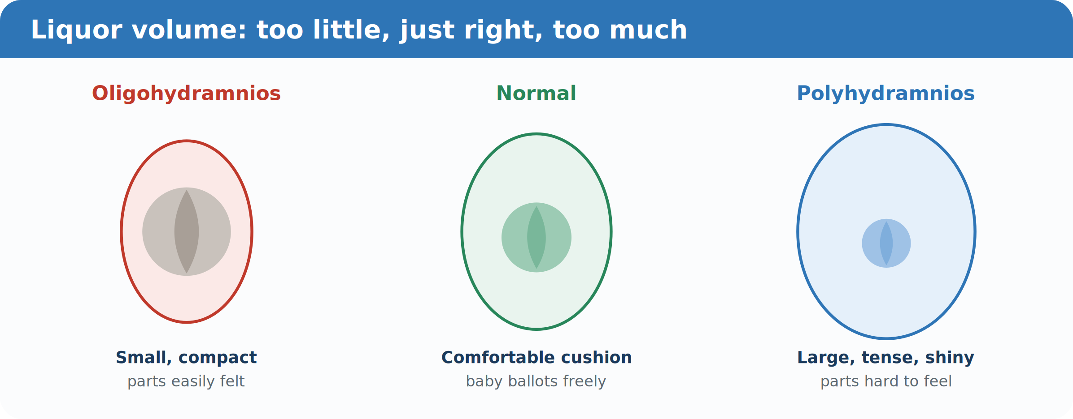
As you palpate, judge the fluid around the baby. Too little (oligohydramnios) makes the uterus feel small and compact, with the baby’s parts easy to feel. Too much (polyhydramnios) makes it feel large, tense and shiny, with parts hard to feel. If the fluid looks abnormal, arrange an ultrasound.
Too little — oligohydramnios | Too much — polyhydramnios
Ruptured membranes (PROM / PPROM) | Maternal diabetes
Placental insufficiency / growth restriction | Twins or higher multiple pregnancy
Fetal kidney problems (e.g. renal agenesis) | Swallowing blocked: oesophageal / duodenal atresia
Post-dates pregnancy | Neural tube defect (e.g. anencephaly); fetal anaemia

6. LISTEN — Auscultation
Important correction to old teaching
Routine “listening in” to the fetal heart is not recommended — it does not predict how the baby is doing. If the mother asks, auscultation may still reassure her, and that is a good enough reason to do it. (NICE NG201.)
- Use a handheld Doppler (or a Pinard) from about 24 weeks; find the baby’s position first so you know where to listen.
- A reassuring fetal heart rate is steady at 110–160 beats per minute (NICE NG229).
- Always check you are hearing the baby, not the mother — feel her pulse at the same time.
- The fetal heart is not a substitute for what the mother feels. Her report of movements matters more.
7. Red flags — Spot it · Act · Refer
Reduced or changed fetal movements
- Spot it: any reduction or sudden change in the baby’s usual movements after 24 weeks.
- Act: you must advise her to contact maternity services immediately, day or night. Do not tell her to wait and see.
- Refer: same-day assessment (fetal heart / CTG and a growth check).
Movements are usually first felt at 18–20 weeks. If she has never felt movement by 24 weeks, she should contact maternity. (RCOG Green-top Guideline 57.)

Size that does not match the dates
- Small for dates or static SFH: offer an ultrasound for growth and wellbeing. Make it more urgent if there are also reduced movements or raised blood pressure.
- Large for dates: consider an ultrasound for growth and fluid volume. (NICE NG201.)

Wrong way round near term
- Breech at 36 weeks: refer to discuss turning the baby (ECV) — offered from 36 weeks in a first pregnancy and from 37 weeks if she has given birth before. (RCOG Green-top Guideline 20a.)
- Transverse or oblique near term: refer (risk of cord prolapse).

Possible pre-eclampsia
Blood pressure ≥140/90 with protein in the urine, or warning symptoms (bad headache, visual disturbance, pain below the ribs, sudden swelling) — arrange urgent obstetric assessment.

8. Writing it up
Record, in order: SFH (cm) and plotted centile · lie · presentation · engagement (fifths) · fetal heart if listened · movements · BP and urine.
Worked example
“SFH 30 cm, on the 50th centile. Longitudinal lie, cephalic presentation, 3/5 palpable. Fetal heart heard, regular, ~140 bpm. Movements normal. BP 118/74, urine NAD.”
In one minute
Look · Feel · Listen — then check the red flags
- Look: size, shape, scars, skin, movements.
- Feel: plot the SFH from 24 weeks (cm ≈ weeks ± 2); then lie, presentation and engagement (2/5 or fewer = engaged).
- Listen: only if she wants it; reassuring rate 110–160 bpm; check it is the baby, not the mother.
- Act on: reduced movements (contact maternity now), small/large for dates (scan), breech or transverse near term (refer), and possible pre-eclampsia.
Normal values at a glance
What you check | Normal / expected | When to act
Symphysis–fundal height | From 24 weeks; cm ≈ weeks ± 2; plotted on a growth chart | Static or small for dates, or large for dates → offer ultrasound
Lie & presentation near term | Longitudinal lie, cephalic presentation | Breech → refer for ECV (36/37 wks); transverse or oblique → refer
Engagement | 2/5 or fewer palpable above the brim = engaged; ~37 wks in a first pregnancy | Use the two-handed pelvic grip; record fifths palpable
Fetal heart (if listened) | 110–160 bpm, regular | Outside range or irregular → same-day assessment / CTG
Fetal movements | First felt 18–20 weeks; established pattern from 24 weeks | Any reduction or change after 24 wks → contact maternity now
BP & urine | Below 140/90, no proteinuria | ≥140/90 with protein or warning symptoms → urgent obstetric assessment
Figures as cited in the sources below. Always plot and interpret in the context of the individual woman and local policy.

Sources
- NICE NG201 — Antenatal care (2021): SFH measured and plotted from 24 weeks; fetal movements after 24 weeks; routine auscultation not recommended.
- NICE NG229 — Fetal monitoring in labour (2022): normal fetal heart rate 110–160 bpm.
- RCOG Green-top Guideline No. 57 — Reduced Fetal Movements: contact maternity immediately for reduced or changed movements.
- RCOG Green-top Guideline No. 20a — External Cephalic Version: ECV from 36 weeks (nulliparous) / 37 weeks (multiparous).
- NICE NG133 — Hypertension in pregnancy: pre-eclampsia thresholds and assessment.

Disclaimer
This document is provided exclusively for educational and training purposes as a teaching aid. It does not constitute formal clinical guidance. Clinicians must independently verify all medical information, prescribing guidance, procedural protocols, and legal requirements against current national guidance, local policies, and the relevant regulatory bodies before applying it in practice.

