BRADFORD VTS TEACHING AIDS
Inhaled Steroids Equivalence
Adults and Children | BNF 91 (March 2026) | NICE NG245 (Nov 2025)
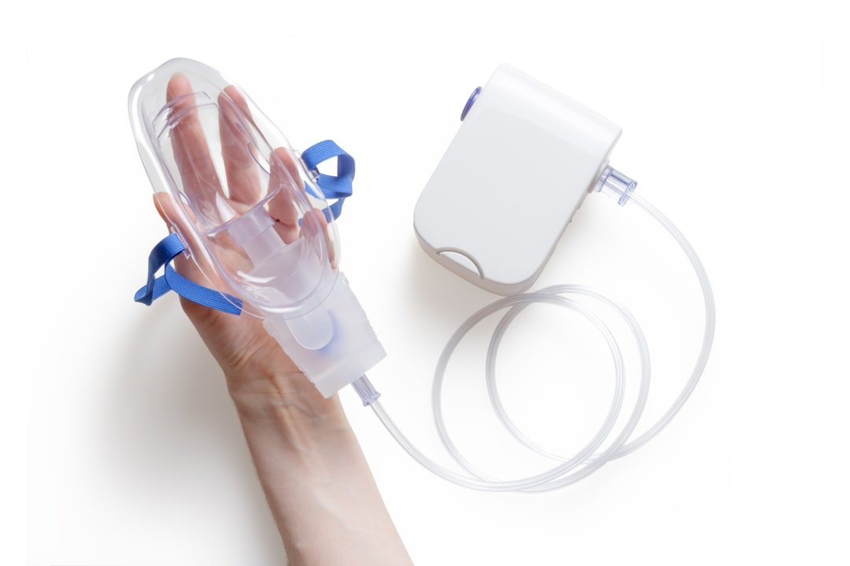
Created May 2026, updated to current BNF 91 / NICE NG245 Nov 2025 standards
1. Why ICS Equivalence Matters
Inhaled corticosteroids (ICS) differ in potency, particle size, and device. When switching between devices or formulations — or when a preparation is discontinued — it is essential to know the equivalent dose to avoid under- or over-treatment.
ALERT: Mometasone (Asmanex) DISCONTINUED Feb 2026
Mometasone Twisthaler inhalers (Asmanex 200mcg and 400mcg) have been discontinued in the UK (MHRA, Feb 2026).
Patients currently prescribed mometasone must be reviewed and switched.
Suggested alternatives: Fluticasone furoate (Ellipta devices), Fluticasone propionate (Flixotide), or Budesonide (Pulmicort) — at equivalent dose.
Always counsel the patient about the device change and re-check inhaler technique.

2. Adult ICS Equivalence Table (BNF 91, March 2026)
The table below shows approximate equivalent daily doses. LOW = typical starting/maintenance dose; MEDIUM = when control is suboptimal; HIGH = specialist or short-term only. Source: BNF 91 [1].
ICS Drug | Device/Brand | LOW dose/day | MEDIUM dose/day | HIGH dose/day | Notes
Beclometasone dipropionate  (standard particle) | MDI (e.g. Clenil) | 200–500 mcg | 500–1000 mcg | >1000 mcg | Particle size ~3.5 mcm
Beclometasone dipropionate  (extrafine, CFC-free) | Qvar MDI / Fostair MDI | 100–200 mcg | 200–400 mcg | >400 mcg | Extrafine = 2.5x more potent than standard. Qvar/Fostair NOT interchangeable mg-for-mg with Clenil.
Budesonide | Turbohaler (Pulmicort) | 200–400 mcg | 400–800 mcg | >800 mcg | Also in Symbicort (MART)
Fluticasone propionate | Accuhaler / MDI (Flixotide) | 100–250 mcg | 250–500 mcg | >500 mcg | Also in Seretide. ~2x potency vs standard BDP.
Fluticasone furoate | Ellipta (Relvar, Incruse) | 92 mcg OD | 184 mcg OD | 184 mcg OD | OD dosing. In Relvar Ellipta (FF/VI). More potent than FP.
Ciclesonide | MDI (Alvesco) | 80–160 mcg | 160–320 mcg | >320 mcg | Pro-drug activated in lung. OD or BD.
Mometasone furoate | Twisthaler (Asmanex) | DISCONTINUED | DISCONTINUED | DISCONTINUED | DISCONTINUED UK Feb 2026. Switch patients.

Key Point: Extrafine Beclometasone
Extrafine BDP (Qvar, Fostair) reaches small airways and is 2.5x more potent than standard BDP.
Do NOT switch from Clenil 400mcg to Qvar 400mcg — this is a 2.5x dose increase.
Correct switch: Clenil 400mcg/day → Qvar 160mcg/day (approx equivalent).

3. Children's ICS Equivalence Table (BNF 91, March 2026)
Children require lower doses. Use the lowest effective dose and review regularly. Source: BNF 91 [1], NICE NG245 [2].
ICS Drug | Age range | LOW dose/day | MEDIUM dose/day | HIGH dose/day | Notes
Beclometasone dipropionate  (standard) | School age (5-11y) | 100–200 mcg | 200–400 mcg | >400 mcg | Via MDI + spacer
Beclometasone dipropionate  (standard) | 12y+ | 200–500 mcg | 500–800 mcg | >800 mcg | Same as adult low/medium
Budesonide | 5-11y | 100–200 mcg | 200–400 mcg | >400 mcg | Via Turbohaler. Also in Symbicort for MART age 12+.
Budesonide | 12y+ | 200–400 mcg | 400–600 mcg | >600 mcg
Fluticasone propionate | 5-11y | 50–100 mcg | 100–200 mcg | >200 mcg | Via Accuhaler/MDI. Approximately 2x potency vs std BDP.
Fluticasone propionate | 12y+ | 100–200 mcg | 200–400 mcg | >400 mcg
Ciclesonide | 12y+ | 80 mcg OD | 160 mcg OD | 160 mcg OD | Not licensed <12y
Mometasone | ALL ages | DISCONTINUED | DISCONTINUED | DISCONTINUED | DISCONTINUED UK Feb 2026

4. Combination ICS/LABA Preparations
For reference when switching or stepping up treatment. Source: BNF 91 [1].
Brand | ICS Component | LABA Component | Doses available | Use
Seretide (MDI/Accuhaler) | Fluticasone propionate | Salmeterol 25mcg/50mcg | 50/25, 125/25, 250/25 (MDI); 100/50, 250/50, 500/50 (Accuhaler) | Step 3+ adults/children
Symbicort Turbohaler | Budesonide | Formoterol | 100/6, 200/6, 400/12 | MART in adults/12+
Fostair MDI | BDP extrafine | Formoterol | 100/6, 200/6 | MART — extrafine, small airway deposition
Relvar Ellipta | Fluticasone furoate | Vilanterol | 92/22, 184/22 | OD — once-daily dosing, 12y+
Flutiform MDI | Fluticasone propionate | Formoterol | 50/5, 125/5, 250/10 | BD regular dosing
DuoResp Spiromax | Budesonide | Formoterol | 160/4.5, 320/9 | MART alternative to Symbicort
5. Stepping Up and Stepping Down
- Always use the lowest effective ICS dose. Review every 3 months.
- Step up: Step up by doubling the ICS dose (or adding LABA) before stepping up to next step.
- Step down: If controlled for 3+ months, consider stepping down by 25-50%. Document review.
- Switching: When switching formulations (e.g. after mometasone discontinuation), always recheck inhaler technique and counsel patient.
- Extrafine alert: Extrafine BDP = 2.5x standard BDP. Never switch mcg-for-mcg.
- Fluticasone furoate: Fluticasone furoate (Relvar) = OD dosing — do not prescribe BD.
6. Exam Tips
GP AKT / SCA Exam Hints
The AKT commonly tests: which ICS preparation is MOST potent per mcg.
Remember: extrafine BDP (Qvar/Fostair) is 2.5x more potent than standard BDP (Clenil).
Mometasone DISCONTINUED — a switching scenario could appear in the SCA.
MART therapy uses ICS/formoterol (fast-onset LABA) — salmeterol cannot be used for MART.
In the SCA: when discussing inhaler changes, always mention: (1) reason for change, (2) equivalent dose, (3) inhaler technique check, (4) follow-up review.
References
[1] British National Formulary (BNF 91). March 2026. NICE/BMJ Group. www.bnf.nice.org.uk
[2] NICE. Asthma: diagnosis, monitoring and chronic asthma management (NG245). November 2024, updated November 2025. www.nice.org.uk/guidance/ng245
[3] MHRA. Mometasone Twisthaler discontinuation notice. February 2026. www.gov.uk/mhra

DISCLAIMER: Always double check this advice and drug doses with the latest NICE/BNF guidance. This document is for educational purposes only.

