BRADFORD VTS TEACHING AIDS
OSCE — Inhaler Use
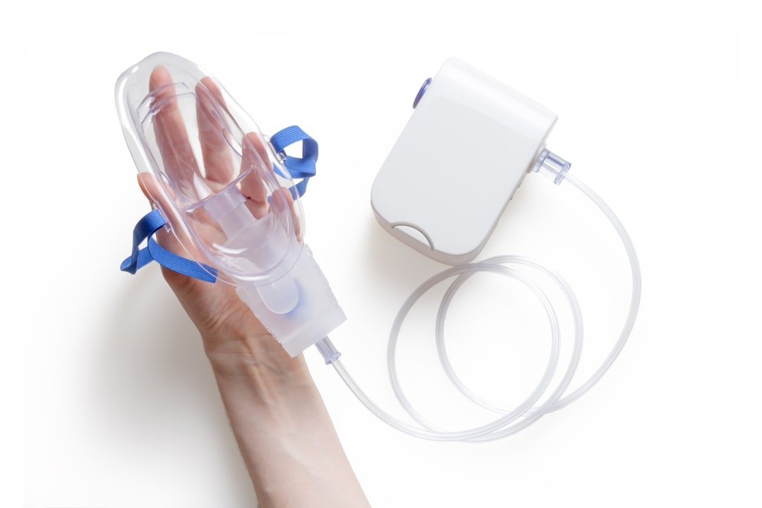
Technique Checklists | MDI | MDI + Spacer | DPI | Respimat | Bradford VTS GP Training

Created May 2026. Reference: BNF 91 (March 2026) | NICE NG245 (Nov 2025) | Asthma + Lung UK Inhaler Guidance
Overview
Correct inhaler technique is essential for effective drug delivery and disease control. Poor technique is one of the most common causes of apparently "refractory" asthma or COPD. The OSCE tests your ability to both perform and teach inhaler technique.
Key Principle
Before adding or changing medication, ALWAYS check inhaler technique.
Up to 80% of patients use their inhaler incorrectly at some point.
Demonstrate technique. Then ask the patient to demonstrate back (teach-back).
1. Pressurised Metered-Dose Inhaler (pMDI) — without Spacer
Examples: Salbutamol MDI (Ventolin Evohaler), Clenil MDI, Atrovent MDI.
Step | Action
1 | Remove the mouthpiece cap and shake the inhaler for 5 seconds.
2 | Breathe out gently and fully (away from inhaler).
3 | Place mouthpiece between lips, creating a good seal.
4 | Start to breathe in SLOWLY and DEEPLY through the mouth.
5 | Simultaneously press the canister down ONCE to release the dose.
6 | Continue inhaling slowly and deeply until lungs are full.
7 | Remove inhaler from mouth and hold breath for 10 seconds (or as long as comfortable).
8 | Breathe out slowly through the nose.
9 | Wait 30–60 seconds before taking a second dose (if required).
10 | Replace mouthpiece cap. If ICS: rinse mouth and gargle with water (spit out).

Common MDI Errors
Firing before starting to breathe in (timing mismatch).
Breathing in TOO FAST — reduces deposition in small airways.
Not holding breath after inhalation.
Forgetting to shake before use.
Not rinsing mouth after ICS (causes oral candidiasis).

2. pMDI with Spacer (Recommended for all ICS, children, poor coordination)
Spacer devices (e.g. Volumatic, AeroChamber) significantly improve drug delivery and reduce oropharyngeal deposition. Always preferred for ICS. Essential for children and elderly.
Step | Action
1 | Assemble spacer and check for cracks/damage. Wash monthly in warm soapy water, air-dry.
2 | Remove mouthpiece cap from inhaler and shake for 5 seconds.
3 | Insert inhaler firmly into the end of the spacer.
4 | Breathe out gently (away from spacer).
5 | Place spacer mouthpiece in mouth — seal lips around it.
6 | Press inhaler canister ONCE to release one dose into spacer.
7 | Breathe in slowly and deeply through the spacer.
8 | Hold breath for 10 seconds.
9 | Breathe out slowly. (For children or difficult technique: 5 tidal breaths after firing.)
10 | Wait 30 seconds before second dose. Always fire once per breath.
11 | If ICS: rinse mouth and gargle, then spit out.

Spacer Tips
NEVER fire more than once per breath into the spacer.
Replace spacer every 6–12 months or if cracked.
Anti-static spacers (AeroChamber Plus) preferred for children.
If whistling noise heard: breathing in too fast — slow down.

3. Dry Powder Inhaler (DPI)
Examples: Turbohaler (Symbicort, Pulmicort), Accuhaler (Seretide, Spiriva Handihaler concept), Ellipta (Relvar), Handihaler. DPIs are BREATH-ACTUATED — no coordination required, but need a FAST breath.
Step | Action
1 | Prepare the device according to its specific mechanism (e.g. rotate Turbohaler base; open Accuhaler lever; open Ellipta lid).
2 | Breathe OUT fully (away from device — do not breathe into DPI).
3 | Place mouthpiece between teeth, seal lips tightly.
4 | Breathe in HARD and FAST (deep, forceful inhalation — not slow like MDI).
5 | Remove device from mouth. Hold breath for 10 seconds.
6 | Breathe out slowly through the nose.
7 | If ICS: rinse mouth and gargle (spit out).
8 | Close/replace cap. Check dose counter if available.

Key DPI Difference vs MDI
DPI: breathe in FAST and HARD (needs inspiratory flow rate >30 L/min).
MDI: breathe in SLOW and STEADY.
DPIs do not need shaking and are breath-actuated (no timing issue).
DPIs should NOT be used with a spacer.
Patients with very low inspiratory flow (severe COPD exacerbation) may not generate enough flow for DPI.

4. Soft Mist Inhaler (SMI) — Respimat
Examples: Spiriva Respimat, Stiolto Respimat, Spiolto. Delivers a slow-moving mist — ideal for patients who cannot coordinate MDI or generate flow for DPI. No propellant. Refillable cartridge system.
Step | Action
1 | Prepare: Turn base a HALF turn until it clicks (do not turn further). Open orange cap.
2 | Breathe out slowly and fully (away from inhaler).
3 | Close lips around mouthpiece (not teeth — just lips).
4 | While SLOWLY breathing in, press the dose-release button.
5 | Continue slow inhalation until lungs are full.
6 | Hold breath for 10 seconds.
7 | Breathe out slowly through nose.
8 | Close orange cap.

5. OSCE / SCA Tips
In the Exam — Inhaler Technique OSCE
Structure: Greet → Establish baseline (what device? how long? ever shown before?) → Demonstrate → Ask patient to demonstrate → Correct errors → Check understanding → Safety net.
Always offer to watch the patient use their own device — not just to ask "are you using it correctly?"
In the SCA: "Before I consider changing your inhaler, let me just check your technique — is that OK?"
Name the commonest real-world error for each device (MDI: timing; DPI: insufficient flow; Spacer: multiple fires per breath; Respimat: pressing before inhaling).
Document: inhaler technique reviewed and corrected / adequate / follow up arranged.
Mention rinsing mouth after EVERY ICS use — it is a safety point.

Red Flags / Safety
Salbutamol use >3 times per week = poor control — do not just optimise technique; review treatment step.
Patient using ICS without rinsing mouth: risk of oral candidiasis.
Unable to use current device (e.g. arthritis, cognitive impairment): consider MDI + spacer or Respimat.
Child under 5: MDI + spacer with face mask ONLY. DPI not appropriate.

References
[1] NICE. Asthma: diagnosis, monitoring and chronic asthma management (NG245). November 2024, updated November 2025. www.nice.org.uk/guidance/ng245
[2] BNF 91. March 2026. NICE/BMJ Group. bnf.nice.org.uk
[3] Asthma + Lung UK. How to use your inhaler. 2024. www.asthma.org.uk
[4] NICE. Chronic obstructive pulmonary disease in over 16s (NG115). Updated March 2026. www.nice.org.uk/guidance/ng115

DISCLAIMER: Always double check this advice and drug doses with the latest NICE/BNF guidance. This document is for educational purposes only.

