GUIDANCE FOR DEVELOPMENT OF SAFEGUARDING ADULTS POLICY AND PROCEDURES

All healthcare organisations and healthcare providers have a duty outlined in legislation to make arrangements to safeguard adults at risk of abuse and neglect.

This policy is consistent with, and should be read in conjunction with, The Joint Multi Agency Safeguarding Adults Policy & Procedures West Yorkshire, North Yorkshire & York, 2021.

These policies and procedures are intended to inform and support staff, in order to ensure personalised approaches to safeguarding: working with the adult at risk to better understand their views and wishes and desired outcome from any safeguarding interventions (The Care Act, 2014).

CONTENTS

Section | Topic | Page
1. | Introduction | 4
2. | Background | 4
3. | Policy Statement | 5
4. | Scope | 5
5. | Equality and Diversity Statement | 6
6. | Governance & Leadership | 6
7. | Safeguarding Adults Related Policies and Procedures | 6
8. | Multi-Agency Working & Information Sharing | 7
9. | Recruitment & Employment | 8
10. | Training | 8
11. | Allegations of abuse against staff/persons in a position of trust (PiPoT) | 8
12. | Safeguarding Adult Procedures | 9
12.1 | Recognising Abuse | 9
12.2 | What to do if you become aware of abuse and/or neglect? | 10
12.3 | Deciding if you need to raise a safeguarding concern to Local Authority/Multi-Agency Safeguarding Hub (MASH) | 11
12.4 | Key Questions When Deciding Whether to Report a Safeguarding Concern | 12
12.5 | How to raise a concern | 13
13 | Deprivation of Liberty | 14
14 | Prevent | 14
15 | Useful Contacts | 16

APPENDICES

Appendix | Topic | Page
A. | Definitions | 17
B | Glossary | 18
C | Roles And Responsibilities Within (Name of The Practice) | 22
D | Training For Staff | 24
E | References And Bibliography | 25

- INTRODUCTION

  - Safeguarding adults is everybody’s business. All staff have a responsibility to help prevent abuse and to act quickly and proportionately to protect people where abuse is suspected. Safeguarding adults will only be effective when Practice staff work in close partnership with other agencies.

  - Everyone has the right to live their lives free from violence and abuse. This right is underpinned by the duty on public agencies under the Human Rights Act (1998) to intervene proportionately to protect the rights of citizens.’ ADASS (2005)

‘Safeguarding means protecting an adult’s right to live in safety, free from abuse and neglect. It is about people and organisations working together to prevent and stop both the risks and experience of abuse or neglect’ (Care Act Guidance, 2023).

  - This policy and procedure document aims to complement and should be read with reference to: The Joint Multi-Agency Safeguarding Adults Policy and Procedures: West Yorkshire, North Yorkshire, and York (2021). Joint Multi-Agency Safeguarding adults Policy Procedures (saferbradford.co.uk)

  - Safeguarding adults is often intrinsically linked with the safeguarding of children and any concerns regarding children should be dealt with using the Safeguarding Children Policies and Procedures. West Yorkshire Consortium Inter Agency Safeguarding and Child Protection Procedures (proceduresonline.com)

  - It is essential that safeguarding adults is considered in line with the Mental Capacity Act, 2005 which provides a statutory framework for people who lack capacity to make decisions for themselves.

- BACKGROUND

  - ‘The experience of abuse and neglect is likely to have a significant impact on a person’s health and well-being. By its very nature, abuse (the misuse of power by one person over another), has a large impact on a person’s independence. Neglect can prevent a person who is dependent on others for their basic needs, exercising choice and control over the fundamental aspects of their life and can cause humiliation and loss of dignity.’ ADASS (2005) Safeguarding Adults.

  - Abuse can be experienced or caused by anyone and in any circumstances. It can be wilful or unintentional and can take many different forms including physical, sexual, emotional (including verbal), financial or material, neglect, and discriminatory abuse. Abuse can occur in many different contexts including domestic violence situations, modern day slavery, organisational abuse and self-neglect.

Although anyone can experience abuse and neglect, some adults are at higher risk and may need additional support to protect themselves. The Care Act (2014) sets out the duties on Local Authorities and other agencies to support ‘adult at risk’. Section 42 of the Care Act (2014) describes an adult at Risk as someone who:
- has needs for care and support (whether or not the local authority is meeting any of those needs) and.
- is experiencing, or at risk of, abuse or neglect.
- and as a result of those care and support needs, is unable to protect themselves from either the risk of, or the experience of abuse or neglect.

  - Safeguarding is underpinned by the following principles, in-order to ensure personalised, effective, and lawful practice:

- Empowerment
- Protection
- Prevention
- Proportionality
- Partnerships
- Accountability

  - When an adult with care and support needs is thought to be at risk of abuse or neglect, the statutory responsibility for undertaking safeguarding adult enquiries lies with the Local authority (The Care Act ,2014). However, GP Practices have an obligation to cooperate with request to support the local authority in their safeguarding enquiries.

  - In many cases, the GP has trusted relationship with patients, and this may mean that the GP Practice is best placed to support both the patient and the Local Authority in their safeguarding enquiry. This may include e.g., providing further contact, discussion, and support to the adult at risk, as well as sharing relevant information with the local authority and undertaking patient examinations, assessments, clinical investigations, and reviews.

  - The Care Act (2014) introduced Safeguarding Adults Boards (SABs) which are led by the Local Authority who, along with the Police and NHS Integrated Care Boards (ICB) as statutory partners. Safeguarding Adults Boards provide strategic leadership across the district, working with a wide range of organisations to support and develop safeguarding adult practice. GP Practices may be involved in the work of the Safeguarding Adults Board via the NHS ICB and have access to resources, support and training provided by the Board.

  - Safeguarding Adults Boards (SABs) also have the duty to arrange a Safeguarding Adults Review (SAR) where an adult at risk has died or sustained significant injury due to abuse or neglect (see Appendix A definitions). GP practices may be required to contribute to Safeguarding Adults Reviews and to implement any recommendations relevant to Primary Care. Practices should ensure that learning from Safeguarding Adult Reviews (SARs) are shared appropriately with staff, in-order to improve future safeguarding related practice.

- POLICY STATEMENT

  - Safeguarding adults is one of the highest priorities for Primary Care and integral to all that we do. This policy outlines how the Practice will fulfil its statutory responsibilities and ensure that there are robust structures and systems in place, in accordance with local safeguarding adult procedures.

- SCOPE

  - This policy will focus on ‘adults at risk’ (Care Act 2014) who need care and support services and are unable to protect themselves from abuse and neglect without additional support. These adults may have additional needs due to, for example, older age, mental or physical ill health, and substance and/or alcohol misuse issues. The policy also includes reference to safeguarding resources that may be appropriate for any adult experiencing or at risk of experiencing abuse and neglect. The policy also covers the PREVENT strategy.

  - This policy applies to all staff within the practice and any services commissioned by the practice. This includes: all employees, locums and agency staff, contractors, volunteers, students, and any other learners undertaking any type of work experience or work-related activity.

- EQUALITY AND DIVERSITY STATEMENT

  - This policy aims to safeguard all individuals who may be at risk of abuse, irrespective of age, disability, gender reassignment, marital status, pregnancy and maternity, race, religion or belief, sex, and sexual orientation.

  - All staff must respect the adult at risk (and their family’s) culture, religious beliefs, gender, and sexuality; however, this must not prevent action to safeguard someone who is at risk or experiencing abuse or neglect.

  - All reasonable endeavours must be used to establish the person’s preferred method of communication and to communicate in a way people can understand. This will include ensuring access to the interpreter’s service where people use languages (including signing) other than English. Every effort must be made to respect the person’s preferences regarding gender and background of the interpreter. If at all possible, please try to use an independent interpreter rather than a family member, especially if abuse or neglect is suspected.

- GOVERNANCE & LEADERSHIP

  - The practice Safeguarding Adults Lead is (Insert Name and contact)

The practice Safeguarding Adults Deputy Lead is (Insert Name and contact)

  - The Safeguarding Adults Leads are responsible for providing advice, support and supervision to any practice staff who wish to discuss a concern or individual case or potential abuse or neglect.

  - Practice leads are also responsible for supporting the ongoing learning and development of all practice staff in relation to safeguarding adults, as well as ensuring that the Practices’ policy, training, and safeguarding adults’ arrangements are up-to-date and effective.

  - The practice leads will ensure that complaints and any incidents are monitored in-order to identify and act on any safeguarding concerns including potential neglect and ensure that these are reported to the Local Authority Safeguarding Team in accordance with local multi-agency procedures.

  - The practice leads will review the effectiveness of the practices safeguarding arrangements at least annually via completion of the GP Assurance Framework offered by the ICB Safeguarding Team.

- SAFEGUARDING ADULTS RELATED POLICIES AND PROCEDURES – This policy should be read in conjunction with the policies mentioned below:

  - Was Not Brought Procedure (WNB): (Insert link) This includes how to manage and escalate concerns for Adults at Risk who are not brought to appointments.

  - Chaperone policy: (Insert Link) This includes how to reduce the risk of abuse or allegations of abuse about practice staff in consultations as well as how to ensure that patients feel free to discuss potential abuse or neglect without being under the influence or control of others (including family or carer).

  - Domestic Abuse Policy: (Insert Link) This includes practice guidance and resources in relation to any adult, including ‘adults at risk’ under the Care Act definition.

  - Repeat Prescribing Policy: (Insert Link) This considers/addresses safeguarding concerns for Adults at Risk (for example, reviewing medications with sedative properties prescribed to new and prospective patients or an attendance for planned reviews).

  - Policies on the use and storage of intimate imagery: (Key principles for intimate clinical assessments July 2020.pdf (rcgp.org.uk)) These ensure that all relevant staff receive training on this so that they can comply with national guidance.

- MULTI-AGENCY WORKING AND INFORMATION SHARING

  - Sharing of information is vital for early intervention and is essential to protect adults at risk from abuse or neglect. It is important that all practitioners understand when, why and how they should share information.

  - Sharing the right information, at the right time, with the right people, is fundamental to good practice in safeguarding adults but has been highlighted as a difficult area of practice. It is important to keep a balance between the need to maintain confidentiality and the need to share information to protect the person others. Decisions to share information must always be based on professional judgement about the safety and wellbeing of the individual and in accordance with legal, ethical, and professional obligations.

  - Information may be shared without consent in some circumstances, e.g., where there are concerns that an adult is at risk of serious harm, or if it would undermine the prevention, detection, or prosecution of a serious crime, including where gaining consent might lead to interference with any potential investigation or escalate risk to the individual.

  - Requests for information from another agency should ideally be accompanied by consent from the patient, however there are times when it may not be appropriate to seek consent, for example when doing so would place the person at serious risk of harm or there is sufficient public interest. Requests for information without the persons consent should set out the legal framework for the request along with an explanation as to why it may be justified. The practitioner is responsible for deciding what information is relevant, necessary and proportionate to share. Advice on sharing information for safeguarding purposes can be sought from the Practice Safeguarding lead, Bradford District and Craven ICB Adult Safeguarding Team, or medical defence organisation.

  - The ‘Seven Golden Rules’ of information sharing are set out in the Information Sharing Advice for practitioners providing safeguarding services:

https://assets.publishing.service.gov.uk/government/uploads/system/uploads/attachment_data/file/1062969/Information_sharing_advice_practitioners_safeguarding_services.pdf (Page 4)

- RECRUITMENT AND EMPLOYMENT

  - The practice will ensure safe recruitment policies and practices, which meet the NHS Employment Check Standards, including enhanced Disclosure and Barring Service (DBS) checks for all eligible staff. This includes staff on fixed-term contracts, temporary staff, locums, agency staff, volunteers, students, and trainees and are completed prior to commencing in their employment.

- TRAINING

  - The Practice will identify the safeguarding training requirements for all staff (permanent and temporary) using the adult safeguarding intercollegiate document within a training needs analysis and develop a training plan. The Practice will assure itself that all staff are aware of the required competencies they need to execute their duties in line with ‘Adult Safeguarding Roles and Competencies for Health Care Staff’ (2018).

  - The Practice will ensure that all staff and volunteers undertake safeguarding training appropriate to their role and level of responsibility. (See appendix G for Adult safeguarding intercollegiate document and RCGP supplementary guidance).

  - The practice will ensure that all staff (including temporary staff), locums, contractors and volunteers have time to read the Safeguarding Adults policies and time for training on key local safeguarding procedures. This must include information about how to report concerns within the service and/or directly into the multi-agency procedures.

- ALLEGATIONS OF ABUSE AGAINST STAFF/ PERSONS IN A POSITION OF TRUST (PIPOT)

Please refer to the Local Authority policy below:
Managing Concerns involving a 'Person in Position of... (trixonline.co.uk)

  - The practice will ensure that they have an effective system to manage all allegations of abuse against staff and volunteers working with Adults at Risk and that these are monitored using the practices incident management systems.

  - The practice will report any safeguarding concerns relating to practice staff, to the local authority safeguarding team as soon as possible, using the locally agreed multi-agency procedures.

  - Safeguarding concerns about staff will also be notified to the ICB Safeguarding Team.

  - The practice will address employment/disciplinary issues when an allegation of abuse or neglect has been substantiated, and, where appropriate; report workers to the Disclosure & Barring service, CQC, statutory and other bodies responsible for professional regulation such as the General Medical Council, the Nursing and Midwifery Council and the Health & Care Professions Council (Care Act Statutory Guidance, 2016).

- SAFEGUARDING ADULT PROCEDURES

As highlighted, all staff have a role to play in safeguarding adults who may be experiencing or at risk of abuse. Staff in any role within the practice can become aware of concerns of abuse or neglect of an adult in any setting, including concerns about the quality of care leading to potential abuse or neglect.

These procedures will support staff to recognise and respond to concerns regarding the potential and actual experience of abuse and/or neglect of an individual(s).

  - Recognising Abuse

It is everyone’s responsibility to recognise abuse and to take immediate action if abuse is suspected. Abuse can be perpetrated by anyone including other patients or service users, family members, visitors, staff, contract workers, volunteers, learners or students, neighbours, people providing goods or services or members of the public.

You should remember that:
  - Abuse may be one off or repeated
  - Abuse can result from actions or in-actions
  - Abuse can be deliberate or unintentional
  - Abuse can be perpetrated by an individual, a group or an organisation
  - Abuse can take place in any setting

Where abuse is occurring, other people may also be at risk, including children. If you think someone may be being abused, you should also consider who else might be at risk. Where you suspect abuse of a child follow the practice Safeguarding Children policy.

  - What to do if you become aware of abuse and/or neglect?

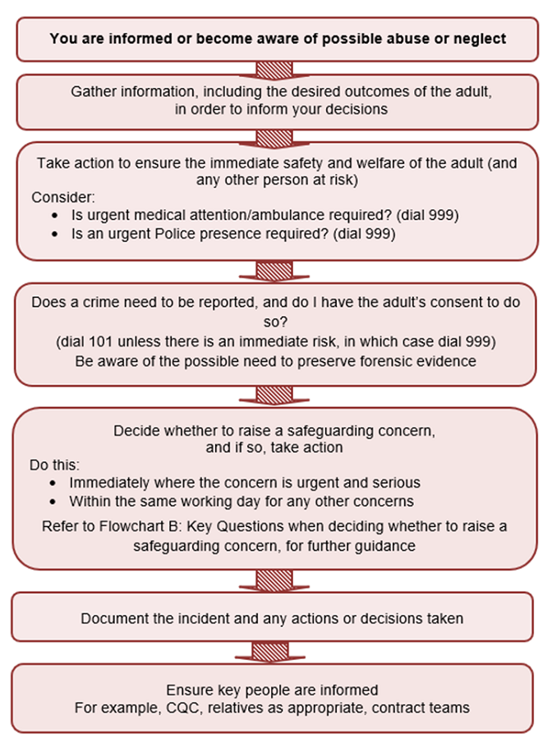

  - Deciding if you need to raise a safeguarding concern to Local Authority:

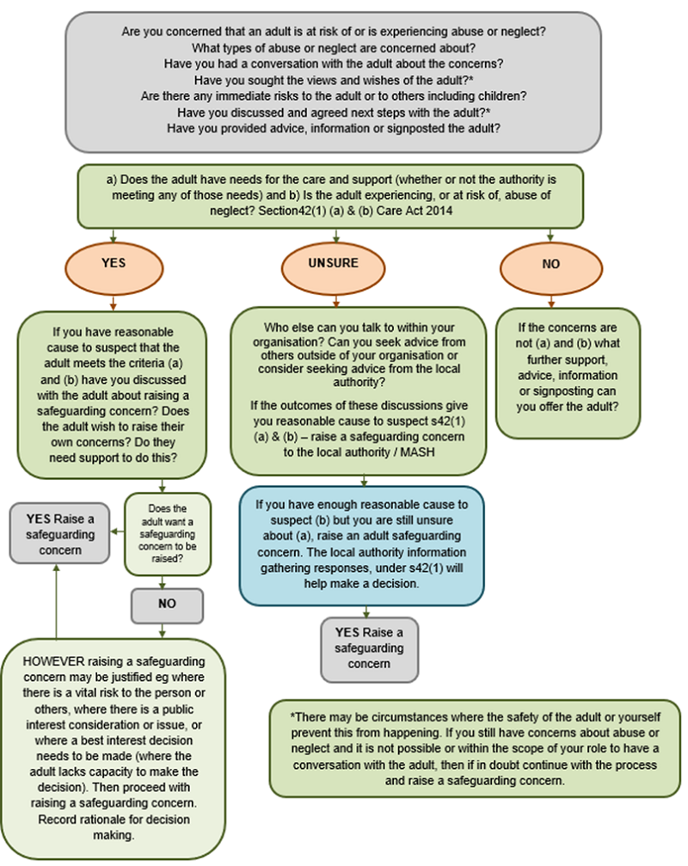

  - Key Questions When Deciding Whether to Report a Safeguarding Concern:

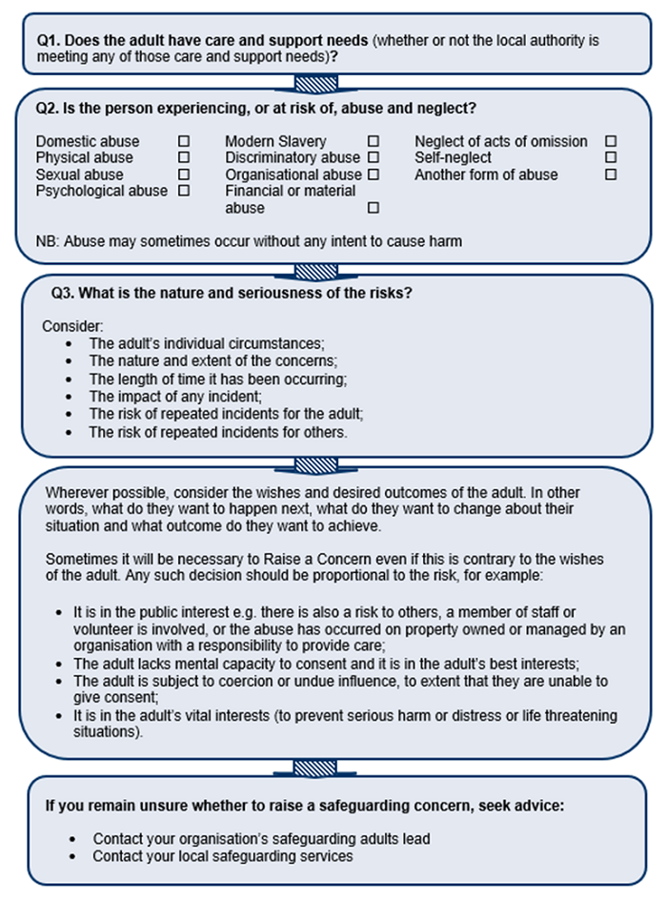

  - How to raise a concern:

Bradford District:
Immediately inform your safeguarding adult practice lead and report the concern if the patient is not in immediate danger via:

The link to report a concern can be found here via the Safer Bradford site:
https://www.saferbradford.co.uk/report-a-concern
or Tel: 01274 431077 (Bradford Safeguarding Adult Team, office hours)
Out of Hours Contact:
Adult Social Care Out of Hours Emergency Duty Team: Tel: 01274 431010

North Yorkshire:
Immediately inform your safeguarding adult practice lead and report the concern if the patient is not in immediate danger.
Contact the North Yorkshire County Council customer services Centre on 0300 131 2 131. This includes outside of office hours.
All of the relevant information and process for the completion of the form is detailed on: https://www.northyorks.gov.uk/safeguarding-vulnerable-adults

See Appendix B for Checklist for reporting a concern.

Remember:

If you don’t report your concerns the abuse may continue.
Your first duty is towards the patient / person who may be experiencing abuse.
You do not need ‘proof’ before you tell someone about your suspicions.
You may have one vital piece of information (the ‘missing piece of the safeguarding jigsaw’).
If you tell someone and they do not appear to do anything, you must tell someone else.

How do I offer support?

Signposting/referral:
Explore the issues with the patient.
Provide relevant information about other sources of support e.g. social prescribing, police, domestic abuse agencies, adult social care, voluntary sector support and support the patient by completing referrals with their consent and/or empower them to self-refer.

Adult Social Care:
If a patient’s needs are unclear consideration of a referral to
Adult Social Care for assessment of their care and support needs under the Care Act, 2014.

Bradford:
Contact Adult Service Contact Point, 01274 435400
Safer Bradford - Adults

North Yorkshire:
https://www.northyorks.gov.uk/social-care-adults
https://www.northyorks.gov.uk/new-adult-social-care

Documentation:
Make clear, contemporaneous, and complete written records in the patient’s clinical record, as you would in a standard consultation.

Concerns and information about vulnerable adults/adults at risk should be recorded in the medical records using the safeguarding adult template. The relevant coding should also be added.

Concerns and information from other agencies such as social care, Police, health agencies etc. and any referrals pertinent to safeguarding planning should be added to the safeguarding adult template with the appropriate coding. Copies of said referrals need to be saved in the communication and records section of SystmOne.

Mark any safeguarding information which could put the patient at additional risk e.g., Domestic abuse disclosures, ‘Not for online viewing’.

Email should only be used when secure, and the email and any response(s) should be copied into the record and relevant safeguarding information, subsequent plans and actions taken added to the patient’s SystmOne safeguarding adult template.

If safeguarding information is related to a person in a position of trust, particularly a member of staff this will be required to be recorded securely in the staff personnel file and in line with your own jurisdiction guidance

Records, storage, and disposal must follow national guidance see: https://www.nhsx.nhs.uk/media/documents/NHSX_Records_Management_Code_of_Practice_2020_3.pdf

- DEPRIVATION OF LIBERTY

Some people lack capacity to make decisions and may need to be cared for in circumstances that deprive them of their liberty (DoL) in their best interests to protect them from harm.

Whenever a member of practice staff believes a patient may be being deprived of their liberty, either at home or in a registered care setting, they should discuss this with the care provider to establish whether the deprivation of liberty has been authorised, e.g., by the court, under the Deprivation of Liberty Safeguards or under the Mental Health Act.

Practitioners should also consider whether a treatment or care they are proposing could, when added to existing arrangements, result in a deprivation of liberty. This could be for example when prescribing medication which may cause sedation or otherwise add to the patient being under constant supervision and control. In these cases, the practitioner should raise this with the care provider who should take steps to ensure the assessment and any necessary authorisation of a DoL.

If, having raised the issue, the practice has concerns that a care provider is not taking steps to have a DoL authorised, the practice should consider whether it is appropriate to raise a safeguarding concern with the local authority. The practice could also consider seeking advice from the commissioners of the care package or ICB safeguarding team.

- PREVENT

All staff should be familiar with the Governments’ Prevent strategy including how to make a Prevent referral and have undertaken the learning appropriate to their role.

Healthcare professionals may meet and treat people who are at greater risk of radicalisation, such as people with mental health issues or learning disabilities, who may have a heightened susceptibility to being influenced by others.

The key challenge for the health sector is to be vigilant for signs that someone has been or is being drawn into terrorism (radicalised). GPs and their staff are the first point of contact for most people and are in a prime position to safeguard those people they feel may be at risk of radicalisation. It is important to note that PREVENT operates within the non-criminal space and is aligned to the multi-agency safeguarding agenda.

- Practice staff who have concerns that someone may be becoming radicalised must seek advice and support from the practice GP Lead for Safeguarding Adults.

- If a referral to PREVENT is required, then use the form below and also follow the PREVENT pathway on GP ASSIST

- The Government website for all concerns and up to date advice:

- National Counter Terrorism Security Office - GOV.UK (www.gov.uk)

- Prevent referral form and process


PREVENT: Information Sweep Requests

Agencies have a statutory duty to cooperate with PREVENT (Counter Terrorism & Security Act, 2015 section 38). As part of this duty, GP Practices can be asked to provide relevant information about specific patients. This is to help assess whether the person is at risk of being groomed for violent extremism.

The ICB Safeguarding Team will forward any request for patient information to the relevant practice. The request sets out the legal basis for sharing information and the practice is requested to

- review the patient record
- complete the provided form
- returned to the Police Officer identified in the request (usually within 5 working days)

Usual information governance rules apply and the practice must decide, based on the information contained in the PREVENT request form, what information about the person or their family is appropriate and reasonable to share.

Any documentation about this request should be marked not for online viewing.

Advice and support in completing PREVENT information requests can be sought from the ICB Safeguarding Adult Team or Practice Safeguarding Lead.

- USEFUL CONTACTS:

Practice Safeguarding Adult Lead GP (Insert name and contact)

Available for professional guidance, support and advice:

Safeguarding Adult Team, ICB:

Dr Seemab Khan – Named GP (Safeguarding Adults)
01274 237665 / 07904 648717 seemab.khan2@bradford.nhs.uk

Nicola Ingle – Specialist Practitioner (Safeguarding Adults)
01274 237665 / 07971 942063 Nicola.ingle@bradford.nhs.uk

Helen Hart - Designated Nurse (Safeguarding Adults) & PREVENT Lead for the ICB
01274 237426 / 07958 476997 helen.hart@bradford.nhs.uk

Katrina Uttley - Deputy Designated Nurse (Safeguarding Adults)
07816 238469 katrina.uttley@bradford.nhs.uk

Matt O’Connor – Designated MCA Lead
07949 886909 Matt.O’Connor@bradford.nhs.uk

Bradford District Local Authority:

Visit the Safer Bradford site:
https://www.saferbradford.co.uk/report-a-concern or
Tel: 01274 431077 (Bradford Safeguarding Adult Team, Adult Protection Unit, office hours).
For out of hours contact Adult Social Care out of hours Emergency Duty Team, Tel: 01274 431010.

North Yorkshire County Council:
Contact the N. Yorkshire County Council customer services centre on 0300 131 2 131. This includes outside of office hours.
And visit:
https://www.northyorks.gov.uk/safeguarding-vulnerable-adults

Bradford: Contact Adult Service Contact Point
01274 435400
https://online.bradford.gov.uk/ufs/contact_us_social_services.eb?ebd=0&ebp=10&ebz=1_1605869155759

North Yorkshire
https://www.northyorks.gov.uk/social-care-adults https://www.northyorks.gov.uk/new-adult-social-care

Police – Emergency
Where an emergency response is required to make the person safe or to secure evidence Call 999

Non – urgent call 101

Counter Fraud Contacts
Fraud and Corruption Reporting Line: 0800 028 4060
https://cfa.nhs.uk/
APPENDIX A

DEFINITIONS

Abuse
Abuse is the violation of an individual’s human or civil rights by any other person/s and involves the misuse of power by one person over another (Safeguarding Adults. ADASS, 2005).

Abuse can be unintentional or deliberate and can result from either actions or inactions.
There are ten categories of abuse or neglect specific to adults at risk recognised by the Care Act 2014:
Physical Abuse | Including assault, hitting, slapping, pushing, misuse of medication, restraint or inappropriate physical sanctions including female genital mutilation.
Domestic Violence | Including psychological, physical, sexual, financial, emotional abuse. So called ‘honour’ based violence and forced marriage.
Sexual Abuse | Including rape, indecent exposure, sexual harassment, inappropriate looking or touching, sexual teasing or innuendo, sexual photography, subjection to pornography or witnessing sexual acts, indecent exposure and sexual assault or sexual acts to which the adult has not consented or was pressured into consenting.
Psychological Abuse | Including emotional abuse, threats of harm or abandonment, deprivation of contact, humiliation, blaming, controlling, intimidation, coercion, harassment, verbal abuse, cyber bullying, isolation or unreasonable and unjustified withdrawal of services or supportive networks
Financial or Material Abuse | Including theft, fraud, internet scamming, coercion in relation to an adult’s financial affairs or arrangements, including in connection with wills, property, inheritance or financial transactions, or the misuse or misappropriation of property, possessions or benefits.
Modern Slavery | Encompasses slavery, human trafficking, forced labour and domestic servitude. Traffickers and slave masters use whatever means they have at their disposal to coerce, deceive and force individuals into a life of abuse, servitude and inhumane treatment.
Discriminatory Abuse | Including forms of harassment, slurs or similar treatment because of race, gender and gender identity, age, disability, sexual orientation or religion.
Organisational Abuse | Including neglect and poor care practice within an institution or specific care setting such as a hospital or care home, for example, or in relation to care provided in one’s own home. This may range from one off incidents to on-going ill-treatment. It can be through neglect or poor professional practice as a result of the structure, policies, processes and practices within an organisation.
Neglect and Acts of Omission | Including ignoring medical, emotional or physical care needs, failure to provide access to appropriate health, care and support or educational services, the withholding of the necessities of life, such as medication, adequate nutrition and heating.
Self-Neglect | This covers a wide range of behaviour neglecting to care for one’s personal hygiene, health or surroundings and includes behaviour such as hoarding.

APPENDIX B - GLOSSARY

Adult
For the purposes of this document, adult refers to anyone who is eighteen years or older.

Adult at Risk:
The Care Act section 42 duty for the local Authority to undertake safeguarding enquiries applies to Adults at Risk i.e. those aged 18 years or more who:

- Have needs for care and support (whether or not these needs are being met).
- Are experiencing, or at risk of, abuse or neglect and
- As a result of those care and support needs is unable to protect themselves from either the risk of, or the experience of abuse or neglect.

In practice this may include:
- Frail older people with additional / long term needs.
- Adults with physical or learning disabilities or mental health conditions.
- People with a long-term illness/condition.
- Someone who misuses substances or alcohol to the extent that it affects their ability to manage day to day living.
- Unpaid carers e.g. family/friends who provide personal assistance to adults.

Carer
ADASS defines a carer as someone who:
‘... spends a significant proportion of their time providing unpaid support to a family member, partner, or friend who is ill, frail, disabled or has mental health or substance misuse problems.’ (Carers and Safeguarding Adults – working together to improve outcomes, July 2011).

CHANNEL process
Channel is part of the Prevent strategy. The process is a multi-agency approach to identify and provide support to individuals who are at risk of being drawn into terrorism or are at risk of radicalisation.

Deprivation of Liberty (DoL)
The law currently defines a person as being Deprived of their Liberty if they are under continuous supervision and control and not free to leave (Permanently) for a not negligible amount of time. If an adult is deprived of their liberty in-order to provide care or treatment, it must be ‘authorised’ by a court or under some other prescribed legal process including for example, the Mental Health Act or Deprivation of Liberty Safeguards (DoLS).

Deprivation of Liberty Safeguards (DoLS)
Deprivation of Liberty Safeguards were introduced to provide legal protection for people who need to be deprived of their, in their best interests. The DoLS process forms part of the Mental Capacity Act (2005) and is set out in the DoLS Code of Practice (2007). It applies to hospital patients and care home residents who are 18 years and over and who are not subject to detention under the Mental Health Act. The DoLS involve independent assessments, including to confirm that the person is unable to make decisions about their care arrangements and that it is their best interests to be Deprived of their Liberty. The Local authority can then authorise the persons Deprivation of Liberty for up to 12 months at a time.

Disclosure and Barring Service (DBS)
This is the public body set up to prevent unsuitable people from working with adults with care and support needs or with children. The DBS keeps a list of people who are barred from such work.

Domestic Homicide Review (DHR)
A Domestic Homicide Review (DHR) is a multi-agency review of the circumstances in which the death of a person aged 16 or over has, or appears to have, resulted from violence, abuse or neglect by a person to whom they were related or with whom they were, or had been, in an intimate personal relationship, or a member of the same household as themselves.

Female Genital Mutilation
Female Genital Mutilation refers to all procedures that involve partial or total removal of external female genitalia, or other removal of the female genital organs for non-medical reasons. Normally carried out in childhood, this is a form of child abuse. It should be noted that women who have had FGM may be at risk of a further more advanced procedure in adulthood.

Hate Crime
Hate Crime is not a stand-alone category within the Care Act but needs to be considered within these categories as a risk factor. This is a crime whereby someone targets an individual because of their membership or perceived membership of a certain social group or race e.g. examples of such groups can include, and are almost exclusively limited to: sex, ethnicity, disability, language, nationality, physical appearance, religion, gender identity or sexual orientation.

Initial Enquiry
This is the initial response to a Safeguarding Concern. It involves gathering information to determine what action, if any, should be taken.

Independent Mental Capacity Advocate (IMCA)
IMCA stands for Independent Mental Capacity Advocate.
IMCA is a type of statutory advocacy introduced by the Mental Capacity Act 2005 (the Act). The Act gives some people who lack capacity a right to receive support from an IMCA.
Local Authorities have commissioned IMCA services in England and Local Health Boards have commissioned them in Wales. Responsible bodies, the NHS and Local Authorities all have a duty to make sure that IMCAs are available to represent people who lack capacity to make specific decisions, so staff affected will need to know when an IMCA must be involved.
IMCA services are provided by organisations that are independent from the NHS and local authorities.

Making Safeguarding Personal (MSP):
MSP means safeguarding should be person-led and outcomes-focused. It means engaging with the adult in a conversation about how best to understand and respond to any risks they face in a way that enhances their involvement, choice and control in improving their quality of life, wellbeing and safety. This includes the wishes of the adult at risk to establish, develop or continue a relationship and their right to make an informed choice (Care Act: Section 14.15).
The key principle of Making Safeguarding Personal is to support and empower individuals by capturing the wishes and feelings of those who experience abuse and neglect and seeing individuals as the experts in their own lives. Professionals should work with the adult to establish what being safe means to them, and how that can be best achieved.

Mental Capacity Act, 2005 (MCA)
Issues of mental capacity and the ability to give informed consent are central to safeguarding practice and the making safeguarding personal ethos. This Act provides a statutory framework to empower and protect people who may lack capacity to make decisions for themselves along with arrangements for making ‘best interest’ decisions on their behalf. All decisions taken within adult safeguarding must comply with this legislation.

Multi-Agency Safeguarding Adults Procedures
This refers to the locally agreed multiagency safeguarding adult procedures coordinated through the local Safeguarding Adults Board.

Multi-Agency Risk Assessment Conference (MARAC)
This is a multi-agency meeting where information is shared on people at highest risk of domestic abuse. A multi-agency action plan is then formulated to reduce risk to them and their children. A Domestic Abuse, Stalking and Harassment (DASH) risk assessment checklist is available for professionals to complete with adults experiencing domestic abuse. If the resulting risk score is high a MARAC referral should be made but can be considered on lower scores on professional judgement and perceived risk.

Multi-Agency Public Protection Arrangements (MAPPA)
These are statutory arrangements for assessing and managing the risks posed by sexual and violent offenders.

Neglect
Neglect is a form of abuse and may be defined as the persistent failure to meet a person’s basic physical and or psychological needs. Neglect can be either unintentional or deliberate.
Neglect can involve failing to provide adequate food, shelter and clothing, failing to protect from physical harm or danger, or the failure to facilitate access to appropriate medical care or treatment. It may also include neglect of, or unresponsiveness to, a person’s basic emotional needs. Examples could include:

- Poor quality care
- Inadequate hygiene support
- Failure to ensure adequate hydration or nutrition
- Under or over-use of medication
- Lack of privacy or dignity
- Serious pressure ulcer (grade 3 or 4)
- Failure of care due to inadequate equipment, systems, procedures or practice

Person Alleged to Have Caused Harm (PATCH)
Someone who is alleged to have caused abuse or neglect to an adult at risk is called a Person Alleged to Have Caused Harm (PATCH).

Prevent Strategy
Prevent is part of the UK’s counter-terrorism strategy, preventing people from becoming involved in terrorism or supporting terrorism. Its focus is on vulnerable individuals who may be at risk of being exploited by radicalisers and subsequently drawn into terrorist-related activity. The aim is to intervene early to protect and divert vulnerable individuals away before anything illegal occurs, offering them positive experiences in place. Vulnerable individuals could be service users, their family/ friends, other members of the public or colleagues.

Safeguarding Adult Review (SAR)
These should be carried out by the Safeguarding Adult Board when an adult in its area, with needs for care and support (whether or not the local authority has been meeting those needs) has died as a result from abuse or neglect or, the SAB ‘knows or suspects that the adult has experienced serious abuse or neglect’, and that there is reasonable cause for concern about how the SAB, members of it or anybody else with relevant functions have worked together to safeguard the adult when someone with care and support needs dies as a result of neglect or abuse and there is a concern that the local authority or its partners could have done more to protect them.

Safeguarding Concern
This refers to any suspicion, allegation, or other concern relating to the abuse or neglect of an adult. Individuals do not need ‘proof’ in order to raise concerns under the safeguarding adults’ procedures.

Whistleblowing
The action of a staff member in raising a reasonable and honest suspicion about a possible fraud, danger or other risk that threatens service users, colleagues, the public, or the GP Practice’s reputation.

APPENDIX C

Roles and responsibilities within (Name of the Practice)

Role | Responsibilities
All Staff | Working actively to identify and safeguard people who may be experiencing or at risk of abuse.  Support and work within agreed practice and multi-agency adult protection policy and procedures relevant to their role and responsibility.  Attend safeguarding adults training appropriate to their role and responsibilities and draw any learning needs (in relation to safeguarding adults) to the attention of their manager.  Take immediate action to minimise risk to adults where abuse is suspected.  Reporting suspicion of abuse or neglect using organisational or multi-agency procedures.  Report serious crimes or situations where a person is at immediate risk due to a crime to the police.  Reporting suspicions of fraud according to the Fraud and Corruption Policy.  Reporting concerns to a manager or via the (whistleblowing policy) where they feel unable to report to their Line Manager or remain concerned that the adult(s) is still at risk.  Reporting concerns directly to the Adult Protection Unit (or the police if they believe a crime has been committed) when they feel unable to raise concerns within the organisation or believe that their concern has not been acted upon.  Work within professional codes of practice.  Identify the need for additional safeguarding advice and support and seek this from the Adult Protection Unit when required.
Practice Management Board | Ensuring that the practice has effective systems and resources in place to meet its legal obligations, monitor safeguarding activity and to safeguard adults who may be at risk of or experiencing abuse.  Identify a lead person with executive responsibility for Safeguarding Adults  Undertake Safeguarding Adults training appropriate to their role and responsibilities
HR Manager in Practice | Ensuring that Criminal Record Bureau checks are carried out on in accordance with legal requirements and national guidance.  Ensure that concerns about staff are monitored and referred to the Independent Safeguarding Authority according to current national guidance and that HR systems are compliant with any succeeding legal requirements or guidance in respect of the protection of vulnerable adults.  Ensuring that recruitment procedures comply with NHS Employment Check Standards and legal requirements in relation to the protection of adults.  Ensure that systems are in place to monitor allegations against staff and to inform managers and other agencies in line with legal requirements and agreed multi-agency policy and procedures.
Practice Manager | Ensure the implementation of the practice and multi-agency safeguarding adult policy and procedures applicable within their sphere of responsibility.  Ensure that safeguarding concerns are reported using organisational and multi-agency procedures.  Identify support for staff who raise safeguarding concerns.  Ensure that implications for the safeguarding of adults are considered in all service developments.

APPENDIX D

Training for Staff
Intercollegiate document:
https://www.rcn.org.uk/professional-development/publications/pub-007069

Training update for ICB



RCGP:
https://www.bedshertslmcs.org.uk/wp-content/uploads/2019/12/190600-RCGP-Safeguarding-training-requirements-for-Primary-Care.pdf

APPENDIX E

References and Bibliography

Adult Safeguarding: Roles & competencies for health staff
https://www.rcn.org.uk/professional-development/publications/pub-007069

The Care Act, 2014
https://www.legislation.gov.uk/ukpga/2014/23

Care and Support Statutory Guidance, Department of Health, Care and Support Statutory Guidance issued under the Care Act 2014, Updated June 2020
https://www.gov.uk/government/publications/care-act-statutory-guidance/care-and-support-statutory-guidance

Care Quality Commission: The Fundamental Standards
https://www.cqc.org.uk/what-we-do/how-we-do-our-job/fundamental-standards

Data Protection Act (1998)
https://www.legislation.gov.uk/ukpga/2018/12/contents/enacted

Human Rights Act (1998)
https://www.legislation.gov.uk/ukpga/1998/42/contents
Department of Health and Office of the Public Guardian (2009) 3rd edition. Making Decisions – The Independent Mental Capacity Advocate (IMCA) Service. Crown, London.

Disability Discrimination Act (2005).
https://www.legislation.gov.uk/ukpga/2005/13/contents

Fraud Act (2006)
https://www.legislation.gov.uk/ukpga/2006/35/contents

Health related Guidance for safeguarding concerns (Safer Bradford) https://www.saferbradford.co.uk/learning-resources/resources/#H

Human Rights Act (1998)
https://www.legislation.gov.uk/ukpga/1998/42/contents

The Joint Multi Agency Safeguarding Adults Policy & Procedures West Yorkshire, North Yorkshire & York, 2018
https://safeguardingadults.co.uk/wp-content/uploads/2019/08/NYSAB-Joint-MA-Safeguarding-Adults-Policy-Procedures-Final-Approved-April-2018.pdf

The Mental Capacity Act, 2005
https://www.legislation.gov.uk/ukpga/2005/9/contents

MCA Code of Practice: Department of Constitutional Affairs (2007) Mental Capacity Act 2005 Code of Practice
https://www.gov.uk/government/publications/mental-capacity-act-code-of-practice

NHS Employment Check Standards (NHS Employers)
https://www.nhsemployers.org/your-workforce/recruit/employment-checks

Prevent:
https://www.gov.uk/government/publications/prevent-duty-guidance/revised-prevent-duty-guidance-for-england-and-wales

RCGP supplementary guide to safeguarding training requirements for all primary care staff
http://www.gpappraisals.uk/uploads/4/5/8/5/4585426/safeguarding_training_requirements_for_primary_care_rcgp.pdf

Safeguarding Adults: Roles and responsibilities in health and care services
https://www.cqc.org.uk/sites/default/files/20140416_safeguarding_adults_-_roles_and_responsibilities_-_revised_draf....pdf

Safeguarding Children and Vulnerable Adults: general practice reporting
https://www.england.nhs.uk/publication/safeguarding-children-and-vulnerable-adults-general-practice-reporting-supporting-documents/

