Different people have a certain interpersonal style when interacting with other people. They have a dominant behavioural style and this also dictates how they prefer others to interact with them. These differing interpersonal styles can broadly be classified on two dimensions: dominance and sociability.

- Dominance refers to assertiveness: the amount of control and forcefulness one attempts to exert over other people and situations. At one end of the scale are the ASK ASSERTIVE people and on the other end are the TELL ASSERTIVE.
  - ASK ASSERTIVE: these individuals exert influence on others by asking questions and in so doing get others to come to their own conclusions naturally. For example, they might say: “Mmm what did you make of that? What would have made it better do you think?”. Typical behaviours include:
    - Quiet voice
    - Measured speech
    - Less intense eye contact
    - Fewer gestures
    - Slower body movements
    - Listening
    - Thinking of others first

  - TELL ASSERTIVE: these individuals influence others by telling them what they want – with little discussion. For example, they might say “Mmm, that wasn’t good was it. Right, let’s start doing it this way.” Typical behaviours include:
    - Loud voice
    - Clipped speech
    - Intense eye contact
    - More gestures
    - Faster actions
    - Stating opinions
    - Thinking of self first

- Sociability refers to responsiveness: one’s willingness to express emotions (i.e. whether you are more focused on the people or the tasks). At one end of the scale are the PEOPLE FOCUSED and at the other end are the TASK FOCUSED.

  - TASK FOCUSED: these individuals are only interested in the task at hand and don’t concern themselves with people’s feelings. They are controlling. Such individuals are easily identifiable because they tend to be of a reserved character and rarely show their emotions. Typical behaviours include:
    - Immobile face
    - Fixed eye contact
    - Closed, formal body posture
    - Monotone voice
    - Task orientation
    - Small gestures
    - Static body

  - PEOPLE FOCUSED: these individuals are really interested in people’s feelings and want them to be happy with the task at hand before proceeding. They are also emotive themselves – openly showing their feelings and emotions. Such individuals are easily identifiable because they are often outgoing sociable individuals. Typical behaviours include:
    - Facial mobility and animation when they speak.
    - Short duration of eye contact
    - Open body position *Informality
    - Inflexion in voice
    - Large gestures
    - Mobile body movements

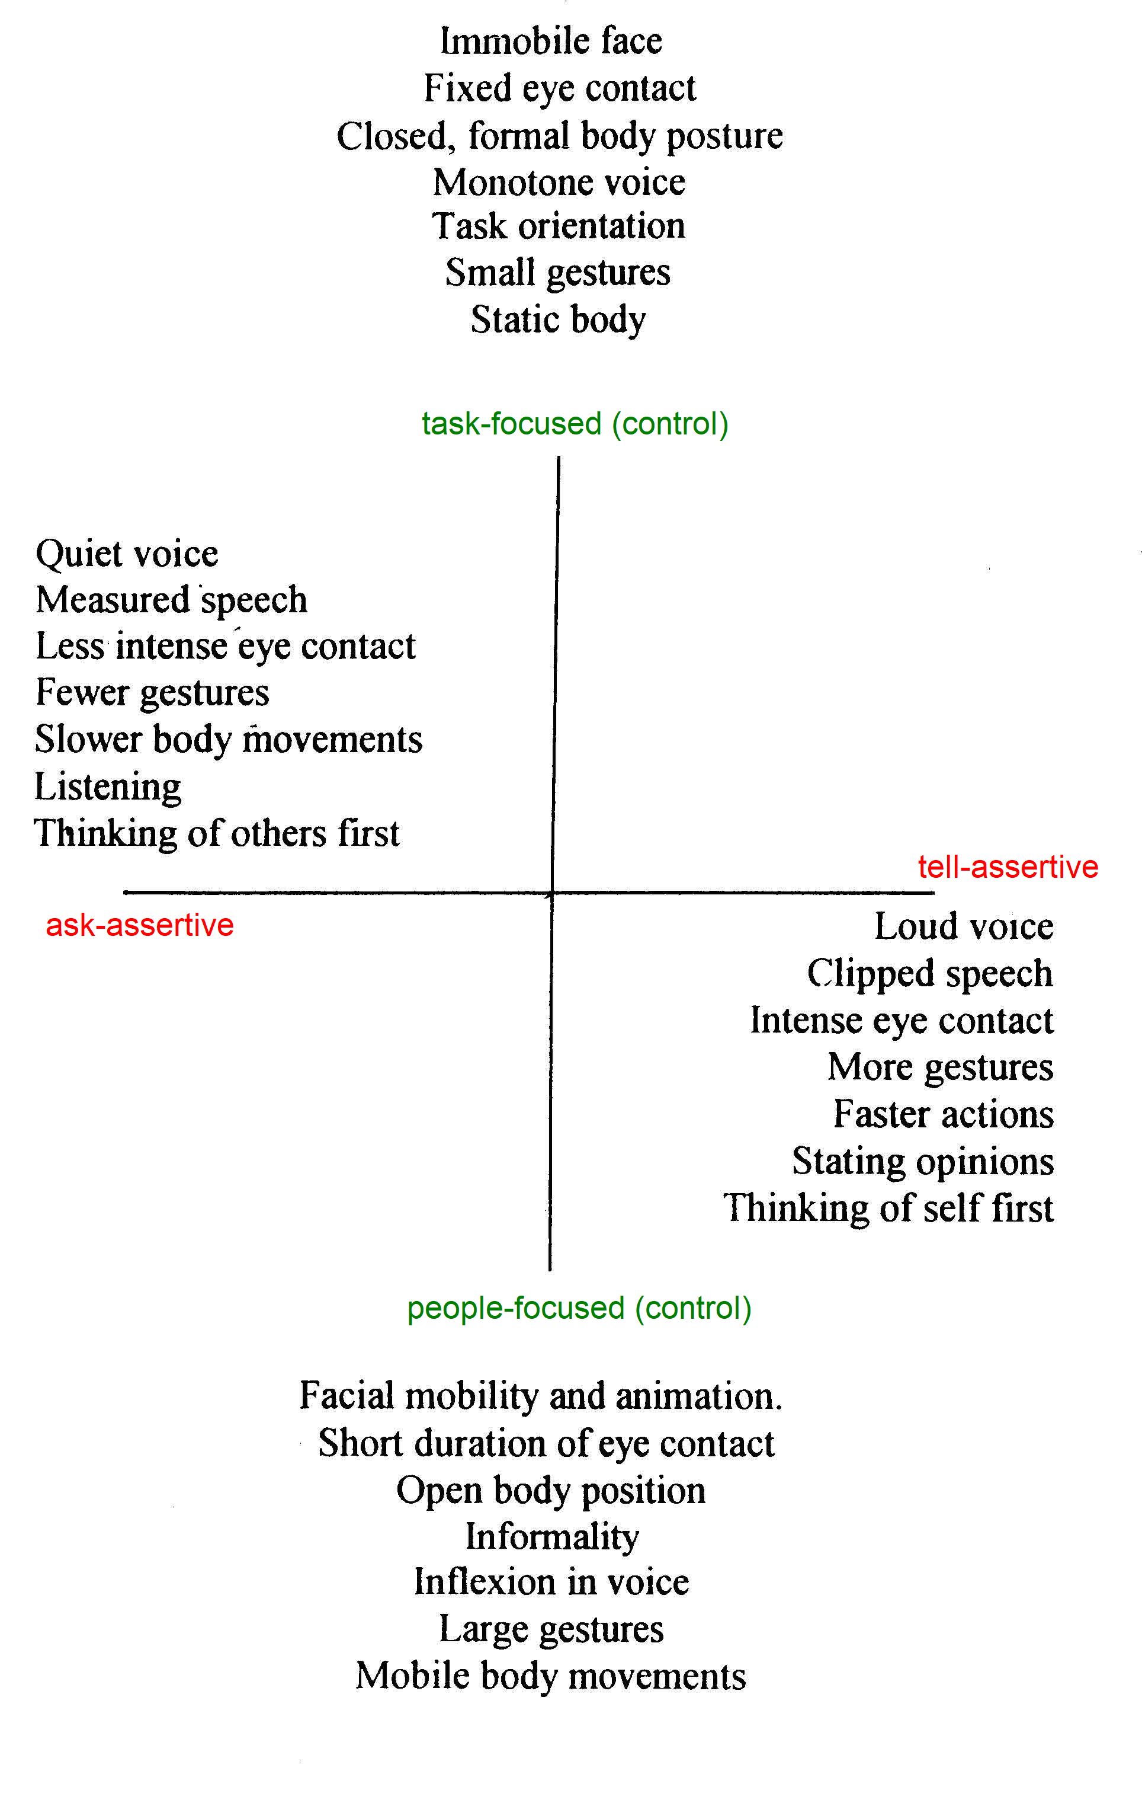

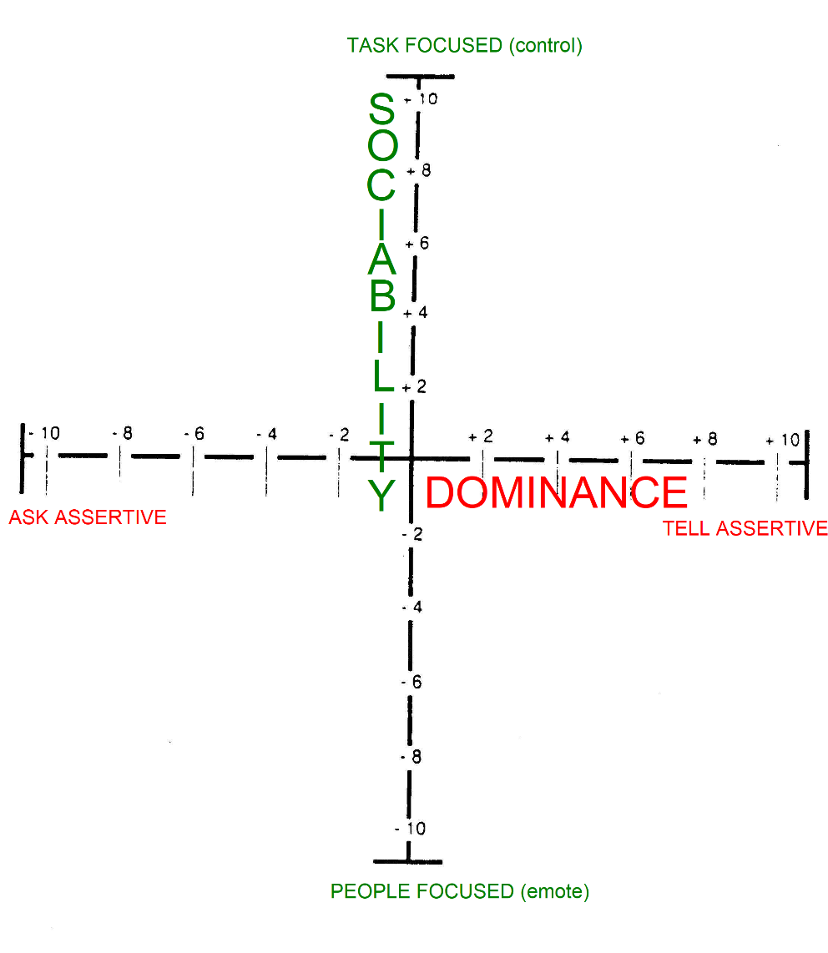
Understand that…
- There is no right or wrong interpersonal style. There is no best style either. We are all different and we should value that. It’s what makes life so interesting and wonderfully creative.
- What you are is NOT a measure of personality, intelligence or emotional well-being.

The great news is that if we understand someone’s interpersonal style, then
- We can understand their preferred interpersonal style
- We can understand what offends their interpersonal style (and minimise that)
- We can engage with them by modifying our behaviour to complement their style

In the graph below, each of us will fall somewhere within one of the quadrants. Each quadrant style has a name – to help us easily identify a person’s interpersonal style and therefore aiding us to know how to respond to such an individual.

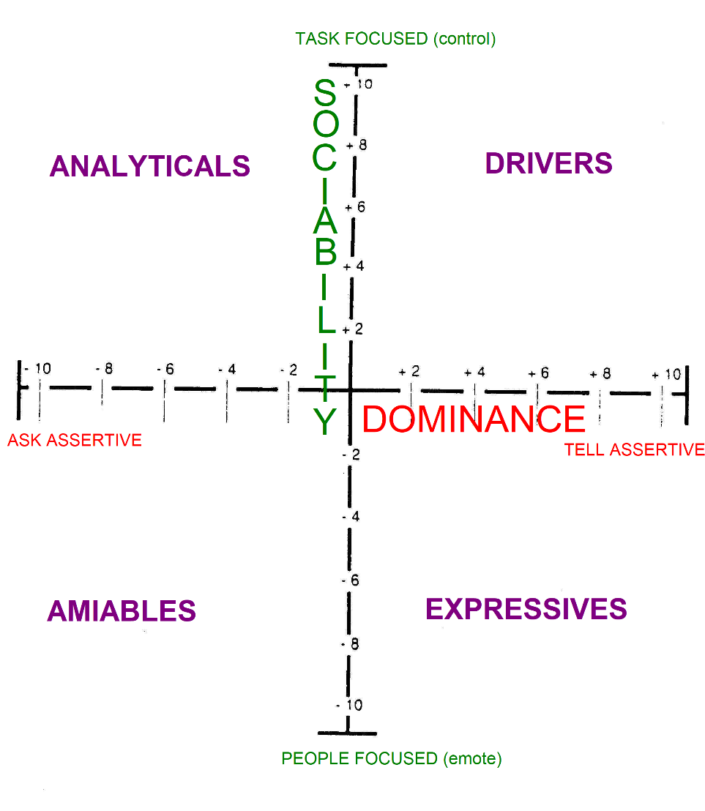
To find out where you are on the graph – you can either
- Do a formal questionnaire (see at the end of the document)
- Work it out from the descriptions below.

ANALYTICALS

LYTICALS
Analytical, or processing style:
- Pace: Measured, systematic
- Voice: Quiet, monotone
- Posture: Formal, stiff
- Gestures: Small, few
- Eye Contact: Reflective, steady
- Face: Fixed, inexpressive

Analyticals are concerned with the job in hand, and the process to achieve it
- hey like time to prepare, and are logical and thorough
- They dislike unpredictability and being rushed
- Base decisions on lots of facts, credibility
- Under pressure will withdraw and avoid cause of stress

How to get on with Analyticals

Do the following:
- Get down to business
- Listen carefully
- Be formal and quiet
- Give them time to think and to put their point of view
- Be specific and logical

Don't:

- Rush them
- Interrupt them
- Be flippant and casual
- Be disorganised or late
- Lack credibility

DRIVERS

S
Driver, or controlling style:
- Pace: Fast, decisive
- Voice: Clipped, monotone
- Posture: Formal, forward
- Gestures: Small, precise
- Eye Contact: Intense, direct
- Face: Fixed, immobile

Drivers are brisk and business-like, and like to get things done
- Like to be in charge and get results
- Hate indecision and inefficiency
- Base decisions on relevant facts, objectivity
- Under pressure become autocratic and dictatorial

How to get on with Drivers

Do the following:
- Get on with it!
- Be factual and succinct
- Talk about results
- Use time efficiently

Don't:
- Waste their time
- Be vague and rambling
- Try to get too personal
- Try to control them
- Be disorganised

AMIABLES

AMIABLES
Amiable, or supportive style:
- Pace: Slow, easy
- Voice: Soft, modulated
- Posture: Relaxed, informal
- Gestures: Large, but few
- Eye Contact: Warm, friendly
- Face: Open, animated

Amiables prefer to maintain relationships and avoid confrontation.
- Want to be appreciated, and in turn are supportive, and think of others first
- Irritated by insensitivity and impatience
- Base decisions on feelings, trust, people
- Under pressure, will aquiesce, or submit

How to get on with Amiables

Do the following:
- Be friendly and informal
- Show interest in them personally
- Take your time
- Give them time to make decisions
- Listen and be supportive of their feelings

Don't:
- Rush them
- Be factual
- Be distant, and stand-offish
- Give them cause to mistrust you

EXPRESSIVESESSIVES

Expressive, or enthusing style:
- Pace: Fast, spontaneous
- Voice: Loud, fast, modulated
- Posture: Relaxed, open
- Gestures: Large, frequent
- Eye Contact: Intense, but infrequent
- Face: Very mobile, animated

Expressives are sociable, flamboyant.
- Seek recognition, and dislike being ignored
- Irritated by routine, and lack of stimulation
- Base decisions on intuition
- Under pressure, will go on the offensive and attack

How to get on with Expressives

Do the following:
- Be prepared to socialise
- Be enthusiastic and energetic
- Offer your opinions
- Support their ideas
- Be flexible, spontaneous

Don't:
- Be impatient or controlling
- Bore them
- Give them too much detail or facts
- Irritate them!

So, what happens if you put each group under pressure?
(i.e. if you upset them)

- Analyticals will avoid you
- Drivers will become even more directive and dominate.
- Amiables will back off and acquiesce.
- Expressives will become directive, aggressive and attack.

Is that how you want them to behave with you?
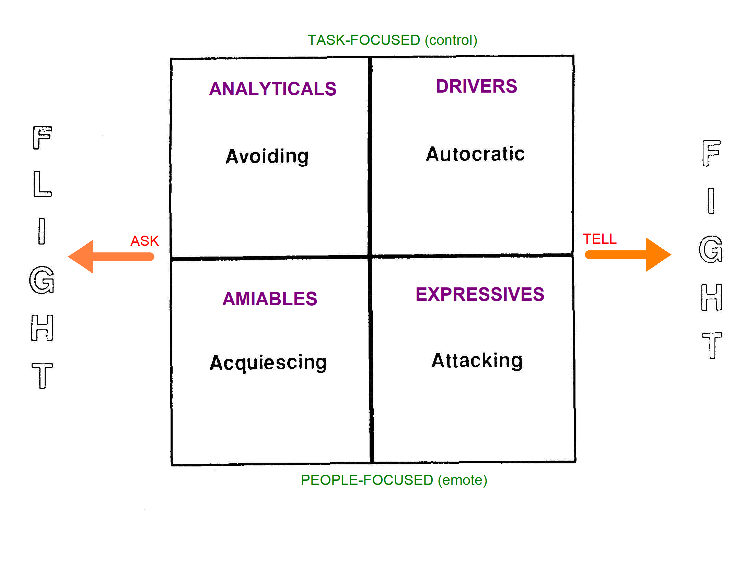

What does this mean in terms of the doctor-patient relationship?
Different patients will have different interpersonal styles. If we want to get patients on board with our line of thinking, or a management plan (for example), then we can easily do so without a fight by simply modifying our own behaviour so that it complements their preferred interpersonal style.

For example, if you had to break bad news, like telling a patient they are diabetic….

- An Analytical will probably want to know how diabetes happens on a biochemical level. They’ll probably want to understand things like insulin and blood sugar levels and perhaps even more theoretical stuff too. And they’ll probably want you to be quite formal in your manner.
- A Driver, however, might not be so interested but will probably want to know ‘what are we going to do about it to fix it?’ (or make things better again). Again, a driver might want you to be formal in your manner.
- An Amiable will want you to be friendly and informal with them. They’ll want you to show an interest in them and how they are feeling. They’ll want you to involve them, give them time to think about things and not necessarily rush into a plan (unlike Drivers and Analyticals).
- An Expressive will be emotional and want you to recognise their pain and empathise with them. Whilst they will not want you to dictate to them or control them, they will be interested in your opinion, if expressed as an opinion. They don’t like too much detail because it bores them so be concise.

In summary
Understanding behaviour styles will help you understand your style of behaviour and the style of others. It will help you manage relationships in your workplace AND at home. These Behaviour Styles are not designed to change a person. It is a tool for building productive relationships and working better with the differences.

THE QUESTIONNAIRE: Behavioural Style Identification Matrix

Answer the following questions by putting a circle around the response E, X, C, or L, that best describes yourself, or the person you are assessing.
Only one answer per question.
In some circumstances, your answer may fall somewhere between the two; in which case you will have to make the decision on balance to ensure you answer all the questions.
If you/they behave in one way in some situations and different in other situations, as is often the case, then decide what is the "real" you/them and what is tension related. Answer with the "real" you/them in mind.
Please, be honest!

1) This person is  X Easy to get to know  E More difficult to get to know | 10) Their level of enthusiasm is  X Higher than average  E Lower than average
2) In conversation or personal interaction, they  E Stay on the subject and focus on the issues at hand  X Reflect on personal & life experiences sometimes straying from the subject | 11) They tend to be  L Forward and initiate  C Reserved and wait for others to initiate
3) They are:  C Talkative  L Quiet | 12) They prefer to manage their time  X Flexibly  E In a disciplined and tight way
4) When it comes to standards or  conventions they  C Adhere to the letter of the law  L Interpret the spirit of the law | 13) In general, they  E Tend to be competitive  X Tend to go with the flow or co-operate
5) They tend to make decisions based on  E Facts, evidence, goals  X Feelings, experiences, relationships | 14) Their behaviour tends to be  L Assertive  C Reserved
6) When putting over their point of view they tend to  L Be emphatic and direct  C More qualified and indirect | 15) When expressing their views, they  L Tend to be reserved  C Express them readily
7) When emphasising points their gestures are  C Few and small  L Frequent and large | 16) Their decision making tends to be  L Rapid and spontaneous  X Slow and deliberate
8) When speaking or listening their facial expression and body language is  X Highly animated  E More limited or fixed | 17) They prefer to work in an environment where they  E Can be independent and dictate conditions  X Can work with others and include relationships
9) When it comes to personal feelings they  E Keep them private sticking to  Business  X More willing to share them | 18) When dealing with risk and change they tend to  C Take a slow or cautious approach  L Embrace it quickly and spontaneously

SCORING
To score the Behavioural Style Identification, plot the position on the Matrix by following these four steps:

1 Total No of times E was circled =

Total No of times X was circled =

(Check that E + X = 9)

2. Total No. of times L was circled =

Total No. of times C was circled =

(Check that L + C = 9)

3. Now calculate E - X and plot on the vertical axis in the graph on the next page

E-X =

4. Now calculate L - C and plot on the horizontal axis

L - C =

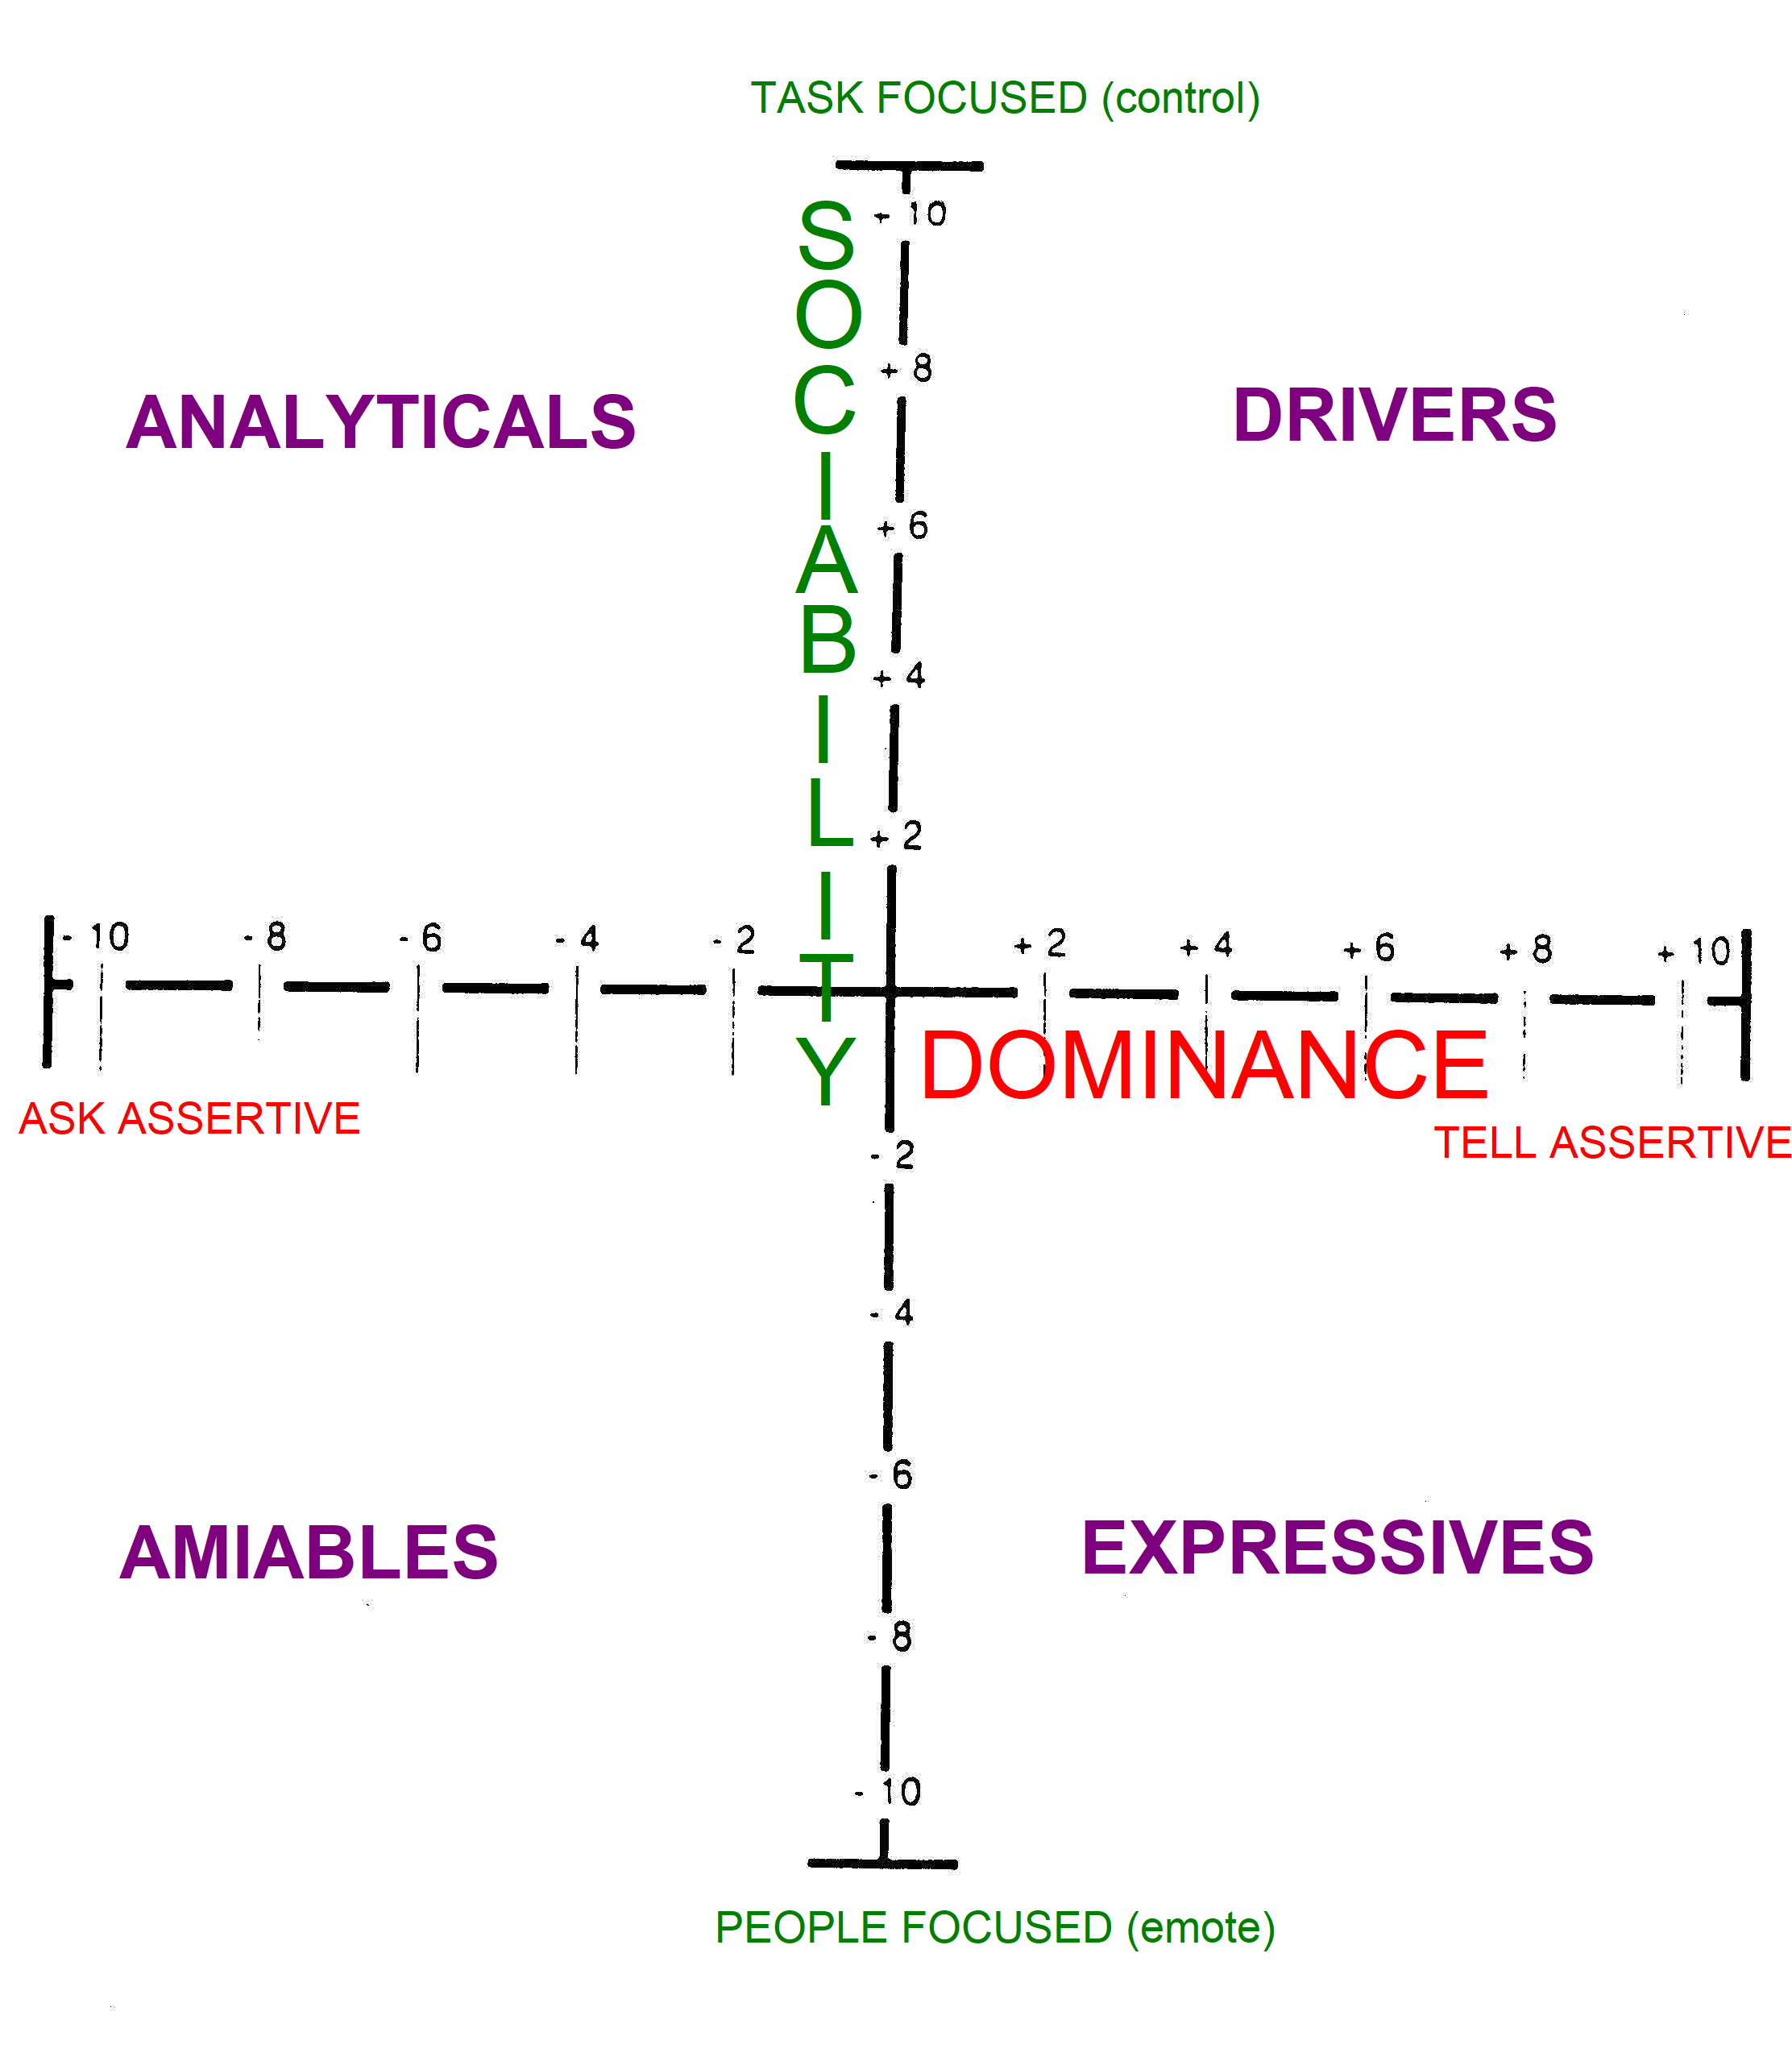

Final food for thought: Understanding Needs

Tangible Needs:
*Conscious
*Explicit
*Impersonal, less important

Intangible Needs:
*Unconscious
*Implicit
*Personal, more important

Intangible Needs are our primary motivators for decision-making. They emanate from the identity and belief levels of our personality. There are 5 groups:

- Ego/Status/Esteem
- Fear/Security/Safety
- Social/Leisure
- Value/Profit
- Self-realisation/Pleasure

We all have all the above, but one of them - the Primary Intangible Need - tends to predominate in all our rational decision making, followed by the others in order.

