Mini-MI: examples of things to say

Compare the two styles
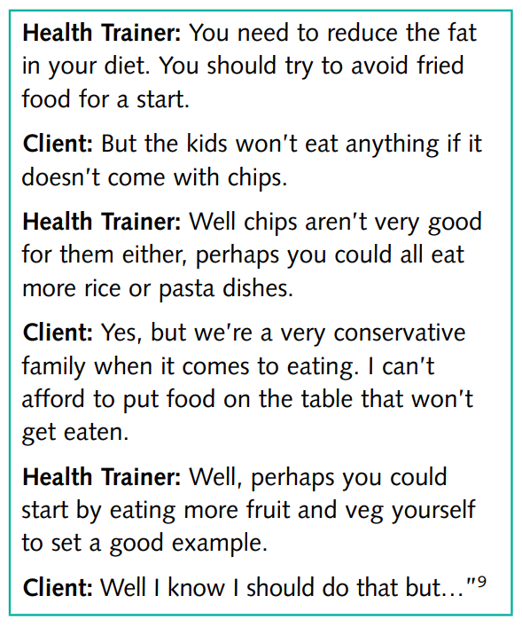 | 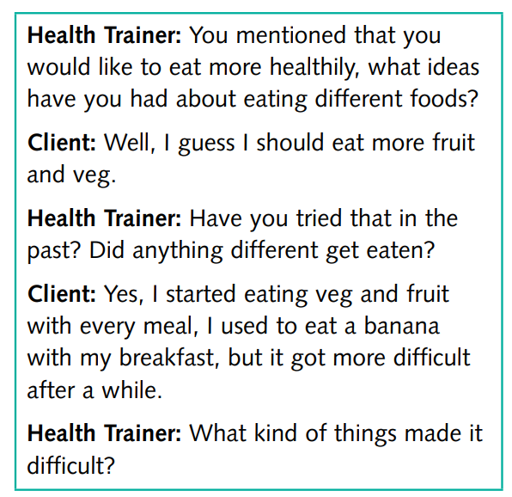

Open Questions
Closed Questions | Open Questions
And that make you feel bad?  So, is are your eating habits bad at the moment?  Do you want to stop smoking?  So, do you think smoking is bad?  Do you want to change your eating habits? | How did that make you feel?  How do you feel about your eating habits as they are at the moment?  What are your thoughts about stopping smoking?  How does smoking affect your life at the moment?  What would be the benefits of changing your eating habits?

Affirmations

Reflective Listening
I really want to get this weight off and eat healthy. But when I get home I cant be bothered to eat healthily so I grab anything I can at that point.
So you would like to eat more healthily and you really do want to lose the weight but when you come get home you find it easier to grab whatever is there. What kind of things make it difficult for you.

Summarising

Providing Information
- Traditional way:
“But the thing is the research shows that if you carry on smoking, by the time you reach 60 your lungs will be super knackered. So there is a chance to do something about it now.”
- MI way: Use Elicit-Provide-Elicit
  - Elicit
    - “What do you think about your smoking?”
    - Well, Im in my 40s now and I suppose its too late all the damage has been done.
  - Provide
    - Thanks for sharing that with me. Is it okay for me to share some of the medical research says about that? (patient nods). Well it’s good news. The research says that even in your 40s, you can still prevent a lot of further lung damage happening. And that by the time youre in your 60s, you would definitely be in a better position than if you carried on.
  - Elicit
    - Now, having heard that, I’d be interested in hearing about your thoughts and feelings.
    - Well, that’s interesting doc. I thought I would have been knackered now. So, there is a bit of a chance?
    - Well, I think it’s more than just a bit. I see. Anyway, I’ll leave that information with you and that my door is always open if you want to talk more. Okay, let’s get back to xxx (dr trying not to be too pushy at this stage).

In the PRECONTEMPLATION phase
This is where there is not real desire to change
- I’m okay as I am doc. Thanks but no thanks.
- And please don’t talk about my smoking, I’m fed up of it.
- “Don’t get me wrong doctor, I want to change but now aint a good time”
- “I know I should, but it’s difficult”
- “I know I need to quit smoking, but I’ve tried so many times and it’s just too hard. There’s just no point.”
What can you do?
The aim is to get them to a point of SUSTAIN TALKE to AMBIVALENCE TALK.
- Rapid engagement – dance with them, stroke their spirit, make them feel important, show them that you care, that youre on their side (through dialogue and behaviour). First 30 seconds are crucial. Otherwise difficult to recover from.
- Get people to a state of ambivalence = the “I want to but I don’t want to” stage or wanting incompatible things at the same time. The competing voices for and against change. Seeing a discrepancy between their values/beliefs and the reality of their current behaviour, they are more likely to want to resolve that discrepancy
  - I love my cigarettes and really am not one for wanting to stop.
  - So it seems that you feel your okay as you are and perhaps never want to stop?
  - Well not never. I mean, I know at some point it might harm my health so I wouldn’t say never.
  - Mmmm…. What sorts of things worry you?
  - You know lung cancer. But also, not breathing and getting really unfit and making me feel like I’m a slouch. And actually I cough all the time and clear lungs would be nice. But I find the damn things help me relax so much.
  - Mmmmm so it sounds like on the one hand cigarettes really help settle you and that you want to carry on. But on the other hand you do have some significant health worries.
  - Be internally delighted when you hear ambivalence. It means they’re on the move.
- Ask a lot of “what if” questions – it is another way of getting the patient into ambivalence through talking about the “other side of the coin”.
  - “What things would be better if I waved my magic wand to make you smoke-free?”
  - “If you quit today, what differences would you notice in say 6 months?”
- Provide information – but only if it is necessary to help the patient get a balanced knowledge set and will help them come to a more optimal decision for them. Do it t the right time (not early on in the consultation, where you should be building rapport). And seek permission before providing it.
- Do a cost-benefit analysis (see below)

In the CONTEMPLATION phase
In this stage, they are ambivalent. They want to change but have reasons why they don’t want to. A bit like when you’re shopping and you see something you absolutely love but really isn’t a necessary purchase. Should you or shouldn’t you? What if money was tight?
- “I do wanna stop because I know smoking is real bad for my health. But I’m so stressed at the moment and I feel I can’t cope without them.”
- “To be honest, I should start a diet straight away. I mean, look at the size of me. At this rate, it’s no wonder I got no energy and feel crap. But I love my food and it makes me feel very happy when I eat”.
- “I know I should take my medication every day, but I love my current care-free life and freedom.”

What to do…
The aim is to move them from AMBIVALENCE TALK to CHANGE TALK. You do this by moving ambivalence talk into DISCONTENT CHANGE TALK. Then crystalise that discontent to move them towards commitment. Don’t just explore (i) reasons and benefits to change, but also (ii) ways they could make the change and be successful at it. The first increases the importance of change. The second increases their confidence to change.

- Help the patient see how their problem behaviour is in conflict with a certain value or goal they have. This discrepancy helps people see the gap between where they are and where they want to be.
  - I love smoking but at some point its going to wreck my lungs aint it. And I wanna be healthy for a good long life.
  - Reflective Listening – On the one hand you love smoking but on the other hand you’re convinced it will damage your health. And health is important to you. (Remember, statement, not question)
- Provide information – but only if it is necessary to help the patient get a balanced knowledge set and will help them come to a more optimal decision for them. Do it t the right time (not early on in the consultation, where you should be building rapport). And seek permission before providing it.
- Do a cost-benefit analysis (see below)

Cost- benefit analysis
This compares the costs and benefits of the behaviour change vs no behaviour change.
- So, what positive things do you get if you continue smoking?
- What are the disadvantages of continuing to smoke?
- What are the positive things you get if you decide to stop smoking?
- What are the disadvantages of stopping smoking?
- On a scale of 1-10, how certain are you now that you want to stay the same?

Supplementary questions
- If there are lots of disadvantages to the stopping behaviour - Is there anything you can do to lessen those disadvantages associated with stopping smoking?
- Ask what their life would be like if they didn’t change and if they did change. Do some Reflective Listening and reinforce the disadvantages of not changing and the advantages of changing.
- Remember, it’s not just about the number of points. Some points more important than others.

