VIDEO CONSULTING WITH YOUR PATIENTS

A quick guide for clinicians

Why choose it?  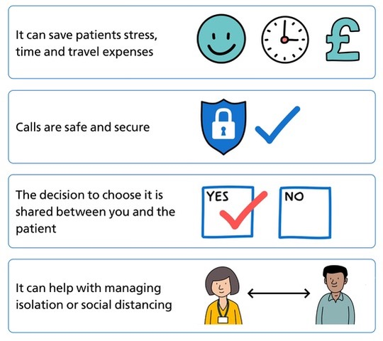 | Preparing for a video consultation  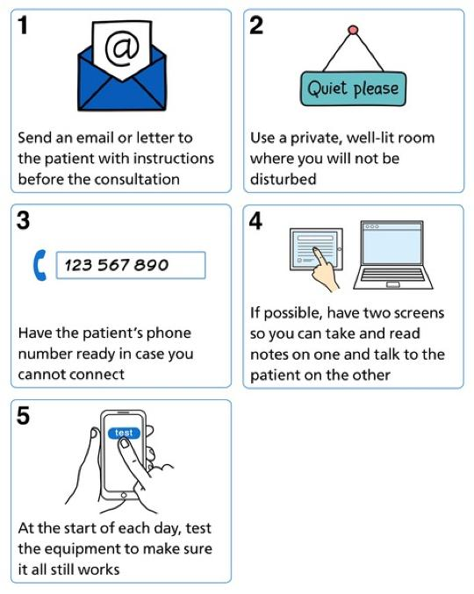

Starting a video consultation  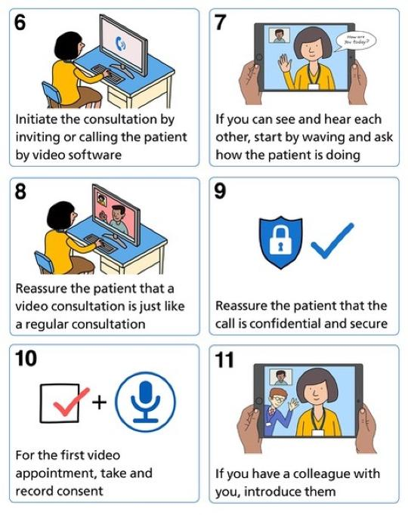  During the Covid 19 crisis, NHSX have published new guidance to say that 'the consent of the patient or service user is implied by them accepting the invite and entering the consultation. But you should safeguard personal/confidential patient information in the same way you would with any other consultation', see  https://www.nhsx.nhs.uk/key-information-and-tools/information-governance-guidance/health-care-professionals​ | Communicating in a video consultation  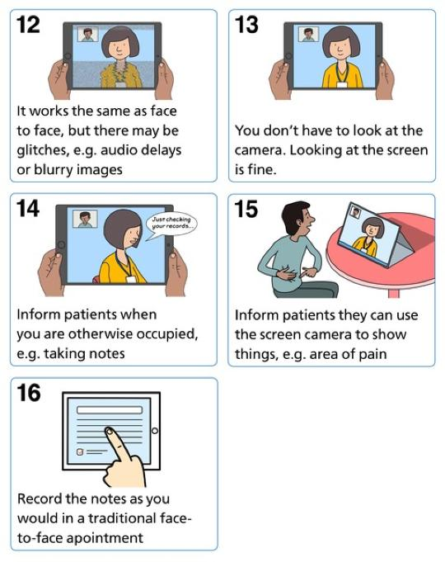

Closing a video consultation  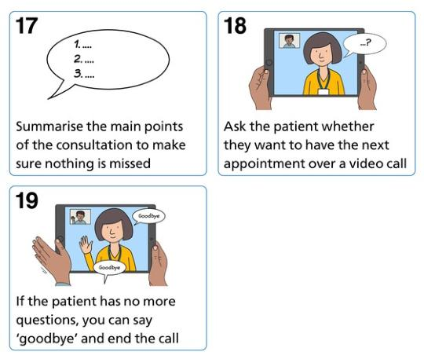 | With thanks to  

