The Best Approach to the AKT
By Youssef Beaini
(A GP trainee in Bradford who got an extremely high score)
Top tips:
- Spend enough time. I read that 100 hours of prep might get you about 70% (roughly the pass mark) and that 150 hours is more likely to get you a comfortable pass (>80%). I can attest to that.
- Take some study/annual leave before the exam to consolidate. Consider using some annual leave. Yes, a sacrifice but it can make a big difference: I used 7 days to consolidate full time (10 hours a day) and got a great score.
- Be smart in targeting your revision time. Don’t read lots of long textbooks:
Use Passmedicine.com or OnExamination.com.
- Practice with the 50 sample AKT questions on the RCGP website. Unofficial answers are on doctors.net.uk
- The BNF is your friend. The examiners write questions directly based on BNF chapters, and they say so in the question! ‘According to the BNF…’
- Use the Oxford Handbook of GP to fill knowledge gaps (need an up-to-date edition since things do change).
- Spend time on the smaller subject areas of Statistics and Health Informatics/Admin. Although these two areas only make up 20% of the marks, they are easier marks to score with just a little effort, and could make a huge difference to your overall mark.
- Know your stats. ‘Medical Statistics Made Easy’ by Harris will equip you well. In particular, make sure you understand forest plots.
- Look at the feedback on AKT exam bulletins that are produced after each exam detailing where candidates have performed poorly and make sure you cover these areas. The feedback is on the college website. You can bet your bottom dollar that the examiners will ask questions about these areas at the next sitting.
- We can easily be under-exposed to areas that are normally managed by Practice Nurses; they are still part of core general practice and examiners will test them. Spend some time on:
- COPD
- Asthma
- IHD
- Diabetes.
- There are some areas that come up regularly and can be prepared for like
- Rashes
- Fitness to return to school
- Vaccinations (especially adults! Not just childhood)
- Fit notes and certification
- DVLA rules
- Fitness to fly
- The early chapters of the BNF.
The AKT exam itself
- Designed to test knowledge and interpretation of data
- Three hours 200 item multiple choice test
- No negative marking
- Delivered on computer terminal at invigilated test centre – runs January, May and October.

Approximately 80% of question items will be on clinical medicine, 10% on critical appraisal and evidence based clinical practice and 10% on health informatics and administrative issues.

The pass mark went up in 2010 so main key is work hard, but also work efficiently. Therefore, be aware of your own learning style and tailor my advice below to that style. Most importantly, do loads of past questions. Some people prefer books but I found the on-line resource www.passmedicine.com much more useful because:
- There is a large bank of questions (2,300)
- Excellent teaching notes accompany each question
- Revise by subject or random, including timed session to simulate the exam
- Excellent links in each question to relevant resources (NICE/SIGN/dermnet.nz etc)
- Track score and compare to other passmedicine users, giving an idea on areas of weakness (of course, not everyone sitting AKT will be using passmedicine but I found that peer comparison was quite accurate)

Others have reportedly found www.OnExamination.com similarly useful (it’s a bit more expensive).

Why I found passmedicine useful.
Look at the example page below:

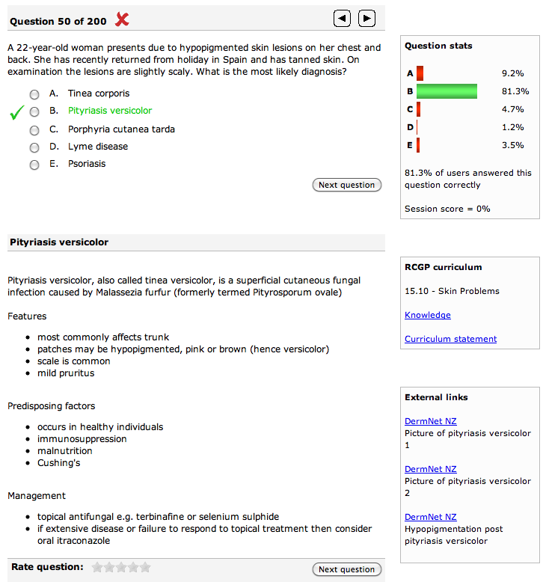

High yield teaching points are highlighted:

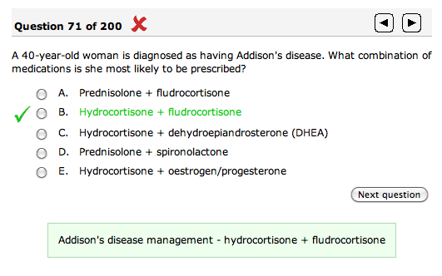

There are succinct and targeted teaching notes:
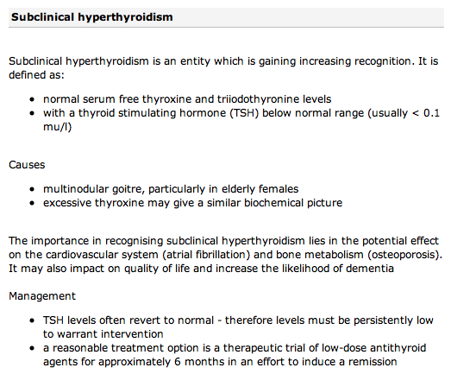

It analyses performance by subject to allow more work on areas of weakness:
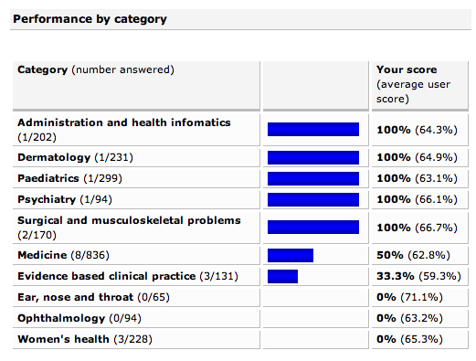

If you want a good mark, do all the questions TWICE. Now it becomes clearer why you need to start 2-3 months before!
In the exam
It is important to have a clear planned approach to taking the exam.
- 200 questions in 3 hours means 54 seconds per question.
- I checked my progress at certain points to assess progress (e.g. at 45 mins should have done 50 questions, 1 ½ hours=minimum 100 questions or half way through)
I found it useful to:
1. Efficiently and quickly go through the questions that you are sure you know (but don’t rush in a panic!), flagging the others.
2. At the second pass, go through flagged questions, answering the ‘I think’ questions
3. On the final third pass, go through the remainder of the questions, making your best guess, since there is no negative marking

There are other approaches but the key element here is to plan how you will manage the ‘I haven’t got a clue’ moment that will come at some point. And don’t get hung up on a question; move on after a minute maximum.

Now read the top tips again!
Good Luck!

Youssef Beaini

