Introduction
We offer this help file “in your best interests”. We leave it for you to choose and use and we hope it makes your training life a lot easier
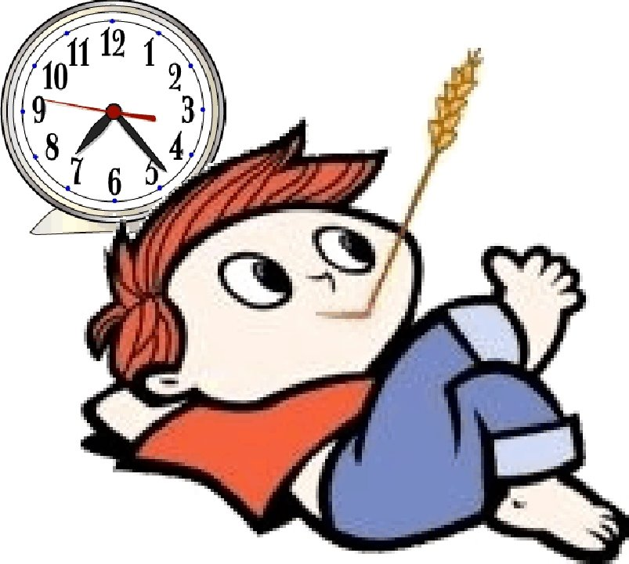

Bear this in mind:
If your ES decides to refer you to the ARCP panel, remember that they are not awarding you a stamp of failure; you’re simply being referred for another opinion.

All of these resources are available at:
www.bradfordvts.co.uk
Just click on the ‘Ed Sup/ARCP’ Link.

The e-Portfolio can be bewildering, especially at first, because there’s a lot in it. Then comes the Educational Supervision (ES) meetings where all of this stuff is reviewed in detail. In June every year, there are the ARCP panels which will further scrutinise your ePortfolio (and they can interrupt your training if they are not happy). This help file has been created to HELP you.
- It will help get your ePortfolio into tip top shape - ensuring your evidence is complete.
- Your ES meeting and ARCP panel will go smoothly = less referrals to central Deanery.
- Therefore, your anxiety will be less and….
- In the process, you’ll probably become a better learner too!

In summary, everyone is happy.

Ramesh Mehay, Paul Johnson & Mike Tomson

Your Responsibility

We feel the need to remind GP trainees that the ownership and responsibility for ensuring that all the evidence is in place in their e-portfolio (as with all aspects of GP workplace based assessment) is with them. We’ve had a number of trainees at ARCP panel interviews who have said “but no one told me....”: this holds no justification and it’s therefore important you understand it is your responsibility to find out and satisfy what is necessary for satisfactory training progression. This is especially important for the educational supervision meeting that precedes the ARCP panels.
When arranging a meeting with your Educational Supervisor, please make contact with them – don’t expect a call or email from them. And please don’t leave it till the last minute – because supervisors may have planned a holiday or something for then. Educational Supervisors have lives too - please be mindful of this.
Essential Web Material
- ‘E-portfolio Pearls – making the e-portfolio work for you’ | - ‘Levels of reflection & learning log entries’
- Assessments – which ones at which ST stage? | - Finding the evidence for the RATING SCALES

If you are reading this document in Microsoft Word or as a pdf, the above are clickable links.
The 15 Step Checklist



A Form-R is a self-declaration form about complaints and significant events. Download one at www.bradfordvts.co.uk (just click Ed Sup) or the Y&H Deanery website http://tinyurl.com/formr-yh
A missing Form-R automatically results in a poor ARCP mark (outcome 5).

You MUST make sure the CSR is done BEFORE the ES meeting. Nag your hospital consultant or GP trainer if needs be.

Please read the ‘Levels of reflection’ and ‘E-portfolio Pearls’ docs - available on www.bradfordvts.co.uk .
Log entries should not just be descriptive and superficial. They should be deep & meaningful.

1) THE AGREED PLAN
- Look at the action plan from your last ES meeting. Which bits have you managed to complete? Which bits need carrying over to the next post?

2) DECLARATIONS, REVIEW DATE, COMPLAINTS & FORM-R
- On the summary page of your ePortfolio (when you log in), you will see some declarations that need signing off (on probity, health and educational contract). Have you signed these? Has your ES too? (if not, drop them an email).
- Has your ES created your Next Review and has the ST year been correctly specified? If not, drop them an email ASAP.
- Have you had any complaints? (please bring associated documentation with you).
- Have you filled out and uploaded to your ePortfolio an electronic Form R? This needs to be done prior to every ARCP and the ES meeting which precedes it. THIS IS CRUCIAL – a missing Form R will result in an adverse panel outcome (the Form R is essential evidence that will allow the dean to recommend your revalidation to the GMC).

3) CLINICAL SUPERVISOR’S REPORT (CSR) & EDUC. NOTES
- In community or innovative posts, you will need a CSR from each supervisor.
- Review that report – are there any themes to note in terms of Relationships, Diagnostics, Management and professionalism? (NB Management is about organisational things like leading people, or managing your time; it is not clinical management.)
- Look at the ‘Educator Notes’ – again, any themes?

4) LOG ENTRIES & CURRICULUM COVERAGE
- Have you shared all the log entries you want your clinical and/or educational supervisor to see? (If you don’t share log entries then your supervisor can’t see or read them).
- Have you logged in enough (around 2 a week as a minimum)?
- Have you logged them in a timely way? (i.e. not all last minute entries - we will check the dates!)
- Do they show some depth? (i.e. in addition to writing about what happened, do you reflect, analyse, talk about feelings and identify learning needs?)
- For the stage you are at in training, how well are you covering the curriculum? (Make sure you are not inappropriately linking to the curriculum headings - again, we will check).
- Has your Clinical Supervisor read most of them, linked them to the corresponding professional competencies AND made comments on some of them? Nag your Clinical Supervisor to read at least a few of them so that your Educational Supervisor can spend time helping you with other areas rather than reading them.
Most learning log entries should be about clinical encounters with a mixture of other types, like SEAs, conversations, online modules and reading.

When there is no reflection, it is hard for the trainee to convince us that they have learnt anything.

Log entries should provide:

1) Enough Information about what happened

2) Self-awareness - openness & honesty about performance + some consideration of feelings generated in self or others

3) Evidence of critical thinking & analysis - describing own thought processes and

4) Evidence of learning - describing what needs to be learned, why & how.

Common Curric. Mistakes:
Management – is not Clinical Management but about Organisational stuff, Teaching – have to do, not simply attend, and cannot link every patient encounter to the Consultation – must write about cons. skills.

Minimum numbers for WPBA can be found here:
http://tinyurl.com/wpbanumbers
- In terms of writing, think how you might improve on your log entries.
- In terms of coverage, which curriculum areas do you need to get more log entries for? By the end of ST3, there should be around 15-20 entries for each curriculum area commonly encountered in GP (e.g. cardiovascular). Lower numbers are okay for those curriculum areas less frequently encountered in General Practice (e.g. Intellectual Disability). But there must not be zero entries for any curriculum heading!
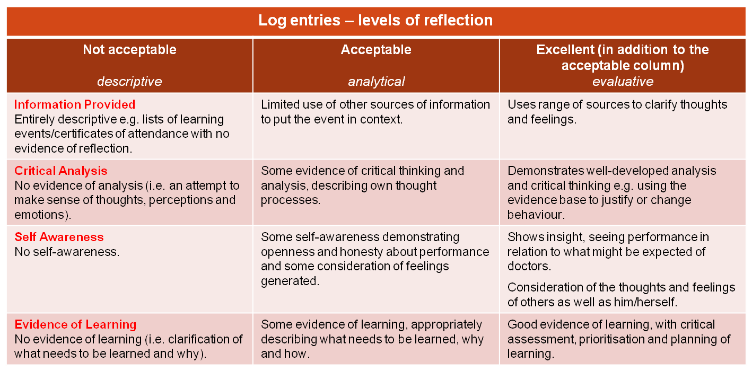
- This table tells you what makes a learning log reflective.

5) THE ES WORKBOOK – CBDs, COTs, MINI-CEXs

- Have you done at least the minimum number before your ES meeting (otherwise you will be referred)? The minimum number should be pro-rata for Less Than Full Time Trainees. The Yorkshire and the Humber Deanery guidance is that it is good practice to exceed the minimum requirements.
- Have you done them in a variety of contexts? (e.g. with a child, elderly, mental health, palliative care)
- All these assessments must be done by senior level staff. DO NOT use your peers!
- Have you downloaded, filled in and uploaded The ES Workbook? This is an essential part of your preparation before your ES meeting – available on Bradford VTS (http://tinyurl.com/ESworkbook). In particular, fill in the mapping forms section.

6) THE ES WORKBOOK – OOH, HDR ATTENDANCE & LEAVE

Try to write up your OOH session like this
- Record the type of session: telephone triage, visiting doctor, base doctor

- Write a quick one-liner summary list of all the patients seen (eg. 24 y old with URTI. 3y old child with rash)

- Then write a deeper and meaningful reflection on the most interesting patients (i.e. analyse, reflect and identify learning needs).

- Summarise with significant learning points.

- Link your log entry to the curriculum headings.

There needs to be a reasonable mix of OOH sessions. For instance, 10 triage + 2 face-face OOH sessions is unsatisfactory. We suggest more face-face (at least 50%).

Extended Hours & emergency surgery done in-practice hours is NOT OOH work

Remind your CS to read your OOH entries and link them to the corresponding OOH competencies.

OOH (this section not applicable if you are in a hospital post)
- Have you done the right number of OOH session hours (if in GP)? The bottom line: a whole-time equivalent GP trainee must do one session per calendar month from the beginning of their GP placement. In other words 18 sessions in total by the time of CCT.
- Whatever the length of the OOH session (e.g. 4, 5 or 6 hours), you are expected to complete the whole session.
- Are you writing up OOH sessions in a learning-orientated way? (see guidance in blue text on the left).
- Has your Clinical or Educational Supervisor read and linked most of them? (linked them to the corresponding professional OOH competencies)
HDR ATTENDANCE
- Record all your sessions attended in The ES Workbook. Have you attended at least 70% of possible sessions? If not, be prepared for questions!
RECORD OF LEAVE
- Record your non-annual/non-study leave in The ES Workbook (i.e. things like sick leave, paternity leave, compassionate leave).
- Have you informed the Deanery of all such leave? This is very important as it can affect your completion date. Inform Esme Ross at the Deanery: esme.ross@yh.hee.nhs.uk
- Does your non-annual/non-study leave amount to more than 2 weeks over the ST year? If so, please inform your scheme administrator and Programme Directors - you will need to make up for this extra loss in time.
MORE ON THE ES WORKBOOK
You can see how crucial The ES workbook is in your preparation before your ES meeting. Please download it from the Bradford VTS website (click Ed Sup/ARCP) and when complete, upload it to your Learning Log as a Professional Conversation with the title ‘The ES Workbook’.

7) DOPS
- Have all your DOPS being done by senior level staff – including nurses (but not your peers)? DOPS on manikins do not count.
- In relation to where you are at with GP training, how well are you progressing in terms of the mandatory DOPS? If you’re an ST3: have you done all the mandatory DOPS?
- If you’ve self-rated any DOPS you must include evidence from an appropriate clinician.
- Which DOPS might you be able to achieve in the remainder of this or the next post?

8) THE PSQ & MSF



If you can’t see your MSF scores, please email your ES to ‘release the scores’. When they’ve done this, you’ll see a tabulation of the results making them easier to interpret.

For more information on NOE see: http://tinyurl.com/qia-noe

Your Ed Supervision Review cannot proceed unless you have done your self-ratings. The expected grade for those in ST1 or ST2 is NFD (with occasional Competent grades). By the time you are ready for CCT (i.e. in ST3), all must be marked as Competent for Licensing.

PSQ

If you are required to do a PSQ, have you done one? Please note: If you are in an Innovative Training Post based in primary care (with some modular experience elsewhere) then a PSQ should be completed. This is non-negotiable and will lead to unsatisfactory progress if not completed.

What are your scores like? What themes emerge – good and bad?

MSF

If you are required to do an MSF, have you done one?
- What are your scores like? What themes emerge – good and bad?

9) NOE – NATURALLY OCCURING EVIDENCE
Have you written up:
- 1 x Significant Event Analysis per 6m? A good trainee aims for around 3 per 6m. You must be involved in this significant event, and not merely a spectator! Link SEAs to Competence 10: Maintaining performance, learning and teaching. SEAs should include details of the improvements made to personal and practice performance.
- Audit or a review of QoF or other project? (x1 in entire scheme) – pref in 1st GP post.
- 1 x Case Study or Presentation per 6m
- A reflection on Key Learning Points for every job
- Other types of NOE:. referrals analysis, prescribing analysis.
- By the end of training, you should have done some form of child protection training. Otherwise, you must include this in your future learning plan as a practising GP.

10) COMPETENCIES – SELF RATING
- Have you rated yourself in all 12 competencies?
- Have you provided the EVIDENCE from your ePortfolio on which you have based your rating? Your grade has to be based on evidence, not gut-feeling! Refer to this Bradford VTS webpage: www.bradfordvts.co.uk/educational-supervision/evidence-rating-scales . You are able to tag up to 3 pieces of evidence (choose good ones!) for each competence. For example, for 'Practising Holistically’ you might write: “6 out of the last 8 CBDs marked as competent”. Then link up to 3 pieces of additional evidence (like a learning log entry, a significant event, a teaching event, or a project and so on) and say what it is about these extras that provides the evidence. The ratings are incredibly important in your ES review – so PLEASE give your write-up some careful consideration. Your Ed Supervisor will expect it! It takes around 45-60 mins to write.
- In terms of the ACTION BEFORE NEXT REVIEW – propose an action plan to address your developmental needs for each competence (think SMART = Specific, Measurable, Achievable, Realistic, Time-bound). You might pick something from here: http://tinyurl.com/actionpts.


11) YOUR PDP
- Are you using the PDP regularly (i.e. adding to the PDP list)? Every time you have an ES meeting, it should generate 3 action points which can be turned into PDPs – you will need to edit them to make them personal and SMART (see below). On top of this, you MUST add AT LEAST one additional PDP entry – and it must relate to the learning opportunities in your post. If you want to add more than one – great stuff!
- Are you writing PDP entries in a SMART way? Specific, Measurable, Achievable, Realistic & Time-bound. Speak to your ES if you don’t know what these mean.
- Are you completing your PDP? In other words, ‘actioning’ PDP items tackled.
- Think about any educational courses you’d like to consider to meet your learning needs? For example: Family Planning, STIF courses, Minor Surgery, Child Health, Consultation Skills, Exit Course, Urgent Care Course, Diversity, MRCGP prep courses.

12) PROGRESS TO CERTIFICATION (only ST3s in their last post)
- AKT & CSA: When do you plan to take it? If you have been unsuccessful, have you a clear plan to ensure better chance of success the next time around?
- Highlight which log entry (date) confirms that you hold a valid CPR/AED certificate; you must attach the certificate. Will your CPR/AED be valid when you progress to certification? The certificate should say, otherwise we will assume it will be valid for ONE year (ALS counts for 3 years).
- Safeguarding: child-protection training (see blue note on the left) – there should a log entry – and you need to highlight it with a title like ‘Child Protection’.
- Write a final OOH Log entry on how you have demonstrated the 5 OOH competencies throughout your logged OOH sessions. Label it with a title like ‘Out of Hours (OOH) Competencies’. The 5 OOH competencies are:
- Ability to manage common medical, surgical and psychiatric emergencies.
- Understanding the organisational aspects of NHS out of hours care (nationally & locally)
- The ability to make appropriate referral to hospitals and other professionals.
- The demonstration of communication and consultation skills required for out of hours care.

The PDP should be a living document where learning needs are added and deleted continuously throughout the post as they are discovered and completed.

Evidence of child protection training is not currently a requirement for the ePortfolio, but the GMC says it is your professional obligation to get some form of training. Most GPs have to do training to level 3. Read this…
http://tinyurl.com/childprot

- Individual personal time and stress management.

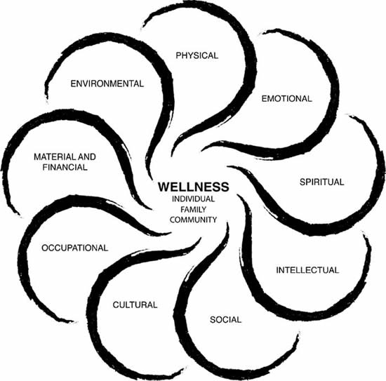
13) THE POST & THE PERSON - if any of these are affecting you, please discuss them with your ES

Please remember that your friendly ES may be able to help you with your problems.

Please consider talking to him or her. You have nothing to lose and everything to gain.

If you go on sick leave, maternity leave or decide to go part-time, it is really important that you work out if your post is going to total to less than 3 months of training in Whole Time Equivalent (WTE) terms. For example, doing a 4 month post at 50% part-time will definitely put you in this category.

REVALIDATION BASICS
All specialist trainees will be revalidated at CCT and at least every 5 years (e.g. when training lasts longer than 5 calendar years).

The Responsible Officer (RO) for trainees is the Postgraduate Dean who will make a revalidation recommendation to the GMC. He/She will do this on the basis of what your ARCP panels say and information from collective exit reports from your employers.

The deanery and your employers will send collective exit reports to the Dean, so you are not required to do anything to ensure this information is available.

- Are there any health, life or work issues you wish to discuss with your ES?
- Is the job providing adequate clinical AND educational experience?
- Are you being allowed release for HDR? If not, what alternative protected educational time is being provided?
- Jot down anything else you’d like to discuss at your review that has not been covered elsewhere.

14) THOSE OF YOU ON SHORTENED POSTS
If any of your training posts have had or will have fewer than 3 months W.T.E. training by the time you complete them YOU MUST ensure the following as a minimum marker of your professional development during that post:
- A Clinical Supervisors Report at the end of the post is essential
- The correct number of WPBAs for the time in post
- Shared learning log entries relating to the post
- At least one PDP entry relating to the post


15) REVALIDATION
In order to revalidate you OR to make a statement about known revalidation concerns, the following 3 pieces of evidence in your ePortfolio will be referred to. Therefore, you MUST make sure they are available:
1. Clinical Supervisors Reports (has a section for the CS to log revalidation concerns).
2. The Enhanced Form R (downloadable from the deanery & Bradford websites) –www.bradfordvts.co.uk/educational-supervision or http://tinyurl.com/formr-yh . If this is not completed and uploaded before your ARCP panel – you will be automatically given an adverse panel outcome. Completing and uploading a Form R is ESSENTIAL and panels will show no leniency towards its absence.
3. Educational Supervisor Reports (has a section for the ES to log revalidation concerns).

Have any suggestions to make this document better? Email: rameshmehay@googlemail.com
END – CREATED MAY 2014

