Intro


More ES resources are available at:
www.bradfordvts.co.uk
Click on the ‘Ed Sup/ARCP’ Link.

If you have any concerns or feel confused about any aspect of Educational Supervision, please contact the ES lead or administrator for your scheme.



“The trainee describes, interprets and reflects. The Educational Supervisor describes interprets and evaluates”.
Educational Supervision is ‘a positive process to chart an individual’s continuing progress and to identify development needs. It is a forward-looking process essential for the development and educational planning needs of an individual.

Its educational aims are to
- Encourage trainees to reflect in order to help them…
- Identify their educational/development needs and thus…
- Facilitate their personal and professional development and
- Formulate an educational plan to help keep them on track for GP training.

This document gives advice on what to look for in the review. Reviewing a trainee’s e-portfolio (for ARCP or ES) involves making qualitative judgments more than quantitative ones. We are not asking you to look for excellence. All we’re asking you is to determine whether there is ‘good enough’ evidence of satisfactory progression. Don’t lose sight of this.

Those judgments need to be holistic too – so, if evidence for a particular competency is lacking in one part of the e-portfolio, check if it is lacking elsewhere. Or perhaps it is demonstrated elsewhere! The WPBA is designed so that each professional competency is tested in a number of different places.

The ultimate question for the final ST3 is whether they are ready for independent practice. As the trainee progresses through training, the evidence of competence demonstrated and degree of readiness should gradually accumulate. The picture becomes clearer as more evidence is gathered. Don’t focus too much on the pixels - look at the big picture, determine whether the evidence is there and remember that ‘good enough is good enough’.

Relationships are important

- A key feature of the Educational Supervision process is that it is built on a supportive and facilitative relationship between two people.
- The more you get on with each other in a safe and supportive environment, the more likely it is the trainee will open up and tell you things which you may then be able to help with. And the more you get to know them, the more they will like you, respect you, and take on board what you have to say.
- Taking part in this process should prove rewarding too. Professional development supported in this way enriches working life, increases job satisfaction and should enable both of you to respond effectively to clinical, organisational and social change.
- Therefore, at the start, remember to spend time getting to know each other and building that relationship. Think about meeting in a nice environment – perhaps your home or a coffee bar with internet access – small things like this help set the scene!

I’m a first-time Educational Supervisor (ES)

- The key to a good Educational Supervision (ES) meeting is to ensure both you and your trainee have done all the pre-meeting prep work.
- The preparation you need to do is to dip into their ePortfolio and have a look around. Familiarise yourself with navigating through the ePortfolio, unless you want to give look inept on the very first day you meet.

The trainee prep work can be found in a document called ‘Getting your ePortfolio ES-ARCP Ready’ – available on
www.bradfordvts.co.uk (click Ed Sup/ARCP).

And don’t forget about the rules for giving constructive feedback.





- This document provides helpful guidance notes for each section of The Bradford ES checklist – also available on www.bradfordvts.co.uk. In fact, there is a wealth of ES advice there (click ‘Ed Sup/ARCP’ link).
- Make sure you’ve been to an ES Training workshop – the Deanery do some and your local scheme will probably do one too. Find out more from your scheme’s administrator and do not leave this to the last minute!
- And there is a chapter devoted to Educational Supervision in ‘The Essential Handbook for GP Training & Education’ by Dr. Ramesh Mehay (now available as a Kindle book too).

When do we meet for ES?
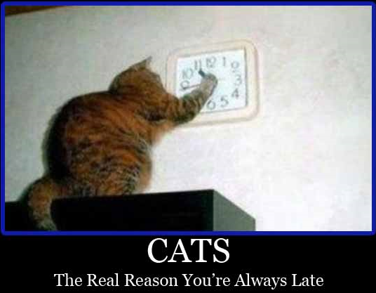
- Basically around May and January time every year – unless your trainee is part-time or ‘out-of-sync’ (ask your friendly neighbourhood TPD).
- For ST1s in their first post (i.e. who have just started) it is good to meet them twice – right at the beginning (August/September time) for an informal chat and the second official one in January time.
- You might also want to consider having two meetings if you feel the trainee is a bit of a concern or needs more input (e.g. using the ePortfolio) – where meeting several times now will help set good behaviour and hopefully make life easier in the future.
How long will the meeting take

- This varies from trainee to trainee and how experienced an ES you are.
- If you’re a newbie, it might take you 3-4 hours per trainee! As you become better, you can get it down to around 1 ½ hours.
- Personally (RM) I like to do my ePortfolio review in the presence of the trainee so that I can give ‘live feedback’ on things that I pick up. It makes future ES meetings go smoothly and you both end up really enjoying the process (rather than picking at faults).

What do I cover in the first of the two ES meetings for the newbie ST1-1?



Useful Links:
Levels of Reflection
http://tinyurl.com/reflectionlevels
Which WPBA at which stage?
http://tinyurl.com/wpbanumbers

Finding the evidence for the rating scales
http://tinyurl.com/justifyratings

Action points for the rating scales
http://tinyurl.com/actionpts

Quality Improvement Activity/NOE
http://tinyurl.com/qia-noe

Child Protection Requirements
http://tinyurl.com/childprot



- Before the meeting: When arranging the first meeting, ask the trainee to write up a couple of learning log entries about clinical encounters from their first post. Tell them not to worry too much about how to write things up - just have a go. This will provide material which you can work with in your first session when you discuss ‘What makes a good reflective log entry’ & how to make the ones they have written better.
- At the start of the meeting: Ask them how they feel about this meeting, their expectations, their concerns and then spend time getting to know each other.
- Explain what Educational Supervision is all about (perhaps starting with what they know about it first?). Dispel any fears and misconceptions (and perhaps discuss previously identified feelings about the meeting). Engage in true two-way dialogue.
- Later in the meeting: Outline the requirements for GP training and show them the ePortfolio, highlighting bits like Learning Logs, PDPs, MSF, PSQs, and so on.
- Use the learning log entries they wrote beforehand to teach:
  - How to write a learning log entry up
  - What sorts of things to write about
  - What reflection means and the ‘Levels of Reflection’ (PS good document on www.bradfordvts.co.uk click ES-ARCP) or click the quick-link on the left.
  - The difference between Curriculum Headings and Professional Competencies – and then do some linking on what they’ve already written.
  - How to encourage trainers/hospital consultants to read their log entries.
- Toward the end of the meeting: summarise what is expected of the trainee prior to ES meetings – and how important it is.
- Summarise key points in an Educator’s Note in the ePortfolio. Do not use the embedded ES form within the ePortfolio for this first meeting. The embedded ES form is for the official ES meeting that you will have in January and May every year.
Where do I write things up?

- For official ES meetings, there is an ES form is embedded within the ePortfolio. Don’t upload any other ES form. There are two exceptions to this rule:
- As we’ve said above, the first introductory ES meeting for the ST1 should be recorded in the Educator’s Notes section of the ePortfolio. The second official ES meeting is the one that needs to be written up in the ES section of the ePortfolio.
- If you are planning to have additional ES meetings with a trainee (e.g. someone who is of concern) write up the additional ES meetings as Educator’s Notes.
What if the trainee is on maternity leave or Out of Programme?

- An ESR must be done before someone goes off on maternity leave for three reasons
- To validate the evidence submitted so far so that it counts towards training
- To record progress
- To help formulate a development plan (i.e. what they need to do) upon their return.
- Before the ES meeting, get them to get a CSR done first.
- If there is substantial evidence submitted in that review period then should comment upon it and record progress, and set out the development plan to be followed on return to the programme.
- A further ES review should be undertaken when the trainee returns to the programme to ensure the personal development plan is appropriate.
- ST3s: If < 6 weeks remains to CCT after the trainee returns from planned leave then the penultimate ESR and ARCP should state that the trainee is fully competent and the ES/Panel is happy to recommend them for CCT once the remainder of their training time is completed (record in the ESR). Otherwise, there will not be enough time to get everything together for a timely CCT. The final ESR and ARCP (done within the 6w) would then officially sign everything off having made reference to the penultimate ESR.



The ES checklist – guidance notes.
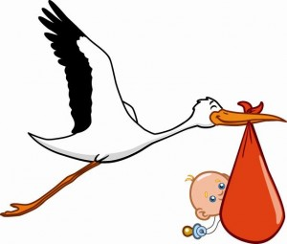

Advice to trainees on Mat leave is that they should continue to make some entries on eP and gather evidence that they are (or remain) competent. However this cannot be mandated and can only happen with their consent. But we could ‘carefully‘(mindful of employment law) make them aware that CCT could be delayed if they choose not to engage.

The information provided on the right are explanatory notes for the document
‘The Bradford ES Checklist’.

The orange bits provide technical help (i.e. what bit to click on the ePortfolio).

.

1. Review previous reports – ESR & ARCP
- Click Review Preparation and look at the last ESR plan from the last post. Has good progress been made on it? What, if anything, needs to be carried over? Cast an eye over how Curriculum Coverage was then and what the Rating Scales were like.
- Similarly, review the last ARCP by clicking on Progress to Certification. Any important points in the last ARCP panel?

2. Sign the declarations
- Click the Summary page.
- Has the trainee signed all the declarations (like probity and health)? Have both you and trainee signed the Educational Contract (important)?

3. Learning Log Entries


Hopefully, the Clinical Supervisor will have read through most (80%) of the log entries. If they haven’t, then you need to.

If a trainee has only done say 20 log entries but each is deep & meaningful with good curriculum coverage, then that is okay. The only problem is whether you can get good enough curriculum coverage with only 20 entries per post (as trainees can only link each entry to a maximum of 3 curriculum areas.

A trainee who has done 75 log entries but they all appear to be superficial (e.g. most are quick and dirty write ups of e-learning modules or things they read up about) is more of a concern.

Most learning log entries should be about clinical encounters with a mixture of other types, like SEAs, conversations, online modules and reading.

When there is no reflection, it is hard for the trainee to convince us that they have learnt anything.

- Click Learning Log; use the Keywords search box to find things like ‘The ES Workbook’. Use drop-down Type box if you want to see how many different types of entries there are.
- Sample some of the Log Entries. How many? – Just enough to give you a flavour of what the trainee is like as a learner – do they learn things superficially or deep & meaningfully. Perhaps a combination of ones the CS has not managed to read and ones that have.
- Numbers: we don’t like to be prescriptive about the number of log entries - the content is more important than the numbers and one needs to look at the ePortfolio as a whole. But trainers and trainees still look to us for a number to use as a rough benchmark. That’s fine as long as you also use your own judgement about how good they are. On that proviso, we would say that trainees should be logging around 1-3 entries per week. This equates to 25-75 per 6m post or 16-48 at end of month 4 (when ES happens). However, what’s more important than the numbers is the quality of those log entries.
- Timely input: have they been added at the 11th hour? (look at the dates).
- Breadth: there should be a range of log entry types – but don’t get too hung up about this. Most entries should be Clinical Encounters followed by a mixture of others.
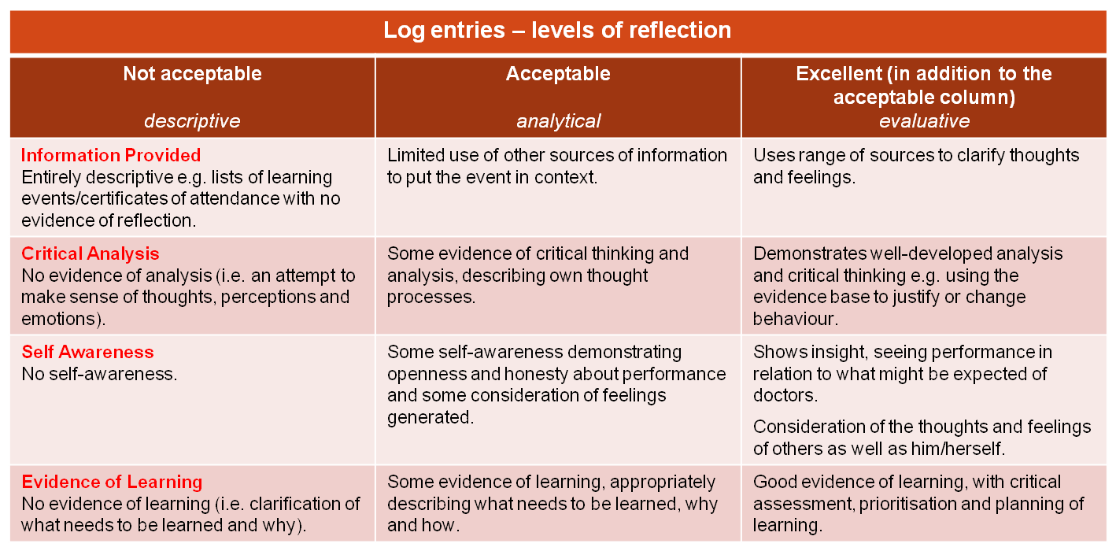
- The quality: the table below is about levels of reflection and should guide you in assessing the quality of learning log entries; whether they are superficial or deep.
- When looking at each log entry, most should show…
- Evidence of critical thinking through describing their own thought processes.
- Some self-awareness – being open & honest about performance and considering the feelings generated (in self or others). I was uncomfortable at the thought of….; I felt upset when I realised; They were distressed because…
- Evidence of learning - describing what needs to be learned, why & how
- Appropriate linkage to the Curriculum Headings
- And finally, demonstration of behaviour that allows you to link to one or more professional competency areas.
- Linkage & Validation: Educational Supervisors often get confused about Curriculum Heading linkage and linkage to the Professional Competencies.
Linkage to the Curriculum Headings (which are essentially subjects/topics like ENT) is done by the trainee to show what areas they have covered. It would be worrying by the time of ST3 if a trainee had never written anything about (say) Cardiovascular Disease!
Then there are the 12 Professional Competencies which GP trainees are ultimately assessed against because it is perceived that these 12 competencies determine what it is to be a good GP. Professional Competencies include things like Practising Holistically, Data Gathering, Clinical Management, Medical Complexity, Ethics, Fitness to Practise and so on (there’s 6 more). Linkage/validation to these can ONLY be done by an authorised person – the CS or ES (i.e. you and not the trainee).
- Remember, validation is NOT a marker of a trainee being competent in that Professional Competency. You should only link to a professional competence if the trainee has explicitly written some reflection on that competence – whether good or bad.

4. NOE/QIA

Although NOE is not compulsory, trainees are strongly encouraged to do them because engagement indicates one’s commitment to improving the quality of care one is giving (GMC requirement although not an RCGP one).

If NOE is missing, you cannot give trainees an adverse outcome. You must look for NOE or other Quality Improvement Activities (QIA) elsewhere - usually in log entries..
A comprehensive list of QIA and NOE activities can be found at:
http://tinyurl.com/qia-noe

- Click Learning Log. Most of these things should be here. Use the Type dropdown box to search for particular entries like SEA, Audit and Project. Use the Keywords search box for others – like Reflection or Presentation.
- For each 6m post, it is highly suggested trainees do: 1 x SEA, 1 x Case Presentation 1 x Reflection of Key Learning Points from that post.
- They should also do ONE audit at some point in their training (preferably ST1) – or alternatively some other Quality Improvement Activity (see left) like an analysis of ones referrals, prescribing or investigations.
- The reflection on post: should be a concise summary of learning points, including reflections on learning achieved (in terms of knowledge, skills and attitudes), and how this relates to a career in GP. This reflection will result in new learning objectives for next posts.
- The Case Study can be a presentation of a clinical case study or a notes review. The presentation may have been given in a departmental setting or VTS group. It should be relevant to GP.
- There must be personal involvement in all QIA/NOE activities (i.e. not spectators!).
- Bradford VTS website: Comprehensive details with sample projects, NOE and QIA can be found on www.bradfordvts.co.uk (Click MRCGP > NOE/QIA). Advise your trainees to look here. Familiarise yourself with these pages too.
- The other great place for specific templates and things is the Yorkshire & Humber Deanery website: click this short link http://tinyurl.com/yhnoe .
- Another great site: http://www.appraisal.nes.scot.nhs.uk/toolkits/qia-examples.aspx

What competencies can NOE/QIA log entries be linked to?
What you can link QIA/NOE activity to depends on the nature of the event.
Audits and Projects
- 07 Primary Care admin and IMT (involves a lot of IT and data gathering)
- 08 Working with colleagues (it’s usually not an activity one does in isolation but as part of a team… persuading people to change, working effectively etc.)
- 09 Community Orientation (audit moves away from caring for the patient immediately in front of the GP and more at the management of the health & social care of the practice population).
- 10 Maintaining PLT (investigating & evaluating performance)
Significant Events
- 8 Working with colleagues (working with colleagues to investigate, analyse and evaluate an event and to learn from it collaboratively)
- 10 Maintaining PLT (reflection on performance & subsequent improvement)

NOE COMPETENCIES.

- 12 Fitness to practice (where one discusses performance of those involved, including oneself).
- 11 Maintaining an ethical approach (the discussion provides an opportunity for the feelings of those involved to be aired - their values, beliefs, prejudices)

Very often SEAs provide a good example of several competencies being demonstrated together and may highlight the way to development in others. Because the SEAs chosen are often clinical it is likely that these will cover especially the first 6 competencies , and should provide the ES and the ARCP panel with a short cut to displays of effective reflective learning on several competencies.

Reflection on the Post
- 12 Fitness to Practise (as the trainee talks about their work-life balance, stress and performance issues).
- 10 Maintaining PLT (as they reflect on learning and what else needs to be learnt)
- 09 Community Orientation (if the trainee talks about their hospital post and what it means in terms of their approach to patients in General Practice).

Case Study/Presentation
- 10 Maintaining PLT (especially if the trainee identifies learning objectives, thinks about teaching/learning methods and assists in the learning of others).
- 08 Working with colleagues (especially if the presentation is a teamwork thing, or if they use the audience to develop a future working plan – i.e. collaboration).

Complaints & SUIs
- 03 Data gathering (as they find out what happened, and all the contributing factors)
- 12 Fitness to Practise (as they write about contributing factors to the untoward event)
- 10 Maintaining PLT (as they analyse ways to stop the untoward event happening again)
- Could also involve 01 Communication skills, 02 Practising Holistically, 03 Data Gathering, 05 Clinical Management, 08 Working with Colleagues,

5. OOH
- Click Learning Log under Type, select Out of Hours Session hit the Search button.
- This only applies to those trainees in a GP post. (Those in a hospital post engage with the hospital on-call rota). The bottom line is that trainees, by the end of their training, should have done 18 sessions of OOH during their GP posts. They have to be spread out and cannot be done all at the end. This equates to ONE session per month of each GP post (i.e. 6 sessions of OOH in each 6m GP post). Each OOH session will be of 4-6h in length – and trainees need to complete the whole session.
- As a minimum, trainees should be recording the following for their OOH sessions:
1) The type of session – telephone triage, visiting doctor, base doctor
2) The number of patients seen (perhaps a one-liner about each of them).
3) A selection of the most interesting patients
4) The significant learning points and,
5) Link these to the curriculum
- Look at a sample of OOH entries: is there depth? (i.e. whether a trainee reflects and analyses experience and considers the wider implications like ethics).
- Sample some OOH entries to make sure the 5 OOH competencies are being covered:
- Ability to manage common medical, surgical and psychiatric emergencies.
- Understanding the organisational aspects of NHS out of hours care (nationally & locally)
- The ability to make appropriate referral to hospitals and other professionals.
- The demonstration of communication and consultation skills required for out of hours care.
- Individual personal time and stress management.
- Prior to the final ST3 panels GPRs should be encouraged to include a log entry detailing the evidence contained within the eP which demonstrates competency in OOH care.

6. PDP & EDUCATIONAL COURSES
- Click PDP. To see what is outstanding select Open Entries from dropdown box.
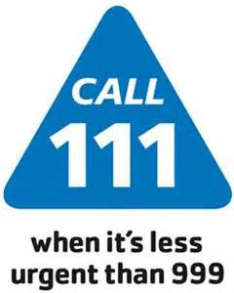

By the end of ST3, 18 sessions of OOH must have been completed in GP. Forget working out number of hours. Each session should last 4-6h and trainees are expected to stay for the entire duration of the OOH shift.

There needs to be a reasonable mix of OOH sessions. For instance, 10 triage + 2 face-face OOH sessions is unsatisfactory. We suggest more face-face (at least 50%).

Extended hours is NOT to be included.

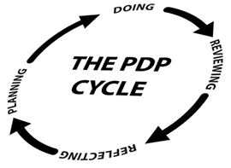

The PDP should be a living educational tool which is in a constant state of flux as learning needs are identified, added to it, completed, and then new one’s identified, added and so on.

The PDP can give you an idea of how good a trainee is in ‘talking the talk’ or ‘writing the script’ versus ‘doing’.

- It is unacceptable to have zero PDP entries for a post.
- Your ESR should generate at least 3 action points which can be turned into PDP items.
- The trainee should generate at least one extra item based on their post.
- Check that the PDP
  - Is being used (& things not being added at the 11th hour).
  - Is up to date (things being done or actioned)
  - Items are SMART (Specific, Measurable, Achievable, Realistic, Time-bound).
  - includes educational courses the trainee should consider.
(Available in Yorkshire & Humber: Family Planning, STIF courses, Minor Surgery, Child Health, Consultation Skills, Exit Course, Urgent Care Course, Diversity, MRCGP preparatory courses)

7. EVIDENCE – WPBA (CBDs, COTs, CEXs & DOPS)


The odd NFD may be present in ST3 in a high flying GP trainee who may have already passed the CSA and is being encouraged to bring along more challenging cases where there may be a chance to stretch them. The odd NFD therefore should not be a significant concern for CCT.

Remember:

Diagnostics is about decision-making rather than diagnosis alone.

Management is about organisational things like time-keeping and getting tasks done than clinical management.



Remember, not every ST stage requires MSF or a PSQ – check the ‘Which Assessments at What Stage?’ on
www.bradfordvts.co.uk
or click here:
http://tinyurl.com/wpbanumbers

- Click Evidence, and then select the Summary tab: Make sure all minimum numbers are satisfied. Remember, minimum numbers are exactly that – MINIMUM. Trainees should be aiming for lots more – tell them this.
- Click Learning Log and in the Keywords search box type ‘ES Workbook’.
- Look at the Competency Mapping sections of ‘The ES Workbook’ which should be uploaded in their ePortfolio as a log entry. This will give an overview of what competencies have been assessed across all the CBDs, COTs and Mini-CEXs.
- In these competency maps, also check the variety of contexts in which these assessments should be done (e.g. child, mental health, palliative care, elderly) – but don’t get too hung up about this.
- Finally, determine which competency areas the trainee needs to focus on. Completing ST3s should have strong evidence for all domains.
- A note on CEXs/CBDs in hospital: Many hospital consultants give ratings based on their assessment of the trainee at that stage of training rather than judging them against a GP fit for independent practice. Many are therefore given inappropriately high ratings.
- Now click on Skills Log: Review progress on DOPS considering their ST stage– make sure trainees are using senior colleagues and not their peers to assess them. Assessment on models is not acceptable.

8. EVIDENCE – CSR & EDUCATORS’ NOTES
- Click Evidence, and then hit the CSR tab.
- The CSR is one of THE most useful places to find useful information on the trainee.
- There may be more than one CSR if the trainee rotates through 2 or more jobs.
- Look under the four areas – Relationships, Diagnostics, Management and Professionalism – are there any themes that emerge?
- You might wish to dip into previous CSRs to view progress on the RDM-p domains.
- Click Educators’ Notes: Any similar or new themes (i.e. triangulate) to CSR?

9. EVIDENCE – MSF & PSQ
- Click Evidence then hit the MSF or PSQ tab. Then tap the Summary tab to see a summary.
- Look for themes in both the feedback provided by working colleagues (MSF) & patient (PSQ) about the trainee’s performance, behaviour and attitude; be wary of 'one off' comments. The MSF is more discriminatory than the PSQ.
- And, when dealing with numbers, remember that numbers DO NOT TELL YOU THE STORY behind them. For instance, in the PSQ – a doctor who gives the patient everything they want may be rated more highly than a doctor with higher skills who appropriately challenges them. As for the MSF’s aggregate scores (the overall score found at the bottom of the table) - a trainee might have an overall score higher than their peers but a significant deficiency in one particular area.



You basically need to determine whether the trainee is making reasonable progress in terms of covering the curriculum for the ST stage they are at.

Common Curric. Mistakes:
Management – is not Clinical Management but about Organisational stuff, Teaching – have to do, not simply attend, and cannot link every patient encounter to the Consultation – must write about cons. skills.

Both the trainee & the Ed Supervisor have to fill in a set of competency rating scales about the trainee. It’s good to see how you both compare.

You can’t just rate them though. Both of you need to provide evidence for your grades (needs to be specific). For instance ‘6 CBDs out of 8 marked competent for Practising Holistically’ is better than ‘see CBDs’ or ‘6 CBDs competent’
(latter - out of how many?)

- Details on how to release the MSF results are on www.bradfordvts.co.uk
- Innovative/Modular/Community training posts - if the ITP has a primary care component (with some modular experience elsewhere) then a PSQ should be completed. This is non-negotiable and will lead to unsatisfactory progress if not completed.

10. CURRICULUM COVERAGE
- Click Curriculum Coverage.
Please remember, if you see low numbers, don’t assume the trainee has been poor. They may have entries mapped to the OLD curriculum before 2010. Scroll to the bottom of the page and see if there is a clickable heading which says ‘Expand Curriculum Statement Headings 2010’. You may want to ask the trainee to develop a table combining these. This structure of the contents on the following will help them with mapping the old with the new: http://www.bradfordvts.co.uk/online-resources/
- By the end of ST3
  - There cannot be zero entries for any one curriculum area.
  - But there is no set number of log entries for each curriculum heading.
  - However, for those areas which are frequently encountered in GP - we would expect double figures. Smaller numbers for areas less frequently encountered.
- What's also important is the quality of those entries - the level of reflection and learning within them? It's not all about the numbers! Please use your judgement – if you find slightly low numbers, look at the quality of those entries – is there enough there to make you feel that there is enough learning in this particular area? (See table on page 5.)
- Look at the weak areas: can these be achieved in the remainder of their scheme?

11. COMPETENCY RATINGS – trainee & ES
- The trainees self-rating is embedded in the ESR section of the ePortfolio. To access it, click Review Preparation, then select the current review and hit the pencil icon. Tap the ‘Competence Areas – Trainee’ tab or ‘Ed Sup’.
- Check to see that the evidence provided to back up each rating is justifiable. If not – educate your trainee.
- Where to look for the evidence: http://tinyurl.com/justifyratings (great page)
- When filling out your section, compare your grades with the trainee’s. How closely matched are they? This might be the first sign of concern if the trainee rates themselves way above the Educational Supervisor or perhaps under-confidence if it is the other way around. A large variance discuss with the trainee to help synchronise wavelengths.
- Time Saving Tip: If the trainee has added a comprehensive self-rating which shows a true picture of their training, the ES should add a comment stating that they agree with all comments and evidence cited. Additional narrative is not necessary. (The new ESR QA markers from the college strongly encourage this narrative). Where the trainee has not given a true or full picture of their progress, the ES must add additional evidence and narrative to support their own competence ratings about the trainee for each review.
- However, Actions for development should be added by the ES for all competency areas. All of us find those Actions hard work because you cannot move on with the ESR unless you fill in every Action box for each of the 12 competencies. To make life easier, Drs. Mike Tomson & Rhiannon Davies at Yorkshire & the Humber Deanery have developed a database of ‘Action’ points for each competency as a result of reviewing masses of ESRs. Click on the following link to access it. http://tinyurl.com/actionpts. You can now copy and paste from a database of useful action points rather than strain your brain.



It’s not that uncommon to finding missing things in a GP trainee’s ePortfolio – for example, the right number of COTs or CBDs or the NOE.

Missing evidence is often a result of an oversight and/or poor organisation on the part of the trainee.

However, sometimes it can indicate something more serious. For instance, a significant deficiency in one’s organisational skills –in practice, does the trainee have outstanding referral letters or blood results that still need looking at? Is this acceptable?

And occasionally, it may represent an issue in professionalism too.

- By the way, ESs can rate trainees as 'Competent for Licensing' even if they have not yet passed the CSA/AKT.
- And finally, if you rate the trainee as NFD – below expectations on 3 or more competencies, you must give an adverse outcome (unsatisfactory progress or panel opinion requested) and inform the scheme administrator/TPDs.

12. PROGRESS TO CERT
Open The ES Workbook and check…
- The ES Workbook should have been uploaded to the Learning Log. Click Learning Log type ‘Workbook’ into the search box hit the Search button.
- Non-Annual/Non-Study leave (e.g. sick leave). If it is >2 weeks per year, it has to be made up – in which case, inform the TPD and scheme’s administrator ASAP.
- Educational Attendance at HDR should be around 75%.
Open Form R and check for SUIs & Complaints
- The Form R should have been uploaded to the Learning Log. Click Learning Log type ‘Form R’ or ‘Revalidation’ into the search box hit the Search button
- Review the SUI/Complaint and see whether progress is being made on it.
- If the SUI is minor, resolved and the trainee has learnt from it with a good reflective log entry, make a note of it and approve if all else in the eP is okay.
- If SUI is serious and is being investigated, again identify the nature of the problem. In this case, you still judge the trainee based on the remaining evidence in their ePortfolio and gives a grade as if the SUI wasn’t there. The reason is that it is not the ES’s job to make a decision on the major SUI/Complaint. You decide whether the trainee is educationally progressing well. The major SUI/Complaint will be dealt with by the dean (as Responsible Officer for trainees) and certification unit – who will decide whether to involve the GMC.
- In other words, the ES makes an assessment of the educational progress and awards a Satisfactory Outcome if all the evidence in the ePortfolio is fine – despite outstanding GMC/hospital/GP Practice investigations. But double check that the TPDs are aware of any such things.
For ST3s who will be finishing the scheme
- Check that they have got AKT and CSA under their belt.
- Check their CPR/AED certificate – it should be uploaded to their Learning Log. Check certificate is in date (it should say when it expires). Otherwise, assume 1 year.
- Check for Child Protection Training to Level 3
- Check for Adult Protection Training (currently undefined to what level)
- All Professional Competencies in the ESR must be marked as Competent for Licensing.
- Check the whole training period for WPBA numbers – Click on ‘Evidence’ and select each ST year from the drop-down box and quickly check. Anything deficient from previous ST years must be made up before finishing the scheme.

13. THE PERSON & THE POST
- Ask how it is going. Are there any problems at work?

This document tells you which assessments are needed for each ST stage and the corresponding numbers: http://tinyurl.com/whichassessments

Child Protection Training - is not an RCGP requirement but it is considered a professional obligation by the GMC. See this article: http://tinyurl.com/childprot

If it is missing, the trainee should mark it as a PDP item for their GP appraisal and future learning.

- Is the job is providing adequate clinical experience and educational experience.
- Are they being allowed release for HDR (attendance should be around 75%)? If not, what alternative protected educational time is being provided instead?
- Personal difficulties? - social, finances and health. Tread carefully & sensitively. How open the trainee is depends on the ethos and relationship you've built up with them.

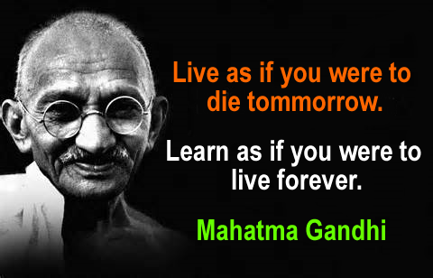
14. AGREED PLAN
- This goes into the last box of the ESR form in the ePortfolio.
- You must put together a plan where at least 3 of the points in the agreed plan can be easily converted into 3 PDP items.
- Remind the trainee that they need to develop AT LEAST one more PDP item based on their next post.
- Other things to consider include:
Where to focus on the Curriculum, what Educational Courses to attend, themes from MSF/PSQ/CSR to work on, NOE activity and anything from The Person & the Post section.

FINAL POINT
In breaking down Educational Supervision into so many elements, we are at risk of losing one of the very first key points that we made in this document. Therefore, we’d like to finish off with a reminder about it:
Remember to look at the whole picture, rather than the individual pixels. What overall impression do you get of the trainee? And remember, good enough is good enough.
End of document.

