C O G P E D

Committee of GP Education Directors

Paper Reference: |  | COGPED/06.2015/Item 7 d) ii
Title: Why do candidates fail the CSA? A comparison of ‘failure’ in the domains.

Summary:

- Candidates who fail the CSA principally do so because of shortcomings in the clinical management domain.

Recommendations for COGPED:
Paper for information. Training interventions for candidates who fail the CSA should take these findings into account.
Author: | Pauline Foreman |  | Contact Details: | Pauline.foreman@rcgp.org.uk
Position: | Chief Examiner |  | Date: | 7/6/15

Why do candidates fail the CSA?
A comparison of ‘failure’ in the domains

Data taken from the CSA 2012-2013 (N = 4054 candidate-attempts of which 1304 were failed)

This paper is in response to a request from the Chief Examiner as follows requesting me “to look at last year's CSA data and work out which domain candidates who fail the CSA fail in most commonly, and then break it down for ethnicity and gender.” The thought behind this was that the College might then be in a position to better help the training community, rather than relying on the most commonly used feedback statements.

The following charts and tables are provided in an attempt to illuminate these issues. As regards ethnicity, I have used a binary classification, despite the inevitable drawbacks, simply because of the restricted size of subgroups if the non-white candidates were to be subdivided further.

1: The big picture regarding domain success and failure

The first chart is based on an aggregation of all domain passes/failures for all candidates: domain scores have been reduced to a ‘pass/fail’ dichotomy, and the number of domain passes is contrasted with the ultimate CSA outcome for each candidate. It is offered without comment, other than to note that the just passing candidate has typically ‘passed’ 29 out of 39 domains. (The scale has a bug: each number should be followed by a ‘+’.)

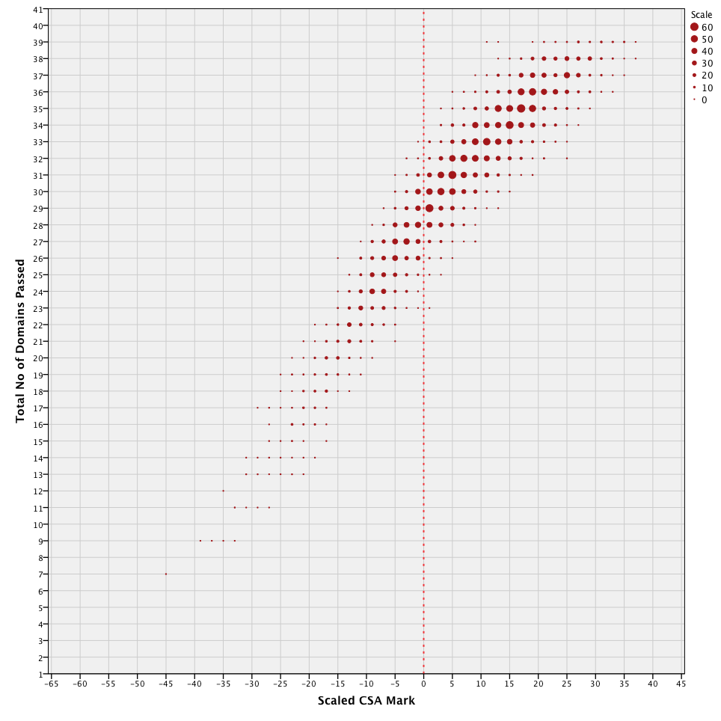
2. The relative importance of the different domains in determining the outcome: descriptive statistics

The following table summarises, for all the candidate-attempts, hereinafter ‘candidates’, the average number of passes (out of 13) for each domain, and for all. The candidates have, it will be noted, been roughly classified in terms of their overall CSA score, to demonstrate any important differences between the various groups.

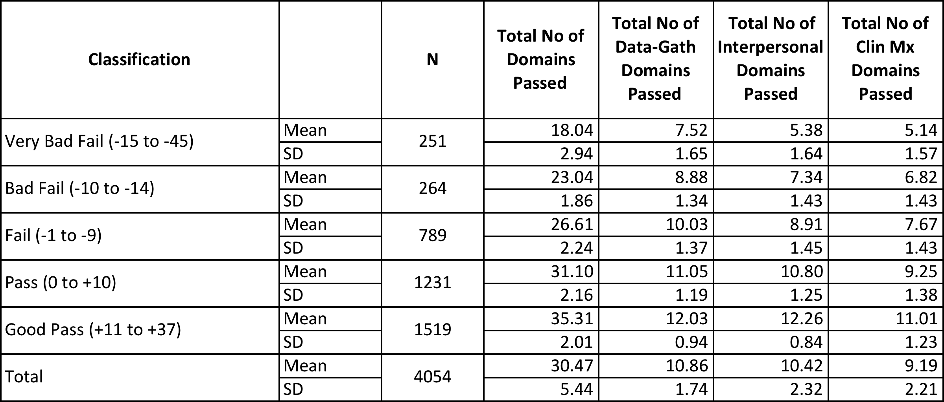

It will be seen that, almost consistently across groups, poor performance is greatest in the ‘clinical management’ domain and least in the ‘data gathering’ one, with ‘interpersonal skills’ being in the middle. The exception is in the highest performing group, who show their best performance in the interpersonal domain.

The following histograms, each to the same scale, summarise the number and distribution of domains passed by all failing candidates. The scatterplots underneath replicate the first chart, by domain, for these failing candidates.

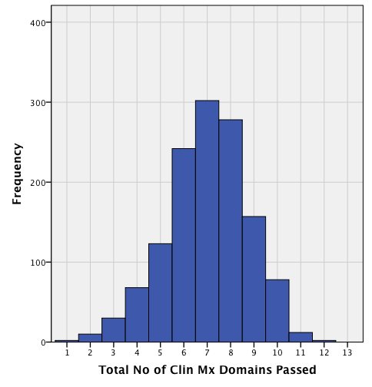
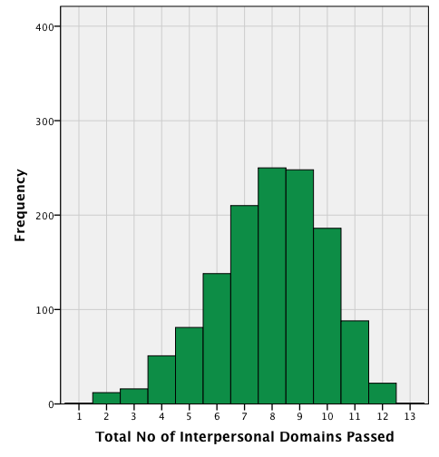
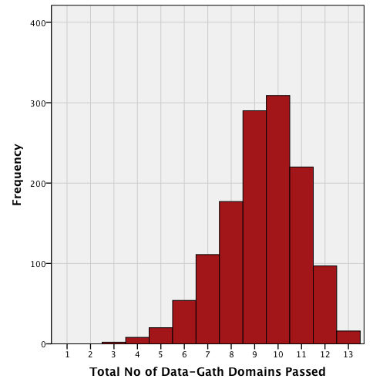

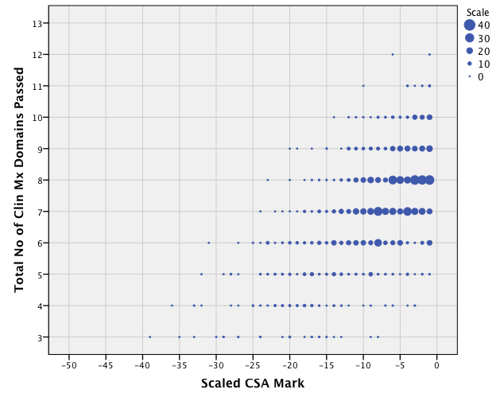
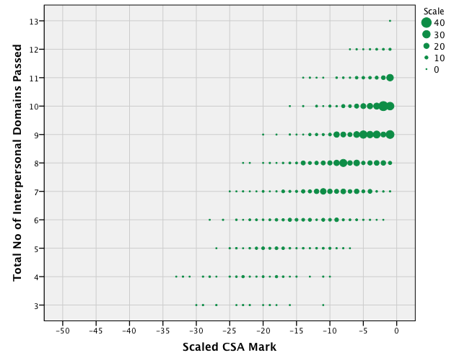
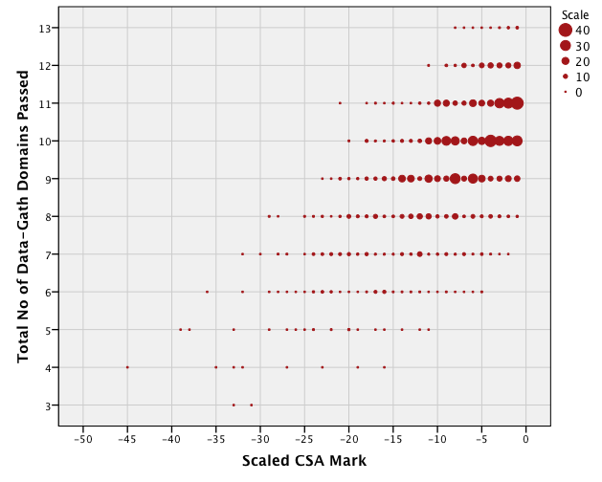
For reference, the country of PMQ and major training institutions of the two poorest-performing groups of candidates (Scaled Mark -10 or less; N = 515) are shown below.
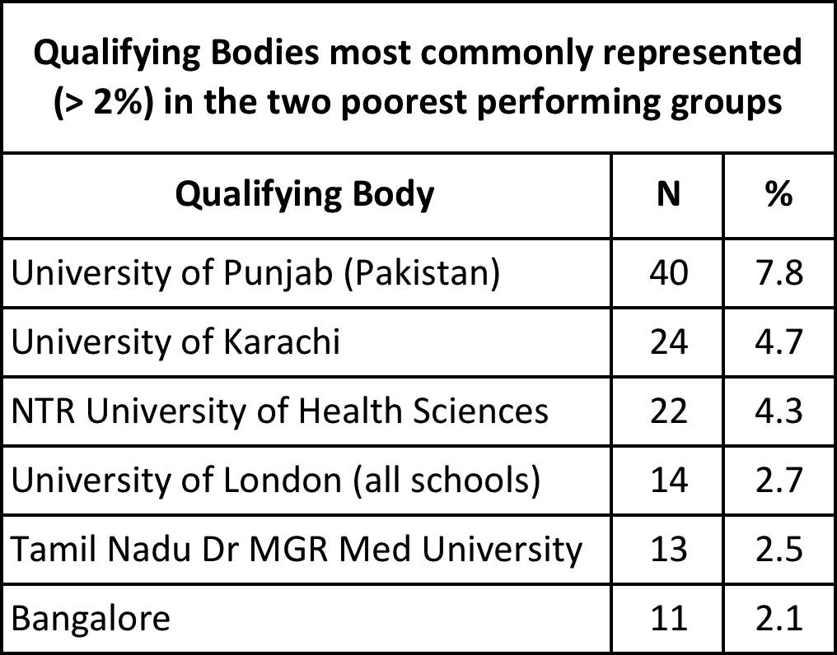
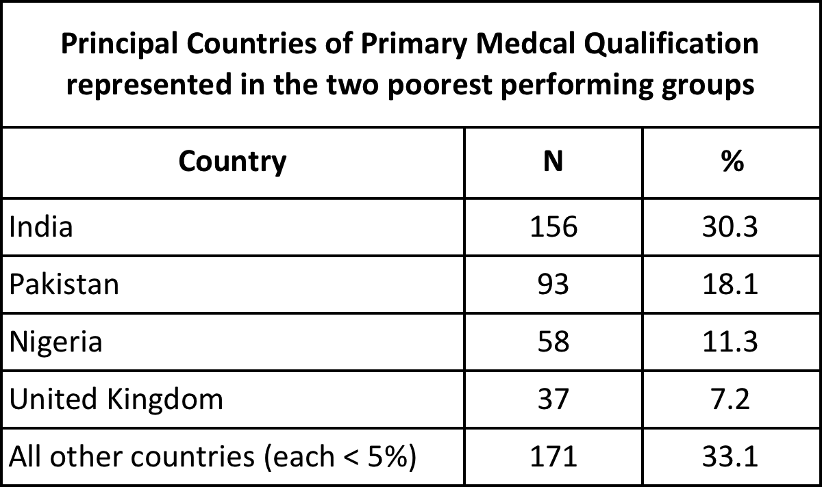

3. The relative importance of the different domains in determining the outcome: multivariate analysis

The table below summarises the results of a stepwise regression analysis of the case score for failing candidates, entering the three domain pass-fail grades as predictors.

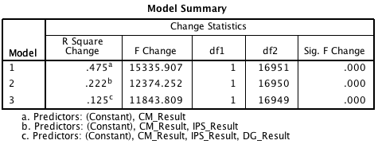

48% of the variance in the case score in this failing group is accounted for by the clinical management result, 22% by the interpersonal skills result, and 13% by the data gathering result.

4: Candidate demographics and overall performance on the cases

It is important first to note that this group of 1304 failing candidates (16,952 cases) is not at all representative of the candidature as a whole. Relatively speaking, it contains fewer UK graduates (15%), white candidates (11%) and women (32%), the figures for the candidature as a whole in 2012-13 being 55%, 41% and 52%, respectively. The group is predominantly IMG, male and non-white.

It is also important to remember that this is a snapshot of all attempts in the year 2012-13, and the fact that a candidate-attempt that results in a fail may well be followed (in the same dataset) by a pass for the same person. This report is simply looking at all the cases seen by candidates who on the attempt in question failed the CSA.

Although the differences are statistically significant (p < .001 ANOVA), they are here relatively small as between UKG and IMG candidates’ mean case scores (5.16 and 4.92 out of 9, respectively). Differences between the sexes continue – men scoring an average of 4.91 on their cases and women scoring 5.15 (p < .001 ANOVA). The differences as regards binary ethnicity are even smaller – 5.05 (whites), 4.95 (non-whites) – and only significant at p < .02 (ANOVA).

5: Candidate demographics and performance by domain

Multivariate analyses and inspection of cross-tabulations suggest that there may indeed be differing patterns amongst candidate sub-groups. There is some evidence that the case scores of male non-UK graduates and of female non-white UK graduates are best predicted by their interpersonal domain scores, whilst those of female non-UK graduates and of female white UK graduates are best predicted by their clinical management domain scores.

However, this information must be subject to a serious general health warning, though, in that the statistical models used are often in practice not resilient, in that modest changes to the data can ‘flip’ the order of predictions. And the differences quoted are based on very variable candidate sub-group numbers. I would not base any training advice on these particular findings, but await further analyses.

6: Conclusions

1: Performance by domain

a) The popular belief that candidates generally are being principally failed on their interpersonal skills, arguably unfairly for non-native English speakers or other international graduates, is not supported by these data and analyses.

b) They do however reinforce the data repeatedly presented in the annual statistical reports on the CSA to the effect that – overall – candidates’ principal shortcoming is in the area of their clinical management of patients.

c) There would clearly be a potential influence here of shortage of time in the consultation: if the candidate ‘does not reach’ management issues because of slow performance, then s/he will gain poor marks in that domain. However, the consultation time seems almost a national ‘given’ and trainers are aware of this, so this would seem more of an excuse than an explanation.

d) In written examinations, potentially unfair time pressure can be explored by examining candidates’ performance on concluding test items. The issue could be examined further if examiners were given one or more additional feedback statements such as ‘ran out of time’, for internal analysis.

2: Performance by background demographics

a) The ‘failing candidates’ are as a group very different in their demographics from the candidature at large, being predominantly IMG, male and non-white.

b) Overall, those three groups (IMG, male and non-white failing candidates) have significantly larger ‘deficits’ than their counterparts, as evidenced by case scores.

c) There is some evidence that the case scores of certain candidate sub groups are better predicted by their interpersonal domain scores, whilst those of other sub-groups are better predicted by their clinical management domain scores. Such differences are small and the statistics tentative and tenuous. I would not offer any training advice based upon these.

Richard Wakeford
Cambridge: June 2014, revised March 2015

