DQT guide to auto consultations for flu

Before you create an auto consultation you need to create a vaccination template (s)
Go to setup, vaccinations and vaccination templates
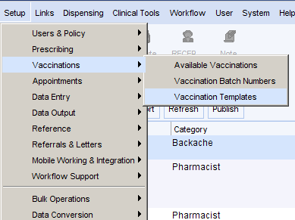
Go to add vaccination and complete the template as required. Some practices like to have a template for left deltoid, right deltoid, flu vacc declined etc. If you do this ensure you state it in the title so you can add it to the correct auto consultation.
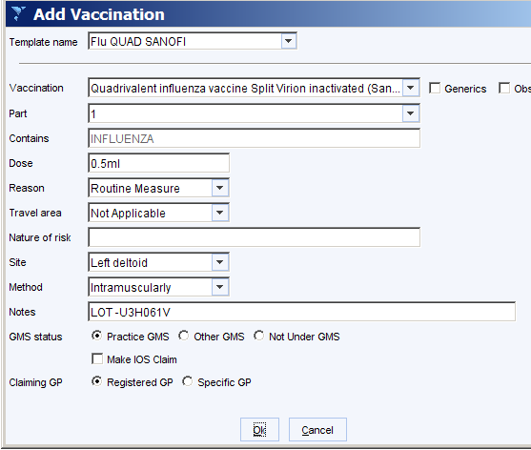
Once the vaccination template is saved, go to setup, workflow support, automatic consultations
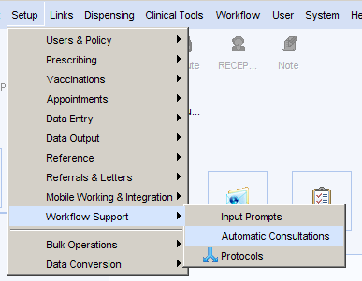
Give your auto consultation a category eg flu vacc 20 21
In the name you can specify which auto consultation it is so for example flu vacc 20 21, Flu left deltoid
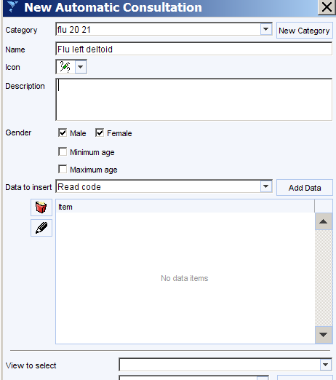
In the data to insert field this is where you select all the criteria you require, click on read code and then add data
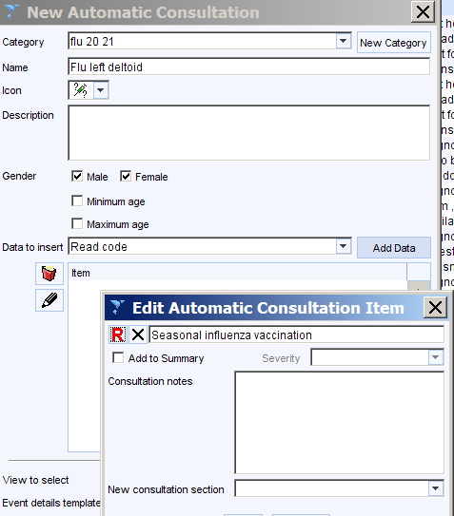

This will open up a read code browser where you can code seasonal influenza given or for other consultations you may want seasonal flu declined or gven by third party
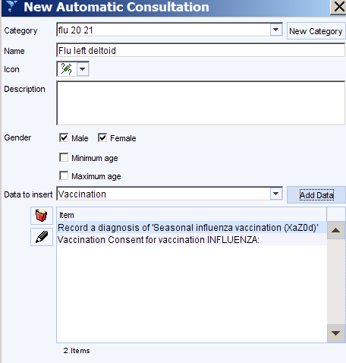
You can then select vaccination consent and add data and the vaccination
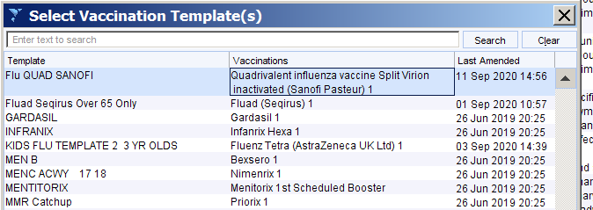
When you add vaccination it will open up all your vaccination templates, you just highlight the correct one and ok.
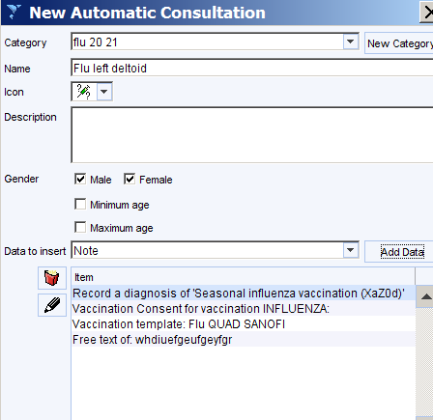
If required you can also add text to put in the patients record

To use an auto consultation

Open the patient and go to auto consultation
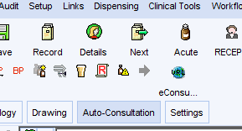
Select the category e.g. flu 20 21 and then the name, e.g. flu left deltoid

