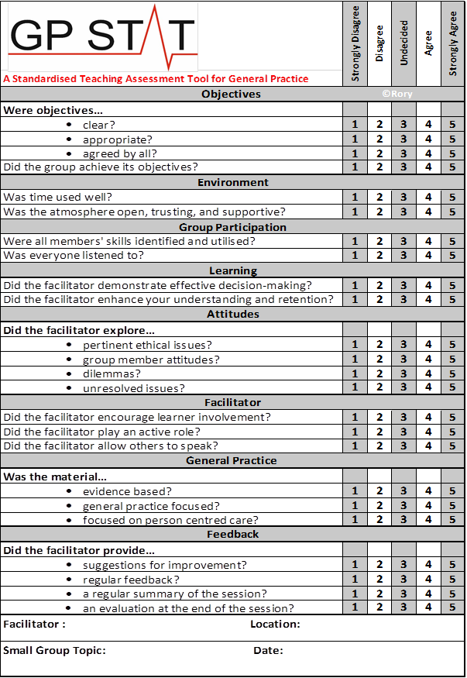
A General Practice Standardised Teaching Assessment Tool for Small Group Learning
Context
Good teaching requires teachers to reflect and receive feedback. This is fundamental to teaching improvement, while helping teachers adapt their teaching style in a manner that is suitable to the group. GP STAT was developed to allow those engaged in GP small group teaching receive feedback from their students and peers. It is anticipated that GP STAT would be used as a means to reflect on teaching practice and thus improve teaching in the general practice setting.

The genesis of GP STAT
Having spent time in recent years as both a GP trainee and as a medical educator, it became clear that the teaching experience, particularly in small groups, can, on occasion, feel quite disconnected. Anyone with experience in small group teaching will recognise the uncomfortable feeling of not knowing if they are managing to get their message across to all members of the group. With this in mind, research was carried out into which constructs would best constitute a feedback tool for GP small group work. The GP STAT provides a practical, evidence-based tool, which addresses this gap in the current literature. It was designed by GP trainers with the input of GP trainees, taking from the extant evidence in the literature.
While the GP STAT is in essence an assessment tool, it is NOT meant as a means of deciding if teaching is deemed ‘sufficient’ or ‘insufficient’ or indeed as a method of censure. No benchmark exists for small group teaching and as such, there is no pass-fail mark for GP STAT. While the tool provides summative data in the form of a numerical result, the idea is that this would be used as part of a formative process, where by, teachers would reflect on their scores for each construct and try to identify what was performed well and what could be done better in future.

How GP STAT was designed

1) A search was conducted to establish criteria for small group teaching. This cast a wide net and incorporated teaching assessment tools drawn from the existing literature. The psychometric properties of many of the constructs taken from these tools have previously been widely validated. The formal validation of the GP STAT as a whole is ongoing.

2) A modified Delphi process was carried out using GP teachers with expertise in small group teaching. Between them, the expert panel had over 130 years of teaching experience. Over three rounds of discussion they identified core criteria necessary to evaluate small group teaching in general practice training. Decisions were made by way of a consensus process.

3) The tool was piloted amongst GP trainees and later amongst GP program directors (those responsible for formal post-graduate GP training in Ireland). The pilot process found the tool to be accessible, relevant, and practical for use in small group teaching.

4) From the initial 129 suitable criteria taken from the literature, the panel reached consensus, using a Modified Delphi Technique, that 25 of these were necessary for a comprehensive small group teaching evaluation instrument. These constructs were grouped into themes to form the final GP STAT tool.

How to use GP STAT?

GP STAT was designed for use in small group work in general practice training.
1) It is advised that copies of the GP STAT would be given to all those partaking in a small group teaching session immediately after it has ended (Trainees, Peer Reviewers, the Facilitator/Trainer).
2) All those involved, regardless of the their role should be offered the opportunity to complete a form.
3) The tool is short and simple to complete. Most people will be able to complete it in 2 or 3 minutes.
4) Receiving feedback is always a sensitive process. We recommend that feedback be kept anonymous.

What do we do with the results?

Reflective practice and feedback is an important part of improving performance. It is best given as close to the event as possible. Depending on time constraints, it may be appropriate to reflect on the results of these assessments on the day the session has taken place or where possible, the data can be collated and trends compared over time.
Obviously how you wish to use the data is entirely up to the person or institution involved. We feel it is useful to keep a composite record of these assessments and compare the feedback over time. By doing this you should be able to see trends evolving in your teaching practice. By identifying areas of your teaching where you are being more or less effective you should be in a position to reflect on this and adapt your teaching style to better suit your student group.

In essence the GP STAT is there to be used as best suits you. The idea is that it would prove to be a useful means of feedback for those engaged in small group teaching in general practice.

