The differences between the hospital doctor & the GP

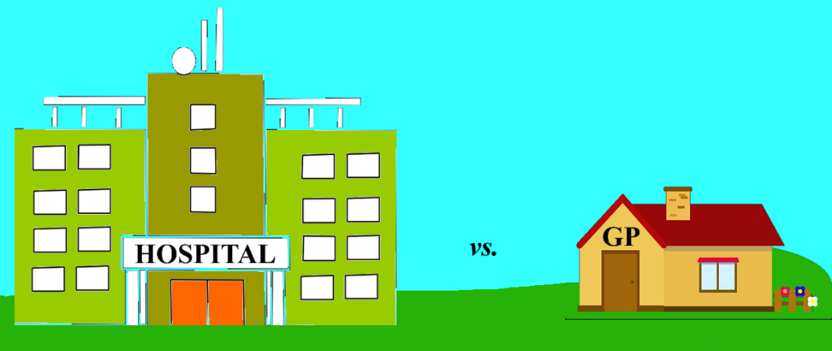

Invariably, most new GP trainees come from a background of hospital medicine – that is their starting point. So, at this point, it is worthwhile examining some of the differences between hospital medicine and general practice. This, together with the rating scale that you’ve just completed above, will help you understand your current starting ‘ethos’ which is probably somewhere on the hospital side. This table should help you identify which parts of you need to change in order to acquire a more GP orientated stance. Feel free to bring this up and chat to your trainer about it.

The Hospital Ethos | The General Practice Ethos
- Normally focus on one problem or clinical area | - Multiple problems addressed simultaneously
- Traditional linear biomedical consultation model (history, HPC, PMH, FH, SH etc.) | - Complex consultation style adapted to needs of each patient e.g. Calgary Cambridge
- Minimal concern for psychological/social aspects | - Psychological and social aspects integral to the whole doctor/patient relationship
- Uncertainty is not tolerated – investigations or admission the norm | - Uncertainty has to be tolerated in many cases
- One way of doing things | - Multiple options with often complex negotiation with the patient
- Prescribing responsibility normally confined to one clinical area | - Responsible for whole of repeat medication list and acute prescribing across multiple clinical areas
- Safety netting often limited to “contact GP if problems” | - 3 point safety netting with clear signposting for potential crises
- Not usually any long term doctor/patient relationship | - Long term doctor/patient relationship is a major element
- No responsibility for the long term patient record | - Responsible for managing the patients long term health records
- Constantly surrounded by a team of health professionals | - Isolated professionally for much of the day
- Junior doctors frequently seek support from “seniors” | - Trainees have to learn autonomous working
- Very hierarchical structure | - Collegiate approach

Are there any things on this list that you had not previously anticipated? Please highlight these.

