Registering with the RCGP as an AiT
Register with the RCGP as an AIT (Associate in Training) – THIS IS REALLY IMPORTANT AND YOU NEED TO DO THIS BEFORE YOU START THE SCHEME.
Registration is online with an initial registration fee which is confirmed by email. Your ePortfolio will be activated between 24 and 48 hours after registration with a welcome pack sent approximately 10 days after.
To register online, go to: https://www.rcgp.org.uk


Click the link above, then on top right corner click the login button.

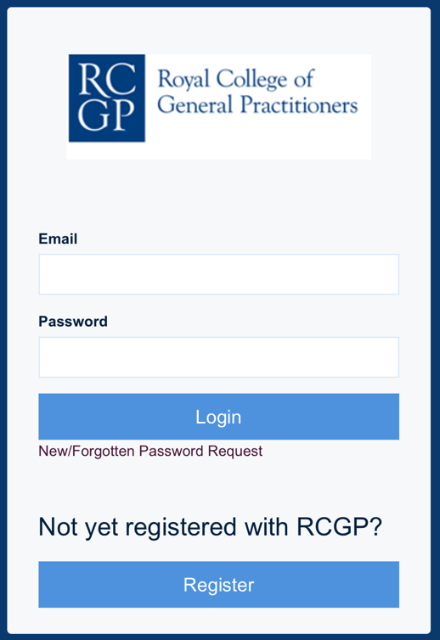
Then click the register box.

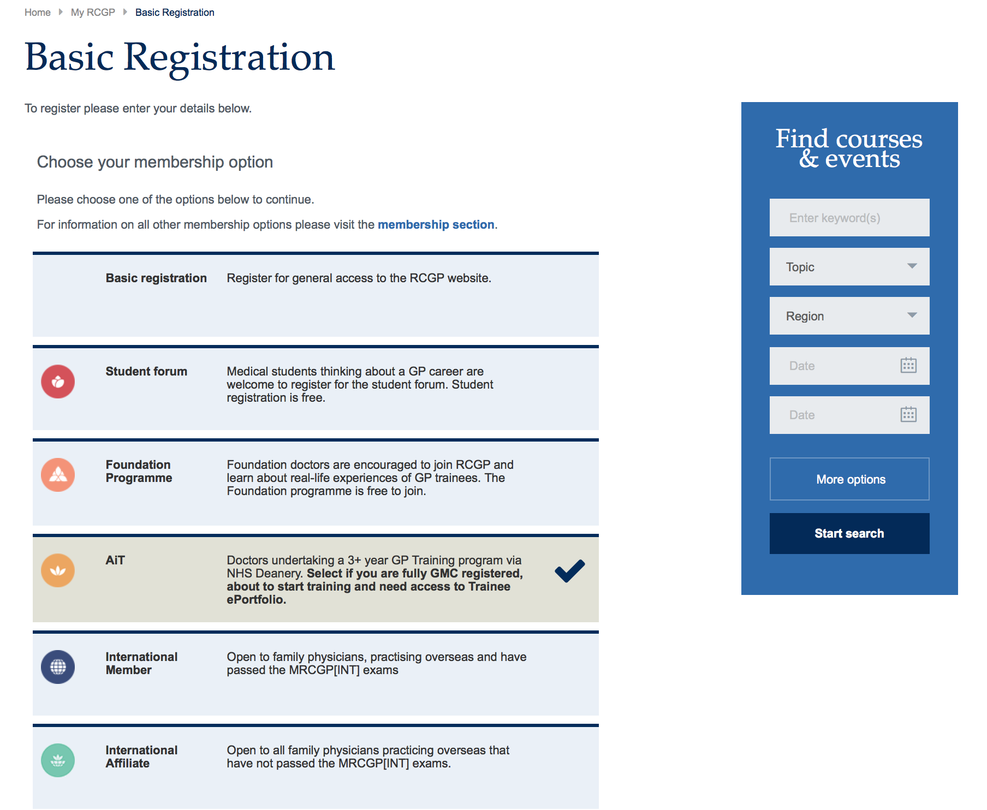
Click the AiT box if you are undertaking the GP training programme
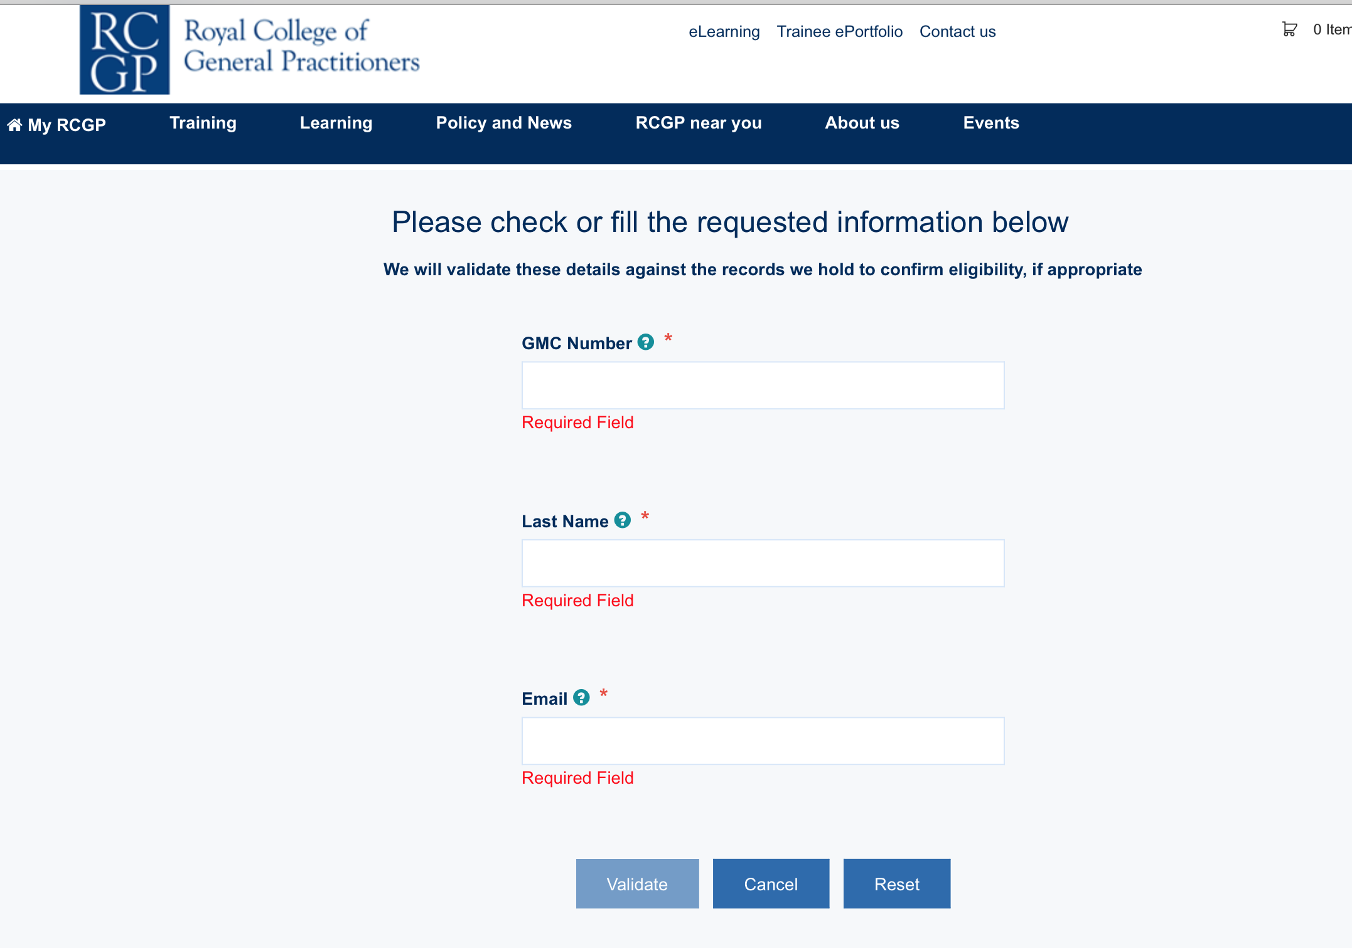
Fill in the requested information

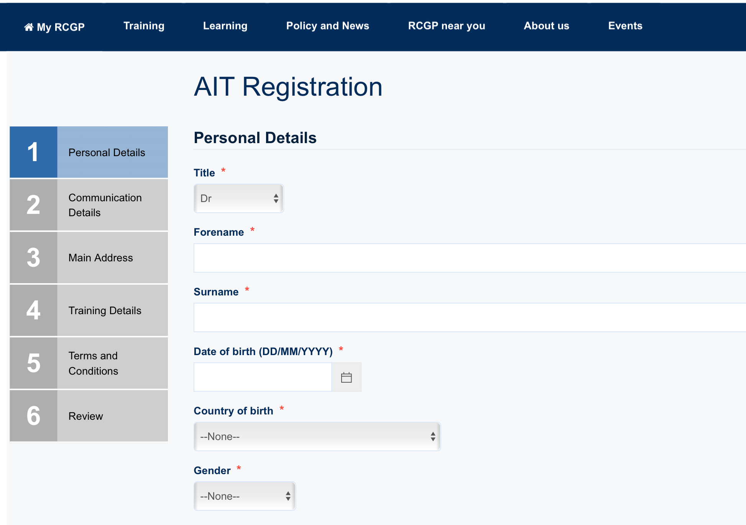
This AIT registration box comes up insert the details

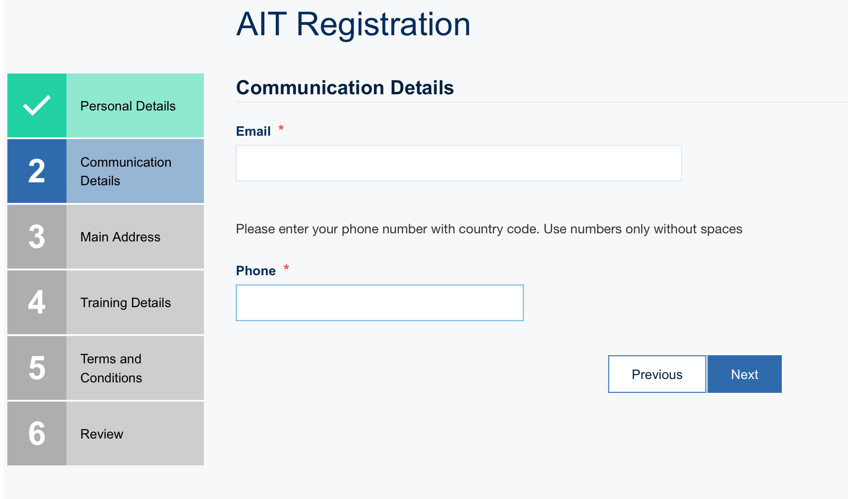

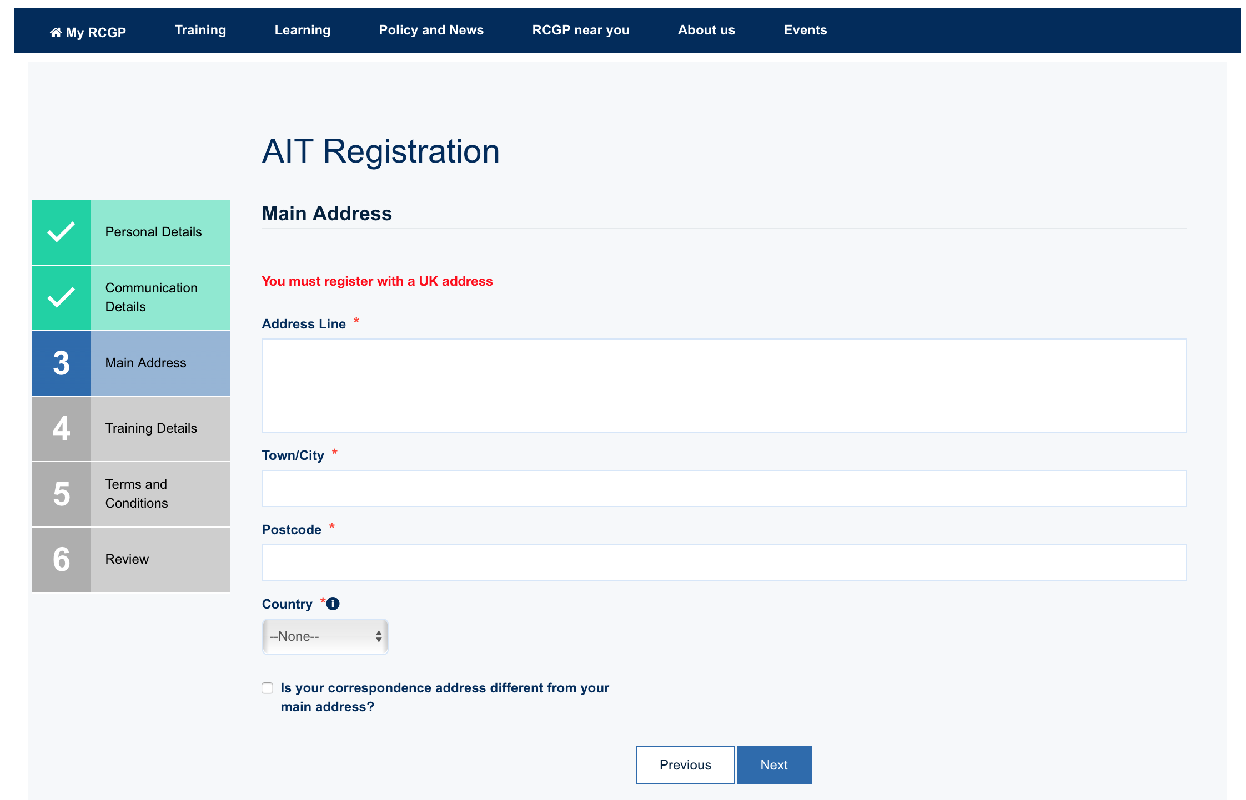

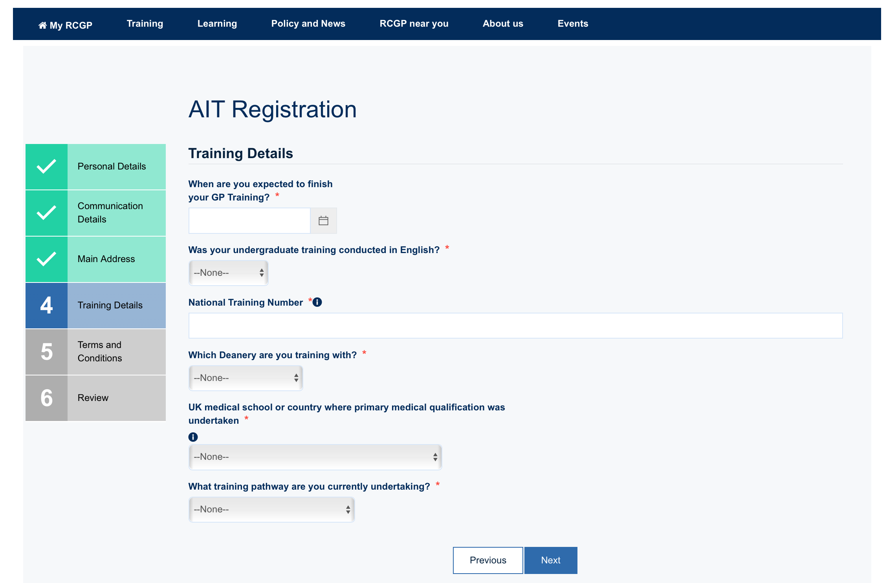

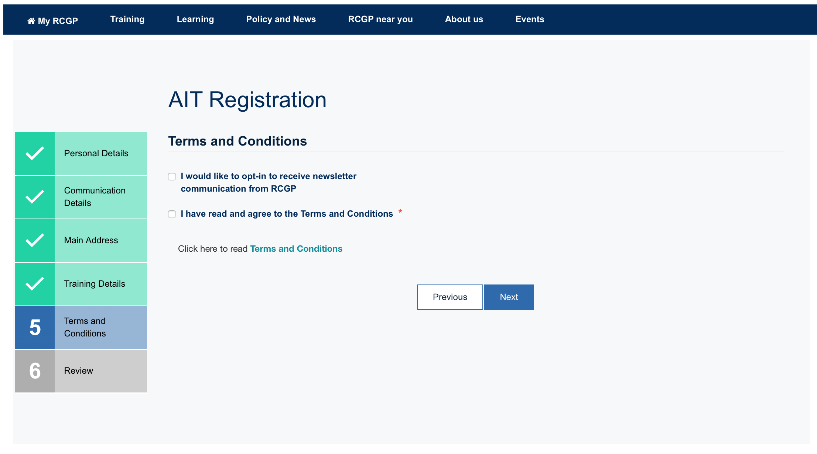

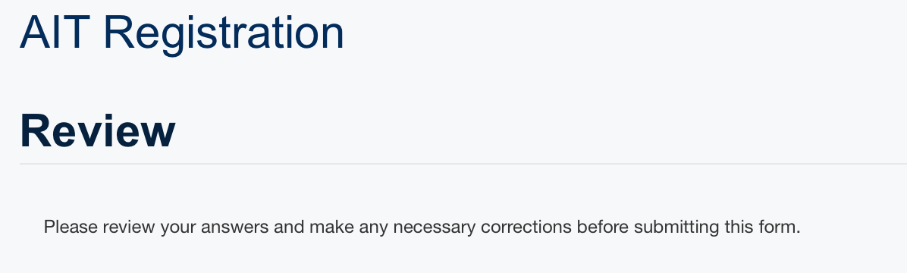
Review the information entered prior to submission

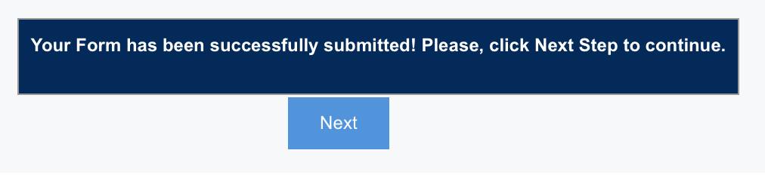
Click Next
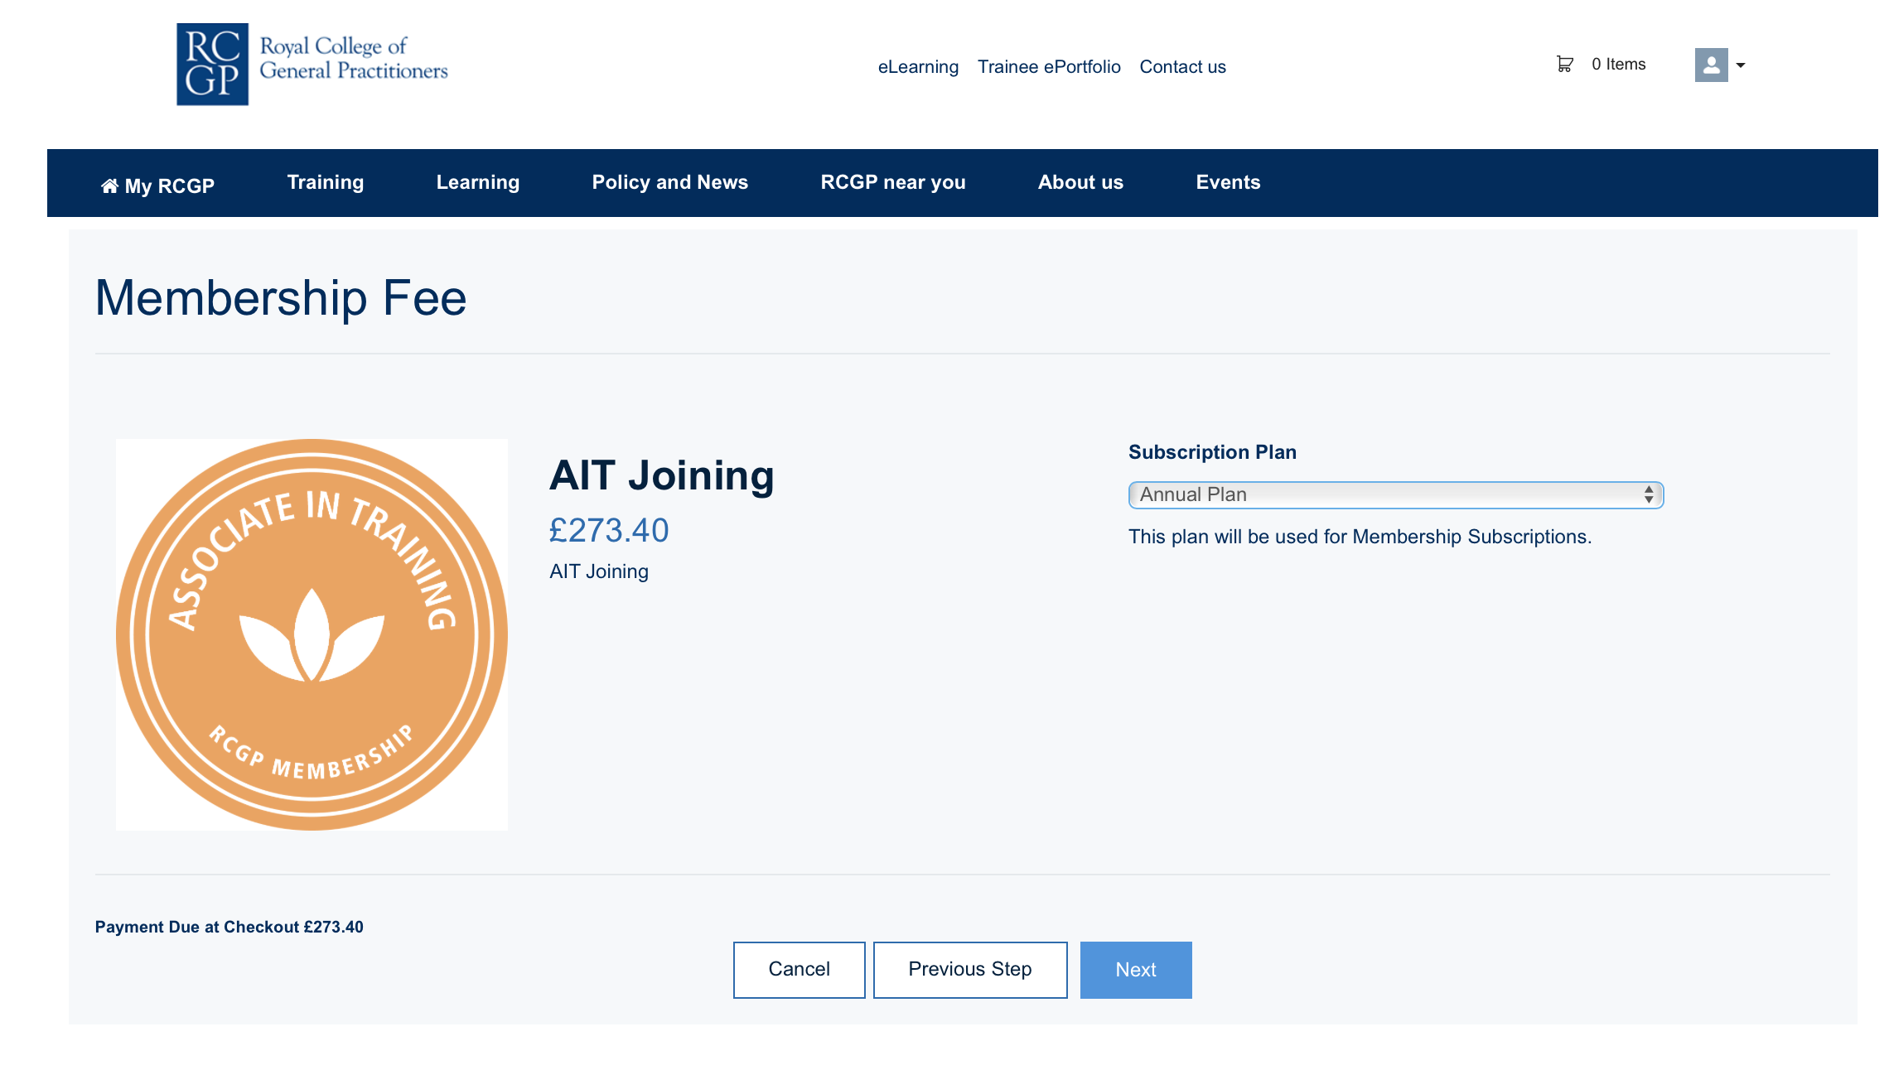
Pay the initial subscription, then the annual fee is collected on 1st April yearly.

You are now registered with the RCGP – await emails and the initial membership pack to arrive.
Ps. Remember to fill out a tax return to get some money back on your subscription.

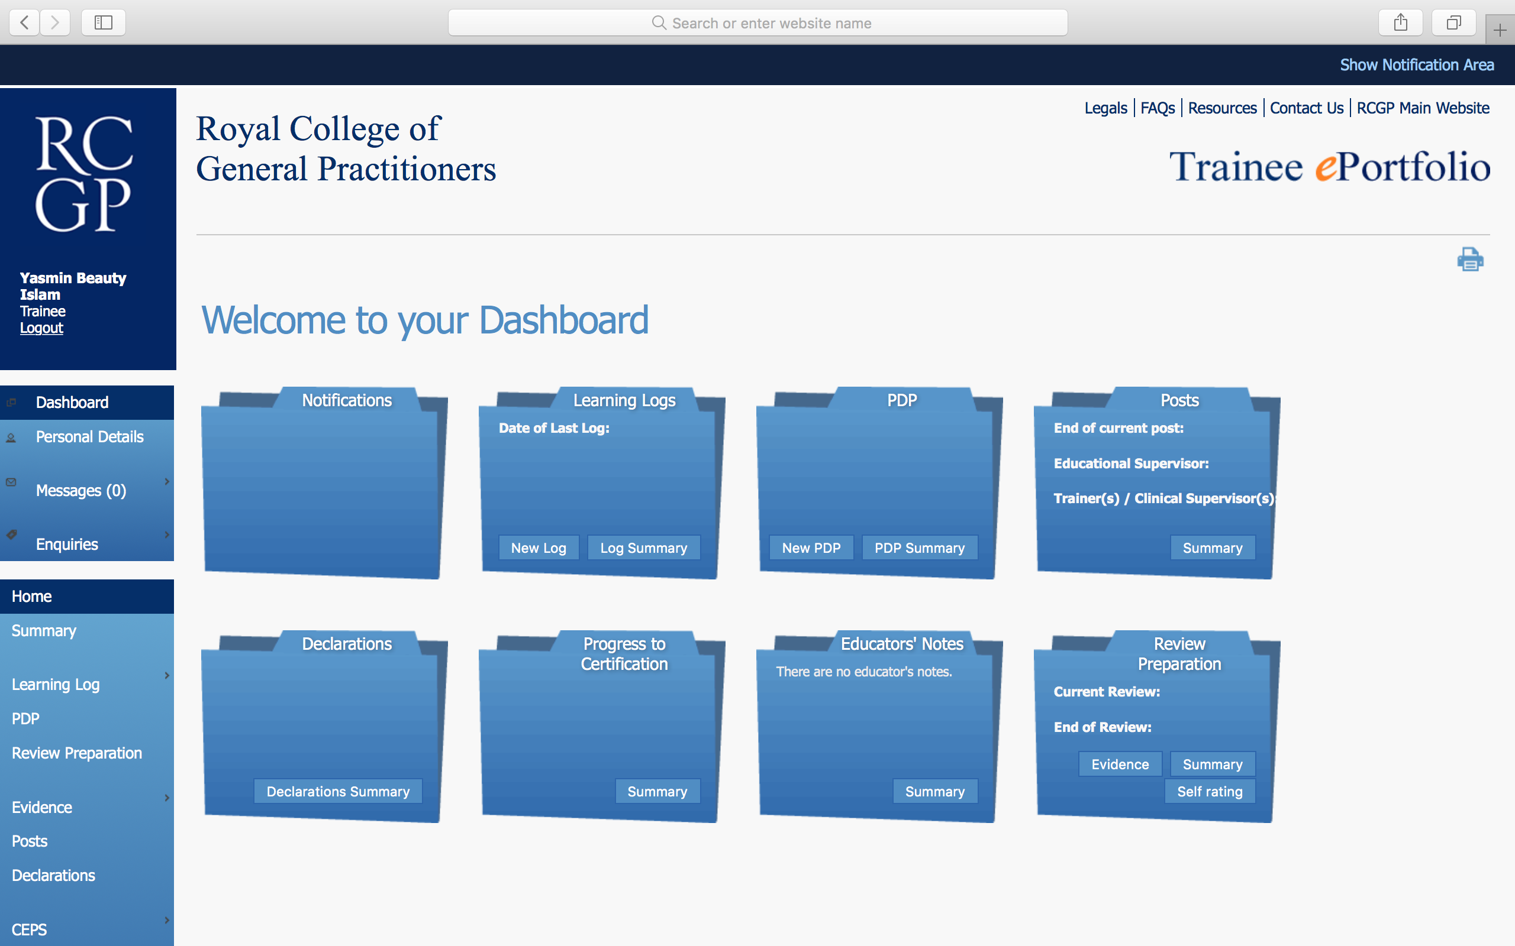
Welcome to your Portfolio

